UNIWERSYTET WROCŁAWSKI
WYDZIAŁ BIOTECHNOLOGII

Filip Pietluch
Phylogenetic analysis and estimation of divergence times for eukaryotic plastid lineages

Praca doktorska wykonana
w Zakładzie Bioinformatyki i Genomiki
Promotor: prof. dr hab. Paweł Mackiewicz
Promotor pomocniczy: dr Przemysław Gagat
Wrocław 2023
Acknowledgments

I am immensely thankful to my supervisor prof. dr hab. Paweł Mackiewicz for his advice, awakening curiosity and resources that allowed me to complete this dissertation.
I would like to extend my heartfelt appreciation to my auxiliary supervisor dr Przemysław Gagat who has been an unwavering source of support and guidance throughout not just my doctoral research, but also during my undergraduate and master's studies. Your dedication, patience, and unwavering belief in my abilities have played a pivotal role in shaping my academic journey.
Additionally, I would like to thank my parents for their unceasing encouragement and support for all these years. This all work would not have been possible without them.
I would like to express my deepest gratitude to my better half who had to endure having a scientist at home all these years. Your patience, support, and understanding have been invaluable throughout this journey. Thank you for standing by me, providing unwavering encouragement, and creating a nurturing environment where I could pursue my passion for science. I am truly fortunate to have you by my side.
My research has been supported by the National Science Centre grant 2019/35/N/NZ8/03366 thanks to F.P and 2017/26/D/NZ8/00444 thanks to P.G.

Contents
Contents 3
Streszczenie 5
Abstract 7
1. Introduction 9
1.1 Plastid evolution 9
1.1.1 Primary plastid endosymbiosis 9
1.1.2 Secondary plastid endosymbiosis 14
1.2 Main groups of plastid bearing organisms 18
1.2.1 Archaeplsatida 18
1.2.2 SAR 18
1.2.2.1 Stramenopiles 18
1.2.2.2 Alveolata 19
1.2.2.3 Rhizaria 19
1.2.3 Cryptista 20
1.2.4 Haptista 20
2. Aim of the thesis 20
3 Materials and methods 22
3.1 Dating the origin and spread of primary plastids and chromatophores 22
3.1.1 Preparing datasets 22
3.1.2 Phylogenetic and Molecular Clock Analyses 22
3.1.3 Comparison of molecular clocks and calibration sets 25
3.1.4 Comparison of diversification rate with climatic and atmospheric parameters 26
3.2 Dating the origin and spread of red alga derived plastid in the Chromalveolata lineages 26
3.2.1 Preparing datasets 26
3.2.2 Phylogenetic and Molecular Clock Analyses 27
3.3 PhyloPlast – plastid knowledge database 29
3.3.1 Preparing datasets and database curation 29
3.3.2 Database implementation 30
4. Results and discussion 32
4.1 Database statistics 32
4.2 Phylogeny and dating the origin and spread of primary plastids and chromatophores 35
4.2.1 Phylogenetic analyses 35
4.2.2 Molecular dating analyses 38
4.2.3 The impact of molecular clocks and calibration sets on age estimations 41
4.2.4 Verification of tentatively assigned microfossils 44
4.2.5 Impact of climatic and atmospheric parameters on diversification rate 45
4.3 Summary of phylogenetic analyses and molecular dating of primary plastids and
chromatophores………………………………………………………………………………...48
4.3.1 Phylogenetic analyses 48
4.3.2 Molecular dating analyses 52
4.3.3 Summary of phylogenetic analyses and molecular dating in chromalveolata lineages 53
5. Conclusions 56
References 58
Appendix A 74
Dorobek naukowy 158
Publikacje...................................................................................................................................................158
Wystąpienia konferencyjne 159
Staże………………. 159

Streszczenie
Organizmy eukariotyczne posiadające zdolność przeprowadzania procesu fotosyntezy kształtowały biosferę Ziemi produkując tlen i wykorzystując energię światła do syntezy związków organicznych w specjalistycznych organellach zwanych plastydami. Plastydy wyewoluowały z wolnożyjących sinic „pochłoniętych” przez heterotroficzne jednokomórkowe eukarionty w procesach zwanych pierwotnymi endosymbiozami. Do tej pory odnotowano takie dwa niezależne procesy. Pierwszy dał początek trzem liniom supergrupy Archaeplastida: glaukofitom, krasnorostom i zielenicom wraz z roślinami lądowymi, podczas gdy drugi skutkował ukształtowaniem ciałek fotosyntetycznych zwanych chromatoforami u ameb z rodzaju Paulinella klasyfikowanych do grupy Rhizaria. Zielenice i krasnorosty przekazały swoje plastydy wielu grupom jednokomórkowych eukariontów (protistom) rozprzestrzeniając fotosyntezę na drzewie życia w procesach zwanych endosymbiozami wtórnymi i dając początek euglenom, chlorarachniofitom, kryptofitom, haptofitom, stramenopilom, bruzdnicom, perkinsidom, kolpodellidom, a nawet pasożytniczym apikompleksom. W celu zrozumienia złożonej ewolucji plastydów przeprowadziłem analizy filogenetyczne na nowych zbiorach danych reprezentujących dużą różnorodność organizmów fotosyntetycznych i datowania molekularne oparte na nowych punktach kalibracyjnych. Zbudowałem również bazę danych o nazwie PhyloPlast (biongram.biotech.uni.wroc.pl/phyloplast/) zawerającą ujednolicone, uporządkowane i zweryfikowane informacje o sekwencjach genów plastydowych z zestawem narzędzi do przeszukiwania bazy oraz analiz filogenetycznych i przewidywania lokalizacji subplastydowej.
Moje analizy wskazują, że pierwotne plastydy wyewoluowały przed 2.1 – 1.8 miliardami lat temu, zanim glaukofity oddzieliły się od pozostałych archaeplastidów. Moje wyniki popierają hipotezę, iż glaukofity były pierwszą linią, która oddzieliła się od siostrzanej grupy krasnorostów oraz zielenic i roślin lądowych, co zgadza się z dużą liczbą cech sinicowych zachowanych w plastydach glaukofitów. Przedstawione badania są pierwszymi, które uwzględniły wiele metod datowania molekularnego i wszystkie znane gatunki fotosyntetyczne Paulinella. Otrzymane filogenezy i wyniki datowań molekularnych wskazują, że chromatofory Paulinella wyewoluowały prawdopodobnie przed 292 - 266 milionami lat temu w siedliskach o niskim zasoleniu, podobnie jak pierwotne plastydy.
Warto wspomnieć, że moje badania dotyczące supergrupy Archaeplastida przesuwają wstecz większość kluczowych wydarzeń związanych z ich ewolucją w porównaniu z wcześniejszymi doniesieniami. Wskazują, że zielenice zostały pochłonięte przez przodków chlorarachniofitów między 1.1 – 1.0 miliardami lat temu. W przeciwieństwie do powszechnego poglądu zakładającego jednokrotne pochłonięcie krasnorostu i przekształcenie go we wtórny plastyd, moje wyniki ujawniają, że musiały wystąpić dwie niezależne wtórne endosymbiozy krasnorostów. Opracowany przeze mnie model zakłada, że pierwsza wtórna endosymbioza krasnorostu dała początek ochrofitom około 1.67-1.52 miliarda lat temu, a druga kryptofitom w okolicach 1.53 – 1.18 miliardów lat. Ochrofity przekazały następnie swoje plastydy podczas trzeciorzędowej endosymbiozy między 1.22-0.93 miliardami lat do wspólnego przodka bruzdnic, perkinsidów, kolpodellidów i apikompleksów, natomiast przekazanie plasydu przez kryptofity do haptofitów również w ramach trzeciorzędowej endosymbiozy nastąpiło nie później niż 1.18 miliarda lat temu. Porównując datowania molekularne z danymi geologicznymi odkryłem istotny wpływ parametrów klimatycznych i atmosferycznych na tempo różnicowania linii plastydowych. Tempo to wzrastało wraz ze wzrostem temperatury i stężeniem dwutlenku węgla, a spadało wraz ze wzrostem stężenia tlenu i aktywności wulkanicznej. Nowe wyniki datowań molekularnych pozwoliły także na weryfikację wątpliwych mikroskamieniałości, np. Grypania i Bangiomorpha. Zbadałem także wpływ różnych metod datowania molekularnego i punktów kalibracyjnych na szacowanie czasu rozejścia się linii filogenetycznych i wskazałem, że modele zegarów molekularnych mają duży wpływ na rozbieżności w datowaniach.

Abstract
Photosynthetic eukaryotes have shaped the Earth's biosphere by producing oxygen and using light energy to synthesize organic compounds in specialized organelles called plastids. Plastids evolved from free-living cyanobacteria engulfed by heterotrophic unicellular eukaryotes in processes called primary endosymbioses. Two independent such processes have been reported so far. The first gave rise to primary plastids and three Archaeplastida lineages: glaucophytes, red algae and green algae with land plants, whereas the second resulted in chromatophores in the rhizarian amoeba Paulinella. Importantly, green and red algae donated their plastids to many unicellular eukaryotes (protists), thereby further spreading photosynthesis across the tree of life, giving rise to euglenids, chlorarachniophytes, cryptists, haptists, stramenopiles, dinoflagellates, perkinsids, colpodellids and even parasitic apicomplexans. To reveal the complex plastid evolution, I performed comprehensive phylogenetic and molecular dating analyses based on new fossil calibration points and datasets, representing a large diversity of photosynthetic organisms. I also build a database called PhyloPlast (biongram.biotech.uni.wroc.pl/phyloplast/), containing unified, ordered and verified information about plastid gene sequences with a set of tools for database search as well as phylogenetic analysis and prediction of sub-plastid localization.
My results indicate that primary plastids evolved prior to 2.1 - 1.8 Ba, i.e. before glaucophytes diverged from the other archaeplastidans. They favour the glaucophyte-first hypothesis, i.e. glaucophytes as the first branching lineage to the sister-group of red algae and green algae with land plants, and agree with the large number of cyanobacterial characteristics preserved in glaucophyte plastids. The presented results are the first to include multiple molecular dating methods for all known Paulinella photosynthetic species. The obtained phylogenies and the results of molecular dating indicate that Paulinella chromatophores evolved possibly before 292 - 266 Ma in low salinity habitats like the primary plastids before.
It is worth mentioning that my studies concerning archaeplastidans push back in the Earth’s history most key events concerning their evolution compared to previous reports. They indicate that green algae were engulfed by chlorarachniophyte ancestors between 1.1 - 1.0 Ba. Contrary to the popular belief that the red algae were engulfed once and transformed into a secondary plastid, my results reveal that there must have been two independent secondary red-alga endosymbioses. In my model, the first secondary red alga-endosymbiosis gave rise to ochrophytes around 1.67-1.52 Ba and the second to cryptists before 1.53 - 1.18 Ba. Ochrophytes next passed their plastids during a tertiary endosymbiosis between 1.22-0.93 Ba to the common ancestor of dinoflagellates, perkinsids, colpodellids and apicomplexans, whereas cryptists passed their plastids to haptists also during a tertiary endosymbiosis no later than 1.18 Ba. Comparing molecular dating with geological data, I discovered a significant impact of climatic and atmospheric parameters on the diversification rate of plastid lineages. It increased with temperature rise and CO₂ concentration but decreased with O₂ concentration and volcanic activity. The new results of molecular dating also allowed to verify controversial microfossils, such as Grypania and Bangiomorpha. I also studied the impact of various methods of molecular dating and calibration sets on the age estimation and clearly indicate that the molecular clocks are the source of greater differences.

Introduction

1.1 Plastid evolution
Plastids represent a highly diverse group of cell organelles that originated through endosymbiosis. While their prominent role in photosynthesis is well-known, they also play crucial roles in nitrogen and sulphur assimilation, as well as the synthesis of various compounds such as amino acids, fatty acids, galactolipids, terpenoids, vitamins, and tetrapyrroles. Plastids exhibit significant variations in ultrastructure, biochemistry, and genetics, including (i) the number of envelope membranes, (ii) thylakoid organization, (iii) composition of photosynthetic pigments, (iv) genome size and content, and (v) targeting pathways for nuclear-encoded proteins [1–4].
Already at the end of the 19th century, it was observed that plastids are not created de novo by the cell, but can only arise through the division of an existing plastid. In 1905, the Russian botanist Konstantin Mereschkowski presented similarities between free-living cyanobacteria and plastids. Based on his observations and previous discoveries, he formulated the hypothesis of the symbiotic origin of plastids. According to him, plastids were not organelles, but foreign organisms that had invaded another cell, and triggered the evolution of plants [5]. This idea was long forgotten and only re-emerged at the end of the 1960s thanks to the American biologist Lynn Margulis. Based on information from various fields and the discovery that DNA is present inside the plastid, she proposed that plastids (as well as other organelles) are the result of symbiosis originating from once-engulfed bacteria [6]. The development of molecular techniques soon provided numerous evidence to support her ideas, and the endosymbiotic theory became widely accepted [1].

Primary plastid endosymbiosis
Sometime around 2.45 billion years ago (Bya), the Earth’s atmosphere started to change due to the accumulation of molecular oxygen. This transition, called the Great Oxidation Event, was a byproduct of sun-powered and water-splitting reaction of photosynthesis performed by cyanobacteria. Undoubtedly, cyanobacteria have fundamentally altered the conditions of life on our planet, but they did more than evolve oxygenic photosynthesis, because they also passed this ability to eukaryotes in the process of primary endosymbiosis i.e. the engulfment and integration of a cyanobacterium into the eukaryotic cell (Figure 1) [7].

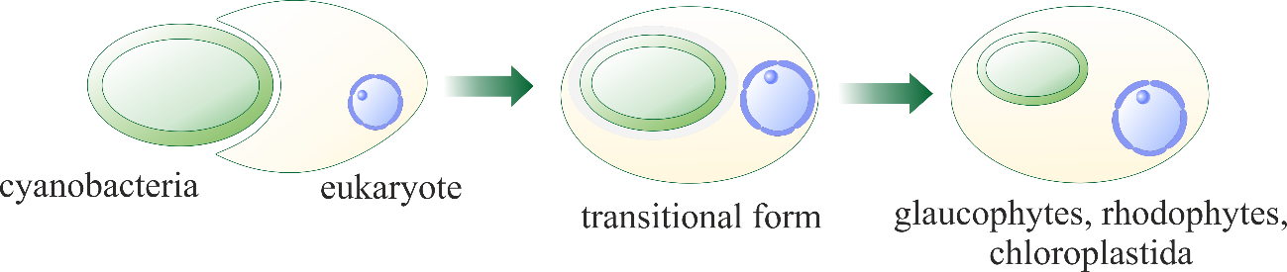
Figure 1. Primary plastid endosymbiosis.

The origin of plastids goes back to the Paleoproterozoic era. Molecular clock analyses date the "birth" of autotrophic eukaryotes to about 2 billion years ago [8,9] and fossil data show that this group is not younger than 1.6 billion years old [10]. This endosymbiotic merger gave rise to three photosynthetic lineages of Archaeplastida: Glaucophyta (glaucophytes), Rhodophyta (red algae) and Chloroplastida (green algae and land plants). Their cyanobacteria-derived photosynthetic organelles are called respectively: muroplasts, rhodoplasts and chloroplasts, and collectively primary plastids (Figure 2).
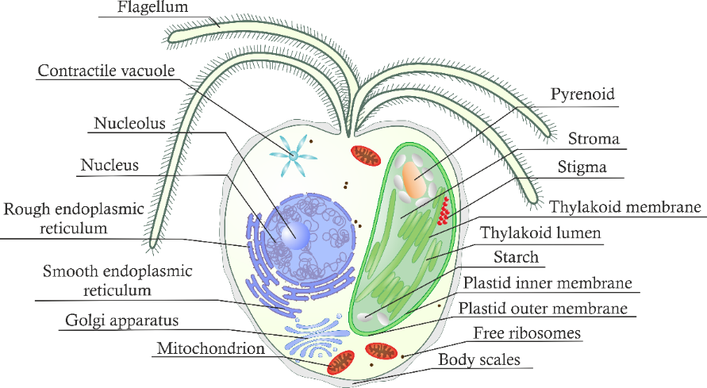
The closest relative of the primary plastid ancestor discovered is a benthic bacterium: Gloeomargarita lithophora. The living environment of this cyanobacterium suggests that photosynthetic eukaryotes evolved in a terrestrial or freshwater environment, rather than in a marine habitat as previously thought [11].
A

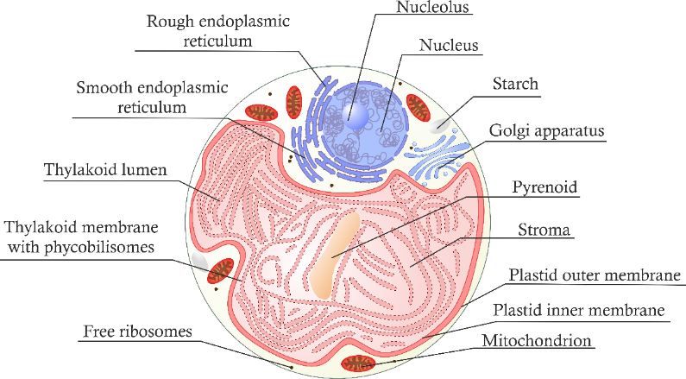
B

(Figure 2. Caption on the next page.)

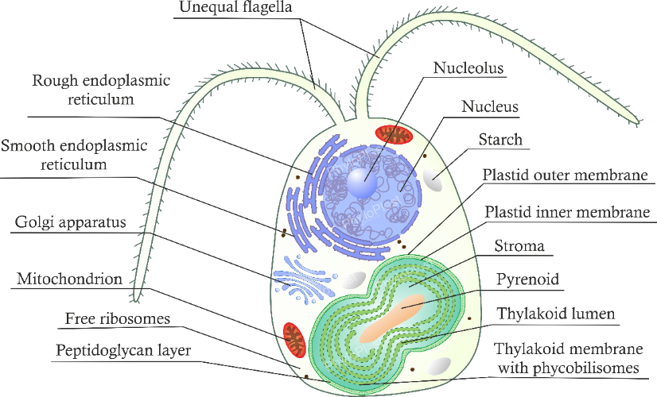
C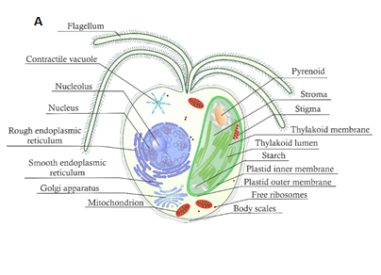

Figure 2. Cell structure of primary plastid bearing organisms. Green alga with chloroplast (A), red alga with rhodoplast (B) and glaucophyte with muroplast (C).
The initial interaction between the cyanobacterium (the prospective plastid) and the eukaryotic host probably did not involve symbiosis but rather a predator-prey relationship. The unicellular eukaryote was a phagotroph that would feed on bacteria, and interestingly, some of its descendants, such as the green alga Cymbomonas tetramitiformis, still retain this ability [12,13]. The question arises as to what prompted the eukaryote to cease hunting for its prey and “capture" cyanobacteria as a permanent "guest" inside its own cell. The "luggage hypothesis" appears to offer some answers. In essence, a change in the environment that led to a decrease in the abundance and availability of cyanobacterial prey could have compelled the predator to store its prey for longer and establish a more stable relationship with it, eventually resulting in a transient and then permanent endosymbiosis [14].
An interesting question arises whether the present-day plastids are the legacy of a single cyanobacterium or the inheritance of multiple cyanobacteria. According to the "you are what you eat" hypothesis, the host, by feeding on cyanobacteria and other bacteria, could have easily assimilated their genes into its genome [15]. It is also possible that transient relationships between the host and numerous cyanobacteria may have occurred before establishing a permanent association. Although the transient endosymbionts were all eventually phagocytized, their DNA was available for an extended period of time, facilitating its transfer to the host nuclear genome. It strengthened relationships between the host and the endosymbionts. Protein products of genes incorporated into the host genome, and the host genes as well, have been targeted to the emerging organelle, making the modern plastid. It is assumed that the genetic material was obtained from various sources and the plastid represents a molecular chimera comprising gene products from multiple organisms. This hypothesis is referred to as the "shopping bag model" [16].
Cyanobacteria was also given a helping hand on their way to become cell organelles by chlamydial intracellular parasites. They provided the host with key carbohydrate metabolism enzymes, e.g. glycogen synthase (GlgA), glycogen debranching enzyme (GlgX) and carbohydrate transporters. This in turn allowed the host to change the cyanobacterial ADP-glucose to eukaryotic-accessible UDP-glucose, and made the products of photosynthesis compatible with the host metabolism [17,18]. According to “the ménage à trois hypothesis”, chlamydia did much more than simply contributing some essential genes. They were to facilitate the process of cyanobacterial endosymbiosis by: (i) protecting from phagocytosis of vesicles that chlamydia were sharing with cyanobacteria inside the host cell, and (ii) by establishing a metabolic connection through their enzymes, which were initially used to exploit the cyanobacteria at the onset of the tripartite relationship between chlamydia, cyanobacteria and eukaryotic host [18]. Irrespective of whether chlamydia were directly involved in primary plastid establishment, the cyanobacterial endosymbiont must have escaped its phagosome at certain point as it is surrounded by two and not three envelope membranes. It is hypothesized that during this escape the outer cyanobacterial membrane acquired some lipids and proteins from the phagosomal membrane, which accounts for its chimeric bacterial-eukaryotic nature [4].
Given the global importance of Archaeplastida, it is not surprising that the group has been extensively studied for many decades [11,19,20]. However, there are still some fundamental inconsistencies around their evolution, such as the diversification time and branching order among the Archaeplastida lineages, or even the number of cyanobacterial endosymbioses that triggered their evolution. These inconsistencies result from the fact that (i) archaeplastidans poorly preserve in a fossil state, (ii) the phylogenetic signal contained in their genomes has eroded to a large extent, and (iii) glaucophytes have been notoriously underrepresented in phylogenetic and molecular clock studies [21]. The formation of the primary plastid was truly an evolutionary milestone, but not a unique one. In fact, just one another instance of cyanobacterial endosymbiosis has been thus far discovered and it is a comparably young because it occurred less than 500 million years ago in the ancestor of testate filose amoeba Paulinella chromatophora, P. micropora and P. longichromatophora [22,23]. This organisms are classified within the supergroup of Rhizaria, which comprises both photoautotrophic and heterotrophic species of testate filose amoeba and is phylogenetically distant to the supergroup Archaeplastida [24,25]. The most important feature of the photosynthetic Paulinella are blue-green bodies called chromatophores that probably evolved from a picocyanobacterium of the Prochlorococcus/Synechococcus/Cyanobium clade. Compared to primary plastids, chromatophores represent cyanobacteria-derived organelles at an earlier stage of endosymbiosis, and they are the sole reason why Paulinella is so important from the evolutionary point of view.
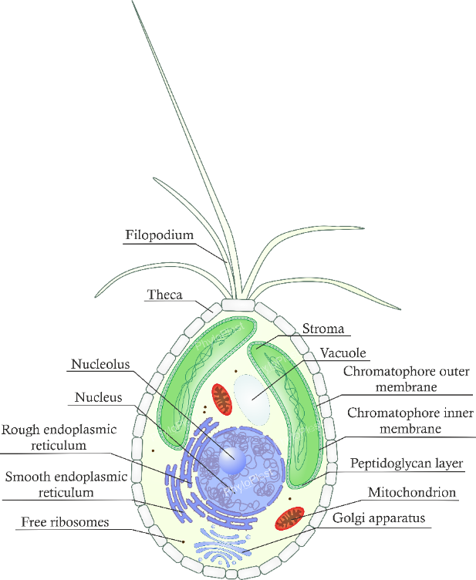
Normally, two Paulinella cyanobacterial endosymbionts reside within the amoeba (Figure 3). Just like plastids, they are surrounded by two membranes and are capable of carrying out photosynthesis, permitting an autotrophic existence for the amoeba. The chromatophores divide in tandem with the host, exchange metabolites with it, and cannot survive without the host [24,25]. Additionally, the chromatophore genome is vastly reduced compared to the genome of its closest free-living relative the cyanobacterium Cyanobium gracile [23,26], the former having about 900 genes, and the latter 3500 genes [27]. This is reminiscent of the reduction of the genomes of archaeplastidian plastids, which encode only around 130 genes [28].
Both in the case of Archaeplastida and Paulinella, a substantial fraction of cyanobacterial genes were transferred to the nuclear genome, whereas others were lost as redundant in the new eukaryotic environment [3,4,29]. Many of the transferred genes are expressed in the host cytosol and their protein products have to be imported into the primary plastids and chromatophores to fulfill their functions. Primary plastids and chromatophores evolved two kinds of import pathways for the nuclear-encoded proteins: (i) based on protein transporters and (ii) on vesicular trafficking. The system based on the transporters in Archaeplastida is responsible for the delivery of the vast majority of plastid nuclear-encoded proteins and is called Toc-Tic (the translocon at the outer/inner chloroplast membrane) [30]. It depends on the recognition of N-terminal targeting signals called plastid transit peptides (pTP), which are present in the transported proteins. After these proteins are inside the plastid the peptides are cut off by proteases and degraded [31]. The Paulinella system is not fully characterized, and therefore requires further investigations. It seems that small proteins enter Paulinella chromatophores in vesicles of the endomembrane system based on signal peptide-like information and the import of the large ones is based on protein transporters and chromatophore transit peptides (crTP) [32,33,33,34].
Figure 3. Paulinella chromatophora cell structure. Two endosymbionts called chromatophores are characteristic feature of the amoeba.
Interestingly, the vesicular trafficking, was once hypothesized to operate in the ancestral plastid of Archaeplastida as the first protein import pathway, a scenario termed as the “early endomembrane trafficking” hypothesis [35,36]. The existence of several “relic” proteins with N-terminal signal peptides targeted to primary plastids in endomembrane vesicles was considered evidence for such primordial transport. Although it seems plausible for chromatophores, the hypothesis was strongly refuted for primary plastids based on phylogenetic and bioinformatics analyses of the imported proteins and targeting signals of their homologues. In the case of Archaeplastida, the vesicular trafficking evolved relatively late to primary plastids, after the evolution of the Tic-Toc translocons, possibly only in higher plants, to permit glycosylation and/or transport to more than one cellular compartment [36].
To sum up, the transformation of cyanobacteria into plastids and chromatophores might be narrowed down to three major process: (i) metabolic integration with the host cells, (ii) genome reduction by gene loss and endosymbiotic gene transfer to the host nuclear genome, and (iii) evolution of protein import machineries in the endosymbiont envelope membranes for nuclear-encoded proteins along with appropriate targeting signals.

Secondary and higher plastid endosymbioses
Two primary plastid-containing lineages, red and green algae, subsequently triggered an evolutionary radiation via a series of eukaryote-to-eukaryote endosymbioses that resulted in a multitude of secondary and higher-order plastids with envelopes composed of three or more membranes [37]. They include organelles of euglenids, chlorarachniophytes, cryptists, haptists, stramenopiles, dinoflagellates, perkinsids, colpodellids and parasitic apicomplexans (Figure 4) These organelles are called complex plastids and their origin has been a topical issue in evolutionary biology for decades [4,38].
In order to explain the evolution of complex plastids, Cavalier-Smith put forward the Cabozoa and the Chromalveolata hypotheses [37]. According to the Cabozoa model, the common ancestor of euglenids and chlorarachniophytes engulfed a green alga, which was transformed to their plastids. The Chromalveolata model postulated that a red alga was engulfed by the common ancestor of many protist lineages called collectively chromalveolates and next evolved to their plastids. To the Chromalveolata supergroup are classified cryptists, haptists, stramenopiles and alveolates, which include dinoflagellates, perkinsids, colpodellids and apicomplexans among others. The Cabozoa hypothesis was quickly refuted by phylogenetic analyses, which revealed that neither the host cells, i.e. euglenids and chlorarachniophytes, nor their potential green alga endosymbionts were closely related. In fact, euglenids and chlorarachniophytes belong to distinct super-assemblages, called Excavata and Rhizaria respectively, and their plastids represent different green alga lineages [39,40]. Consequently, their green alga plastids must have been acquired independently. In contrast to the Cabozoa model, the Chromalveolata hypothesis shaped our views on the evolution of red alga-derived plastids for more than a decade [41,42]. Yet through the test of time, the phylogenetic analyses also disproved this model as the nuclear markers did not support the monophyly of the Chromalveolata clade [43–45]. Moreover, this clade contains numerous heterotrophic and parasitic lineages that had to loose plastids under this hypothesis, which is also an unparsimonious evolutionary assumption [46].

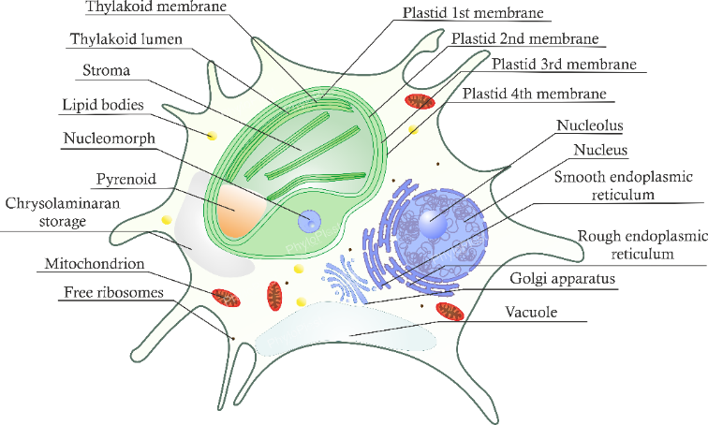
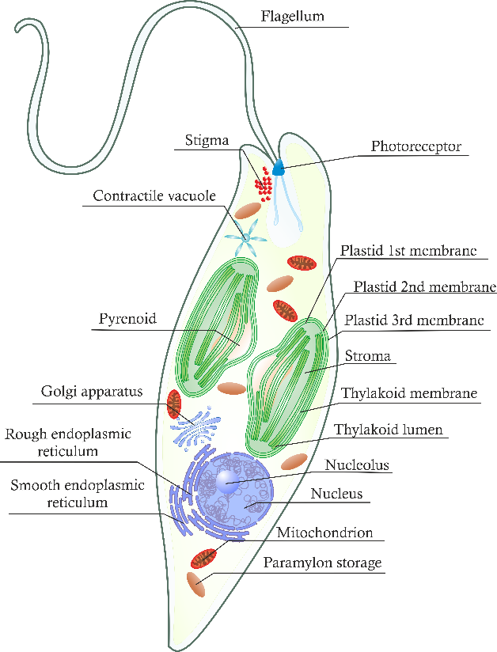
A
B

C

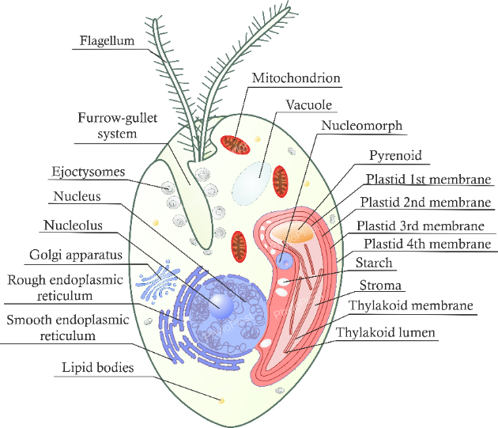

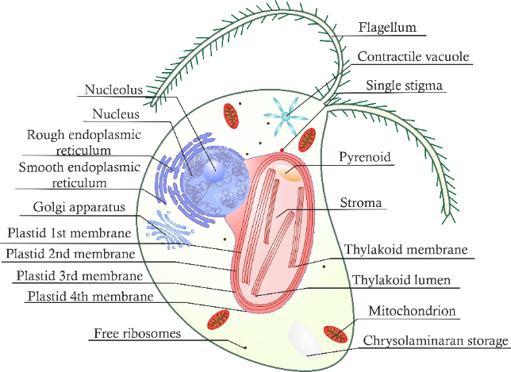
D

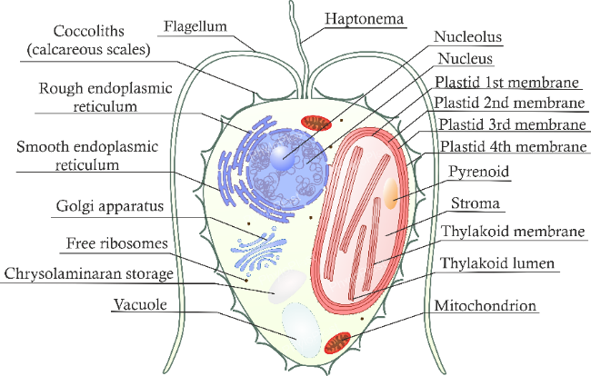
E

(Figure 4. Caption on the next page.)
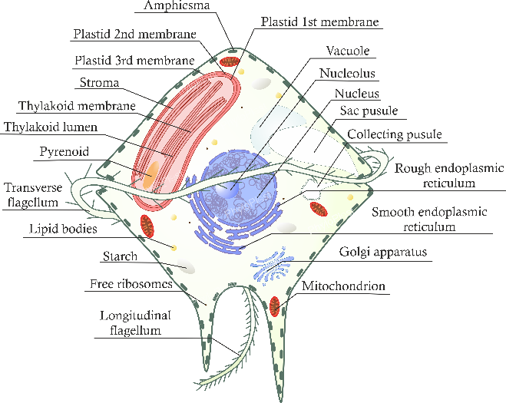
F

G
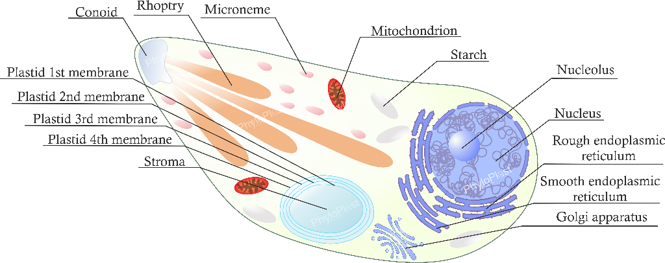

Both the Cabozoa and the Chromalveolata hypotheses embraced the principle of minimizing endosymbiotic events and assumed that the process of endosymbiont-to-organelle transformation is very difficult and by definition rare [37,47]. This sort of thinking was changed by the discovery of: (i) the second case of primary endosymbiosis in Paulinella photosynthetic species [48,24], (ii) the promiscuity of dinoflagellates in terms of plastid acquisition and replacement [49], and (iii) numerous cases of endosymbioses in progress described in many protists from different phylogenetic lineages [2,50–52].
Figure 4. Cell structures of organisms that have acquired plastids in secondary and higher-level endosymbiosis process. Pictures A and B represent cells of chlorarachniophyte and euglena, respectively, which have acquired their plastids through secondary endosymbiosis from green algae. Images C, D, and E represent cells of cryptists, stramenopiles, and haptists, respectively, which harbour plastids acquired from red algae through secondary endosymbiosis. Images F and G represent organisms that have acquired plastids through higher-level endosymbiotic events: dinoflagellates and apicomplexans, respectively.
The downfall of the principle of minimizing endosymbiotic events and the need to reconcile nuclear and plastid marker-based phylogenies caused that recent hypotheses for the origin and spread of red alga-derived plastids prefer models of serial endosymbioses. For example, Bodył [53] and Stiller et al. [38] both proposed that only the cryptist (precisely cryptophyte or cryptomonad) plastid is of direct red alga descent, i.e. represents a true secondary plastid. According to their models, the cryptist plastid was subsequently transferred to some stramenopiles, known as Ochrophyta, in a tertiary endosymbiosis. In turn, stramenopiles passed their plastids to haptists (precisely to Haptophyta) and in Bodył [53] scenario additionally and independently to the common ancestor of dinoflagellates, perkinsids, colpodellids and apicomplexans. In a quinary endosymbiosis, a haptist plastid replaces the former quaternary stramenopile-derived plastid in peridinin ‘core’ dinoflagellates but not in their basal lineages (Figure 5A) [53]. Interestingly, some peridinin dinoflagellates also experienced further endosymbiotic plastid switches that involved organelles of cryptists, stramenopiles and haptists [49]. As a result, dinoflagellates became famous for plastid acquisition from various sources. Importantly, the former scenario by Bodył et al. [54] assumed that cryptists donated their plastids in two tertiary endosymbioses to: (i) stramenopiles and (ii) haptists, which later transfered their plastids to some alveolate lineages (Figure 5B). The presented models seem complex at first glance but they also address a serious problem of many plastid losses under the Chromalveola model. It is assumed that plastid losses are highly unlikely in free-living protists given their vital non-photosynthetic functions [46]. The presented models for serial endosymbioses restrict plastid losses to only selected parasitic lineages such as apicomplexans (Cryptosporidium and gregarines) and dinoflagellates (Hematodinium) [55].

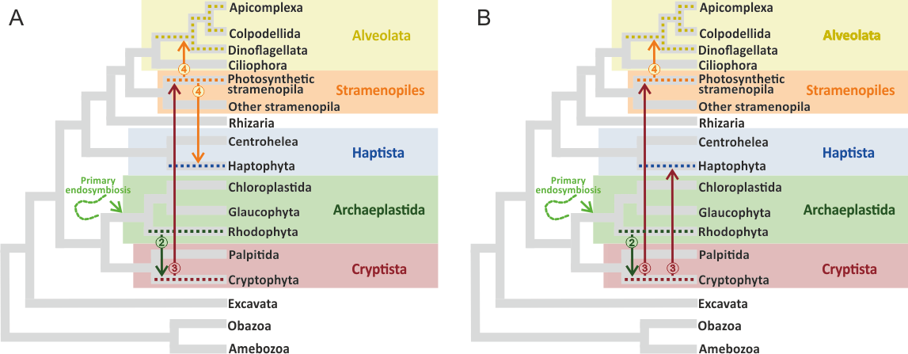
Figure 5. Serial endosymbioses models for complex plastid acquisition. The model on the left was proposed by Stiller et al. [38] and Bodył [53]; however the former does not include plastid-containing lineages of Alveolata (A). The model on the right visualizes a hypothesis by Bodył et al. [54] (B). The arrows indicate plastid transfers and the numbers in circles correspond to the level of endosymbiosis: 2 – secondary, 3 – tertiary and 4 - quaternary.

Main groups of plastid bearing organisms

Archaeplastida
Supergroup Archaeplastida contains unicellular, colonial, and multicellular eukaryotes, some with the composite tissue organization like land plants (Figure 2, 6). Their members are grouped into three lineages: glaucophytes, red algae, and green plants. All they are characterized by the presence of a two-membrane primary plastid of cyanobacterial origin [56]. Almost all species conduct photosynthesis and only a few lost this ability. However, even these parasitic forms still retain reduced non-photosynthetic plastids [57]. The monophyly of Archaeplastida and the single acquisition of their plastid by a common ancestor are widely accepted and seem to be supported by most phylogenetic trees [21].
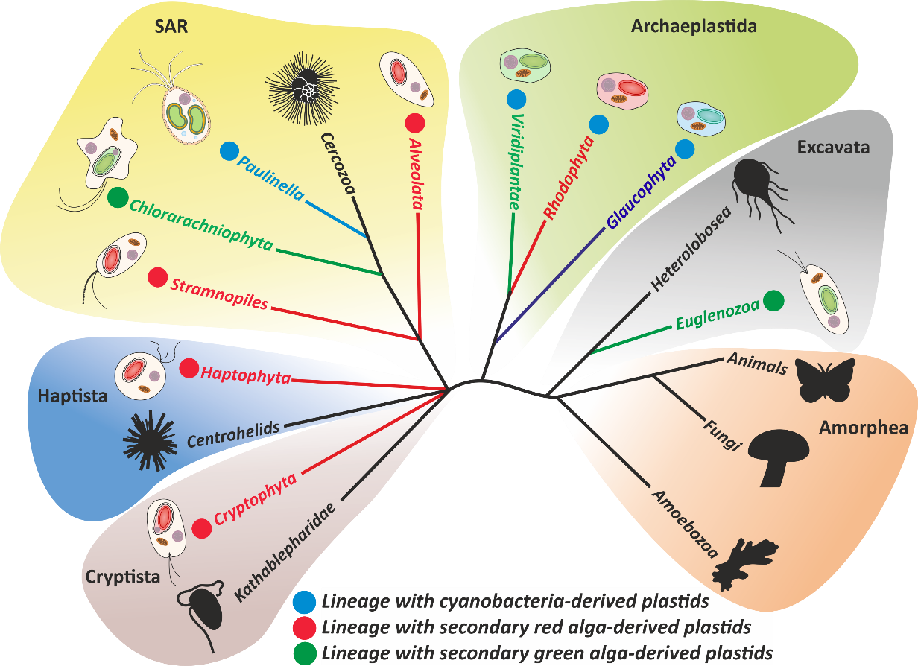
Figure 6. Major eukaryotic groups on the tree of life [25].

SAR
The SAR supergroup is a clade within the realm of Eukaryotes, encompassing the taxonomic groups of stramenopiles, alveolates, and rhizaria [56]. The name "SAR" is derived from the first letters of each of these prominent clades, creating an acronym. It is noteworthy that members of the SAR supergroup were once categorized in the supergroup Chromalveolata. However, the phylogenetic studies, revealed that stramenopiles and alveolates group with Rhizaria, leading to the exclusion of haptists and cryptists from the clade that previously grouped them with alveolates and rhizaria [44,54]

Stramenopiles
Stramenopiles (Heterokonts) encompass a diverse group of protists in terms of morphology and feeding strategies (Figure 4, 6). This group includes single-celled forms, colonial forms, as well as multicellular organisms whose thallus resembles tissue structure, e.g. in brown algae (Phaeophyceae) [56]. A characteristic feature of their cells is the presence of two unequal-length flagella, though absent in photosynthetic diatoms (Bacillariophyceae). Stramenopiles encompasses both many plastid-bearing and plastid-lacking lineages (e.g. Phytophtora or Blastocystis), which probably diverged earlier than those with plastids. Photosynthetic stramenopiles carry four-membrane plastids and are classified to Ochrophyta, containing mostly photosynthetic species [58]. One of the major group of ochrophytes are diatoms; they produce a unique cell wall made of silica and are one of the most important component of phytoplankton [59].

Alveolata
Alveolata groups unicellular protists characterized by a complex outer covering called a pellicle, reinforced by a sophisticated system of sacs and vesicles known as alveoli, from which the group derives its name [56]. The mitochondria of alveolates have tubular cristae, and many forms possess flagella or cilia. Alveolates consist of ciliates, colponemids, apicomplexans, colpodellids, perkinsids and dinoflagellates (Figure 4, 6). Ciliates represent the earliest diverged branch of Alveolata. Their cell is typically covered in numerous short flagella called cilia. Ciliates and colponemids include exclusively unicellular heterotrophs and do not contain any plastids. Apicomplexans are obligate and mostly intracellular parasites of invertebrates and vertebrates and are causative agents of malaria (Plasmodium), toxoplasmosis (Toxoplasma), and coccidiosis (Eimeria). A characteristic feature of this group is the intricate apical complex involved in the invasion to host cells. Apicomplexans, perkinsids and colponemids carry four-membrane plastids; however, plastids of apicomplexans and perkinsids are non-photosynthetic [56,60]. Dinoflagellates also contain plastids. They are predominantly unicellular protists with one transverse and one longitudinal flagellum located within corresponding grooves. Their cells are often covered by distinct peripheral armor plates. Among the various types of plastids found in dinoflagellates, the three-membrane peridinin plastid (named after the carotenoid pigment peridinin) is the most well-known and is present in approximately half of all species [49]. Despite being photosynthetic due to the presence of plastids, these organisms retain their ability to feed as heterotrophs and are thus referred to as mixotrophs. This mixotrophic capability is thought to be crucial in their ability to acquire new photosynthetic endosymbionts and plastids from other types of algae. There are several examples of dinoflagellates that have obtained plastids through secondary endosymbiosis from green algae (e.g., Lepidodinium) or tertiary endosymbiosis from cryptophytes (e.g., Dinophysis), haptophytes (e.g., Karenia), and stramenopiles (e.g., Karlodinium and Durinskia) [49].

Rhizaria
Rhizaria comprises several large and diverse groups of amoebas, flagellates, and cercozoans [56]. Although they are common and significant components of many heterotrophic environments, most of them remain poorly understood. Among the heterotrophic organisms belonging to this supergroup are also plant parasites (Phytomyxea) and animal parasites, particularly marine invertebrates (Ascetosporea). Nearly all representatives of Rhizaria possess mitochondria with tubular cristae and produce long, slender pseudopodia that form a network-like structure. Some, such as radiolarians (Radiolaria) and foraminifera (Foraminifera), form tests or shells, which facilitate their preservation in fossil state and play a crucial role in stratigraphy [61]. Members of the Chlorarachniophyta group acquired four-membrane plastids through secondary endosymbiosis with green algae and possess a nucleomorph, which is a reduced nuclear remnant of the previous endosymbiont [1,62]. An intriguing member of the Rhizaria supergroup are Paulinella photosynthetic species (Figure 3, 6), which harbor two-membrane endosymbionts derived from cyanobacteria. This association is an example of primary endosymbiosis that occurred independently of endosymbiosis in the Archaeplastida lineage [24,25].

Cryptista
Cryptista are a group of small, biflagellar algae widespread in aquatic environments, where they form a significant part of plankton (Figure 6). They include cryptophytes (cryptomonads), kathablepharids and Palpitomonas. Among cryptists, only cryptophytes possess plastid and can perform photosynthesis [56]. Like in the case of chlorarachniophytes, cryptomonad plastid is surrounded by four envelope membranes and there is a reduced nucleus called nucleomorph placed between the four and third outermost membrane. According to the Chromalveolata hypothesis and the serial plastid endosymbioses models, cryptophytes gave rise to plastids in other species containing red alga-derived plastids [38,53,54]. At the moment, there is also an interesting debate going on whether cryptists are related to Archaeplastida. According to some researchers, they could branch within the group, which would question the monophyly of primary-plastid containing leaneage [56].

Haptista
Haptista include centrohelids and haptophytes (Figure 4, 6). The former are spherical unicellular eukaryotes with stiff arms (axopods) protruding from their cells responsible for food capturing. The latter are autotrophic, mixotrophic or heterotrophic single-cell eukaryotes with two slightly unequal flagella, and a unique anterior appendage called the haptonema used for adhesion and prey capture [56]. The best known representatives of haptophytes are coccolithophores, which produce exoskeleton of calcium carbonate scales (coccoliths). They played a big role in chalk deposits formation [63].

Aim of the thesis
The aim of this thesis was to explain controversies in the evolution of plastids using bioinformatics approaches and to provide a valuable resource – a plastid database for future investigations on this organelle. In more detail, I was to do:
- create a freely available database facilitating access to information on plastids that can contribute to further analyses aimed at unraveling the intricate evolutionary history of these organelles;
- perform phylogenetic analysis of major groups possessing plastids, with a particular focus on archaeplastids and chromalveolates;
- determine the acquisition age of plastids in major groups with primary and higher order plastids;
- verify hypotheses describing the origin of historic Chromalveolata supergroup and plastid evolution within its lineages
- .

Materials and methods

PhyloPlast – plastid knowledge database

3.1.1 Preparing datasets and database curation
During preparing datasets for analyses in Section 3.1 and 3.2 we realized that there is a lack of database containing standardized and verified data source for conducting analyses on plastid genomes. Therefore, we decided to create a database to fill this gap. Plastid genomes derived from algae and land plants have been obtained from National Center for Biotechnology Information (NCBI) Genome Database [64,65] as separate genbank files (.gbff). Using R scripts, Genbank files were proceeded to extract data into fasta files (.fas) including of:
- nucleotide sequences of genes coding for proteins;
- nucleotide sequences of RNA genes: rRNA, tRNA, mRNA, miscRNA, ncRNA, tmRNA;
- amino acid sequences of protein-coding genes.
RNA and gene sequences were extracted from genome sequences according to their annotated positions. Each sequence was validated in terms of its annotation using Blastn algorithm in case of RNA and gene as well as Blastp algorithm in case of protein sequence. Duplicates and partial records were removed. Each collected sequence has been assigned a unique PhyloPlast identifier.
Next, all protein fasta files were processed using Pannzer software [66] to obtain GO annotation for Molecular function, Cellular component and Biological process. To keep clearness of Database we chose 10 best Pannzer hits for each annotation category. Additionally, we have estimated localization of each protein inside plastid organelle using PlastoGram R package [67].
Each taxon received two classification systems: NCBI taxonomy and PhyloPlast systematic. NCBI taxonomy was gathered from GenBank files, whereas PhyloPlast systematic was prepared based on Adl et al. work [56]. All data were merged into a dataframe. For easier database searching also information about NCBI Genome ID, NCBI Gene ID, Gene name, Locus tag, NCBI protein ID, Product name, UniProt ID, Plastid source, Plastid type, Alternative plastid name, Organism name, Tax ID were attached.

3.1.2 Database organisation
The database was built with R Shiny package [68]. All data were displayed using JavaScript library DataTables to establish a user-friendly, front-end interface, which provides features, such as data filtering, pagination, sorting and downloading Moreover, on the menu bar at the top of the page, there are located buttons for additional options or tools (Figure 7):
- Home - a link to PhyloPlast database that provides overall information about plastids and their evolution;
- Database - a link to the main tabular format of the database. It allows the user to search for a record, select the desired information from one of the 32 columns, perform custom sorting and arrangement of data as well as retrieve selected information with the option to separately download sequences in FASTA format;
- Plastid genome map - a link to a JavaScript tool [69] for visualizing and interacting with all genomes from PhyloPlast database;
- BLAST - a link to search the database using nucleotide or amino acid sequences as queries
(i.e. Blastp, Blastx) [70];
- Alignment - a link to MAFFT version 7 [71] to make a multiple sequence alignment on sequences selected from PhyloPlast database;
- Phylogeny - a link to IQ-TREE 2.0 [72] to calculate phylogenetic trees;
- PlastoGram - a link to a shiny application [99] to identify subchloroplast localisation of proteins using machine learning predictor [67].

All data and the engine of PhyloPlast database is deployed on the computer server at the Department of Bioinformatics and Genomics, Faculty of Biotechnology in University of Wroclaw as an online web server and is freely available under web address: http://biongram.biotech.uni.wroc.pl/phyloplast/.
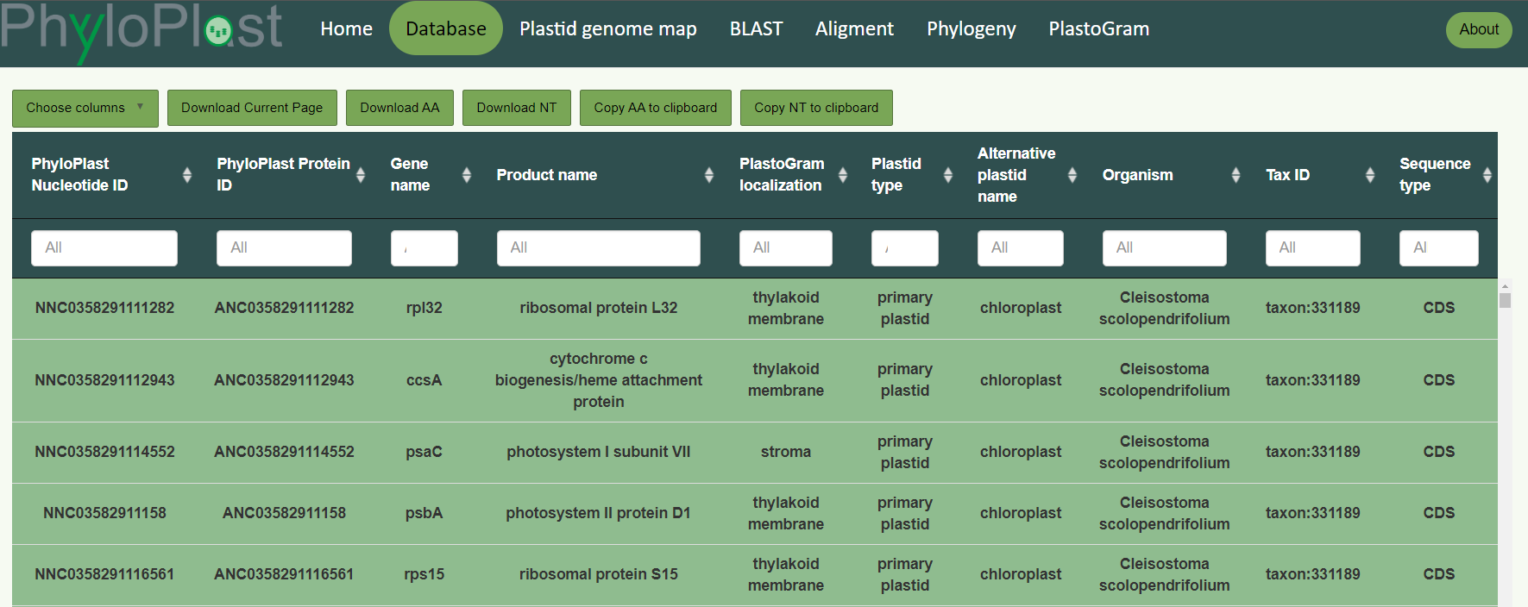
Figure 7. Screenshot from the PhyloPlast database. There are seven main tabs in the menu page: Home, Database, Plastid genome map, BLAST, Alignment, Phylogeny, PlastoGram. The “Database” tab is selected and five first records within ten default columns in tabular interface presented.

Phylogeny and dating the origin and spread of primary plastids and chromatophores

3.2.1 Preparing datasets
We used carefully selected 30 amino acid sequences of conserved plastid-encoded proteins presented in Table A1 from five organisms: Gloeomargarita lithophora, Cyanobium sp., Cyanophora paradoxa, Galdieria sulphuraria and Arabidopsis thaliana for homolog searches using PSI-BLAST with e-value: < 0.001, the number of iterations 5 and word size 2 against amino acid sequences encoded by plastid, cyanobacteria and chromatophore genomes [70]. The plastid proteins were retrieved from the NCBI reference sequence database [65], whereas cyanobacteria and chromatophore proteins from GenBank [64]. The final set included 108 representatives of cyanobacteria and plastid-carrying eukaryotes (mainly archaeplastidans). Each representative contained all markers, with the exception of chlorarachniophytes that lacked the CCSA protein sequences. Each protein group was aligned in MAFFT v7.429 using a slow and accurate L-INS-i algorithm [71]. The multiple sequence alignments were inspected in AliView [73] and the sites best suited for phylogenetic analyses were selected with TrimAl assuming gappyout option [74]. All 30 trimmed alignments were concatenated into the supermatrix of 9,823 aligned amino acid positions with SequenceMatrix 1.8 [75]. This is a commonly accepted approach because the plastid genes represent a single coalescent marker, i.e. they are linked and inherited on one molecule and should demonstrate the same evolutionary history [76].

3.2.2 Phylogenetic and Molecular Clock Analyses
The phylogenetic trees were obtained based on: (i) the maximum likelihood (ML) method in
IQ-TREE 2.0 [72] and RAxML 8.2.12 [77] as well as (ii) the Bayesian method in PhyloBayes MPI 1.7a [78] and, along with the molecular dating analyses, in MrBayes 3.2.7a [79] and Beast 2.6.0 [80]. The ML and Bayesian approaches represent two different but preferentially used methods for phylogeny estimation and both are able to tackle big data sets with parameter-rich models. We did not use summary coalescent methods because a plastome tree build on a concatenated set is generally always better supported than that relying on individual gene trees [76].
In order to deal with potential data heterogeneity (different substitution patterns and rates across sites), we considered all 30 potential partitions, represented by each protein group, in finding the best substitution models for the concatenated set. To estimate the best-fitted substitution models, we used ModelFinder [81] in IQ-TREE [72], and PartitionFinder [82] for RAxML, MrBayes [79] and
Beast [80]. In PhyloBayes [78], we estimated phylogenies under the CAT-GTR+Γ model to account for the among-lineage and among-site heterogeneity without the necessity of defining partitions. Branch support was inferred based on 100 replicates of non-parametric bootstrap in IQ-TREE [83] and RAxML [77], and estimation of posterior probabilities in MrBayes [79], PhyloBayes [78] and Beast [80]. Substitution models as well as partitioning schemes are presented in Tables A10-A13.
To test the assumptions of stationarity (constant amino-acid frequencies over time) and homogeneity (constant substitution rates over time) in our data, we preformed tests of symmetry in
IQ-TREE [83] using Bonferroni correction for multiple testing. In the case of MrBayes [79] and RAxML [77] data sets, 18 out of 19 partitions passed the test, and for Beast 21 out of 22; in total 87% of the supermatrix sites. In IQ-TREE [83], eight of nine partitions passed the test, which accounted for 63% of the supermatrix sites. Accordingly, in most cases, the lineage-specific heterogeneity and non-stationarity concerned only a small part of our data sets.
In molecular dating, we used only relaxed molecular clock methods that decouple amino acid substitution rates between descendant lineages thereby further handling the problem of heterogeneity. In total, we calculated 18 chronograms (phylogenetic trees with branch lengths scaled to time in years) for three calibration sets and explored six molecular clock approaches. The calibration sets differed in using calibration points, i.e. assumptions on separation times of selected lineages (Table 1).
Table 1. Calibration constraints for dating plastid evolution. C1, C2 and C3 represent the first, second and third calibration set, respectively. C1 was similar to the calibration strategy by Sánchez-Baracaldo et al. [8]. C2 and C3 differ from C1 over using the microfossil of P. antiquus to calibrate the minimum age for the node 10 [84]. In turn, C2 vary from C3 in calibration for node 6, the former uses widely recognized Bangiomorpha pubescens [85] while the latter much older and recently discovered R. chitrakootensis [10]. Further small differences between C1 and the other calibration sets result from the fact that for C2 and C3, we always applied the minimum or maximum constraints on nodes by selecting the lower or upper interval for microfossil dating, respectively.

Node no. | Node name | Minimum |  |  | Maximum |  |  | References
Node no. | Node name | Set C1 | Set C2 | Set C3 | Set C1 | Set C2 | Set C3 |  | Minimum | Maximum
 | Cyanobacteria
1 | Great Oxidation Event | 2,320 | 2,320 | 2,320 | 3,000 | 3,000 | 3,000 |  | [86] | [87]
2 | Earliest cyanobacteria | 1,900 | 1,900 | 1,900 | 3,000 | 3,000 | 3,000 |  | [88,89] | [87]
3 | Pleurocapsales | 1,700 | 1,640 | 1,640 | 1,900 | 3,000 | 3,000 |  | [90] | [87–89]
4 | Nostocales | 1,600 | 1,580 | 1,580 | 1,900 | 3,000 | 3,000 |  | [91,92] | [87–89]
5 | Richelia | 110 | 110 | 110 | 3,000 | 3,000 | 3,000 |  | [93] | [87]
 | Rhodoplast
Node no. | Node name | Minimum |  |  | Maximum |  |  |  | References
Node no. | Node name | Set C1 | Set C2 | Set C3 | Set C1 | Set C2 | Set C3 |  | Set C1 | Set C2
6 | Earliest Rhodophyta | 1,050 | 1,030 | 1,560 | 3,000 | 2,300 | 2,300 |  | [10,85] | [19,87]
7 | Floridiophyceae | 600 | 595 | 595 | 3,000 | 2,300 | 2,300 |  | [94] | [19,87]
 | Rhodophyta-derived plastid
8 | Earliest diatom | 190 | 185 | 185 | 3,000 | 2,300 | 2,300 |  | [95] | [19,87]
9 | Bacillariophytina | 110 | 110 | 110 | 3,000 | 2,300 | 2,300 |  | [93] | [19,87]
 | Chloroplast
10 | Ulvophyceae | 635 | 948 | 948 | 3,000 | 2,300 | 2,300 |  | [84] | [19,87]
11 | Earliest land plants | 475 | 471 | 471 | 501 | 515 | 515 |  | [96] | [8,97,98]
12 | Tracheophyta | 446 | 446 | 446 | 501 | 515 | 515 |  | [99] | [8,97,98]
13 | Angiosperms/Gymnosperms | 385 | 385 | 385 | 501 | 515 | 515 |  | [100] | [8,97,98]
14 | Angiosperms | 130 | 130 | 130 | 501 | 515 | 515 |  | [101,102] | [8,97,98]
15 | Eudicots | 125 | 125 | 125 | 501 | 515 | 515 |  | [103] | [8,97,98]
16 | Zygnemataceae | 345 | 345 | 345 | 3,000 | 2,300 | 2,300 |  | [104] | [19,87]
17 | Gymnosperms | 385 | 385 | 385 | 501 | 515 | 515 | [100] |  | [8,97,98]

We performed Bayesian molecular dating with: autocorrelated log normal model (LN), Cox–Ingersoll–Ross model (CIR) and uncorrelated gamma multiplier model (UGAM) in PhyloBayes 4.1c [105] autocorrelated Thorne–Kishino 2002 model (TK02) and uncorrelated independent gamma rate model (IGR) in MrBayes; as well as uncorrelated lognormal model (UCLNR) in Beast. Consequently, we implemented two different relaxed molecular clock methods: autocorrelated and uncorrelated, which assume dependent or independent rate of evolution on adjacent branches of the phylogenetic tree, respectively. For the uncorrelated models, the rates across the tree are drawn from a single underlying distribution: lognormal (UNCLNR) or gamma (UGAM and IGR).
In PhyloBayes [105], we used the fixed tree topology from IQ-TREE [83] because it was
congruent with most inferred phylogenies (from RAxML, MrBayes [79] and
Beast [80]) and calculated the molecular dating under LN, CIR and UGAM models coupled with a CAT-GTR+Γ model. We selected cyanobacterium Gloeobacter kilaueensis as an outgroup. For each molecular clock and calibration set, two replicate chains were run. Analyses were performed using hard bounded gamma-distributed prior for the root and uniform hard bounded priors for the rest calibration constraints. We selected burnin to get the maximum discrepancy lower than 0.3 and the minimum effective size greater than 50 in tracecomp. Mean dates were assessed by running readdiv with burnin selected for each analysis in tracecomp.
In Beast [80], we implemented Yule tree prior and exponential priors on calibration constraints because the Yule model was favoured over the birth-death model according to Akaike Information Criterion for all chronograms. The testing was conducted in R software using pureBirth and bd functions from laser package [106]. Tree samples were saved every 1000 iterations. The first 25% samples were discarded as burnin to get the effective sample size greater than 100 for all parameters calculated in Tracer 1.7. The final chronograms were obtained in Treeannotator using 25% burnin and mean heights.
In MrBayes [79], offset exponential priors were used for divergence times together with birth-death tree prior. Samples were saved every 100 iterations. To summarize the results, we used sump command discarding 25% of the first samples. We made sure that the potential scale reduction factor was close to
1 and the average effective sample size greater than 100 for all parameters. The final chronograms were obtained in Treeannotator using 25% burnin and mean heights.

3.2.3 Comparison of molecular clocks and calibration sets
In order to assess a potential bias in the estimation of divergence times among molecular clocks and calibration sets, we calculated for each set the percentage difference from the mean age of all sets obtained for each node, and next the average differences across all nodes $D$ according to the equation:
$D=\frac{\sum_{i=1}^{n}{100\%∙(x_{i}-{\overline{x}}_{i})/{\overline{x}}_{i}}}{n}$,
where: $x_{i}$ is an age for the node $i$, ${\overline{x}}_{i}$ is a mean age of sets for the node $i$ and $n$ is the number of nodes. In the analysis we included 104 nodes and excluded three nodes that were not shared in all tree topologies. The calculations were performed separately for: (i) different calibration sets assuming the same molecular clock as well as (ii) for each calibration set with different clocks.
Moreover, we calculated the mean pairwise difference in ages across all nodes between individual sets $P$ according to the equation:
$P=\frac{\sum_{i=1}^{n}{(x_{i}-y_{i})}}{n}$,
where: $x_{i}$ is an age in the set $x$ for the node $i$, $y_{i}$ is an age in the set $y$ for the node $i$ and $n$ is the number of nodes. Similarly, we calculated the mean percentage pairwise difference:
$P\%=\frac{\sum_{i=1}^{n}{100\%∙(x_{i}-y_{i})/0.5∙(x_{i}+y_{i})}}{n}$.
These values were used for multidimensional scaling (MDS) in R software [106] to compare age estimations under various assumptions in a graphical way. Statistical significance of differences between the compared sets was assessed using the paired Wilcoxon test. The resulted p-values were corrected using the Benjamini-Hochberg method.

3.2.4 Comparison of diversification rate with climatic and atmospheric parameters
For 18 chronograms based on primary plastid proteins, we calculated diversification rates of phylogenetic lineages carrying primary plastids. The rates were estimated within various periods using yuleWindow function in R software [106]. For each chronogram, we took into account the periods of 10, 20, 30, 40, 50, 60, 70, 80, 90 and 100 Myr as overlapping windows with the shift of the half of window length. The middle value of the window was ascribed to the calculated diversification rate.
The Spearman correlation coefficient and its significance were calculated between the values of diversification rate and various climatic/atmospheric parameters (Table A2). The parameter values for the same time points as for rates were obtained based on a fitted smoothing spline calculated by ss function in R software. The p-values of the correlation coefficient were corrected using the Benjamini-Hochberg method to control the false discovery rate. Differences were considered significant when p-values were smaller than 0.05.
The relationship between the area of Large Igneous Provinces and geological age was expressed in two ways. In the first approach, the total area of Large Igneous Provinces was calculated in the window of 10 Myr from the available data. When the age range was given, the mean age was assumed for the data. In the second approach, the area per 1 Myr was calculated, when the age range was given, and next the sum was calculated in the period of 10 Myr. Finally, the middle value of the window was included in the studied relationship.
The mean diversification rate for 18 chronograms was also calculated in the periods of six main glaciations and interglaciations (Table A3). The final results were presented as the ratio between the latter and the former rate values. The significance of the difference between these values was assessed in the unpaired Wilcoxon-Mann-Whitney test using R programming language [106,107].

Dating the origin and spread of red alga derived plastid in the Chromalveolata lineages

3.2.1 Preparing datasets
We employed 97 amino acid sequences of conserved plastid-encoded proteins, carefully selected from the NCBI reference sequence database [65] and GenBank [64], representing 113 organisms. Our dataset included 111 eukaryotes carrying red-alga derived plastids, Lepidodinium chlorophorum with plastids of green algal origin, and the closest plastid cyanobacterial relative Gloeomargarita lithophora Alchichica D10 (Table A4). We performed independent alignments of each homologous protein group using a slow and accurate L-INS-i algorithm [71] implemented in MAFFT v7.429. The resulting multiple sequence alignments were carefully assessed using AliView [71], and phylogenetically informative sites were selected through trimAl [74] and ClipKIT [108] using algorithms indicated in Table 2. The trimmed alignments were concatenated into supermatrices using SequenceMatrix 1.8 [75]. to generate comprehensive datasets for phylogenetic and molecular clock analyses. We also studied a supermatrix composed of untrimmed alignments. The obtained datasets were compared using PhyKIT [109] to evaluate the number of variable and parsimony informative sites among supermatrices (Table 2).
Table 2. Multiple sequence alignment statistics for alignment trimming strategies from ClipKIT and trimAl.
Trimming strategy | Total number of sites | Percentage of left sites | Number of variable sites | Percentage of variable sites | Relative composition variability | Number of parsimony informative sites | Percentage of parsimony informative sites
Original alignment | 40342 | 100% | 34842 | 86.4% | 0.07 | 22749 | 56.4%
ClipKIT
gappy | 24962 | 62% | 23995 | 96.1% | 0.09 | 20979 | 84%
kpic | 23592 | 58% | 22466 | 95.2% | 0.10 | 20894 | 88.6%
kpic-smart-gap | 22848 | 57% | 21791 | 95.4% | 0.09 | 20361 | 89.1%
smart-gap | 27506 | 68% | 26449 | 96.2% | 0.08 | 22039 | 80.1%
trimAl
automated1 | 21708 | 54% | 20742 | 95.6% | 0.08 | 17722 | 81.6%
gappyout | 23102 | 57% | 22142 | 95.8% | 0.09 | 19180 | 83%
strict | 19887 | 49% | 18923 | 95.2% | 0.08 | 15978 | 80.3%

3.3.2 Phylogenetic and Molecular Clock Analyses
In our phylogenetic analyses of plastid proteins, we used two widely adopted methods known for their ability to handle large datasets with parameter-rich models: (i) maximum likelihood (ML) in IQ-TREE [72] and RAxML 8.2.12 [77], as well as (ii) Bayesian approach in MrBayes 3.2.7a [79] and Beast 2.6.7 [80], the latter were also employed in molecular dating analyses. Since phylogenies constructed on a concatenated set provides better supported trees than those based on individual markers, we did not employ summary coalescent methods [110].
In order to account for potential data heterogeneity arising from differences in substitution patterns and rates across sites, we considered all 97 potential partitions in all supermatrices, each corresponding to a given plastid protein group, to identify the most suitable substitution models for the concatenated datasets. The substitution models were selected by ModelFinder [81] in IQ-TREE (Table A16-A23) and PartitionFinder [82] for analyses in RAxML, MrBayes and Beast (Table A14-A15, A24-A31). To further deal with data heterogeneity, we only employed relaxed molecular clocks (see below). They allow substitution rates to vary independently among different branches in the phylogenetic tree, thereby accounting for rate variation across lineages. We also employed the CAT model in IQ-TREE [111]. In the case of the CAT model, we tested variants with 10, 20 and 30 profiles assuming substitution matrices Poisson, LG and Q.yeast (because it was selected as the best for the whole alignment without partitions). According to BIC, we selected the best-fit model LG+C20+F+R10. The confidence of the inferred phylogenetic relationships was measured by non-parametric bootstrap test (100 replicates) for ML analyses in IQ-TREE and RAxML, and posterior probability for Bayesian approaches in MrBayes and Beast; in the case of the CAT model inferred in IQ-TREE we assumed 1,000 replicates.
We obtained three chronograms using uncorrelated relaxed molecular clock methods. In MrBayes: independent gamma rate model (IGR) [79], and in Beast: uncorrelated lognormal model (UCLNR) as well as uncorrelated exponential model (UCEL) [80]. These models assume that the substitution rates along different branches of the phylogenetic tree are drawn independently from a gamma distribution, a lognormal distribution and an exponential distribution, respectively. Calibration constrains were presented in
Table 3.
Table 3. Calibration constraints for dating evolution red algae derived plastid. We always applied the minimum or maximum constraints on nodes by selecting the lower or upper interval for microfossil dating, respectively.
Node no. | Node name | Constraint | Constraint type | References
1 | Gloeomargarita + Archaeplastida | 1807 Mya | MIN | [45]
1,4,5,6 | Gloeomargarita + Archaeplastida | 2207 Mya | MAX | This study
2 | Cryptista – Haptista | 573 Mya | MIN | [45]
2,3 | Cryptista – Haptista | 1701 Mya | MAX | This study
3 | The oldest coccolithophores | 225 Mya | MIN | [112]
4 | Bangiomorpha pubescens | 1030 Mya | MIN | [85]
5 | Floridophyceae | 595 Mya | MIN | [94]
6 | Rafatazmia chitrakootensis | 1560 Mya | MIN | [10]
7 | Oldest diatoms | 185 Mya | MIN | [95]
7,8,9,10,11 | Rafatazmia chitrakootensis | 1560 Mya | MAX | [10]
8 | diatoms –Coscinodiscophyceae | 110 Mya | MIN | [113]
9 | diatoms – Mediophyceae | 110 Mya | MIN | [113]
10 | diatoms – Cyclotella sp. | 24 Mya | MIN | [114]
11 | diatoms - earliest pennates | 75 Mya | MIN | [113]

In Beast 2 [80], we employed the Yule tree prior and exponential priors to specify calibration constraints. Tree samples were saved every 1000 iterations during the Markov chain Monte Carlo (MCMC) process. To ensure robust parameter estimation, we discarded the first 10% of samples as burnin and confirmed that the effective sample size was greater than 100 for all parameters using Tracer 1.7. The final chronograms were obtained using Treeannotator, where we applied 10% burnin of trees and calculated the median heights.
In MrBayes [79], we utilized offset exponential priors for divergence times in conjunction with the birth-death tree prior. During the MCMC process, we saved samples every 1000 iterations. We discarded the initial 10% of samples as burnin employing the sump command. We ensured that the potential scale reduction factor was close to 1 and that the average effective sample size exceeded 100 for all parameters, indicating reliable parameter estimation. The final chronogram was generated using the sumt command, employing 10% burnin of trees.

Results and discussion

PhyloPlast – plastid knowledge database

4.1.1 Database content
To showcase the content of the database, we have prepared 7 graphics (Figures 8-10) summarizing all the collected data. These diagrams provide a comprehensive overview of information contained within the database. PhyloPlast includes 10,646 (Figure 8A) plastid genomes that represent all lineages possessing plastids, including chromatophores of Paulinella. The most numerous are sequences from representatives of Archaeplastida (Figure 8A, B). In total, the database comprises 1,397,436 sequences (Figure 8B), of which 929,463 are protein-coding genes (Figure 9A), mostly ribosomal proteins (Figure 10A). RNAs make up 467,973 (Figure 9A) sequences, with tRNAs being the most abundant, accounting for over 80% of the RNAs (Figure 10B). The most common RNA in plastids is tRNA(LEU), representing almost 9% of all RNA types found in plastids. According to PlastoGram predictions, the majority of plastid proteins are found in the thylakoid membranes (Figure 9C).

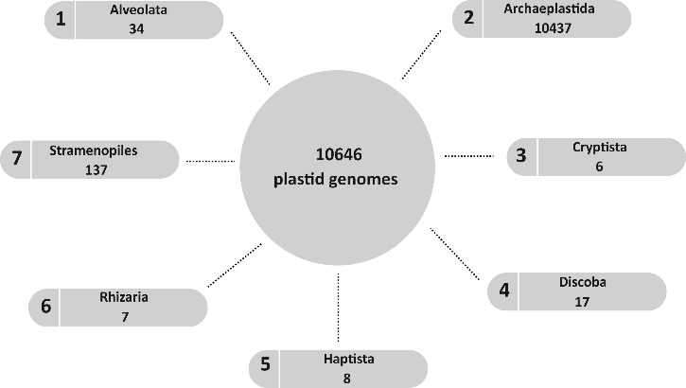
A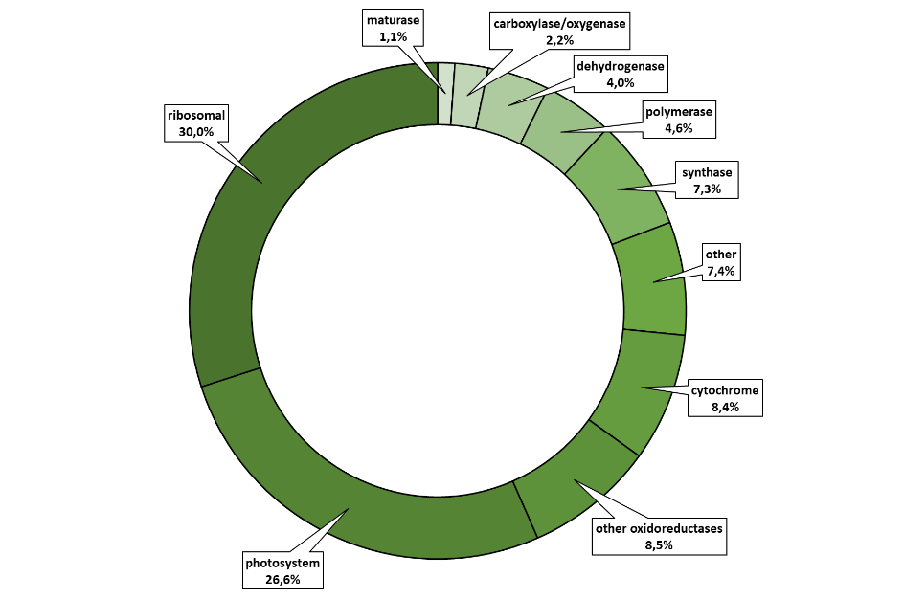

B
Figure 8. PhyloPlast data content. The number of plastid genomes categorized by groups of organisms (A). The number of database records divided into numbers of records in each group of organisms (B).

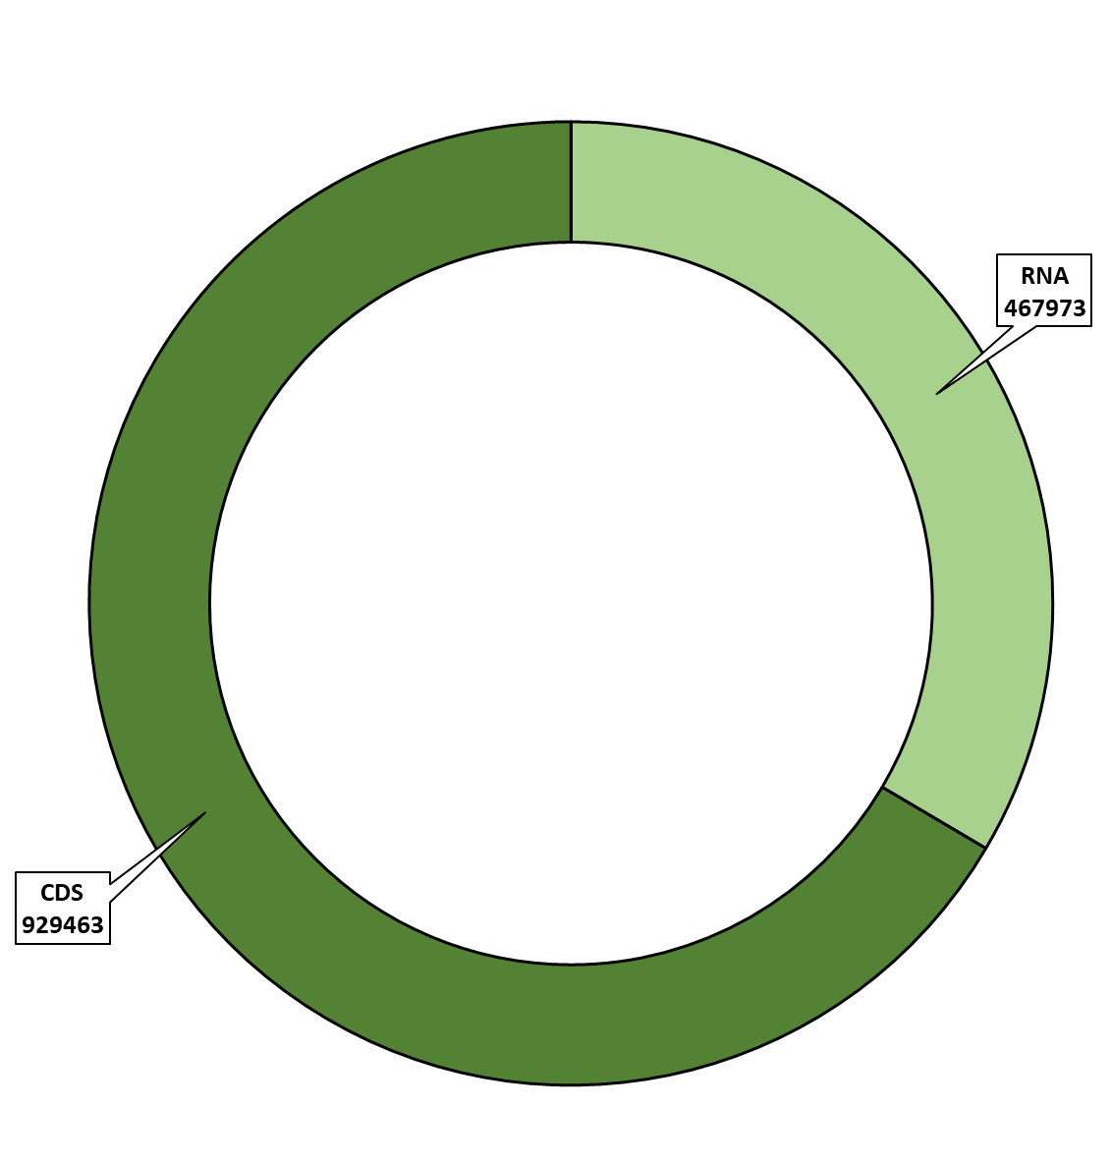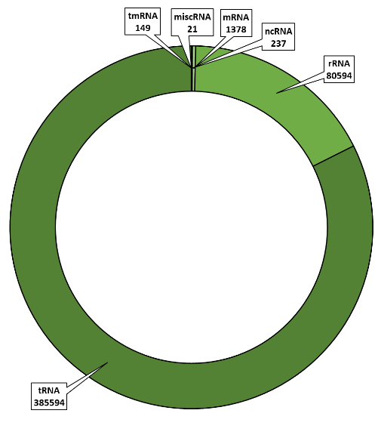
C
B
A

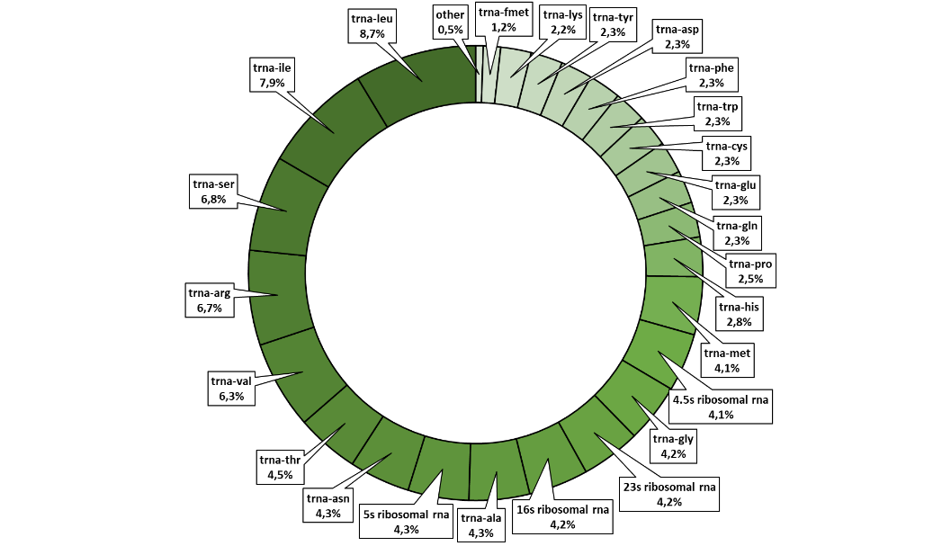
Figure 9. Protein and RNA coding sequences in PhyloPlast. The number of coding sequences (A).
The number of main RNA sequences (B). The number of RNA sequences non-coding proteins (C).

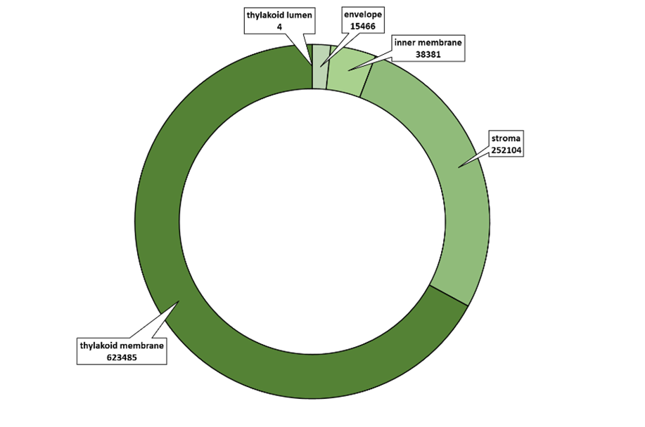
B
A
Figure 10. Types of proteins and subplastid localization in PhyloPlast. The number of main protein groups (A). PlastoGram predicted subchloroplast localisation of proteins included in PhyloPlast database (B).

4.1.2 Database functionality
PhyloPlast provides comprehensive information about plastid sequences, plastid types and plastid evolution. The database was created to allow user friendly browsing and downloading of records. This might involve searching for and selecting records based on defined criteria, e.g.: (i) gene name, (ii) protein name, (iii) protein function, (iv) plastid location (e.g. thylakoid and/or stroma), (v) plastid type (e.g. primary or complex plastids), and (vi) taxonomy (Figure 11).
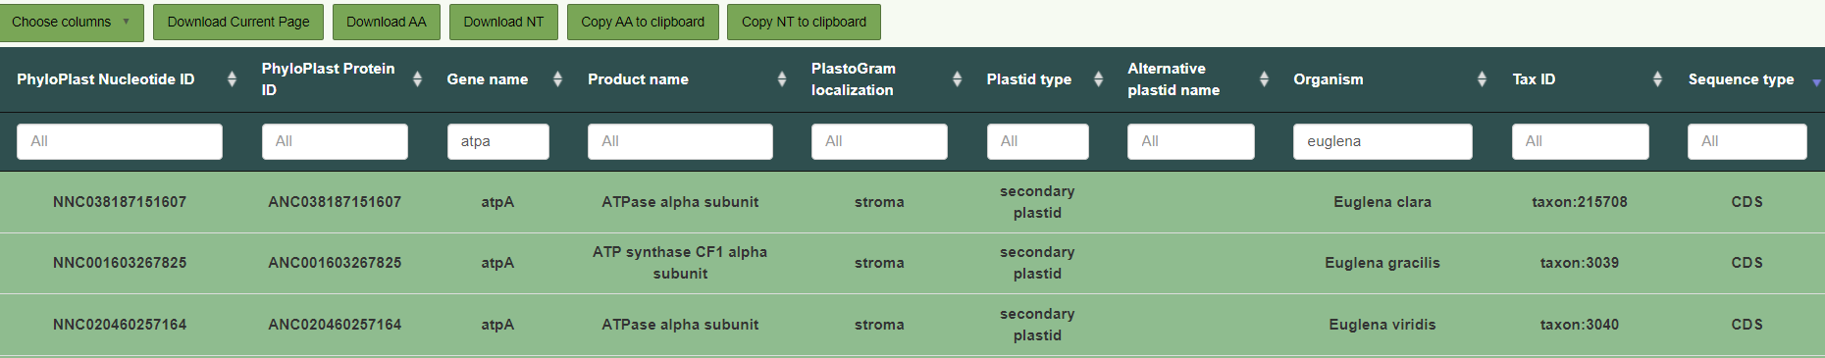

Figure 11. The example of database filtering. “Gene name” and “Organism” were used as filters.

The creation of the database was guided by the philosophy of establishing a resource with sequences ready for analysis, e.g. gene sequences that undergo transplicing are kept in PhyloPlast as the final products and do not require any further bioinformatic processing. A potential user can search the database using BLAST (Figure 12A) [70], conduct alignment with MAFFT version 7 (Figure 12B) [71] and reconstruct phylogenetic trees in IQ-TREE 2.0 (Figure 12C) [72].
This functionality empowers users to swiftly investigate sequence relationships using their chosen markers. Furthermore, users can access and examine interactive maps of genomes, e.g. allowing for comparisons of precise gene locations within/among genomes (Figure 13). Finally, the implementation of PlastoGram software [67] within the platform facilitates the prediction of protein localization within plastid compartments (Figure 14).

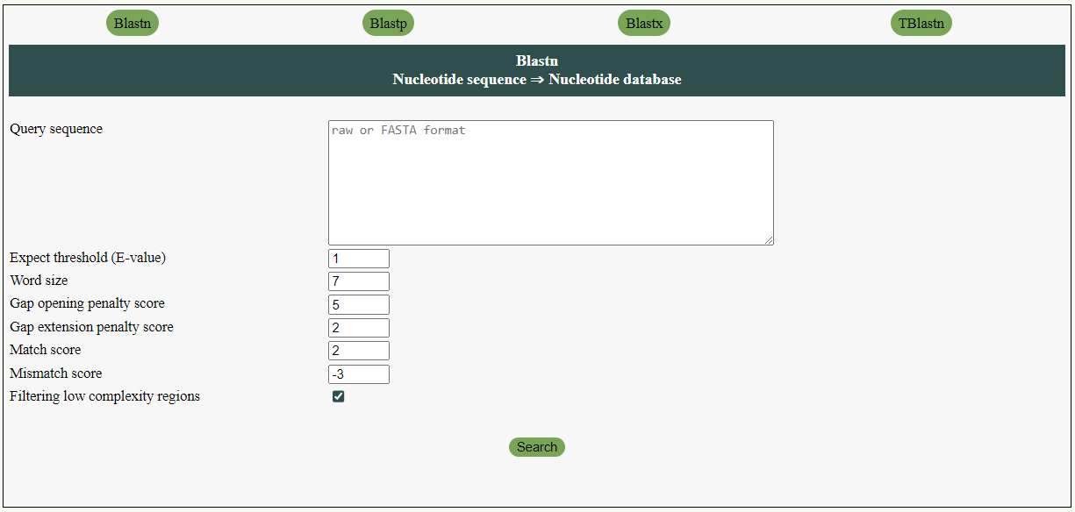
A

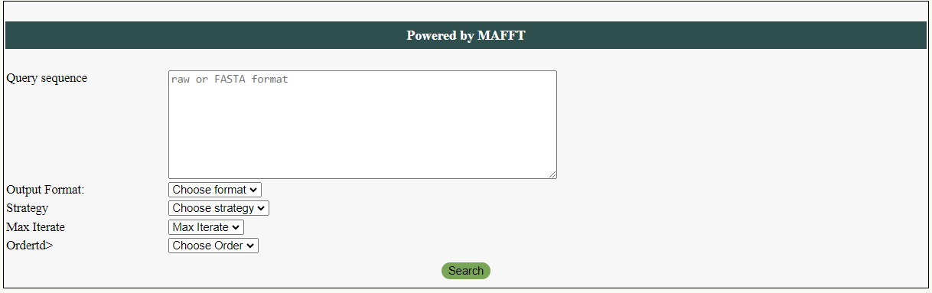
B

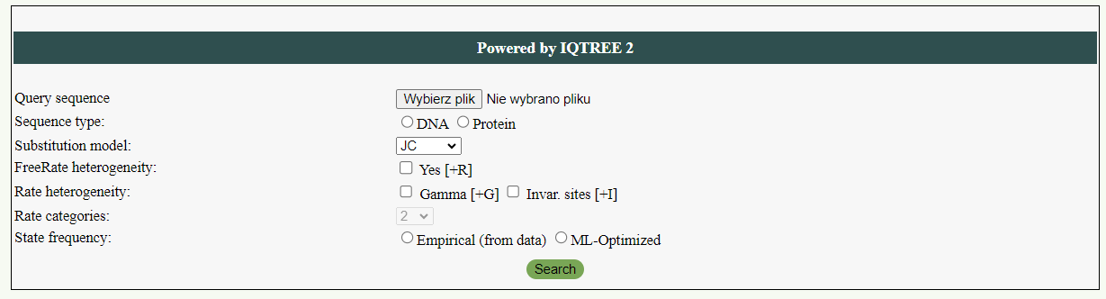
C
Figure 12. Input windows of BLAST (A), MAFFT (B), and IQ-TREE (C). All tools implemented in PhyloPlast contain the most relevant options.

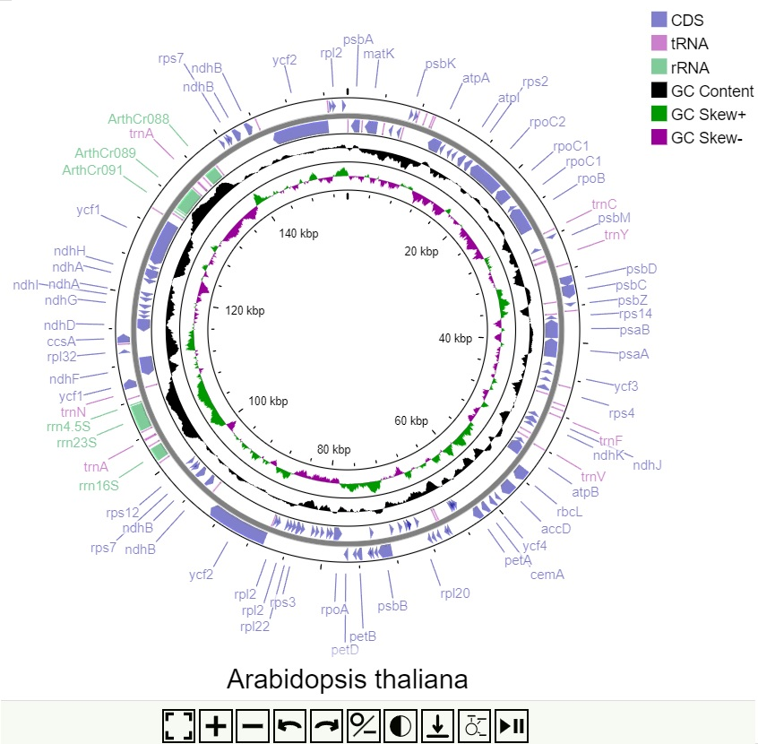
Figure 13. Visualization of the plastid genome implemented in PhyloPlast. Plastid genome of Arabidopsis thaliana was used as an example. The controls below the map also serve for navigation and changing the map display (from circual to linear).

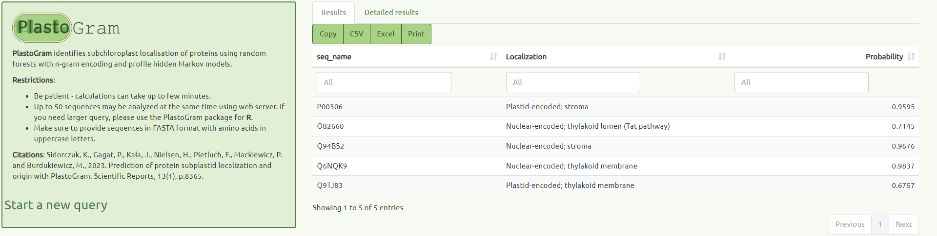
Figure 14. PlastoGram prediction result. Prediction was conducted on five exemplary protein sequences. The result window allows download results in tabular formats or copying to clipboard.

4.1.3 Database importance and challenges
One of the primary challenges encountered during plastid data studies is the absence of a unified database where comprehensive information with tools for bioinformatic and phylogenetic analyses in one place. Source databases, such as GenBank, often contain annotations that are not presented in a uniform form or even contain errors, which can lead to inaccurate analyses. It concerns also plastid genomes, which are present in a huge number in GenBank. That is why our work entailed compiling data from various sources and transforming them into a consistent and improved database.
While creating plastid data, we faced certain difficulties, e.g. the presence of transplicing genes, which were not accommodated by the software packages commonly used. Therefore, it was necessary to include the specific characteristics of plastid genomes and write new functions for correct parsing GenBank files. A substantial amount of information included in PhyloPlast precluded using SQL queries, which occurred too slow in the database searching. Therefore, to mitigate this issue, we implemented Shiny Server technology, enabling faster access and analysis of the data. Moreover, we unified gene names and their products, which were presented in original files in many ways and synonyms. Thereby, the database search is more comprehensive and provides all relevant results in one query. To enhance the consistency of our dataset, we also standardized species names and introduced a novel taxonomy based on the framework proposed by Adl et al. [56]. Furthermore, we conducted Gene Ontology (GO) analyses for each record, unifying the description of gene and gene product attributes, i.e. presence in cellular components, fulfilling molecular functions and participation in biological processes.
The PhyloPlast is the first database that in a comprehensive and unified way integrates various data about plastid genes offering useful tools for their searching and analyses. The database can find many applications in genomic and phylogenetic studies and contribute to better understanding of plastid genomes and their significance in plant evolution.

Phylogeny and dating the origin and spread of primary plastids and chromatophores

4.2.1 Phylogenetic analyses
In MrBayes [79] and Beast [80], the inference of phylogenies and node ages was performed simultaneously, whereas in PhyloBayes [115] the chronograms were calculated using fixed trees from
IQ-TREE [72] (Figure 15, A1-A18). Additionally, we used RAxML [77] to verify the tree topology with one additional maximum likelihood method (Figure A19). Our analyses strongly support the monophyly of all primary plastids, which is common in phylogenies based on plastid markers [21], but with the exclusion of much recently and independently acquired chromatophores of Paulinella species. Both photosynthetic organelles of Archaeplastida and Paulinella diverged from early-branching freshwater cyanobacteria. The former groups with Gloeomargarita lithophora and the latter with Cyanobium gracile as their most closely related cyanobacteria relatives, which is consistent with previous studies [11,26].

All calculated 11 phylogenies favoured the glaucophyte-first hypothesis, i.e. Glaucophyta as the first branching lineage to the sister-group of Rhodophyta and Chloroplastida; nine Bayesian trees strongly supported this topology but the maximum likelihood methods did not (Figure 15, A1-19). Our results agree with the greatest number of cyanobacterial characteristics preserved in muroplasts compared with rhodoplasts and chloroplasts, e.g. the presence of peptidoglycan and carboxysomes [21]. However, morphological conservatism does not have to necessarily mean that Glaucophyta diverged first because the other Archaeplastida lineages could have simply lost certain ancestral traits independently. In accordance with this, previous phylogenetic analyses based on plastid markers support all the possible evolutionary models, which are in descending order of support: Glaucophyta-, Chloroplastida- or Rhodophyta-first hypothesis [7,11,21,116,117]. Interestingly, the trees built on nuclear markers that do support the monophyly of Archaeplastida prefer either the Glaucophyta or Rhodophyta as the first branching lineage [21,45,118–122]. There is also generally greater support for the former scenario [21,122] but, on the other hand, the most recent studies seem to favour the latter [45,118–121].
Similar to Sánchez-Baracaldo et al. [8], Chlorokybus and Mesostigma broke up the monophyly of Streptophyta (freshwater green algae and land plants) in all our phylogenies, and they were placed at the base of Chloroplastida with strong or moderate support (Figure 15, A1-19). Consequently, these two green algae possibly branched before the split of Streptophyta and Chlorophyta (mainly marine green algae). However, this position was questioned by Lemieux et al. [123]. Although they recovered a similar topology in the maximum likelihood trees on the set of 45 plastid proteins, their trees based on the same set but nucleotide sequences supported Chlorokybus and Mesostigma as the earliest-branching Streptophyta. Additionally, their further analyses of gene content and/or gene order, and trees based on the amino acid sequences enriched in slow-evolving sites also preserved the monophyly of Streptophyta with Chlorokybus and Mesostigma [123].

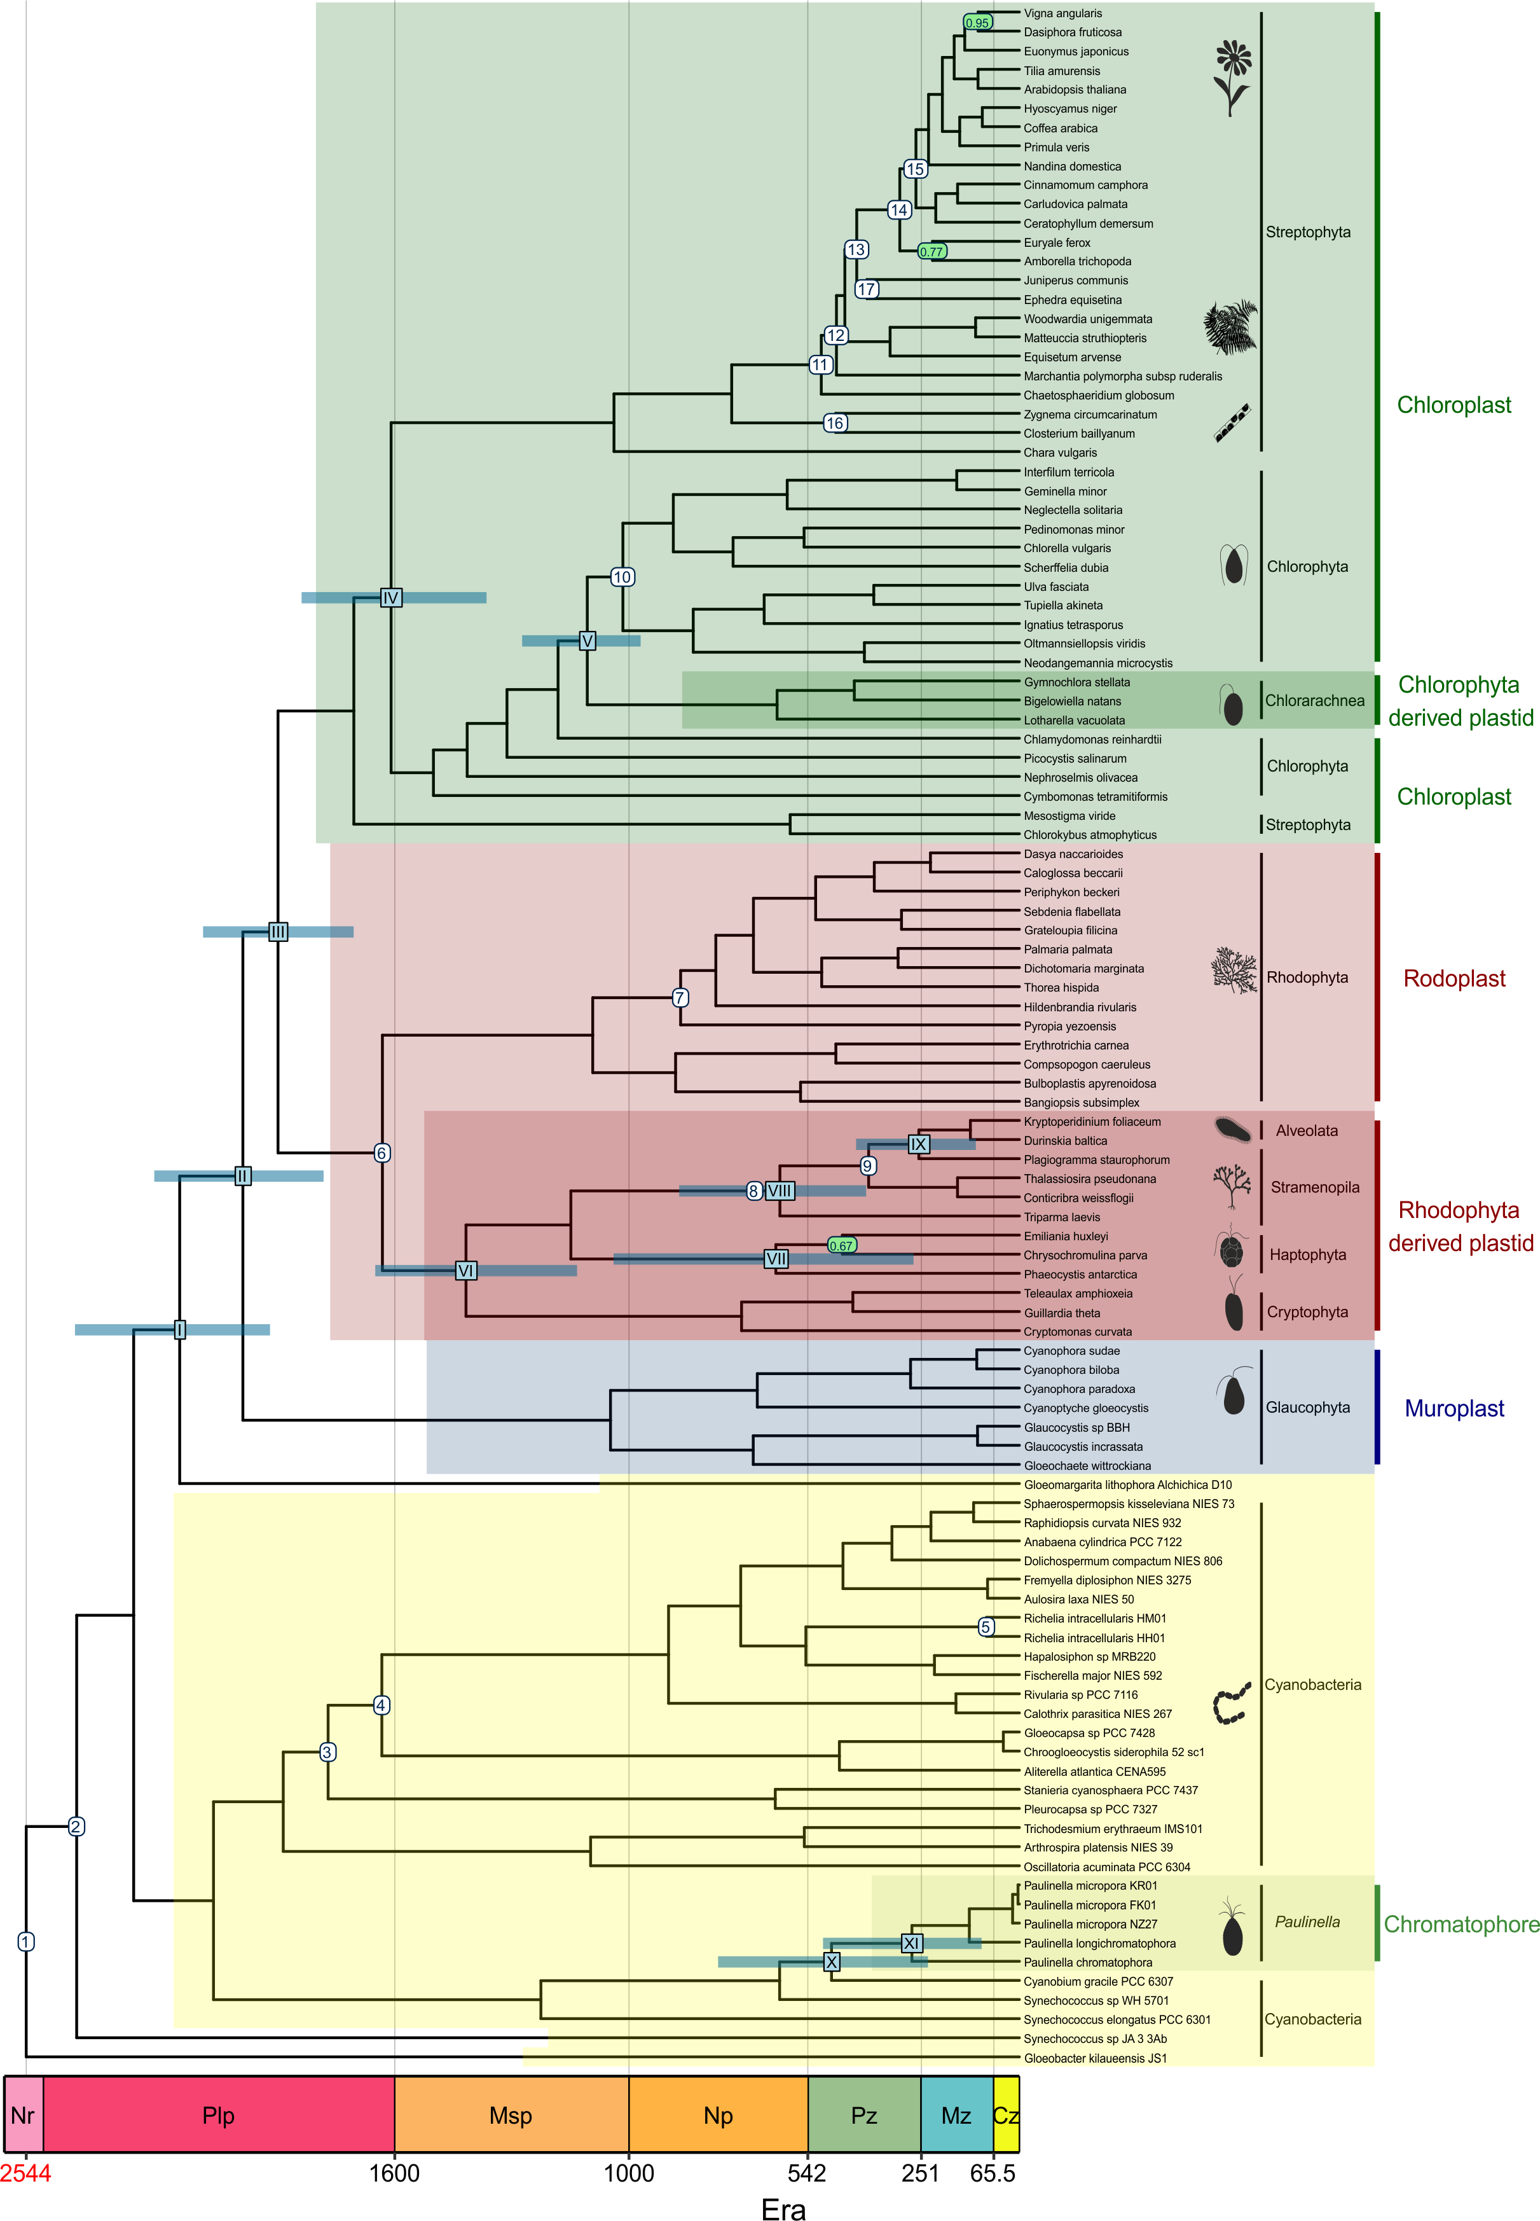 (Figure 15. Caption on the next page.)
Figure 15. Time-calibrated phylogeny of photosynthetic organelles and cyanobacteria. The tree was inferred with Beast under UCLNR model and calibrated with data set C3 (Table 1). Arabic numerals in white circles indicate the calibration constraints. The roman numerals in blue rectangles mark key evolutionary events for plastids discussed in the text. At these nodes, there are blue bars representing 95% credibility intervals of the node age. The nodes supported with posterior probability lower than one are indicated with green circles. The scale presents time in million years. The time marked in red represents the age of the tree root.
In our phylogenies Paulinella groups with C. gracile instead of Prochlorococcus or Synechococcus species (Figure 15, A1-19) [8]. This allows us to formulate a new scenario for chromatophore acquisition. Under this scenario, the ancestors of photosynthetic Paulinella dwelled in marine habitats and fed on common picocyanobacteria, i.e. Prochlorococcus and Synechococcus, similarly to extant heterotrophic Paulinella [124]. We assume that there was a preference for small prey like picocyanobacteria because Paulinella cells are surrounded by an oval theca, and consequently, the food has to fit through a narrow terminal aperture (~1 µm in P. ovalis) [125]. After transition to a new brackish/freshwater habitat, there would be no exclusively marine Prochlorococcus, but instead freshwater Cyanobium and possibly also some Synechococcus spp. [126]. As a result, Paulinella would switch to Cyanobium as the more accessible prey. Next, it would learn to keep Cyanobium for prolonged time, e.g. as food for later use, and simultaneously profit from undergoing photosynthesis by absorbing carbon compounds, and possibly other nutrients, without killing the cyanobacterial prey. The transport of photosynthetic products and the other nutrients could provide the selective pressure for forging the endosymbiotic bond. In the final stage of endosymbiotic transformation, the host cell would abandon phagotrophy for the full photoautotrophic existence. Interestingly, it has been shown that eutrophic habitats preferred by photosynthetic Paulinella do drive unicellular eukaryotes into specialized trophic strategies, i.e. either photoautotrophy or heterotrophy [127].

4.2.2 Molecular dating analyses
In total, we calculated 18 chronograms (Figure 15, A1-17)., six for each of the three calibration sets: C1, C2 and C3 (Table 1). C3 represents our most up to date calibration set since it includes microfossils of R. chitrakootensis [10] and P. antiquus [84]. The other sets (C1 and C2) were used for comparative studies to investigate the impact of calibration constraints on molecular clocks (see below). The estimated ages are presented as ranges of mean dates from all six molecular clocks: UCLNR, IGR, TK02, CIR, LN and UGAM, unless stated otherwise. We discuss only selected results concerning the evolution of major photosynthetic lineages though more datings are included in the section: Verification of tentatively assigned microfossils.
According to our chronograms based on set C3 (Table 1), the cyanobacterial ancestors of muroplasts, rhodoplasts and chloroplasts diverged from G. lithophora in the Paleoproterozoic Era between 2.2 and 2.0 Bya (Figure 15, 16 A1-A5; Table A6). Soon after, they got involved in the endosymbiotic interaction with an unknown unicellular eukaryote, probably in a freshwater environment [8]. This endosymbiotic merger must have taken place before the divergence of the first Archaeplastida lineage. We indicate that the lineage in question was Glaucophyta and that the process occurred before 2.1 to 1.8 Bya (Figure 15, 16, A1-A5; Table A6). Our age for the first cyanobacterial endosymbiosis is in line with the chronograms calculated on nuclear markers by Strassert et al. [45], plastid markers by Blank [128] and Sánchez-Baracaldo et al. [8], but much older than the other estimations summarised in Table A5.
Following the emergence of glaucophytes, red and green algae diverged between 2.0 and 1.8 Bya (Figure 15, 16, A2-A5; Table A6). Their first species were unicellular algae, but the multicellularity in Archaeplastida could have evolved as early as 1.9 Bya and surely before 1.6 Bya. The first date represents the age of controversial fossil of Grypania, possibly an early red or green multicellular alga [129], and the latter R. chitrakootensis [10]. According to our datings, the crown groups of Chloroplastida and Rhodophyta were both established in the late Paleoproterozoic Era, between 1.8 and 1.6 Bya; only the CIR model inferred ~1.5 billion years (Byr) for Chloroplastida. This time range is much older than the previous estimations (Tab. S1) that indicated the Mesoproterozoic and for extant Chloroplastida also the Neoproterozoic Era as the period of origin (Figure 15, 16, A1-A5; Table A6). The only exceptions were datings by Blank [128] and Strassert et al. [45] for Chloroplastida and Rhodophyta, respectively; they anchored the crown groups in the late Paleoproterozoic as well (Table A5).
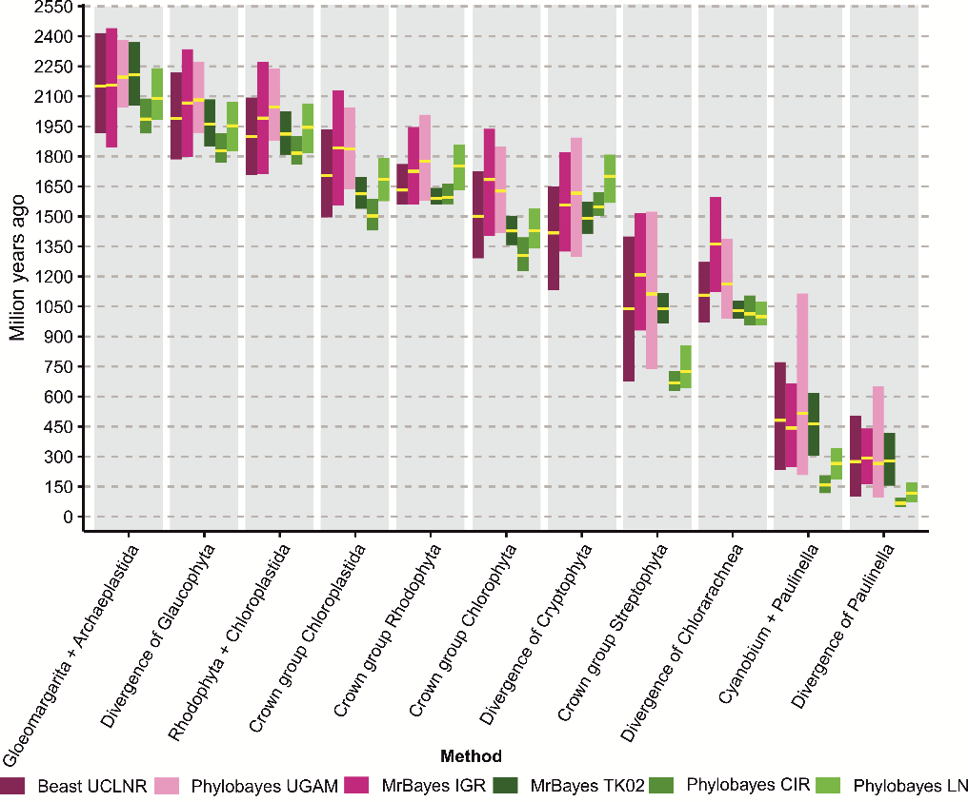
(Figure 16. Caption on the next page.)
Figure 16. Comparison of molecular clock estimations for key evolutionary events for photosynthetic organisms discussed in the text. Purple and green colours mark uncorrelated and autocorrelated clocks, respectively. The yellow lines indicate the mean age and the bars 95% credibility intervals for the mean.
The Chloroplastida lineage is made up of two large clades: Chlorophyta and Streptophyta. The former includes mainly marine green algae and the latter freshwater green algae (charophytes) and all land plants. We estimated the age for the crown group of Chlorophyta between 1.7 and 1.3 Bya
(Figure 15, 16, A1-A5; Table A6), and it was similar to Blank’s [128] results, but much older than the other molecular clock indications (Table A5). Interestingly, the extant streptophytes seem to be younger according to our molecular clocks compared with recent reports (Table A5), except for Sánchez-Baracaldo et al. [8]. We inferred that they evolved in the late Mesoproterozoic, between 1.2 and 1.0 Bya (Figure 15, 16, A1, A2,A5; Table A6). However, this time range does not take into account the mean dates calculated by CIR (Figure A3) and LN (Figure A4) clocks (~700 Myr), which differed strongly from our other models.
Single-celled green algae belonging to Chlorophyta, class Ulvophyceae, got involved in an endosymbiotic interaction with a cercozoan amoeba resulting in a new photosynthetic lineage Chlorarachnea [62]. Chlorarachniophytes, e.g. Bigelowiella, are best known for their nucleomorph, a vestigial nucleus preserved in the reduced ulvophycean cell that now represents a secondary plastid. According to our studies, this complex plastid split from their ancestral green algae between 1.1 and 1.0 Bya (Figure 15, 16, A2-A5; Table A6), only the IGR model (Figure A1) indicated an earlier mean age (1.36 Byr). These results are consistent with nuclear marker-based clock by Parfrey et al. [20], dating this event to about 1.0 Bya, but not with estimations based on plastid proteins by Jackson et al. [62], assuming the mean date ~600 Mya.
Nucleomorph is not only characteristic of Chlorarachnea but also Cryptista; however, both organelles were acquired independently from green and red algae, respectively. Contrary to chlorarachniophytes, the red alga acquisition triggered plastid transfers to other protist lineages in tertiary or indirectly in higher order endosymbioses, e.g. to stramenopiles, haptists and dinoflagellates [45]. The up to date scenarios for evolution of red alga-derived plastids mostly agree that there was a single secondary endosymbiosis beginning with cryptists and a few subsequent serial plastid acquisitions (see [45] and citations therein). Our results indicate that the process started between 1.7 and 1.4 Bya (Figure 15, 16, A2-A5; Table A6), which is similar to Strassert et al. [45] estimation.
The minimum age for the second cyanobacterial endosymbiosis amounting to about 60 Mya was first proposed by Nowack et al. [27]. They assumed that the rate of pseudogene disintegration requiring from 40 to 60 Myr in the endosymbiotic bacteria Buchnera aphidicola is comparable to that of Paulinella in chromatophores. Subsequent molecular clock studies based on 18S rRNA with the UCLNR model by Delaye et al. [22] and also Lhee et al. [130] estimated that photosynthetic Paulinella species diverged from their heterotrophic relatives 141-94 Mya and 193-64 Mya, respectively. In turn, Sánchez-Baracaldo et al. [8] based on plastid markers calculated the split of P. chromatophora from the Synechococcus/Cyanobium clade between 634 Mya and 350 Mya.
We are the first to present multi-clock studies that include all known Paulinella photosynthetic species. According to our four clocks, cyanobacterial ancestors of chromatophores diverged from C. gracile in the early Palaeozoic Era between 516 and 443 Mya (Figure 15, 16, A1, A2, A5; Table A6). These results are in line with Sánchez-Baracaldo et al. [8] estimations but we managed to narrow the upper and lower limits of the time range for about 100 Myr each. The second cyanobacterial endosymbiosis must have taken place before 292 to 266 Mya, i.e. before P. chromatophora separated from the other photosynthetic Paulinella species. It would mean that this endosymbiosis is much older than the other authors assumed. However, these time ranges do not include mean dates calculated by LN and CIR clocks, which strongly differed from our other models. LN and CIR chronograms indicate that Paulinella split later from C. gracile between 266 and 158 Mya, respectively, and therefore acquired plastids between 118 and 67 Mya (Figure 15, A3-A4; Table A6). In turn, these ages agree better with Delaye et al. [22] and Lhee et al. [130] datings.

4.2.3 The impact of molecular clocks and calibration sets on age estimations
In order to evaluate the discrepancies in age estimations by different approaches, we compared (i) different calibration sets assuming the same molecular clock and (ii) a given calibration set with different molecular clocks.
The first comparison indicates that the data set C3 (Table 1) always provided older ages than the global mean for all the three calibration sets. The average percentage difference from the global mean per node $D$ for C3 depended on the clock model and ranged from about 1% to 7% (Table 5). The ages estimated based on C1 were mostly younger than the global mean, from about 1% to 9%, and those based on C2 were in the middle in this respect (Table 1, 5). We also visualized these tendencies in Figure A20 as pairwise comparisons of the calibration sets, and the differences between them were statistically significant
(p < 2e-45). The largest average pairwise differences in ages per node P equal to 135 Myr and 121 Myr were observed for the comparison of C1 with C3 for clocks TK02 and LN, respectively, and they corresponded to the average percentage pairwise difference per node $P\%$ 17% and 14%. It is also worth mentioning that molecular dating by the UGAM model was least affected by the change in the calibration set (Table 5).
Table 5. The average percentage difference from the global mean per node $D$ calculated for the three calibration sets assuming the same molecular clock model. The values should be compared in rows. U –uncorrelated model, A – autocorrelated model.

Software and molecular clock | Calibration set
Software and molecular clock | C1 | C2 | C3
Beast UCLNR (U) | -3.57 | -0.33 | 3.90
MrBayes IGR (U) | -1.30 | -2.47 | 3.77
MrBayes TK02 (A) | -9.30 | 1.90 | 7.40
Phylobayes CIR (A) | -2.06 | 0.05 | 2.01
Phylobayes LN (A) | -8.32 | 3.24 | 5.08
Phylobayes UGAM (U) | -0.84 | 0.14 | 0.69

Much greater differences could be noticed for the second comparison, i.e. of different molecular clocks with the same calibration set (Table 6). For each calibration set, the LN model estimated on average from 13% to 20% older ages than the mean calculated for all the six chronograms. Quite old ages were also obtained for the IGR clock, from 6.5% to 13% greater than the global mean. The younger ages were produced by UCLNR, and they were about 18% smaller than the global mean. UGAM and CIR also provided younger ages but the results of TK02 depended on the calibration set. The pairwise comparison between the clocks is presented in Figure A21, and the differences in the estimated ages are statistically significant for the comparison of LN and UCLNR with the other five models (p < 6.5e-07), for the comparisons of UGAM-CIR (p = 0.041) and UGAM-IGR (p = 0.019). As expected from the global comparison, we found the biggest average pairwise difference in ages per node $P$ between the LN and UCLNR clocks. The ages were on average 208 Myr, 273 Myr and 282 Myr older for LN than UCLNR for C1, C2 and C3 sets, respectively, which corresponds to the mean percentage pairwise difference per node $P\%$ 25%, 33% and 31%.

Table 6. See on the next page. The average percentage difference from the global mean per node $D$ calculated for the six molecular clocks assuming the same calibration set. The values should be compared in columns The values should be compared in rows. U –uncorrelated model, A – autocorrelated model.

Software and molecular clock | Calibration set
Software and molecular clock | C1 | C2 | C3
Beast UCLNR (U) | -17.93 | -18.58 | -18.05
MrBayes IGR (U) | 13.16 | 6.51 | 9.79
MrBayes TK02 (A) | -5.61 | 0.49 | 2.21
Phylobayes CIR (A) | -0.15 | -3.19 | -4.29
Phylobayes LN (A) | 13.03 | 20.96 | 19.14
Phylobayes UGAM (U) | -2.50 | -6.19 | -8.80

We also performed multidimensional scaling to visualize the similarities and differences indicated above for all the combinations of calibration sets and molecular clocks (Figure 17). This analysis illustrates that there are clearly greater differences in the age estimations between molecular clocks compared to calibration sets. In most cases, the calibration sets were grouped together independently of the clock model applied, but the clocks were generally scattered across the plot.

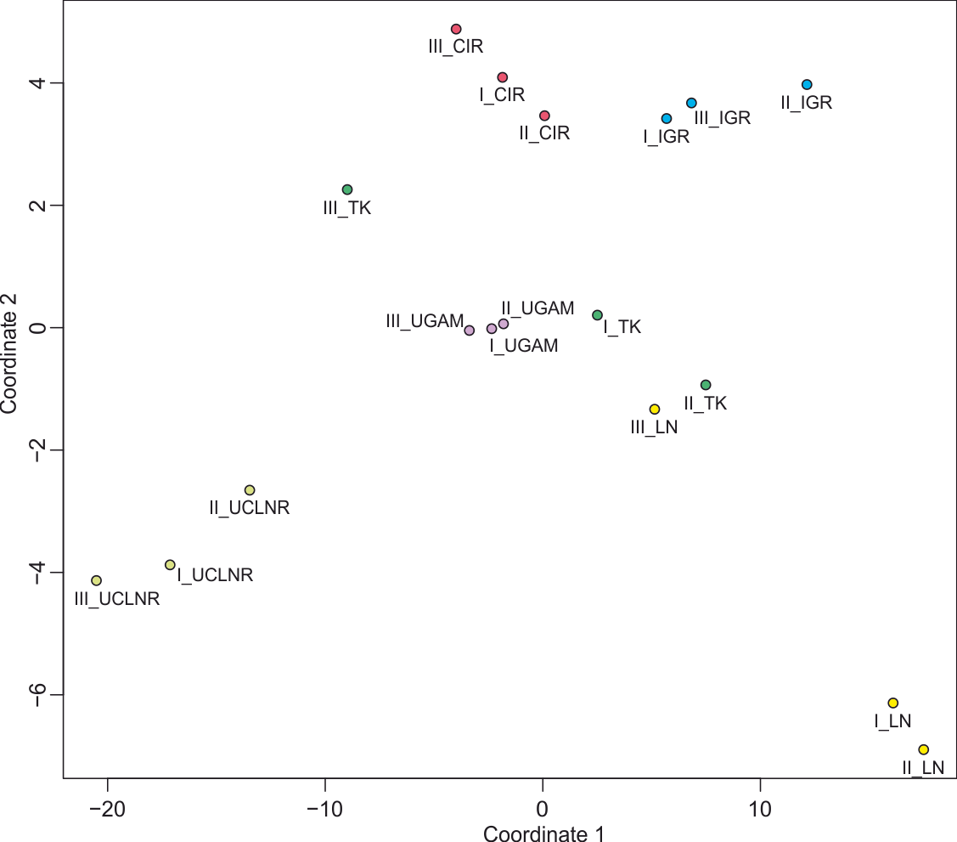
Figure 17. Visualization of similarities and differences in age estimation for all combinations of calibration sets and molecular clocks in multidimensional scaling. The three calibration sets with the UCLNR clock (light green dots) and the set C2 and C3 with the LN clock (yellow dots) represent the most distant points because they produced the most extreme age estimations in our analyses, the youngest and the oldest respectively. The other combinations of clocks and sets, depicted as dots of appropriate colour, are located between them since they provided more moderate datings.

4.2.4 Verification of tentatively assigned microfossils
In the light of the obtained chronograms based on C3, we were able to verify taxonomic affiliation of tentatively and controversially assigned fossils. Our estimations indicate that the main extant cyanobacterial lineages diverged between 2.5 and 1.6 Bya (Figure 15, A1, A3-A5); only TK02 model indicated an older mean dating (2.74 Bya) (Figure A2). Consequently, the assignment of individual Archaean microfossils to contemporary classes or orders of cyanobacteria is not substantiated based on our results. Actually, many of these specimens are the subject of hot debate because they may represent other bacteria groups or are considered not to be organismal remains at all [131]. Our chronograms support the assignment of Oscillatoriopsis (2.2 - 1.8 Byr, Australia [132]) but not Siphonophycus (2.5 - 2.3 Byr, South Africa [133]) to Oscillatoriales because Oscillatoriales diverged between 2.1 and 1.8 Bya (Figure 15,
A1-A5). Moreover, Eoentophysalis belcherensis, the oldest microfossil interpreted with certainty as a cyanobacterium (~1.9 Byr, Canada), does not represent the contemporary lineage of Chroococcales; according to our results this order together with other coccoidal cyanobacteria (Chroococcidiopsidales) evolved between 1.8 and 1.6 Bya [134] (Figure 15, A1-A5).
An interesting but controversial fossil represents Grypania, with the oldest occurrence described from 1.9 Byr-old formations in Michigan, USA [135,136]. Grypania has been commonly interpreted as a macroalga but alternatively named: a pseudofossil, trace fossil, cyanobacterium or even a metazoan [129]. Its age falls well within the estimated time range for the split of the Archaeplastida lineages, i.e. between 2.1 and 1.8 Bya (Figure 15, 16, A1-A5). Accordingly, Grypania might represent an early green or red alga though it would mean that the multicellularity evolved rather early in the archaeplastidian evolution.
Bangiomorpha is another example of an interesting microfossil and until recently it has been considered to be the oldest red alga specimen (~1.0 Byr, Canada [85]). Our chronograms indicate that it could be directly related to extant representatives of the order Bangiales, class Bangiophyceae, as morphological data suggest [85]. We estimated the age for this group between 1.4 and 1.0 Bya
(Figure A1-A5); only the Beast model indicated a younger mean dating 868 Myr (Figure 16).
According to our analyses, some acritarchs, i.e. unicellular organic-walled microfossils of Proterozoic era, described as Dictyosphaera-Shuiyousphaeridium, Gigantosphaeridium and Leiosphaeridia, could belong to the Chloroplastida as interpreted by some authors e.g. Agić et al [137]. Their oldest representatives were found in 1.7 - 1.4 Byr-old deposits in China [137], which is more or less at the time of the diversification of extant green algae in our chronograms (1.84 - 1.55 Byr) (Figure 15,
A2-A5). Moreover, our results also support the classification of some acritarchs to prasinophytes [137,138]. Some of the oldest fossils of such type are Simia (1.7 - 1.4 Myr, China), Valeria (1.7 - 1.4 Byr, China), Tasmanites (~1.6 Byr, India) and Pterospermella (1.3 - 1.2 Byr, Greenland); their age corresponds well with the divergence of prasinophytes in our study between 1.7 and 1.2 Bya (Figure 15,
A2-A5).
We estimated the split of the clade consisting of Trebouxiophyceae, Ulvophyceae and Chlorophyceae from prasinophytes between 1.5 and 1.2 Bya (Figure 15, A2-A5).
Consequently, the assignment to this group of Osculosphaera, Trachyhystrichosphaera and Vandalosphaeridium dated to 1.25 Bya could be correct [139]. However, Tappania plana (1.7 - 1.4 Byr, China) probably represents a fungus, especially taking into account that only two models: IGR (Figure 15) and UGAM (Figure A5) indicated datings older than 1.4 Byr [137]. Leiosphaeridia gorda, Cerebrosphaera, Culcitulisphaera and Lanulatisphaera presumably belong to Chlorophyceae [139,140], and their oldest remains dated ~1.0 Bya from Canada and 800 - 750 Mya from Kazakhstan, Sweden and Spitsbergen do agree with the divergence of Chlorophyceae in our analyses estimated between 1.4 and 1.0 Bya (Figure 15, A2-A5). The chronograms we obtained also support that Archaeoclada, Variaclada and Eoprotoderma described from ~1.0 Byr-old formations in Siberia [139,141] belong to the Ulvophyceae class that evolved between 1.27 and 1.0 Bya (Figure 15, A2-A5). However, the classification of Spiromorpha (1.7 - 1.4 Byr, China) to Zygnematophyceae seems inconsistent with our estimations because our results indicate that Zygnematophyceae separated only between 941 and 551 Mya (Figure 15, A2-A5).
We also calculated the divergence of land plants (embryophytes) and the bryophyte-tracheophyte clade to 508 - 514 Mya and 479 - 462 Mya, respectively; only IGR (831 Mya, 618 Mya) and TK02 (660 Mya, 569 Mya) models indicated older mean datings (Figure 15, A2-A5). Our estimations allow us to assume that the ~510 Myr-old spores from Arizona and Tennessee in USA [142] and ~480-Myr-old spores from Australia [143] could indeed represent the early land plants, whereas the ~460 Myr-old trilete spores from Sweden could have been produced by vascular plants [144].

4.2.5 Impact of climatic and atmospheric parameters on diversification rate
The obtained chronograms (Figure 15, A1-17) were used to estimate the diversification rates of photosynthetic organisms and their correlation with various climatic and atmospheric parameters. We took into account the global and oceanic temperature as well as the atmospheric concentration of carbon dioxide and oxygen (Table A2). The volcanic activity was approximated by the area of Large Igneous Provinces (Table A2). We also calculated the mean diversification rate during six main glaciations and in the warmer periods between them (Table A3).
All statistically significant Spearman correlation coefficients (ρ) calculated for various combinations of the diversification rates with temperature and CO₂ were positive (Figure 18). The mean
ρ was 0.54 and 0.61, and for some cases this coefficient reached 0.7 and 0.93, respectively. In accordance with that, we found a significantly higher diversification rate in warmer periods, compared to glaciations (p-value = 0.00006). The mean ratio between the warm periods and glaciations for the diversification rate was 1.41, and it amounted to 2.35 in some extreme cases.

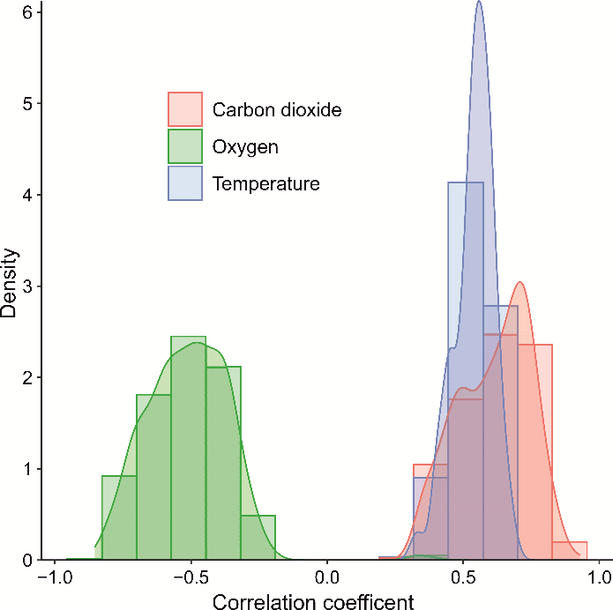
Figure 18. Distribution of statistically significant Spearman correlation coefficients. Calculated for various combinations of the diversification rates with many parameters of temperature as well carbon dioxide and oxygen concentration.

Our results indicate that the diversification rate of photosynthetic organisms significantly rose in warmer times under higher CO₂ concentrations. Significantly, these conditions have already been reported to have a positive impact on photosynthesis and the global growth and reproduction of various alga and plant species [145–148]. Additionally, the increase in CO₂ may reduce the stomatal conductance and transpiration in plants and, therefore, alleviate the negative influence of drought and improve the use of nutrients and water [149]. A similar beneficial effect might produce the rising temperature, but only to some extent. It results in higher enzyme activity [150] that, in turn, is also associated with the stimulation of cell growth and proliferation [151–155].
The positive impact of the carbon dioxide and temperature can be further enhanced by their synergy [153,156]. For example, the influence of elevated CO₂ on photosynthesis is stronger at higher temperatures due to the suppression of photorespiration, a competitive reaction to photosynthesis [157]. Moreover, higher concentration of CO₂ can shift the optimum temperature for plant photosynthesis, growth and development to greater values [157–159].
As a consequence of the positive effect of CO₂ and temperature, the population size of photosynthetic organisms would increase, and trigger higher speciation rates in accordance with the unified neutral theory of biodiversity [160]. The theory postulates that ‘the number of new species arising per unit time is a function of the total number of individuals in a metacommunity’. Warmer temperatures are also responsible for boosting metabolism, higher mutation rates and shorter generation times, which may accelerate speciation as well [161,162]. Elevated temperatures were shown to increase the selection strength on genome-wide polymorphism causing more rapid evolution and diversification in warmer regions [163]. Accordingly, there is increasing species richness of pteridophytes and seed plants with growing temperature [164,165].
Our findings are in agreement with Barrett and Willis [166]; they postulated that the major plant groups emerged at times of increasing CO₂. More detailed analyses showed that CO₂ concentration was strongly and positively correlated with gymnosperm and pteridophyte speciation [167]. In another study, the diversity in neotropical wet forests was also positively related with CO₂ over long timescales during the Cenozoic [168]. Moreover, Fiz-Palacios et al. [169] found that the majority of shifts in the diversification rate of angiosperms, ferns, and mosses coincided with warm climates.
In contrast to the positive effect of CO₂ and temperature, the significant correlations between the diversification rate and O₂ concentration were in 99.4% cases negative (Figure 18). The mean ρ was -0.51 and in an extreme case it amounted to -0.85. This can be associated with an adverse role of oxygen in photosynthesis. O₂ is a competitive inhibitor of CO₂ fixation by ribulose-1,5-bisphosphate carboxylase/oxygenase [170] and stimulates photorespiration [171]. A negative influence of oxygen could also be related to fueling fire on land biota and it was included in some paleoclimatic models [172].
A weak negative correlation was also noticed between the diversification rate and the volcanic activity (data not shown). Regardless of the measure used the mean ρ was -0.29 for statistically significant cases. Considering a long-term influence, the negative effect of volcanos could be related to blocking sunlight and climate cooling by ash and dust as well as to droplets of sulfuric acid, which decrease photosynthesis activity [173,174]. Covering leaves and their stomata by the ash and dust can also disturb respiration processes, whereas acidic rains can cause their direct damage. However, volcanos are important sources of CO₂, a substrate to photosynthesis. Thus, this two-sided influence can cause that the correlation coefficient is not very high but the negative effect apparently prevails.

Summary of phylogenetic analyses and molecular dating of primary plastids and chromatophores
According to our phylogenetic and molecular clock analyses, the primary plastids evolved prior to 2.1 to 1.8 Bya, i.e. before the first Archaeplastida lineage, Glaucophyta, diverged. Similarly to the primary plastids, Paulinella chromatophores evolved in low salinity habitats because they group in all our trees with the freshwater picocyanobacterium C. gracile. This relatively recent endosymbiosis took place possibly before 292 and 266 Mya though two of six clocks indicated younger ages. Following our chronograms, the red algae secondary endosymbioses started with cryptophytes between 1.7 and 1.4 Bya, whereas chlorarachniophytes acquired their green alga-derived plastids between 1.1 and 1.0 Bya (Figure 16). Generally, the age estimations for our key evolutionary events concerning photosynthetic organelles were older compared to previous reports (Table A5), and at least partially due to the inclusion into our calibration set of new microfossils: R. chitrakootensis and P. antiquus; they represent the oldest-known red and green alga specimens, respectively. The diversification rate of the investigated photosynthetic organisms was positively correlated with temperature and carbon dioxide concentrations but negatively with oxygen levels and volcanic activity (Figure 18). Our analyses of the impact of molecular clocks and calibration sets on the age estimations also indicate that there are clearly greater differences in the ages between the clocks compared to the calibration sets (Figure 17). However, we do not see the dependence of uncorrelated and autocorrelated models with the estimation of younger and older ages, respectively, though some models seem to follow this rule.
  - Phylogeny and dating the origin and spread of red alga-derived plastids in Chromalveolata lineages

4.3.1 Phylogenetic analyses
Phylogenetic analyses heavily rely on the quality of sequence alignments, as alignment errors have been demonstrated to impact their accuracy [175]. Numerous trimming strategies have been developed to enhance phylogeny inference by identifying and removing poorly aligned regions, highly divergent sites, or retaining parsimony-informative sites. However, it is important to note that the removal of alignment sites unavoidably results in the loss of information and phylogenetic signal from the alignment [176]. Given the delicate balance between the amount of phylogenetic signal and noise of poorly aligned regions, we have decided to build our phylogenetic trees using the maximum likelihood (ML) method in IQ-TREE [72] and RAxML [80], assuming in total seven trimming strategies employed by two top-ranking trimming software:trimAl [74] and ClipKIT [108], as well as on an original alignment (Table 2).
The trimming resulted in 49-68% sites remaining and increase the percent of variable sites from 86% to 95-96% and parsimony informative site from 56% to 80-89% (Table 2). Relative composition variability increased very little from 0.07 to 0.08-0.10 in the trimmed alignments. The alignment produced by smart-gap strategy in ClipKIT [108] was characterized by the largest number of variable sites (26,449) and parsimony informative sites (22,039) of all trimmed alignments. Almost 97% of all parsimony informative present in the original alignment were retained in this trimmed alignment.
All our 16 inferred ML phylogenies broke the monophyly of chromalveolate plastids and supported with strong or moderate support values (bootstrap range 64-88% and mean 78%, 0.85-1 posterior probability) the grouping of cryptista and haptista plastids with the clade comprising two red algae groups, Proteorhodophytina and Eurhodophytina (Figures 19, A27-A42). Stramenopile plastids were either (i) placed with other red algae Cyanidiales (10 out of 16 trees; Figures 19, A27-A42) or (ii) branched between Cyanidiales and Proteorhodophytina/Eurhodophytina grouped with cryptista and haptista (6 out of 16 trees, Figures 19, A27-A42). Despite the fact that the position of stramenopile clade in our ML phylogenies was generally not strongly supported, the IQ-TREE tree based on CAT model indicated 68% bootstrap and two Bayesian trees provided posterior probability equal to 1 for the stramenopile clustering with Cyanidiales. The alternative placement of Stramenopiles reached the maximum 71% bootstrap in the RAxML tree. Since the former topology was produced by the larger number of trees including Bayesian ones, it seems more probable. Nevertheless, our results indicate that there were two secondary red-alga endosymbioses: one leading to the establishment of photosynthesis in cryptista+ haptista and the second in stramenopiles. Consequently, the plastids of cryptists, haptists and stramenopiles do not form a monophyletic but a polyphyletic clade.
Figure 19. Two tree topologies obtained in IQ-TREE and RAxML. Analyzes were based on various trimming strategies from ClipKIT and trimAl (Table 2). In both trees cryptista and haptista plastid lineages are clustered with those from Proteorhodophytina/Eurhodophytina red algae, whereas stramenopile plastids are grouped either with Cyanidiales red algae (A) or are branched between Cyanidiales and the clade Proteorhodophytina/Eurhodophytina + cryptista/haptista (B).
Interestingly, there seems to be a dependence between the tree topologies we obtained using the ML methods and the length of supermatrices (Table 2, 6). Generally, the longer supermatrices, i.e. with the greater number of variable and parsimony informative sites, produced trees supporting the grouping of stramenopiles with Cyanidiales (9 of 14 trimming strategies), whereas the shorter supermatrices provided the alternative topology (5 of 14 trimming strategies) (Table 2, 6). Importantly, the untrimmed supermatrix produced both topologies depending on software, e.g. in the RAxML tree stramenopiles grouped with Cyanidiales and in the IQ-TREE phylogeny they branched between Cyanidiales and Proteorhodophytina/Eurhodophytina + Cryptista/Haptista clade. (Table 6).
Table 6. Results of phylogenetic analyses categorized by software, trimming strategy and obtained topologies. Topology A: stramenopile plastids are placed with Cyanidiales, topology B: stramenopile plastids branch between Cyanidiales and Proteorhodophytina/Eurhodophytina/cryptista/haptista clade.
Software | Trimming strategy | Topology A | Topology B
Beast lognormal | ClipKIT smart-gap | X
Beast expotential | ClipKIT smart-gap | X
MrBayes IGR | ClipKIT smart-gap | X
IQ-TREE | ClipKIT gappy | X
IQ-TREE | ClipKIT kpic | X
IQ-TREE | ClipKIT kpic-smart-gap |  | X
IQ-TREE | ClipKIT smart-gap | X X*
IQ-TREE | trimAl automated1 |  | X
IQ-TREE | trimAl gappyout | X
IQ-TREE | trimAl strict |  | X
IQ-TREE | original alignment |  | X
RAxML | ClipKIT gappy | X
RAxML | ClipKIT kpic | X
RAxML | ClipKIT kpic-smart-gap | X
RAxML | ClipKIT smart-gap | X
RAxML | trimAl automated1 | X
RAxML | trimAl gappyout |  | X
RAxML | trimAl strict |  | X
RAxML | original alignment | X
*two trees - one inferred based on models in Table A19 and one inferred using CAT model
We also inferred three phylogenies using the Bayesian approach, two in Beast and one in MrBayes, and one additional in IQ-TREE under the CAT model, all based on the alignment produced by smart-gap trimming strategy. This particular method provided the supermatrix with the greatest number of variable and parsimony informative sites compared to other used and contained 68% sites of the untrimmed supermatrix. Significantly, all the trees supported the placement of stramenopiles with Cyanidiales, though only two Bayesian methods with high statistical support (Figure 20, A22, A23).
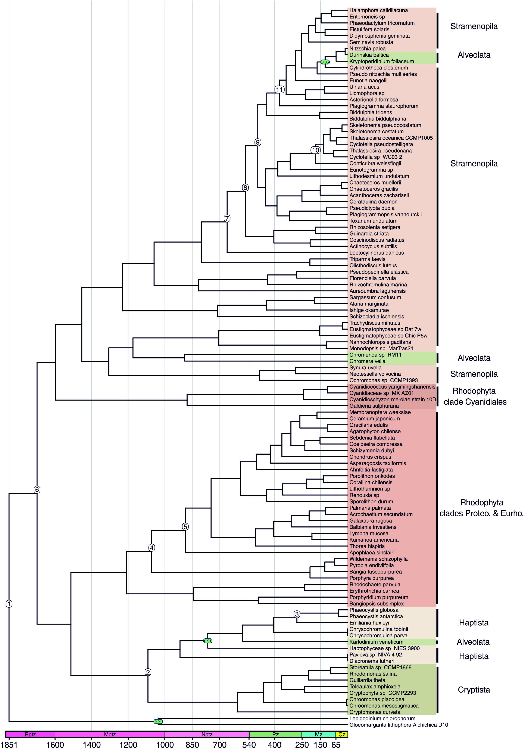(Figure 20. Caption on the next page.)
Figure 20. Time-calibrated phylogeny of red alga and red alga-derived plastids. The tree was inferred with Beast under exponential model and calibrated with constraints presented in Table 3 and substiton models presented in Table A14. The nodes supported with posterior probability lower than one are indicated in green circles.
In all our phylogenies, the representatives of alveolates, i.e. colpodellids: Chromerida sp. RM11 and Chromera velia and dinoflagellates: Durinskia baltica and Kryptoperidinium foliaceum, reside among stramenopile species. However, they do not group together, the colpodellids form a sister clade with Eustigmatophyceae, whereas the dinoflagellates branch among Nitzchia, Cylindrotheca and Pseudo-nitschia species. Importantly, the dinoflagellates are not monophyletic because D. baltica is clustered with N. palea, whereas K. foliaceum is sister to them. It indicates independent ochrophyte endosymbioses in theses lineages. An additional dinoflagellate Karlodinium veneficum groups with haptists [38,49,53,45].

4.3.2 Molecular dating analyses
According to our chronograms, red algae diverged during the Paleoproterozoic Era after ~1.85 billion years ago (Ba) (Figure 20, A22, A23, Table A7-A9). We determined the age of the crown group Rhodophyta to be ~1.75 Ba and this dating also corresponds to the divergence of Cyanidiales from the clade containing Proteorhodophytina and Eurhodophytina red algae.
Our phylogenetic analyses provide compelling evidence that stramenopiles did not acquire their plastids from cryptists, but directly from red algae, most probably related to Cyanidiales. According to our molecular clock estimations, this event occurred after plastids of Cyanidiales and ochrophytes diverged ~1.67 Ba but before the estimated age of the crown group Ochrophyta ~1.52 Ba. Furthermore, we determined that ochrophytes transferred their plastids to colpodellids possibly as early as ~1.22 Ba, when colpodellid plastid diverged from Ochrophyta, but no later than ~926 million years ago (Ma), which corresponds to the age of separation of studied colpodellids (Figure 20, A22, A23, Table A7-A9).
Interestingly, our analyses reveal not only the occurrence of two secondary endosymbioses involving red algae, but also indicate that the acquisition of plastids by cryptists might have occurred after the establishment of photosynthetic organelles in stramenopiles. However, the opposite scenario cannot be ruled out as the estimated intervals of their plastid endosymbioses do overlap. According to our chronograms, the divergence of cryptist and haptist plastids from Proteorhodophytina and Eurhodophytina red algae took place in the Mesoproterozoic Era ~1.53 Ba, but their establishment must have occurred before ~1.18 Ba, i.e. prior to the separation of cryptist and haptist lineages.
In our molecular clock studies, we also investigated plastid transfers to dinoflagellates: K. veneficum, K. foliaceum and D. baltica. They acquired their photosynthetic organelles through three independent endosymbiotic events, ~670 Ma, ~84 Ma and 17.5 Ma, respectively (Figure 20, A22, A23).
Comparing our chronograms with clocks calculated by other researchers is challenging because of differences in markers (plastid vs. nuclear), species, calibration points, molecular clock methods and tree topologies obtained (Table A32) [177–179,20,45]. It is also worth noting that our datings concerning evolution of red algae (~1.92 Ba) as well as the determined age for the crown group Rhodophyta (~1.75 Ba) align with our previous molecular clock estimations (Table A6) and the recent discovery of the oldest fossils of multicellular red alga Rafatazmia chitrakootensis (~1.6 Ba) [180]. According to our clocks, the crown group Ochrophyta was established approximately 1.52 Ba. This dating significantly differs from previous estimations, which ranged from ~575 Ma [179] to ~1.22 Ba [45]. However, this difference is understandable considering the new placement of stramenopile plastids in our phylogenies. Our estimated age for colpodelids, a lineage representing plastid-containing alveolates, is approximately 926 Ma, consistent with more recent nuclear marker-based clocks by Parfrey et al. [20] and Strassert et al. [45]. We inferred the age of the crown group Cryptophyta to be around 550 Ma and Haptophyta to be around 1050 Ma. These estimations agree with the lower boundaries for these points calculated by Strassert et al. [45].

4.3.3 New model of red alga-derived plastid endosymbioses
In modelling plastid evolution, researchers have always used parsimony to explain phylogenetic, genetic and morphological data concerning plastids and their host lineages, to infer how they could have arisen and diversified over time. The principle of minimizing endosymbiotic events invokes the complexity and challenges associated with establishing endosymbiont-derived organelles, especially development of protein import machineries in their membranes along with targeting peptides. Therefore, this concept postulates to simply limit the number of plastid acquisitions [181]. Importantly, the principle still holds true for primary plastids of Archaeplastida, though cyanobacterial endosymbiosis has been shown not to be a unique evolutionary phenomenon as the photosynthetic Paulinella indicates [21,45,48].
In the case of complex plastids, the rigorous application of the principle of minimizing endosymbiotic events was undermined, as the Cabozoa and the Chromalveolata hypotheses collapsed, demanding too many plastid losses over more parsimonious explanation of independent plastid gains [181]. At this point, it is important to emphasize that (i) photosynthetic clades are separated on the tree of life by heterotrophic ones [182] and that (ii) plastid losses are extremely rare even though the loss of photosynthesis has occurred multiple times from Archaeplastida to historic Chromalveolata lineages [183]; parasitic species that were once photosynthetic still require plastids e.g. for synthesis of heme, fatty acids, isoprenoids or assembly of iron-sulphur clusters [184]. In order to reconcile plastid and nuclear gene-based phylogenies two independent green alga endosymbioses are commonly accepted for euglenids and chlorarachniophytes [39,40], and serial endosymbioses models have been proposed as plausible scenarios for the red-alga plastid acquisition in cryptists, haptists, stramenopiles and alveolates [54,38,53] (Figure 5).
Our phylogenetic analyses contradict all serial endosymbioses models that assume a single secondary red alga endosymbiosis within cryptists and then subsequent plastid transfers to other red-alga containing lineages [54,38,53] (Figure 5). According to our phylogenies, there were two secondary red alga endosymbioses, one within cryptists and one within stramenopiles, and they gave rise to cryptophytes which ochrophytes, respectively (Figure 21). Such a possibility has already been mentioned by Dorrell and Bowler [185] as an alternative to the tertiary cyprophyte plastid transfer to stramenopiles and, moreover, it was recovered in the Kim et al. [186] tree based on 93 plastid proteins. From our phylogenies, we can also infer two independent tertiary endosymbioses: (i) cryptophytes passed their plastids to haptophytes and (ii) ochrophytes donated their plastids to colpodellids (Figure 21). Assuming that the colpodellid plastid represents the organelle acquired by the ancestor of dinoflagellates, perkinsids, colpodellids and apicomplexans, our results align with the serial endosymbioses models in Figure 5 for this particular plastid transfer. It is also worth mentioning that in our and Ševčíková et al. [187] phylogenies, colpodellids group with Eustigmatophyceae (Ochrophyta). Both lineages do not possess chlorophyll c, a characteristic that was defining Chromalveolata, but instead rely on chlorophyll a, violaxanthin and β-carotene for capturing light energy [188–190]. Accordingly, photosynthetic pigment composition further strengthens the hypothesis that stramenopiles, precisely Eustigmatophyceae, donated their plastid to the ancestor of alveolate plastid-containing lineages.

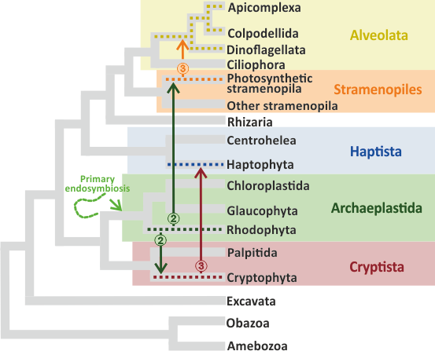
(Figure 21. Caption on the next page.)
Figure 21. Multiple and serial endosymbioses model proposed in this study. The arrows indicate plastid transfers and the numbers in circles correspond to the level of endosymbiosis: 2 – secondary, 3 – tertiary. The topology of the tree presented is based on Stiller et al. [38], Bodył [53] and Strassert et al. [45].
In accordance with the serial endosymbioses hypotheses, stramenopiles donated their plastid to the ancestor of colpodellids, apicomplexans and dinoflagellates, and later on in some dinoflagellates the stramenopile plastid was replaced by other plastids, e.g. from cryptists, stramenopiles and haptists, and sometimes more than once [49,53,45] (Figure 5). This scenario is reflected in our phylogenies. Firstly, colpodellids and dinoflagellates do not group together because, the former carries the ancestral stramenopile plastid, whereas the latter its substitutes obtained from other stramenopile. This is also in agreement with Janouškovec et al. [191] and Ševčíková et al. [187]; however, in our and Ševčíková et al. [187] trees colpodellids branch within stramenopiles, precisely Eustigmatophyceae, instead of occupying a sister position to the whole stramenopile clade (Figure 20). Secondly, the dinoflagellates: D. baltica and K. foliaceum are separated in all our trees by N. palea, which indicates two independent ochrophyte endosymbioses in these species. D. baltica and K. foliaceum represent “dinotoms”, i.e. endosymbiotic consortia of a dinoflagellate and diatom. The former carries a pennate diatom endosymbiont, whereas the latter a centric one [49,192]. Thirdly, in our phylogenies, we also observe two additional dinoflagellates: L. chlorophorum and K. veneficum. L. chlorophorum acquired a green alga secondary endosymbiont and K. veneficum the so called fucoxanthin plastid derived from haptophytes [49]. In accordance with their plastid origin, L. chlorophorum was placed outside the whole chromalveolate and red alga tree, whereas K. veneficum was grouped with haptists. Concerning evolution of protein import into complex plastids of red alga origin, the multiple and serial endosymbioses model (Figure 21) seems at first glance less parsimonious than serial endosymbioses models (Figure 5). In short, protein import into four-membrane plastids of cryptophytes and ochrophytes is based on a bipartite presequence, composed of a signal peptide and a transit peptide, and four protein complexes: Sec61, SELMA, Toc and Tic, which are located in the fourth (continuous with the host ER), third, second and first plastid membrane (counting from outside), respectively [193]. The signal peptide is used for crossing the outermost membrane whereas the transit peptide the three remaining ones. The same system operates in haptophyte and colpodellid/apicomplexan plastids; however, the latter use a form of vesicular trafficking to connect the host ER with their plastid outermost membrane [194]. Importantly, the Toc-Tic translocons represents the same cyanobacteria-host-derived complexes that operate in primary plastids along with transit peptides [4,195], and Sec61 is an ancient system responsible for protein movement into the ER [196]. The only major innovation in complex plastid in term of protein import is SELMA (symbiont-specific ERAD-like machinery) that evolved by adaptation of red alga derived ERAD (endoplasmic reticulum-associated degradation) complex previously used to export misfolded/aberrant proteins from the ER [197–199]. Under the serial endosymbiosis hypotheses, the ERAD system was adapted only once while our multiple and serial endosymbioses model requires two independent adaptations. However, unlike the Toc-Tic supercomplex, which represents a chimeric cyanobacterial-host innovation, SELMA seems to be a simple adaptation of red alga system that had already been used for protein transport. Therefore, we do not consider two independent ERAD adaptations and two subsequent SELMA transfers in two independent tertiary endosymbioses (Figure 21) significantly more challenging that one ERAD adaptation and three subsequent SELMA transfers in three independent higher-order endosymbioses (Figure 5). In both scenarios, the same number of the same set of genes is required to be transferred to the host genome. Several secondary endosymbioses do not have to be rare than endosymbioses of higher order. This view is supported by the independent acquisition of green algal plastids by euglenid and chloarachniophyte lineages. So far, there are not known cases of passing these secondary plastids to other lineages. The two secondary endosymbioses involving red algae proposed by our model are not in contradistinction with this assumption.

Conclusions
- The PhyloPlast database includes infromation and sequences of plastid genes with many options for their searching and downloading. Moreover, it is equipped with a set of tools for alignment, phylogenetic analyzes and prediction of localization within different plastid compartments was established.
- We have estimated the order and times of evolution for primary plastids in Archaeplastida and Paulinella species, which are direct descendants of cyanobacteria. Our results indicate that primary plastids evolved between 2.1 to 1.8 billion years ago, predating the separation of glaucophytes from other Archaeplastida. Similarly, like primary plastids before them, Paulinella chromatophores evolved in a low-salt environment, emerging approximately 292 to 266 million years ago. Generally, our results revise the timing of key events in plastid evolution in Earth's history, pushing them further back compared to previous reports.
- Our phylogenetic analyses not only challenge the Chromalveolata model but also all serial endosymbioses models that assume a single secondary red alga endosymbiosis within cryptists and subsequent plastid transfers to other lineages containing red alga-derived plastids. Based on our analyses, we proposed a new model for complex plastid evolution. According to the model, there were two secondary endosymbioses, one within cryptists and one within stramenopiles, which acquired plastid independently from different red alga lineages. These events gave rise to cryptophytes and ochrophytes, which passed their plastids to haptists and some alveolates, respectively.
- We estimated the divergence time of clades belonging to the historic Chromalveolata group. Our molecular clock studies reveal that plastids of Cyanidiales and ochrophytes diverged after~1.67 Ba but before the estimated age of the crown group Ochrophyta ~1.52 Ba. The divergence of cryptist and haptist plastids from red algae took place in the Mesoproterozoic Era between 1.53 – 1.18 Ba.
- Our studies of various molecular clocks and calibration sets clearly indicate that the molecular clock models and their alghotitms are the source of greater differences in the age estimation than calibration constraints.
- We investigated the effect of alignment trimming on tree topologies. Both excessive trimming and using original alignments can enhance noise that disrupts the phylogenetic signal from informative sites.
- We investigated the impact of climatic factors on the rate of diversification of photosynthetic organisms. The diversification rate of the photosynthetic organisms increased with temperature and carbon dioxide but decreased with oxygen and volcanic activity.
- The estimated divergence times enabled us to reinterpret taxonomic classification of controversial fossils e.g. Grypania, with the oldest occurrence described from 1.9 Byr-old formations and commonly interpreted as a macroalga but alternatively named: a pseudofossil, trace fossil, cyanobacterium or even a metazoan. Our investigation has revealed that Grypania may represent an early green or red alga and means that the multicellularity evolved rather early in the archaeplastidian evolution.

References
1. Archibald JM. Genomic perspectives on the birth and spread of plastids. Proceedings of the National Academy of Sciences. 2015;112: 10147–10153. doi:10.1073/pnas.1421374112
2. Ligrone R. The Chloroplast and Photosynthetic Eukaryotes. In: Ligrone R, editor. Biological Innovations that Built the World: A Four-billion-year Journey through Life and Earth History. Cham: Springer International Publishing; 2019. pp. 269–310. doi:10.1007/978-3-030-16057-9_9
3. Cavalier-Smith T, Lee JJ. Protozoa as Hosts for Endosymbioses and the Conversion of Symbionts into Organelles1,2. The Journal of Protozoology. 1985;32: 376–379. doi:10.1111/j.1550-7408.1985.tb04031.x
4. Bodył A, Mackiewicz P, Stiller JW. Early steps in plastid evolution: current ideas and controversies. Bioessays. 2009;31: 1219–1232.
5. Martin W, Kowallik KV. Annotated English translation of Mereschkowsky’s 1905 paper ‘Über Natur und Ursprung der Chromatophoren im Pflanzenreiche.’ European Journal of Phycology. 1999;34: 287–295.
6. Sagan L. On the origin of mitosing cells. Journal of Theoretical Biology. 1967;14: 225-IN6. doi:10.1016/0022-5193(67)90079-3
7. Sánchez-Baracaldo P, Bianchini G, Wilson JD, Knoll AH. Cyanobacteria and biogeochemical cycles through Earth history. Trends in Microbiology. 2021.
8. Sánchez-Baracaldo P, Raven JA, Pisani D, Knoll AH. Early photosynthetic eukaryotes inhabited low-salinity habitats. Proc Natl Acad Sci USA. 2017;114: E7737. doi:10.1073/pnas.1620089114
9. Strassert JF, Irisarri I, Williams TA, Burki F. A molecular timescale for eukaryote evolution with implications for the origin of red algal-derived plastids. Nature communications. 2021;12: 1–13.
10. Bengtson S, Sallstedt T, Belivanova V, Whitehouse M. Three-dimensional preservation of cellular and subcellular structures suggests 1.6 billion-year-old crown-group red algae. PLoS Biology. 2017;15: e2000735.
11. Ponce-Toledo RI, Deschamps P, López-García P, Zivanovic Y, Benzerara K, Moreira D. An Early-Branching Freshwater Cyanobacterium at the Origin of Plastids. Current Biology. 2017;27: 386–391. doi:10.1016/j.cub.2016.11.056
12. Maruyama S, Kim E. A Modern Descendant of Early Green Algal Phagotrophs. Current Biology. 2013;23: 1081–1084. doi:10.1016/j.cub.2013.04.063
13. Gagat P, Mackiewicz P. Cymbomonas tetramitiformis - a peculiar prasinophyte with a taste for bacteria sheds light on plastid evolution. Symbiosis. 2017;71: 1–7. doi:10.1007/s13199-016-0464-1
14. Wouters J, Raven JA, Minnhagen S, Janson S. The luggage hypothesis: Comparisons of two phototrophic hosts with nitrogen-fixing cyanobacteria and implications for analogous life strategies for kleptoplastids/secondary symbiosis in dinoflagellates. Symbiosis. 2009;49: 61–70. doi:10.1007/s13199-009-0020-3
15. Ford Doolittle W. You are what you eat: a gene transfer ratchet could account for bacterial genes in eukaryotic nuclear genomes. Trends in Genetics. 1998;14: 307–311. doi:10.1016/S0168-9525(98)01494-2
16. Larkum AWD, Lockhart PJ, Howe CJ. Shopping for plastids. Trends in Plant Science. 2007;12: 189–195. doi:10.1016/j.tplants.2007.03.011
17. Moustafa A, Reyes-Prieto A, Bhattacharya D. Chlamydiae Has Contributed at Least 55 Genes to Plantae with Predominantly Plastid Functions. PLOS ONE. 2008;3: e2205. doi:10.1371/journal.pone.0002205
18. Ball SG, Subtil A, Bhattacharya D, Moustafa A, Weber APM, Gehre L, et al. Metabolic Effectors Secreted by Bacterial Pathogens: Essential Facilitators of Plastid Endosymbiosis? The Plant Cell. 2013;25: 7–21. doi:10.1105/tpc.112.101329
19. Hedges SB, Blair JE, Venturi ML, Shoe JL. A molecular timescale of eukaryote evolution and the rise of complex multicellular life. BMC evolutionary biology. 2004;4: 1–9.
20. Parfrey LW, Lahr DJG, Knoll AH, Katz LA. Estimating the timing of early eukaryotic diversification with multigene molecular clocks. Proceedings of the National Academy of Sciences. 2011;108: 13624–13629. doi:10.1073/pnas.1110633108
21. Mackiewicz P, Gagat P. Monophyly of Archaeplastida supergroup and relationships among its lineages in the light of phylogenetic and phylogenomic studies. Are we close to a consensus? Acta Societatis Botanicorum Poloniae. 2014;83. doi:10.5586/asbp.2014.044
22. Delaye L, Valadez-Cano C, Pérez-Zamorano B. How Really Ancient Is Paulinella Chromatophora? PLoS Curr. 2016;8: ecurrents.tol.e68a099364bb1a1e129a17b4e06b0c6b. doi:10.1371/currents.tol.e68a099364bb1a1e129a17b4e06b0c6b
23. Pietluch F, Mackiewicz P, Sidorczuk K, Gagat P. Dating the photosynthetic organelle evolution in Archaeplastida, Paulinella and secondary-plastid bearing lineages. bioRxiv. 2022; 2022–07.
24. Nowack ECM. Paulinella chromatophora - rethinking the transition from endosymbiont to organelle. Acta Societatis Botanicorum Poloniae. 2014;83. doi:10.5586/asbp.2014.049
25. Gagat P, Sidorczuk K, Pietluch F, Mackiewicz P. The Photosynthetic Adventure of Paulinella Spp. In: Kloc M, editor. Symbiosis: Cellular, Molecular, Medical and Evolutionary Aspects. Cham: Springer International Publishing; 2020. pp. 353–386. doi:10.1007/978-3-030-51849-3_13
26. Gagat P, Mackiewicz P. Protein translocons in photosynthetic organelles of Paulinella chromatophora. Acta Societatis Botanicorum Poloniae. 2014;83. Available: https://bibliotekanauki.pl/articles/56561
27. Nowack ECM, Melkonian M, Glöckner G. Chromatophore Genome Sequence of Paulinella Sheds Light on Acquisition of Photosynthesis by Eukaryotes. Current Biology. 2008;18: 410–418. doi:10.1016/j.cub.2008.02.051
28. Green BR. Chloroplast genomes of photosynthetic eukaryotes. The Plant Journal. 2011;66: 34–44. doi:10.1111/j.1365-313X.2011.04541.x
29. Nowack ECM, Vogel H, Groth M, Grossman AR, Melkonian M, Glöckner G. Endosymbiotic Gene Transfer and Transcriptional Regulation of Transferred Genes in Paulinella chromatophora. Molecular Biology and Evolution. 2011;28: 407–422. doi:10.1093/molbev/msq209
30. Chen L-J, Li H. Stable megadalton TOC–TIC supercomplexes as major mediators of protein import into chloroplasts. The Plant Journal. 2017;92: 178–188. doi:10.1111/tpj.13643
31. Kmiec B, Branca RMM, Murcha MW, Lehtiö J, Glaser E, Teixeira PF. A Common Peptidolytic Mechanism for Targeting Peptide Degradation in Mitochondria and Chloroplasts. Mol Plant. 2018;11: 342–345. doi:10.1016/j.molp.2017.11.008
32. Mackiewicz P, Bodył A, Gagat P. Possible import routes of proteins into the cyanobacterial endosymbionts/plastids of Paulinella chromatophora. Theory Biosci. 2012;131: 1–18. doi:10.1007/s12064-011-0147-7
33. Singer A, Poschmann G, Mühlich C, Valadez-Cano C, Hänsch S, Hüren V, et al. Massive Protein Import into the Early-Evolutionary-Stage Photosynthetic Organelle of the Amoeba Paulinella chromatophora. Current Biology. 2017;27: 2763-2773.e5. doi:10.1016/j.cub.2017.08.010
34. Oberleitner L, Perrar A, Macorano L, Huesgen PF, Nowack ECM. A bipartite chromatophore transit peptide and N-terminal protein processing in the Paulinella chromatophore. Plant Physiology. 2022;189: 152–164. doi:10.1093/plphys/kiac012
35. Bhattacharya D, Archibald JM, Weber APM, Reyes-Prieto A. How do endosymbionts become organelles? Understanding early events in plastid evolution. BioEssays. 2007;29: 1239–1246. doi:10.1002/bies.20671
36. Gagat P, Bodył A, Mackiewicz P. How protein targeting to primary plastids via the endomembrane system could have evolved? A new hypothesis based on phylogenetic studies. Biol Direct. 2013;8: 18. doi:10.1186/1745-6150-8-18
37. Cavalier-Smith T. Principles of Protein and Lipid Targeting in Secondary Symbiogenesis: Euglenoid, Dinoflagellate, and Sporozoan Plastid Origins and the Eukaryote Family Tree1,2. Journal of Eukaryotic Microbiology. 1999;46: 347–366. doi:10.1111/j.1550-7408.1999.tb04614.x
38. Stiller JW, Schreiber J, Yue J, Guo H, Ding Q, Huang J. The evolution of photosynthesis in chromist algae through serial endosymbioses. Nat Commun. 2014;5: 5764. doi:10.1038/ncomms6764
39. Archibald JM, Keeling PJ. Recycled plastids: a ‘green movement’ in eukaryotic evolution. Trends in Genetics. 2002;18: 577–584. doi:10.1016/S0168-9525(02)02777-4
40. Rogers MB, Gilson PR, Su V, McFadden GI, Keeling PJ. The Complete Chloroplast Genome of the Chlorarachniophyte Bigelowiella natans: Evidence for Independent Origins of Chlorarachniophyte and Euglenid Secondary Endosymbionts. Molecular Biology and Evolution. 2007;24: 54–62. doi:10.1093/molbev/msl129
41. Gould SB, Maier U-G, Martin WF. Protein Import and the Origin of Red Complex Plastids. Current Biology. 2015;25: R515–R521. doi:10.1016/j.cub.2015.04.033
42. Keeling PJ. Chromalveolates and the Evolution of Plastids by Secondary Endosymbiosis1. Journal of Eukaryotic Microbiology. 2009;56: 1–8. doi:10.1111/j.1550-7408.2008.00371.x
43. Burki F, Okamoto N, Pombert J-F, Keeling PJ. The evolutionary history of haptophytes and cryptophytes: phylogenomic evidence for separate origins. Proceedings of the Royal Society B: Biological Sciences. 2012;279: 2246–2254. doi:10.1098/rspb.2011.2301
44. Burki F, Kaplan M, Tikhonenkov DV, Zlatogursky V, Minh BQ, Radaykina LV, et al. Untangling the early diversification of eukaryotes: a phylogenomic study of the evolutionary origins of Centrohelida, Haptophyta and Cryptista. Proceedings of the Royal Society B: Biological Sciences. 2016;283: 20152802. doi:10.1098/rspb.2015.2802
45. Strassert JFH, Irisarri I, Williams TA, Burki F. A molecular timescale for eukaryote evolution with implications for the origin of red algal-derived plastids. Nat Commun. 2021;12: 1879. doi:10.1038/s41467-021-22044-z
46. Lane CE, Archibald JM. The eukaryotic tree of life: endosymbiosis takes its TOL. Trends in Ecology & Evolution. 2008;23: 268–275. doi:10.1016/j.tree.2008.02.004
47. Cavalier-Smith T. Genomic reduction and evolution of novel genetic membranes and protein-targeting machinery in eukaryote-eukaryote chimaeras (meta-algae). Philosophical Transactions of the Royal Society of London Series B: Biological Sciences. 2003;358: 109–134.
48. Bodył A, Mackiewicz P, Gagat P. Organelle Evolution: Paulinella Breaks a Paradigm. Current Biology. 2012;22: R304–R306. doi:10.1016/j.cub.2012.03.020
49. Gagat P, Bodył A, Mackiewicz P, Stiller JW. Tertiary Plastid Endosymbioses in Dinoflagellates. In: Löffelhardt W, editor. Endosymbiosis. Vienna: Springer; 2014. pp. 233–290. doi:10.1007/978-3-7091-1303-5_13
50. Yamaguchi H, Nakayama T, Hongoh Y, Kawachi M, Inouye I. Molecular diversity of endosymbiotic Nephroselmis (Nephroselmidophyceae) in Hatena arenicola (Katablepharidophycota). J Plant Res. 2014;127: 241–247. doi:10.1007/s10265-013-0591-1
51. Qiu D, Huang L, Lin S. Cryptophyte farming by symbiotic ciliate host detected in situ. Proceedings of the National Academy of Sciences. 2016;113: 12208–12213. doi:10.1073/pnas.1612483113
52. Fujishima M, Kodama Y. Mechanisms for establishing primary and secondary endosymbiosis in Paramecium. Journal of Eukaryotic Microbiology. 2022;69: e12901. doi:10.1111/jeu.12901
53. Bodył A. Did some red alga-derived plastids evolve via kleptoplastidy? A hypothesis. Biological Reviews. 2018;93: 201–222. doi:10.1111/brv.12340
54. Bodył A, Stiller JW, Mackiewicz P. Chromalveolate plastids: direct descent or multiple endosymbioses? Trends in Ecology & Evolution. 2009;24: 119–121. doi:10.1016/j.tree.2008.11.003
55. Sibbald SJ, Archibald JM. Genomic Insights into Plastid Evolution. Genome Biology and Evolution. 2020;12: 978–990. doi:10.1093/gbe/evaa096
56. Adl SM, Bass D, Lane CE, Lukeš J, Schoch CL, Smirnov A, et al. Revisions to the Classification, Nomenclature, and Diversity of Eukaryotes. Journal of Eukaryotic Microbiology. 2019;66: 4–119. doi:10.1111/jeu.12691
57. Krause K. From chloroplasts to “cryptic” plastids: evolution of plastid genomes in parasitic plants. Curr Genet. 2008;54: 111–121. doi:10.1007/s00294-008-0208-8
58. Riisberg I, Orr RJS, Kluge R, Shalchian-Tabrizi K, Bowers HA, Patil V, et al. Seven Gene Phylogeny of Heterokonts. Protist. 2009;160: 191–204. doi:10.1016/j.protis.2008.11.004
59. Armbrust EV. The life of diatoms in the world’s oceans. Nature. 2009;459: 185–192. doi:10.1038/nature08057
60. Waller RF, McFadden GI. The Apicoplast: A Review of the Derived Plastid of Apicomplexan Parasites. Current Issues in Molecular Biology. 2005;7: 57–80. doi:10.21775/cimb.007.057
61. Tekin UK, Okuyucu C, Sayit K, Bedi Y, Noble PJ, Krystyn L, et al. Integrated Radiolaria, benthic foraminifera and conodont biochronology of the pelagic Permian blocks/tectonic slices and geochemistry of associated volcanic rocks from the Mersin Mélange, southern Turkey: Implications for the Permian evolution of the northern Neotethys. Island Arc. 2019;28: e12286. doi:10.1111/iar.12286
62. Jackson C, Knoll AH, Chan CX, Verbruggen H. Plastid phylogenomics with broad taxon sampling further elucidates the distinct evolutionary origins and timing of secondary green plastids. Sci Rep. 2018;8: 1523. doi:10.1038/s41598-017-18805-w
63. Arundhathy M, Jyothibabu R, Santhikrishnan S, Albin KJ, Parthasarathi S, Rashid CP. Coccolithophores: an environmentally significant and understudied phytoplankton group in the Indian Ocean. Environ Monit Assess. 2021;193: 144. doi:10.1007/s10661-020-08794-1
64. Sayers EW, Cavanaugh M, Clark K, Pruitt KD, Schoch CL, Sherry ST, et al. GenBank. Nucleic Acids Research. 2021;49: D92–D96. doi:10.1093/nar/gkaa1023
65. O’Leary NA, Wright MW, Brister JR, Ciufo S, Haddad D, McVeigh R, et al. Reference sequence (RefSeq) database at NCBI: current status, taxonomic expansion, and functional annotation. Nucleic Acids Research. 2016;44: D733–D745. doi:10.1093/nar/gkv1189
66. Koskinen P, Törönen P, Nokso-Koivisto J, Holm L. PANNZER: high-throughput functional annotation of uncharacterized proteins in an error-prone environment. Bioinformatics. 2015;31: 1544–1552. doi:10.1093/bioinformatics/btu851
67. Sidorczuk K, Gagat P, Kała J, Nielsen H, Pietluch F, Mackiewicz P, et al. Prediction of protein subplastid localization and origin with PlastoGram. Sci Rep. 2023;13: 8365. doi:10.1038/s41598-023-35296-0
68. Chang W, Cheng J, Allaire JJ, Sievert C, Schloerke B, Xie Y, et al. shiny: Web Application Framework for R. 2022. Available: https://cran.r-project.org/web/packages/shiny/index.html
69. Stothard P, Grant JR, Van Domselaar G. Visualizing and comparing circular genomes using the CGView family of tools. Briefings in Bioinformatics. 2019;20: 1576–1582. doi:10.1093/bib/bbx081
70. Altschul SF, Madden TL, Schäffer AA, Zhang J, Zhang Z, Miller W, et al. Gapped BLAST and PSI-BLAST: a new generation of protein database search programs. Nucleic Acids Research. 1997;25: 3389–3402. doi:10.1093/nar/25.17.3389
71. Katoh K, Standley DM. MAFFT Multiple Sequence Alignment Software Version 7: Improvements in Performance and Usability. Molecular Biology and Evolution. 2013;30: 772–780. doi:10.1093/molbev/mst010
72. Minh BQ, Schmidt HA, Chernomor O, Schrempf D, Woodhams MD, von Haeseler A, et al. IQ-TREE 2: New Models and Efficient Methods for Phylogenetic Inference in the Genomic Era. Molecular Biology and Evolution. 2020;37: 1530–1534. doi:10.1093/molbev/msaa015
73. Larsson A. AliView: a fast and lightweight alignment viewer and editor for large datasets. Bioinformatics. 2014;30: 3276–3278. doi:10.1093/bioinformatics/btu531
74. Capella-Gutiérrez S, Silla-Martínez JM, Gabaldón T. trimAl: a tool for automated alignment trimming in large-scale phylogenetic analyses. Bioinformatics. 2009;25: 1972–1973. doi:10.1093/bioinformatics/btp348
75. Vaidya G, Lohman DJ, Meier R. SequenceMatrix: concatenation software for the fast assembly of multi-gene datasets with character set and codon information. Cladistics. 2011;27: 171–180. doi:10.1111/j.1096-0031.2010.00329.x
76. Doyle JJ. Defining Coalescent Genes: Theory Meets Practice in Organelle Phylogenomics. Systematic Biology. 2022;71: 476–489. doi:10.1093/sysbio/syab053
77. Stamatakis A. RAxML version 8: a tool for phylogenetic analysis and post-analysis of large phylogenies. Bioinformatics. 2014;30: 1312–1313. doi:10.1093/bioinformatics/btu033
78. Lartillot N, Rodrigue N, Stubbs D, Richer J. PhyloBayes MPI: Phylogenetic Reconstruction with Infinite Mixtures of Profiles in a Parallel Environment. Systematic Biology. 2013;62: 611–615. doi:10.1093/sysbio/syt022
79. Ronquist F, Teslenko M, van der Mark P, Ayres DL, Darling A, Höhna S, et al. MrBayes 3.2: Efficient Bayesian Phylogenetic Inference and Model Choice Across a Large Model Space. Systematic Biology. 2012;61: 539–542. doi:10.1093/sysbio/sys029
80. Bouckaert R, Heled J, Kühnert D, Vaughan T, Wu C-H, Xie D, et al. BEAST 2: A Software Platform for Bayesian Evolutionary Analysis. PLOS Computational Biology. 2014;10: e1003537. doi:10.1371/journal.pcbi.1003537
81. Kalyaanamoorthy S, Minh BQ, Wong TKF, von Haeseler A, Jermiin LS. ModelFinder: fast model selection for accurate phylogenetic estimates. Nat Methods. 2017;14: 587–589. doi:10.1038/nmeth.4285
82. Lanfear R, Frandsen PB, Wright AM, Senfeld T, Calcott B. PartitionFinder 2: New Methods for Selecting Partitioned Models of Evolution for Molecular and Morphological Phylogenetic Analyses. Molecular Biology and Evolution. 2017;34: 772–773. doi:10.1093/molbev/msw260
83. Naser-Khdour S, Minh BQ, Zhang W, Stone EA, Lanfear R. The Prevalence and Impact of Model Violations in Phylogenetic Analysis. Genome Biology and Evolution. 2019;11: 3341–3352. doi:10.1093/gbe/evz193
84. Tang Q, Pang K, Yuan X, Xiao S. A one-billion-year-old multicellular chlorophyte. Nature Ecology & Evolution. 2020;4: 543–549.
85. Gibson TM, Shih PM, Cumming VM, Fischer WW, Crockford PW, Hodgskiss MS, et al. Precise age of Bangiomorpha pubescens dates the origin of eukaryotic photosynthesis. Geology. 2018;46: 135–138.
86. Bekker A, Holland HD, Wang P-L, Rumble D, Stein HJ, Hannah JL, et al. Dating the rise of atmospheric oxygen. Nature. 2004;427: 117–120.
87. Crowe SA, Døssing LN, Beukes NJ, Bau M, Kruger SJ, Frei R, et al. Atmospheric oxygenation three billion years ago. Nature. 2013;501: 535–538.
88. Hofmann HJ. Precambrian microflora, Belcher Islands, Canada: significance and systematics. Journal of Paleontology. 1976; 1040–1073.
89. Demoulin CF, Lara YJ, Cornet L, François C, Baurain D, Wilmotte A, et al. Cyanobacteria evolution: Insight from the fossil record. Free Radical Biology and Medicine. 2019;140: 206–223.
90. Zhang Y. Proterozoic stromatolitic micro-organisms from Hebei, North China: Cell preservation and cell division. Precambrian Research. 1988;38: 165–175.
91. Page RW, Jackson MJ, Krassay AA. Constraining sequence stratigraphy in north Australian basins: SHRIMP U–Pb zircon geochronology between Mt Isa and McArthur River. Australian Journal of Earth Sciences. 2000;47: 431–459.
92. Tomitani A, Knoll AH, Cavanaugh CM, Ohno T. The evolutionary diversification of cyanobacteria: molecular–phylogenetic and paleontological perspectives. Proceedings of the National Academy of Sciences. 2006;103: 5442–5447.
93. Sims PA, Mann DG, Medlin LK. Evolution of the diatoms: insights from fossil, biological and molecular data. Phycologia. 2006;45: 361–402.
94. Xiao S, Knoll AH, Yuan X, Pueschel CM. Phosphatized multicellular algae in the Neoproterozoic Doushantuo Formation, China, and the early evolution of florideophyte red algae. American Journal of Botany. 2004;91: 214–227.
95. Kooistra WH, Medlin LK. Evolution of the diatoms (Bacillariophyta): IV. A reconstruction of their age from small subunit rRNA coding regions and the fossil record. Molecular phylogenetics and evolution. 1996;6: 391–407.
96. Rubinstein CV, Gerrienne P, de la Puente GS, Astini RA, Steemans P. Early Middle Ordovician evidence for land plants in Argentina (eastern Gondwana). New Phytologist. 2010;188: 365–369.
97. Morris JL, Puttick MN, Clark JW, Edwards D, Kenrick P, Pressel S, et al. The timescale of early land plant evolution. Proceedings of the National Academy of Sciences. 2018;115: E2274–E2283.
98. Strother PK. Systematics and evolutionary significance of some new cryptospores from the Cambrian of eastern Tennessee, USA. Review of Palaeobotany and Palynology. 2016;227: 28–41.
99. Steemans P, Le Hérissé A, Melvin J, Miller MA, Paris F, Verniers J, et al. Origin and radiation of the earliest vascular land plants. Science. 2009;324: 353–353.
100. Turnau E, Zavialova N, Prejbisz A. Wall ultrastructure in some dispersed megaspores and seed-megaspores from the Middle Devonian of northern Poland. Review of Palaeobotany and Palynology. 2009;156: 14–33.
101. Hughes NF, McDougall AB, Chapman JL. Exceptional new record of Cretaceous Hauterivian angiospermid pollen from southern England. Journal of Micropalaeontology. 1991;10: 75–82.
102. Friis EM, Pedersen KR, Crane PR. Cretaceous angiosperm flowers: innovation and evolution in plant reproduction. Palaeogeography, palaeoclimatology, palaeoecology. 2006;232: 251–293.
103. Soltis PS, Soltis DE. The origin and diversification of angiosperms. American Journal of Botany. 2004;91: 1614–1626.
104. Mullins GL, Servais T. The diversity of the Carboniferous phytoplankton. Review of Palaeobotany and Palynology. 2008;149: 29–49.
105. Lartillot N, Lepage T, Blanquart S. PhyloBayes 3: a Bayesian software package for phylogenetic reconstruction and molecular dating. Bioinformatics. 2009;25: 2286–2288. doi:10.1093/bioinformatics/btp368
106. Ihaka R, Gentleman R. R: A Language for Data Analysis and Graphics. Journal of Computational and Graphical Statistics. 1996;5: 299–314. doi:10.1080/10618600.1996.10474713
107. Giorgi FM, Ceraolo C, Mercatelli D. The R Language: An Engine for Bioinformatics and Data Science. Life (Basel). 2022;12: 648. doi:10.3390/life12050648
108. Steenwyk JL, Iii TJB, Li Y, Shen X-X, Rokas A. ClipKIT: A multiple sequence alignment trimming software for accurate phylogenomic inference. PLOS Biology. 2020;18: e3001007. doi:10.1371/journal.pbio.3001007
109. Steenwyk JL, Buida TJ III, Labella AL, Li Y, Shen X-X, Rokas A. PhyKIT: a broadly applicable UNIX shell toolkit for processing and analyzing phylogenomic data. Bioinformatics. 2021;37: 2325–2331. doi:10.1093/bioinformatics/btab096
110. Doyle JJ. Defining Coalescent Genes: Theory Meets Practice in Organelle Phylogenomics. Systematic Biology. 2022;71: 476–489. doi:10.1093/sysbio/syab053
111. Lartillot N, Philippe H. A Bayesian Mixture Model for Across-Site Heterogeneities in the Amino-Acid Replacement Process. Molecular Biology and Evolution. 2004;21: 1095–1109. doi:10.1093/molbev/msh112
112. Bown PR, Lees JA, Young JR. Calcareous nannoplankton evolution and diversity through time. In: Thierstein HR, Young JR, editors. Coccolithophores: From Molecular Processes to Global Impact. Berlin, Heidelberg: Springer; 2004. pp. 481–508. doi:10.1007/978-3-662-06278-4_18
113. Medlin LK. A timescale for diatom evolution based on four molecular markers: reassessment of ghost lineages and major steps defining diatom evolution. Vie et milieu-life and enVironment. 2015.
114. Kaczmarska I, Jr BSG, Ehrman JM, Thaler M. Sexual reproduction in plagiogrammacean diatoms: First insights into the early pennates. PLOS ONE. 2017;12: e0181413. doi:10.1371/journal.pone.0181413
115. Lartillot N, Lepage T, Blanquart S. PhyloBayes 3: a Bayesian software package for phylogenetic reconstruction and molecular dating. Bioinformatics. 2009;25: 2286–2288.
116. Moore KR, Magnabosco C, Momper L, Gold DA, Bosak T, Fournier GP. An Expanded Ribosomal Phylogeny of Cyanobacteria Supports a Deep Placement of Plastids. Frontiers in Microbiology. 2019;10. Available: https://www.frontiersin.org/article/10.3389/fmicb.2019.01612
117. Karkar S, Facchinelli F, Price DC, Weber APM, Bhattacharya D. Metabolic connectivity as a driver of host and endosymbiont integration. Proceedings of the National Academy of Sciences. 2015;112: 10208–10215. doi:10.1073/pnas.1421375112
118. Brown MW, Heiss AA, Kamikawa R, Inagaki Y, Yabuki A, Tice AK, et al. Phylogenomics Places Orphan Protistan Lineages in a Novel Eukaryotic Super-Group. Genome Biol Evol. 2018;10: 427–433. doi:10.1093/gbe/evy014
119. Irisarri I, Strassert JFH, Burki F. Phylogenomic Insights into the Origin of Primary Plastids. Systematic Biology. 2022;71: 105–120. doi:10.1093/sysbio/syab036
120. Gawryluk RMR, Tikhonenkov DV, Hehenberger E, Husnik F, Mylnikov AP, Keeling PJ. Non-photosynthetic predators are sister to red algae. Nature. 2019;572: 240–243. doi:10.1038/s41586-019-1398-6
121. Lax G, Eglit Y, Eme L, Bertrand EM, Roger AJ, Simpson AGB. Hemimastigophora is a novel supra-kingdom-level lineage of eukaryotes. Nature. 2018;564: 410–414. doi:10.1038/s41586-018-0708-8
122. Strassert JFH, Jamy M, Mylnikov AP, Tikhonenkov DV, Burki F. New Phylogenomic Analysis of the Enigmatic Phylum Telonemia Further Resolves the Eukaryote Tree of Life. Molecular Biology and Evolution. 2019;36: 757–765. doi:10.1093/molbev/msz012
123. Lemieux C, Otis C, Turmel M. A clade uniting the green algae Mesostigma viride and Chlorokybus atmophyticus represents the deepest branch of the Streptophyta in chloroplast genome-based phylogenies. BMC Biology. 2007;5: 2. doi:10.1186/1741-7007-5-2
124. Bhattacharya D, Price DC, Yoon HS, Yang EC, Poulton NJ, Andersen RA, et al. Single cell genome analysis supports a link between phagotrophy and primary plastid endosymbiosis. Sci Rep. 2012;2: 356. doi:10.1038/srep00356
125. Johnson PW, Hargraves PE, Sieburth JMcN. Ultrastructure and Ecology of Calycomonas ovalis Wulff, 1919, (Chrysophyceae) and Its Redescription as a Testate Rhizopod, Paulinella ovalis N. Comb. (Filosea: Euglyphina)1. The Journal of Protozoology. 1988;35: 618–626. doi:10.1111/j.1550-7408.1988.tb04160.x
126. Strunecký O, Koblizek M. Whole genome phylogeny of Cyanobacteria documents a distinct evolutionary trajectory of marine picocyanobacteria. 2021. doi:10.1101/2021.05.26.445609
127. Troost TA, Kooi BW, Kooijman SALM. Ecological Specialization of Mixotrophic Plankton in a Mixed Water Column. The American Naturalist. 2005;166: E45–E61. doi:10.1086/432038
128. Blank CE. Origin and early evolution of photosynthetic eukaryotes in freshwater environments: reinterpreting proterozoic paleobiology and biogeochemical processes in light of trait evolution. Journal of Phycology. 2013;49: 1040–1055. doi:10.1111/jpy.12111
129. Wang Y, Wang Y, Du W. The long-ranging macroalga Grypania spiralis from the Ediacaran Doushantuo Formation, Guizhou, South China. Alcheringa: An Australasian Journal of Palaeontology. 2016. pp. 303–312. doi:10.1080/03115518.2016.1127725
130. Lhee D, Ha J-S, Kim S, Park MG, Bhattacharya D, Yoon HS. Evolutionary dynamics of the chromatophore genome in three photosynthetic Paulinella species. Sci Rep. 2019;9: 2560. doi:10.1038/s41598-019-38621-8
131. Wacey D, Saunders M, Kong C, Brasier A, Brasier M. 3.46Ga Apex chert ‘microfossils’ reinterpreted as mineral artefacts produced during phyllosilicate exfoliation. Gondwana Research. 2016;36: 296–313. doi:10.1016/j.gr.2015.07.010
132. Knoll AH, Strother PK, Rossi S. Distribution and diagenesis of microfossils from the lower proterozoic duck creek dolomite, Western Australia. Precambrian Research. 1988;38: 257–279. doi:10.1016/0301-9268(88)90005-8
133. Klein C, Beukes NJ, Schopf JW. Filamentous microfossils in the early proterozoic transvaal supergroup: their morphology, significance, and paleoenvironmental setting. Precambrian Research. 1987;36: 81–94. doi:10.1016/0301-9268(87)90018-0
134. Hofmann HJ. Precambrian Microflora, Belcher Islands, Canada: Significance and Systematics. Journal of Paleontology. 1976;50: 1040–1073.
135. Han TM, Runnegar B. Megascopic eukaryotic algae from the 2.1-billion-year-old negaunee iron-formation, Michigan. Science. 1992. pp. 232–5. doi:10.1126/science.1631544
136. Pietrzak-Renaud N, Davis D. U–Pb geochronology of baddeleyite from the Belleview metadiabase: Age and geotectonic implications for the Negaunee Iron Formation, Michigan. Precambrian Research. 2014. pp. 1–5. doi:https://doi.org/10.1016/j.precamres.2014.05.018
137. Agić H, Moczydłowska M, Yin L. Diversity of organic-walled microfossils from the early Mesoproterozoic Ruyang Group, North China Craton – A window into the early eukaryote evolution. Precambrian Research. 2017. pp. 101–130. doi:10.1016/j.precamres.2017.04.042
138. Teyssedre B. Precambrian palaeontology in the light of molecular phylogeny–an example: the radiation of the green algae. Biogeosciences Discussions. 2007. pp. 3123–3142.
139. Moczydłowska M, Landing ED, Zang W, Palacios T. Proterozoic phytoplankton and timing of Chlorophyte algae origins. Palaeontology. 2011. pp. 721–733. doi:10.1111/j.1475-4983.2011.01054.x
140. Loron C, Moczydłowska M. Tonian (Neoproterozoic) eukaryotic and prokaryotic organic-walled microfossils from the upper Visingsö Group, Sweden. Palynology. 2018;42: 220–254. doi:10.1080/01916122.2017.1335656
141. Hermann TN, Podkovyrov VN. A discovery of riphean heterotrophs in the Lakhanda group of Siberia. Paleontological Journal. 2010. pp. 374–383. doi:10.1134/s0031030110040027
142. Strother PK. Systematics and evolutionary significance of some new cryptospores from the Cambrian of eastern Tennessee, USA. Review of Palaeobotany and Palynology. 2016. pp. 28–41. doi:10.1016/j.revpalbo.2015.10.006
143. Strother PK, Foster C. A fossil record of land plant origins from charophyte algae. Science. 2021. pp. 792–796.
144. Rubinstein CV, Vajda V. Baltica cradle of early land plants? Oldest record of trilete spores and diverse cryptospore assemblages; evidence from Ordovician successions of Sweden. Gff. 2019. pp. 181–190. doi:10.1080/11035897.2019.1636860
145. Brown T-RW, Lajeunesse MJ, Scott KM. Strong effects of elevated CO2 on freshwater microalgae and ecosystem chemistry. Limnology and Oceanography. 2020;65: 304–313. doi:10.1002/lno.11298
146. Jablonski LM, Wang X, Curtis PS. Plant reproduction under elevated CO2 conditions: a meta-analysis of reports on 79 crop and wild species. New Phytologist. 2002;156: 9–26. doi:10.1046/j.1469-8137.2002.00494.x
147. Ma J, Wang P. Effects of rising atmospheric CO₂ levels on physiological response of cyanobacteria and cyanobacterial bloom development: A review. Sci Total Environ. 2021;754: 141889. doi:10.1016/j.scitotenv.2020.141889
148. Poorter H, Knopf O, Wright IJ, Temme AA, Hogewoning SW, Graf A, et al. A meta-analysis of responses of C3 plants to atmospheric CO2: dose–response curves for 85 traits ranging from the molecular to the whole-plant level. New Phytologist. 2022;233: 1560–1596. doi:10.1111/nph.17802
149. Ainsworth EA, Rogers A. The response of photosynthesis and stomatal conductance to rising [CO2]: mechanisms and environmental interactions. Plant Cell Environ. 2007;30: 258–270. doi:10.1111/j.1365-3040.2007.01641.x
150. Arcus VL, Prentice EJ, Hobbs JK, Mulholland AJ, Van der Kamp MW, Pudney CR, et al. On the Temperature Dependence of Enzyme-Catalyzed Rates. Biochemistry. 2016;55: 1681–1688. doi:10.1021/acs.biochem.5b01094
151. Dusenge ME, Duarte AG, Way DA. Plant carbon metabolism and climate change: elevated CO2 and temperature impacts on photosynthesis, photorespiration and respiration. New Phytologist. 2019;221: 32–49. doi:10.1111/nph.15283
152. Lindo Z, Griffith DA. Elevated Atmospheric CO2 and Warming Stimulates Growth and Nitrogen Fixation in a Common Forest Floor Cyanobacterium under Axenic Conditions. Forests. 2017;8: 73. doi:10.3390/f8030073
153. Morison JIL, Lawlor DW. Interactions between increasing CO2 concentration and temperature on plant growth. Plant, Cell & Environment. 1999;22: 659–682. doi:10.1046/j.1365-3040.1999.00443.x
154. Nalley JO, O’Donnell DR, Litchman E. Temperature effects on growth rates and fatty acid content in freshwater algae and cyanobacteria. Algal research. 2018 [cited 15 Jun 2022]. Available: https://dx.doi.org/10.1016/j.algal.2018.09.018
155. Zhang P, Grutters BMC, van Leeuwen CHA, Xu J, Petruzzella A, van den Berg RF, et al. Effects of Rising Temperature on the Growth, Stoichiometry, and Palatability of Aquatic Plants. Frontiers in Plant Science. 2019;9. Available: https://www.frontiersin.org/article/10.3389/fpls.2018.01947
156. Reddy AR, Rasineni GK, Raghavendra AS. The impact of global elevated CO₂ concentration on photosynthesis and plant productivity. Current Science. 2010;99: 46–57.
157. Gutiérrez D, Gutiérrez E, Pérez P, Morcuende R, Verdejo AL, Martinez-Carrasco R. Acclimation to future atmospheric CO2 levels increases photochemical efficiency and mitigates photochemistry inhibition by warm temperatures in wheat under field chambers. Physiologia Plantarum. 2009;137: 86–100. doi:10.1111/j.1399-3054.2009.01256.x
158. Alonso A, Pérez P, Morcuende R, Martinez-Carrasco R. Future CO2 concentrations, though not warmer temperatures, enhance wheat photosynthesis temperature responses. Physiol Plant. 2008;132: 102–112. doi:10.1111/j.1399-3054.2007.00997.x
159. Ghannoum O, Phillips NG, Sears MA, Logan BA, Lewis JD, Conroy JP, et al. Photosynthetic responses of two eucalypts to industrial-age changes in atmospheric [CO2] and temperature. Plant, Cell & Environment. 2010;33: 1671–1681. doi:10.1111/j.1365-3040.2010.02172.x
160. Hubbell SP. A Unified Theory of Biodiversity and Biogeography–Princeton University Press. Princeton, NJ. 2001.
161. Allen AP, Brown JH, Gillooly JF. Global biodiversity, biochemical kinetics, and the energetic-equivalence rule. Science. 2002;297: 1545–1548.
162. Wright S, Keeling J, Gillman L. The road from Santa Rosalia: a faster tempo of evolution in tropical climates. Proceedings of the National Academy of Sciences. 2006;103: 7718–7722.
163. Berger D, Stångberg J, Baur J, Walters RJ. Elevated temperature increases genome-wide selection on de novo mutations. Proceedings of the Royal Society B: Biological Sciences. 2021;288: 20203094. doi:10.1098/rspb.2020.3094
164. Qian H, Kessler M, Deng T, Jin Y. Patterns and drivers of phylogenetic structure of pteridophytes in China. Global Ecology and Biogeography. 2021;30: 1835–1846. doi:10.1111/geb.13349
165. Qian H, Deng T, Jin Y, Mao L, Zhao D, Ricklefs RE. Phylogenetic dispersion and diversity in regional assemblages of seed plants in China. Proc Natl Acad Sci U S A. 2019;116: 23192–23201. doi:10.1073/pnas.1822153116
166. Barrett PM, Willis KJ. Did dinosaurs invent flowers? Dinosaur-angiosperm coevolution revisited. Biol Rev Camb Philos Soc. 2001;76: 411–447. doi:10.1017/s1464793101005735
167. McElwain J, Willis K, Niklas K, Hodkinson T, Jones M, Waldren S, et al. Long term fluctuations in atmospheric CO2 concentration influence plant speciation rates. Cambridge University Press Cambridge UK; 2011.
168. Royer DL, Chernoff B. Diversity in neotropical wet forests during the Cenozoic is linked more to atmospheric CO2 than temperature. Proceedings of the Royal Society B: Biological Sciences. 2013;280: 20131024. doi:10.1098/rspb.2013.1024
169. Fiz-Palacios O, Schneider H, Heinrichs J, Savolainen V. Diversification of land plants: insights from a family-level phylogenetic analysis. BMC Evolutionary Biology. 2011;11: 341. doi:10.1186/1471-2148-11-341
170. Björkman O. The Effect of Oxygen Concentration on Photosynthesis in Higher Plants. Physiologia Plantarum. 1966;19: 618–633. doi:10.1111/j.1399-3054.1966.tb07046.x
171. Sharkey TD. Estimating the rate of photorespiration in leaves. Physiologia Plantarum. 1988;73: 147–152. doi:10.1111/j.1399-3054.1988.tb09205.x
172. Bergman NM, Lenton TM, Watson AJ. COPSE: A new model of biogeochemical cycling over Phanerozoic time. American Journal of Science. 2004;304: 397–437. doi:10.2475/ajs.304.5.397
173. Kennedy RA. The eruption of Mount St. Helens: impact on agriculture and the effects of Mount St. Helens ash on plants [Washington]. Scanning Electron Microscope (USA). 1981 [cited 15 Jun 2022]. Available: https://scholar.google.com/scholar_lookup?title=The+eruption+of+Mount+St.+Helens%3A+impact+on+agriculture+and+the+effects+of+Mount+St.+Helens+ash+on+plants+%5BWashington%5D&author=Kennedy%2C+R.A.&publication_year=1981
174. Robock A. Volcanic eruptions and climate. Reviews of Geophysics. 2000;38: 191–219. doi:10.1029/1998RG000054
175. Nie Y, Foster CSP, Zhu T, Yao R, Duchêne DA, Ho SYW, et al. Accounting for Uncertainty in the Evolutionary Timescale of Green Plants Through Clock-Partitioning and Fossil Calibration Strategies. Systematic Biology. 2020;69: 1–16. doi:10.1093/sysbio/syz032
176. Talavera G, Castresana J. Improvement of Phylogenies after Removing Divergent and Ambiguously Aligned Blocks from Protein Sequence Alignments. Systematic Biology. 2007;56: 564–577. doi:10.1080/10635150701472164
177. Douzery EJP, Snell EA, Bapteste E, Delsuc F, Philippe H. The timing of eukaryotic evolution: Does a relaxed molecular clock reconcile proteins and fossils? Proceedings of the National Academy of Sciences. 2004;101: 15386–15391. doi:10.1073/pnas.0403984101
178. Yoon HS, Hackett JD, Ciniglia C, Pinto G, Bhattacharya D. A molecular timeline for the origin of photosynthetic eukaryotes. Mol Biol Evol. 2004;21: 809–818. doi:10.1093/molbev/msh075
179. Berney C, Pawlowski J. A molecular time-scale for eukaryote evolution recalibrated with the continuous microfossil record. Proceedings of the Royal Society B: Biological Sciences. 2006;273: 1867–1872. doi:10.1098/rspb.2006.3537
180. Bengtson S, Sallstedt T, Belivanova V, Whitehouse M. Three-dimensional preservation of cellular and subcellular structures suggests 1.6 billion-year-old crown-group red algae. Penny D, editor. PLOS Biology. 2017;15: e2000735. doi:10.1371/journal.pbio.2000735
181. Stiller JW. Toward an empirical framework for interpreting plastid evolution. Journal of Phycology. 2014;50: 462–471. doi:10.1111/jpy.12178
182. Mansour JS, Anestis K. Eco-Evolutionary Perspectives on Mixoplankton. Frontiers in Marine Science. 2021;8. Available: https://www.frontiersin.org/articles/10.3389/fmars.2021.666160
183. Hadariová L, Vesteg M, Hampl V, Krajčovič J. Reductive evolution of chloroplasts in non-photosynthetic plants, algae and protists. Curr Genet. 2018;64: 365–387. doi:10.1007/s00294-017-0761-0
184. Ralph SA, Van Dooren GG, Waller RF, Crawford MJ, Fraunholz MJ, Foth BJ, et al. Metabolic maps and functions of the Plasmodium falciparum apicoplast. Nat Rev Microbiol. 2004;2: 203–216. doi:10.1038/nrmicro843
185. Dorrell RG, Bowler C. Chapter Three - Secondary Plastids of Stramenopiles. In: Hirakawa Y, editor. Advances in Botanical Research. Academic Press; 2017. pp. 57–103. doi:10.1016/bs.abr.2017.06.003
186. Kim JI, Yoon HS, Yi G, Kim HS, Yih W, Shin W. The Plastid Genome of the Cryptomonad Teleaulax amphioxeia. PLOS ONE. 2015;10: e0129284. doi:10.1371/journal.pone.0129284
187. Ševčíková T, Horák A, Klimeš V, Zbránková V, Demir-Hilton E, Sudek S, et al. Updating algal evolutionary relationships through plastid genome sequencing: did alveolate plastids emerge through endosymbiosis of an ochrophyte? Scientific reports. 2015;5: 10134.
188. Kotabová E, Jarešová J, Kaňa R, Sobotka R, Bína D, Prášil O. Novel type of red-shifted chlorophyll a antenna complex from Chromera velia. I. Physiological relevance and functional connection to photosystems. Biochimica et Biophysica Acta (BBA) - Bioenergetics. 2014;1837: 734–743. doi:10.1016/j.bbabio.2014.01.012
189. Füssy Z, Oborník M. Chapter Six - Chromerids and Their Plastids. In: Hirakawa Y, editor. Advances in Botanical Research. Academic Press; 2017. pp. 187–218. doi:10.1016/bs.abr.2017.07.001
190. Amaral R, de Melo JSS, dos Santos LMA. Pigments from Eustigmatophyceae: an interesting class of microalgae for carotenoid production. J Appl Phycol. 2021;33: 371–384. doi:10.1007/s10811-020-02312-z
191. Janouškovec J, Horák A, Oborník M, Lukeš J, Keeling PJ. A common red algal origin of the apicomplexan, dinoflagellate, and heterokont plastids. Proceedings of the National Academy of Sciences. 2010;107: 10949–10954. doi:10.1073/pnas.1003335107
192. Tillmann U, Wietkamp S, Kretschmann J, Chacón J, Gottschling M. Spatial fragmentation in the distribution of diatom endosymbionts from the taxonomically clarified dinophyte Kryptoperidinium triquetrum (= Kryptoperidinium foliaceum, Peridiniales). Sci Rep. 2023;13: 8593. doi:10.1038/s41598-023-32949-y
193. Stork S, Lau J, Moog D, Maier U-G. Three old and one new: protein import into red algal-derived plastids surrounded by four membranes. Protoplasma. 2013;250: 1013–1023. doi:10.1007/s00709-013-0498-7
194. Stork S, Moog D, Przyborski JM, Wilhelmi I, Zauner S, Maier UG. Distribution of the SELMA Translocon in Secondary Plastids of Red Algal Origin and Predicted Uncoupling of Ubiquitin-Dependent Translocation from Degradation. Eukaryotic Cell. 2012;11: 1472–1481. doi:10.1128/ec.00183-12
195. Richardson LGL, Schnell DJ. Origins, function, and regulation of the TOC–TIC general protein import machinery of plastids. Journal of Experimental Botany. 2020;71: 1226–1238. doi:10.1093/jxb/erz517
196. Osborne AR, Rapoport TA, van den Berg B. Protein Translocation by the Sec61/Secy Channel. Annual Review of Cell and Developmental Biology. 2005;21: 529–550. doi:10.1146/annurev.cellbio.21.012704.133214
197. Bolte K, Gruenheit N, Felsner G, Sommer MS, Maier U-G, Hempel F. Making new out of old: Recycling and modification of an ancient protein translocation system during eukaryotic evolution. BioEssays. 2011;33: 368–376. doi:10.1002/bies.201100007
198. Felsner G, Sommer MS, Gruenheit N, Hempel F, Moog D, Zauner S, et al. ERAD Components in Organisms with Complex Red Plastids Suggest Recruitment of a Preexisting Protein Transport Pathway for the Periplastid Membrane. Genome Biology and Evolution. 2011;3: 140–150. doi:10.1093/gbe/evq074
199. Lau JB, Stork S, Moog D, Schulz J, Maier UG. Protein–protein interactions indicate composition of a 480 kDa SELMA complex in the second outermost membrane of diatom complex plastids. Molecular Microbiology. 2016;100: 76–89. doi:10.1111/mmi.13302
200. Mills BJW, Krause AJ, Scotese CR, Hill DJ, Shields GA, Lenton TM. Modelling the long-term carbon cycle, atmospheric CO2, and Earth surface temperature from late Neoproterozoic to present day. Gondwana Research. 2019;67: 172–186.
201. Krissansen-Totton J, Arney GN, Catling DC. Constraining the climate and ocean pH of the early Earth with a geological carbon cycle model. Proc Natl Acad Sci U S A. 2018;115: 4105–4110. doi:10.1073/pnas.1721296115
202. Royer DL. 6.11 - Atmospheric CO2 and O2 During the Phanerozoic: Tools, Patterns, and Impacts. In: Holland HD, Turekian KK, editors. Treatise on Geochemistry (Second Edition). Oxford: Elsevier; 2014. pp. 251–267. doi:10.1016/B978-0-08-095975-7.01311-5
203. Lenton TM, Daines SJ, Mills BJW. COPSE reloaded: an improved model of biogeochemical cycling over Phanerozoic time. Earth-Science Reviews. 2018;178: 1–28.
204. Foster GL, Royer DL, Lunt DJ. Future climate forcing potentially without precedent in the last 420 million years. Nat Commun. 2017;8: 14845. doi:10.1038/ncomms14845
205. Franks PJ, Royer DL, Beerling DJ, Van de Water PK, Cantrill DJ, Barbour MM, et al. New constraints on atmospheric CO2 concentration for the Phanerozoic. Geophysical Research Letters. 2014;41: 4685–4694. doi:10.1002/2014GL060457
206. Diamond CW, Lyons TW. Mid-Proterozoic redox evolution and the possibility of transient oxygenation events. Emerg Top Life Sci. 2018;2: 235–245. doi:10.1042/ETLS20170146
207. Catling DC, Zahnle KJ. The Archean atmosphere. Sci Adv. 2020;6: eaax1420. doi:10.1126/sciadv.aax1420
208. Bekker A, Holland HD, Wang P-L, Rumble D, Stein HJ, Hannah JL, et al. Dating the rise of atmospheric oxygen. Nature. 2004;427: 117–120.
209. Large RR, Mukherjee I, Gregory D, Steadman J, Corkrey R, Danyushevsky LV. Atmosphere oxygen cycling through the Proterozoic and Phanerozoic. Mineralium Deposita. 2019;54: 485–506. doi:10.1007/s00126-019-00873-9
210. Vérard C, Veizer J. On plate tectonics and ocean temperatures. Geology. 2019. doi:10.1130/G46376.1
211. Robert F, Chaussidon M. A palaeotemperature curve for the Precambrian oceans based on silicon isotopes in cherts. Nature. 2006;443: 969–972. doi:10.1038/nature05239
212. Scotese CR, Song H, Mills BJW, van der Meer DG. Phanerozoic Paleotemperatures: The Earth’s Changing Climate during the Last 540 million years. Earth-Science Reviews. 2021;215. Available: https://eprints.whiterose.ac.uk/169823/
213. Song H, Wignall PB, Song H, Dai X, Chu D. Seawater Temperature and Dissolved Oxygen over the Past 500 Million Years. J Earth Sci. 2019;30: 236–243. doi:10.1007/s12583-018-1002-2
214. Ernst RE, Bond DPG, Zhang S-H, Buchan KL, Grasby SE, Youbi N, et al. Large Igneous Province Record Through Time and Implications for Secular Environmental Changes and Geological Time-Scale Boundaries. Large Igneous Provinces. American Geophysical Union (AGU); 2021. pp. 1–26. doi:10.1002/9781119507444.ch1
215. Sensarma S, Storey B, Malviya VP. Gondwana Large Igneous Provinces (LIPs): distribution, diversity and significance. Special Publications. 2017. doi:10.1144/SP463.11
216. Gargaud M, Amils R, Cleaves HJ. Encyclopedia of astrobiology. Springer Science & Business Media; 2011.
217. Hoffman PF, Abbot DS, Ashkenazy Y, Benn DI, Brocks JJ, Cohen PA, et al. Snowball Earth climate dynamics and Cryogenian geology-geobiology. Science Advances. 2017;3: e1600983. doi:10.1126/sciadv.1600983
218. Cather S, Dunbar N, Mcdowell F, McIntosh W, Scholle P. Climate forcing by iron fertilization from repeated ignimbrite eruptions: the icehouse-silicic large igneous province (SLIP) hypothesis. 2009. doi:10.1130/GES00188.1
219. Yang EC, Boo SM, Bhattacharya D, Saunders GW, Knoll AH, Fredericq S, et al. Divergence time estimates and the evolution of major lineages in the florideophyte red algae. Sci Rep. 2016;6: 21361. doi:10.1038/srep21361
220. Estimating the timing of early eukaryotic diversification with multigene molecular clocks | PNAS. [cited 27 May 2022]. Available: https://www.pnas.org/doi/abs/10.1073/pnas.1110633108

Appendix A
Table A1. List of 30 conserved plastid-encoded proteins and query species used for homologous search by PSI-BLAST.
Gene | Protein | NCBI accession number
Gene | Protein | Arabidopsis thaliana | Cyanobium sp. NIES-981 | Cyanophora paradoxa | Galdieria sulphuraria | Gloeomargarita lithophora
atpA | ATP synthase subunit alpha | ANW47776.1 | SBO44543.1 | NP_043222.1 | AIG92565.1 | APB33236.1
atpB | ATP synthase subunit beta | NP_051066.1 | WP_087068740.1 | NP_043241.1 | AIG92549.1 | APB34992.1
atpH | ATP synthase subunit c | ANW47777.1 | SBO44542.1 | NP_043226.1 | AIG92561.1 | WP_071453852.1
ccsA | Cytochrome c biogenesis protein | NP_051108.1 | SBO42325.1 | NP_043267.1 | P31564.1 | APB32776.1
petA | Component of the cytochrome b6-f complex | ANW47803.1 | SBO42987.1 | NP_043244.1 | AIG92543.1 | APB32505.1
petB | Component of the cytochrome b6-f complex | NP_051088.1 | SBO43464.1 | NP_043175.1 | AIG92473.1 | APB34594.1
petD | Component of the cytochrome b6-f complex | NP_051089.1 | SBO43463.1 | NP_043174.1 | AIG92474.1 | APB34593.1
psaA | Photosystem I P700 chlorophyll a apoprotein A1 | NP_051059.1 | SBO43593.1 | AAA81181.1 | AGZ04878.1 | APB33122.1
psaC | Photosystem I iron-sulfur center | ANW47840.1 | SBO43969.1 | AAA81301.1 | AIG92625.1 | WP_071454602.1
psbA | Photosystem II protein D1 | CAA56270.1 | SBO44640.1 | NP_043238.1 | AIG92634.1 | APB33505.1
psbB | Photosystem II CP47 reaction center protein | ANW47816.1 | SBO43481.1 | AAA81198.1 | AIG92640.1 | APB33253.1
psbC | Photosystem II CP43 reaction center protein | ANW47786.1 | SBO44375.1 | NP_043248.3 | AIG92464.1 | APB33217.1
psbD | Photosystem II D2 protein | ANW47785.1 | SBO44818.1 | NP_043247.1 | AIG92463.1 | APB33216.1
psbE | Cytochrome b559 subunit alpha | NP_051076.1 | SBO43722.1 | NP_043178.1 | AIG92575.1 | APB32556.1
psbK | Photosystem II reaction center protein K | ANW47774.1 | SBO43700.1 | AAA81280.1 | AIG92530.1 | WP_071454683.1
rbcL | Ribulose bisphosphate carboxylase large chain | AAB68400.1 | SBO42577.1 | NP_043240.1 | AGZ04769.1 | APB32635.1
rpl14 | 50S ribosomal protein L14, chloroplastic | ANW47826.1 | WP_087068059.1 | AAA63624.1 | AIG92509.1 | APB34322.1
rpL20 | 50S ribosomal protein L20, chloroplastic | NP_051082.1 | SBO44063.1 | NP_043162.1 | AIG92539.1 | APB32669.1
rpoA | DNA-directed RNA polymerase subunit alpha | NP_051090.1 | SBO43574.1 | NP_043256.1 | AIG92499.1 | APB34409.1
rpoB | DNA-directed RNA polymerase subunit beta | CAA74024.1 | SBO44625.1 | NP_043230.1 | AIG92555.1 | APB34630.1
rpoC1 | DNA-directed RNA polymerase subunit beta' | NP_051050.1 | WP_087068805.1 | NP_043229.1 | AIG92556.1 | WP_071455042.1
rpoC2 | DNA-directed RNA polymerase subunit beta'' | NP_051049.1 | WP_087068804.1 | NP_043228.1 | AIG92557.1 | APB34628.1
S11 | 30S ribosomal protein S11, chloroplastic | NP_051091.1 | SBO43573.1 | NP_043257.1 | AIG92500.1 | APB34410.1
Gene | Protein | NCBI accession number
 | Protein | Arabidopsis thaliana | Cyanobium sp. NIES-981 | Cyanophora paradoxa | Galdieria sulphuraria | Gloeomargarita lithophora
S12 | 30S ribosomal protein S12, chloroplastic | ALE59953.2 | SBO43601.1 | NP_043209.1 | AIG92495.1 | APB33533.1
S19 | 30S ribosomal protein S19, chloroplastic | NP_051098.1 | SBO43555.1 | NP_043198.1 | AIG92514.1 | APB34316.1
S2 | 30S ribosomal protein S2, chloroplastic | NP_051048.1 | SBO42340.1 | NP_043227.1 | AIG92558.1 | APB35091.1
S3 | 30S ribosomal protein S3, chloroplastic | NP_051096.1 | WP_087069299.1 | NP_043196.1 | AIG92512.1 | APB34318.1
S4 | 30S ribosomal protein S4, chloroplastic | ANW47792.1 | WP_087067709.1 | NP_043212.1 | AIG92603.1 | APB34495.1
S7 | 30S ribosomal protein S7, chloroplastic | NP_051118.1 | SBO43602.1 | NP_043208.1 | AIG92494.1 | APB33532.1
ycf3 | Photosystem I assembly protein | BAA84386.1 | SBO44825.1 | AAA81185.1 | Q08814.1 | WP_071453871.1

Table A2. Climatic and atmospheric parameters used to correlate with the diversification rate.
Parameter | Period [Mya] | Reference
Atmospheric CO₂ | 4000-750; 750-0 | [200,201]
Atmospheric CO₂ (COPSE model) | 750-0 | [200]
Atmospheric CO₂ (GEOCARBSULF model) | 570-0 | [200]
Atmospheric CO₂ | 570-0 | [202]
Atmospheric CO₂ | 550-0 | [203]
Atmospheric CO₂ | 420-0 | [204]
Atmospheric CO₂ | 414-0 | [202]
Atmospheric CO₂ | 405-0 | [205]
Atmospheric O₂ | 2900-0 | [206,207]
Atmospheric O₂ | 2900-0 | [207]
Atmospheric O₂ | 2800-0 | [208]
Atmospheric O₂ | 2610-0 | [209]
Atmospheric O₂ | 630-0 | [209]
Atmospheric O₂ | 570-0 | [202]
Atmospheric O₂ | 550-0 | [203]
Oceanic temperature | 3500-520; 520-0 | [210,211]
Global temperature | 550-0 | [203]
Global average temperature | 540-0 | [212]
Oceanic temperature | 520-0 | [210]
Parameter | Period [Mya] | Reference
Mean sea surface temperature | 498-0 | [213]
The area of Large Igneous Province | 2865-0 | [214,215]

Table A3. Main glaciations for which the diversification rate was calculated.
Name | Period [Mya] | Reference
Huronian (Makganyene) | 2450-2220 | [216]
Sturtian | 717.5-658.5 | [217]
Marinoan | 649.9-634.7 | [217]
Andean-Saharan (Hirnantian and Late Ordovician glaciation) | 456-428 | [218]
Karoo | 380-345 | [218]
Permian | 335-256 | [218]

Table A4. Number of proteins selected for analysis for each taxon.
Organism | Count
Acanthoceras zachariasii | 94
Acrochaetium secundatum | 95
Actinocyclus subtilis | 94
Agarophyton chilense | 95
Ahnfeltia fastigiata | 95
Alaria marginata | 92
Apophlaea sinclairii | 95
Asparagopsis taxiformis | 94
Asterionella formosa | 94
Aureoumbra lagunensis | 87
Balbiania investiens | 95
Bangia fuscopurpurea | 93
Bangiopsis subsimplex | 95
Biddulphia biddulphiana | 94
Biddulphia tridens | 94
Ceramium japonicum | 95
Cerataulina daemon | 94
Chaetoceros gracilis | 94
Chaetoceros muellerii | 94
Chondrus crispus | 95
Chromera velia | 49
Chromerida sp. RM11 | 61
Chroomonas mesostigmatica CCMP1168 | 94
Chroomonas placoidea | 94
Chrysochromulina parva | 94
Chrysochromulina tobinii | 94
Coeloseira compressa | 94
Conticribra weissflogii | 94
Corallina chilensis | 94
Coscinodiscus radiatus | 94
Cryptomonas curvata | 94
Cryptista sp. CCMP2293 | 93
Cyanidiaceae sp. MX-AZ01 | 94
Cyanidiococcus yangmingshanensis | 94
Cyanidioschyzon merolae strain 10D | 94
Cyclotella pseudostelligera | 94
Cyclotella sp. WC03 2 | 94
Cylindrotheca closterium | 94
Diacronema lutheri | 93
Didymosphenia geminata | 94
Durinskia baltica | 94
Emiliania huxleyi | 92
Entomoneis sp. | 94
Erythrotrichia carnea | 95
Eunotia naegelii | 94
Eunotogramma sp. | 94
Eustigmatophyceae sp. Bat 8/9-7w | 94
Organism | Count
Eustigmatophyceae sp. Chic 10/23 P-6w | 94
Fistulifera solaris | 93
Florenciella parvula | 91
Galaxaura rugosa | 94
Galdieria_sulphuraria | 94
Gloeomargarita_lithophora_Alchichica-D10 | 91
Gracilaria_edulis | 95
Guillardia_theta | 93
Guinardia_striata | 94
Halamphora_calidilacuna | 94
Haptophyceae_sp._NIES-3900 | 93
Ishige_okamurae | 92
Kryptoperidinium_foliaceum | 94
Kumanoa americana | 95
Leptocylindrus danicus | 94
Licmophora sp. | 94
Lithodesmium undulatum | 94
Lithothamnion sp. | 94
Lympha mucosa | 94
Membranoptera weeksiae | 95
Monodopsis sp. MarTras21 | 93
Nannochloropsis gaditana | 93
Neotessella volvocina | 91
Nitzschia palea | 94
Ochromonas sp. CCMP1393 | 90
Olisthodiscus luteus | 94
Palmaria palmata | 95
Pavlova sp. NIVA-4/92 | 93
Phaeocystis antarctica | 94
Phaeocystis globosa | 94
Phaeodactylum tricornutum | 94
Plagiogramma staurophorum | 94
Plagiogrammopsis vanheurckii | 94
Porolithon onkodes | 95
Porphyra purpurea | 95
Porphyridium purpureum | 95
Pseudictyota dubia | 94
Pseudo-nitzschia multiseries | 93
Pseudopedinella elastica | 91
Pyropia endiviifolia | 95
Renouxia sp. | 95
Rhizochromulina marina | 92
Rhizosolenia setigera | 94
Rhodochaete parvula | 95
Rhodomonas salina | 94
Sargassum confusum | 92
Schizocladia ischiensis | 93
Organism | Count
Schizymenia dubyi | 95
Sebdenia flabellata | 95
Seminavis robusta | 94
Skeletonema costatum | 94
Skeletonema pseudocostatum | 94
Sporolithon durum | 95
Storeatula sp. CCMP1868 | 94
Synura uvella | 91
Teleaulax amphioxeia | 94
Thalassiosira oceanica CCMP1005 | 94
Thalassiosira pseudonana | 94
Thorea hispida | 95
Toxarium undulatum | 94
Trachydiscus minutus | 94
Triparma laevis | 94
Ulnaria acus | 94
Wildemania schizophylla | 94
Karlodinium veneficum | 50
Lepidodinium chlorophorum | 49

Table A5. Comparison of molecular clock estimates from various studies for the divergence of the crown groups of Archaeplastida.
 | Strassert et al. 2021 [45] |  | Nie et al. 2020 [175] |  | Sánchez-Baracaldo et al. 2017 [8] |  | Yang et al. 2016 [219] | Blank 2013 [128] |  | Parfrey et al. 2011 [220] | Berney at al. 2006 [179] | Yoon at al. 2004 [178] |  | Douzery et al. 2004 [177] | Hedges et al. 2004 [19]
Crown Group | MIN | MAX | MIN | MAX | MIN | MAX | MEAN | MIN | MAX | MEAN | MEAN | MIN | MAX | MEAN | MEAN
Archaeplastida | 1807,29 | 2137,51 | 1644^{bc} | 1644^{bc} | 1900 | 1939 | 1693^{c} | 2006 | 2274 | 1556^{b} | 930 | 1535 | 1719 | 1017^{bc} | 1428^{c}
Glaukophyta | 681,61 | 1440,58 | - | - | 1695ª | 1781ª | - | 1729ª | 1952ª | 598^{b} | - | 1535ª | 1719ª | - | -
Rhodophyta | 1606,29 | 1657,63 | 1264^{b} | 1264^{b} | 1060 | 1161 | 1511^{b} | 1412 | 1504 | 1236^{b} | 740^{b} | 1349 | 1452 | 928ª | 1428^{ac}
Chloroplastida | 1064,73 | 1523,87 | 1162,9 | 1738,2 | 1254^{b} | 1254^{b} | - | 1597 | 1710 | 941^{b} | 695^{b} | - | - | 729 | 968
Chlorophyta | 940,89 | 1376,12 | 1065,8 | 1428,3 | 1037 | 1092 | - | 1394 | 1599 | 851^{b} | 616^{b} | - | - | 729ª | 968ª
Streptophyta | 942,75 | 1394,45 | 1115,1 | 1575 | 880 | 999 | 482^{b} | 1438 | 1607 | 739^{b} | 604^{b} | 646 | 792 | 450^{b} | 707
Markers | 320 nuclear-encoded protein genes |  | 81 chloroplast-encoded protein genes |  | 26 plastid-encoded protein genes |  | nuclear-encoded EF2, LSU and SSU rRNAs, mitochondrial-encoded cox1, and plastid-encoded rbcL, psaA and psbA genes | plastid-encoded LSU/SSU rRNA genes |  | 15 nuclear-encoded protein genes | plastid-encoded SSU rRNA gene | plastid-encoded SSU rRNA, psaA, psaB, psbA, rbcL, and tufa genes |  | 129 nuclear-encoded protein genes | 50-74 nuclear-encoded protein genes

a – one species represents the crown group
b – age read from the tree
c – tree without any glaukophyta representatives

Table A6. Molecular clock estimates for key nodes in our analyses.
Node | Clade | Age in million years (Myr) according to the calibration set |  |  | Software
Node | Clade | C1 | C2 | C3 | Software
I | Gloeomargarita  + Archaeplastida | 2039.29 (2342.93-1755.29) | 2040.2 (2383.37-1762.4) | 2156.46 (2440.91-1843.44) | MrBayes IGR
I | Gloeomargarita  + Archaeplastida | 1926.77 (2045.7-1817.55) | 2132.25 (2311.24-1954.47) | 2207.3 (2370.7-2053.59) | MrBayes TK02
I | Gloeomargarita  + Archaeplastida | 1929.82 (2172.05-1589.29) | 2044.85 (2362.47-1712.71) | 2150.93 (2416.38-1916.71) | Beast UCLNR
I | Gloeomargarita  + Archaeplastida | 2172 (2343-2016.44) | 2189 (2374-2029.18) | 2196 (2382-2044.88) | Phylobayes UGAM
I | Gloeomargarita  + Archaeplastida | 1937 (2016-1853.27) | 1947 (2047-1858.44) | 1986 (2089-1914.05) | Phylobayes CIR
I | Gloeomargarita  + Archaeplastida | 1951 (2041-1849) | 2066 (2207-1947) | 2090 (2241-1982) | Phylobayes LN
II | Divergence  of Glaucophyta | 1943.82 (2232.79-1674.82) | 1938.39 (2271.99-1644.06) | 2066.61 (2335.76-1797.55) | MrBayes IGR
II | Divergence  of Glaucophyta | 1673.76 (1783.11-1569.51) | 1884.4 (2027.79-1746.16) | 1961.93 (2084.77-1849.59) | MrBayes TK02
II | Divergence  of Glaucophyta | 1765.99 (2015.53-1528.39) | 1879.78 (2172.08-1568.27) | 1989.09 (2218.78-1785.02) | Beast UCLNR
II | Divergence  of Glaucophyta | 2057 (2238-1883.46) | 2075 (2264-1901.99) | 2082 (2272-1917.57) | Phylobayes UGAM
II | Divergence  of Glaucophyta | 1760 (1848-1662.12) | 1780 (1880-1692.45) | 1827 (1916-1768.82) | Phylobayes CIR
II | Divergence  of Glaucophyta | 1772 (1869-1642) | 1929 (2063-1814) | 1953 (2074-1827) | Phylobayes LN
III | Rhodophyta  + Chloroplastida | 1865.54 (2159.6-1615.89) | 1860.63 (2199.38-1582.97) | 1991.06 (2272.93-1710.75) | MrBayes IGR
III | Rhodophyta  + Chloroplastida | 1617.86 (1727.17-1512.74) | 1830.81 (1966.04-1703.3) | 1911.82 (2024.92-1808.12) | MrBayes TK02
III | Rhodophyta  + Chloroplastida | 1671.79 (1930.5-1429.17) | 1786.14 (2043.62-1445.63) | 1899.1 (2093.84-1708.03) | Beast UCLNR
III | Rhodophyta  + Chloroplastida | 2023 (2207-1845.08) | 2041 (2233-1863.43) | 2047 (2238-1879.27) | Phylobayes UGAM
III | Rhodophyta  + Chloroplastida | 1748 (1839-1648.34) | 1768 (1869-1679.89) | 1816 (1902-1759.08) | Phylobayes CIR
III | Rhodophyta  + Chloroplastida | 1761 (1861-1626) | 1921 (2054-1807) | 1945 (2065-1817) | Phylobayes LN
IV | Crown group  Chloroplastida | 1734.31 (1980.26-1494.98) | 1738.38 (2045.77-1465.15) | 1842.62 (2128.78-1555.16) | MrBayes IGR
IV | Crown group  Chloroplastida | 1333.18 (1434.37-1235.94) | 1542.71 (1636.32-1455.86) | 1613.12 (1696.34-1538.08) | MrBayes TK02
IV | Crown group  Chloroplastida | 1467.81 (1746.76-1237.7) | 1619.35 (1860.73-1354.01) | 1704.88 (1935.74-1495.19) | Beast UCLNR
IV | Crown group  Chloroplastida | 1812 (2019-1599.16) | 1832 (2039-1628.45) | 1837 (2045-1637.09) | Phylobayes UGAM
IV | Crown group  Chloroplastida | 1397 (1529-1255.47) | 1454 (1545-1374.24) | 1501 (1586-1427.86) | Phylobayes CIR
IV | Crown group  Chloroplastida | 1403 (1582-1207) | 1672 (1803-1566) | 1685 (1791-1576) | Phylobayes LN
V | Crown group  Rhodophyta | 1561.2 (1833.6-1249.82) | 1556.62 (1877.42-1264.31) | 1725.66 (1946.86-1560) | MrBayes IGR
V | Crown group  Rhodophyta | 1243.13 (1381.37-1083.67) | 1438.21 (1590.67-1257.29) | 1589.55 (1642.73-1560) | MrBayes TK02
V | Crown group  Rhodophyta | 1366.18 (1669.52-1040.01) | 1345.37 (1633.12-1081.83) | 1631.66 (1761.57-1560) | Beast UCLNR
V | Crown group  Rhodophyta | 1734 (1984-1436.78) | 1748 (2002-1454.58) | 1775 (2008-1579.91) | Phylobayes UGAM
V | Crown group  Rhodophyta | 1495 (1609-1365.58) | 1528 (1642-1419.17) | 1594 (1663-1561.13) | Phylobayes CIR
V | Crown group  Rhodophyta | 1525 (1660-1359) | 1726 (1868-1581) | 1753 (1859-1631) | Phylobayes LN
VI | Crown group  Chlorophyta | 1573.77 (1798.44-1338.25) | 1563.82 (1854.79-1323.15) | 1684.43 (1937.8-1403.17) | MrBayes IGR
VI | Crown group  Chlorophyta | 1182.84 (1270.39-1096.79) | 1378.07 (1454.4-1306.17) | 1427.42 (1503.76-1356.86) | MrBayes TK02
VI | Crown group  Chlorophyta | 1251.99 (1499.09-1023.75) | 1428.38 (1656.37-1201.08) | 1500.98 (1726.29-1290.89) | Beast UCLNR
VI | Crown group  Chlorophyta | 1601 (1828-1368.07) | 1624 (1846-1414.53) | 1627 (1850-1417.64) | Phylobayes UGAM
VI | Crown group  Chlorophyta | 1204 (1343-1063.81) | 1274 (1353-1211.39) | 1304 (1396-1227.31) | Phylobayes CIR
VI | Crown group  Chlorophyta | 1129 (1336-986) | 1425 (1528-1343) | 1429 (1539-1339) | Phylobayes LN
VII | Divergence  of Cryptista | 1407.77 (1713.89-1129.5) | 1396.14 (1710.32-1085.27) | 1557.89 (1820.99-1324.36) | MrBayes IGR
VII | Divergence  of Cryptista | 1140.74 (1304.45-963.74) | 1315.8 (1511.17-1084.34) | 1490.19 (1572.41-1413.96) | MrBayes TK02
VII | Divergence  of Cryptista | 1223.85 (1585.08-886.72) | 1183.98 (1535.52-914.64) | 1417.57 (1649.53-1132.57) | Beast UCLNR
VII | Divergence  of Cryptista | 1578 (1870-1232.57) | 1593 (1888-1247.86) | 1616 (1894-1296.78) | Phylobayes UGAM
VII | Divergence  of Cryptista | 1446 (1564-1306.6) | 1477 (1595-1356.91) | 1547 (1619.29-1500.88) | Phylobayes CIR
VII | Divergence  of Cryptista | 1475 (1618-1300) | 1672 (1824-1509) | 1701 (1809-1567) | Phylobayes LN
VIII | Crown group  Streptophyta | 1066.49 (1386.76-762.54) | 1111.18 (1407.31-806.47) | 1207.99 (1517.29-929.74) | MrBayes IGR
VIII | Crown group  Streptophyta | 893.29 (954.49-832.3) | 1017.32 (1088.87-946.38) | 1039.51 (1115.72-964.75) | MrBayes TK02
VIII | Crown group  Streptophyta | 934.62 (1252.09-628.56) | 977.08 (1285.09-653.5) | 1038.51 (1399.84-676.33) | Beast UCLNR
VIII | Crown group  Streptophyta | 1100 (1513-721.91) | 1109 (1522-734.58) | 1114 (1525-738.7) | Phylobayes UGAM
VIII | Crown group  Streptophyta | 647 (703-607.41) | 670 (722-629.42) | 669 (726-628) | Phylobayes CIR
VIII | Crown group  Streptophyta | 651 (731-597) | 727 (863-640) | 725 (856-641) | Phylobayes LN
IX | Divergence  of Chlorarachnea | 1278.52 (1496.93-1065.85) | 1261.96 (1500.83-1011.07) | 1361.38 (1596.18-1123.31) | MrBayes IGR
IX | Divergence  of Chlorarachnea | 786.3 (872.12-694.81) | 1013.77 (1049.55-983.86) | 1029.02 (1078.44-989.03) | MrBayes TK02
IX | Divergence  of Chlorarachnea | 865.33 (1043.84-672.93) | 1076.52 (1219.55-960.21) | 1106.88 (1272.62-969.12) | Beast UCLNR
IX | Divergence  of Chlorarachnea | 1132 (1378-900.72) | 1164 (1389-990.69) | 1164 (1389-989.93) | Phylobayes UGAM
IX | Divergence  of Chlorarachnea | 914 (1049-780.98) | 991 (1059-954.61) | 1013 (1105-957.52) | Phylobayes CIR
IX | Divergence  of Chlorarachnea | 741 (928-649) | 995 (1060-955) | 999 (1073-956) | Phylobayes LN
X | Cyanobium  + Paulinella | 450.67 (658.98-283.24) | 416.01 (594.64-218.22) | 442.6 (667.69-248.5) | MrBayes IGR
X | Cyanobium  + Paulinella | 425.31 (592.21-291.33) | 442.37 (611.57-286.99) | 463.08 (617.13-306.18) | MrBayes TK02
X | Cyanobium  + Paulinella | 424.81 (692.39-190.55) | 434.21 (715.68-189.82) | 481.24 (772.09-234.4) | Beast UCLNR
X | Cyanobium  + Paulinella | 511 (1109-203.27) | 512 (1103-207.69) | 516 (1115-207.52) | Phylobayes UGAM
X | Cyanobium  + Paulinella | 156 (203-116.82) | 159 (208-119.13) | 158 (207-117.32) | Phylobayes CIR
X | Cyanobium  + Paulinella | 240 (308-167) | 259 (335-178) | 266 (344-184) | Phylobayes LN
XI | Divergence  of Paulinella | 298.39 (456.31-157.48) | 278.82 (436-140.53) | 291.97 (440.69-162.8) | MrBayes IGR
XI | Divergence  of Paulinella | 259.74 (417.13-145.19) | 263.91 (433.97-136.33) | 279.23 (419.01-154.71) | MrBayes TK02
XI | Divergence  of Paulinella | 231.31 (386.95-107.74) | 239.99 (419.71-85.72) | 275.32 (505.49-99.24) | Beast UCLNR
XI | Divergence  of Paulinella | 264 (656-95.44) | 264 (645-96.98) | 266 (653-96.6) | Phylobayes UGAM
XI | Divergence  of Paulinella | 66 (92-46.33) | 68 (95-47.36) | 67 (94-46.18) | Phylobayes CIR
XI | Divergence  of Paulinella | 106 (150-64) | 114 (163-70) | 118 (170-72) | Phylobayes LN

Table A7. MrBayes molecular clock IGR estimates for nodes presented in Figure A26.

Node | Age mean | Age median | Age 0,95HPD
114 | 1997,67 | 1951,24 | 1807-2328,73
115 | 1806,96 | 1790,95 | 1560,01-2075,65
116 | 1739,97 | 1724,53 | 1493,79-2016,16
117 | 1567,70 | 1554,96 | 1319,81-1848,73
118 | 1389,45 | 1393,35 | 1029,51-1710,08
119 | 1237,29 | 1231,95 | 916,04-1537,71
120 | 854,61 | 824,56 | 592,24-1150,57
121 | 651,57 | 641,18 | 434,26-862,06
122 | 521,43 | 516,04 | 365,59-675,19
123 | 462,32 | 457,20 | 313,68-599,69
124 | 431,37 | 426,62 | 303,02-570,39
125 | 388,22 | 386,70 | 251,14-514,82
126 | 341,81 | 339,83 | 206,12-473,45
127 | 246,56 | 241,66 | 140,29-379,3
128 | 185,34 | 180,27 | 91,48-298,76
129 | 33,77 | 28,92 | 9,74-68,7
130 | 131,06 | 122,91 | 50,91-227,35
131 | 348,69 | 348,08 | 228,02-471,92
132 | 275,85 | 272,02 | 182,25-373,67
133 | 158,88 | 153,92 | 95,99-226,53
134 | 124,76 | 122,08 | 76,31-176,38
135 | 97,39 | 95,24 | 54,19-139,42
136 | 77,20 | 75,36 | 39,55-114,65
137 | 29,62 | 26,91 | 10,22-54,84
138 | 84,87 | 82,34 | 39,34-138,55
139 | 395,68 | 390,33 | 273,97-532,98
140 | 328,93 | 327,62 | 225,14-430,04
141 | 297,67 | 296,66 | 193-382,47
142 | 219,61 | 214,82 | 141,9-312,39
143 | 132,09 | 124,85 | 62,73-217,02
144 | 252,60 | 252,35 | 170,07-327,86
145 | 224,89 | 224,57 | 148,86-288,87
146 | 168,90 | 165,15 | 108,78-232,04
147 | 146,19 | 138,74 | 89,6-210,43
148 | 87,81 | 83,18 | 38,04-143,11
149 | 15,56 | 14,02 | 5,08-30,43
150 | 193,12 | 192,23 | 129,84-253,69
151 | 154,87 | 152,96 | 100,71-209,15
152 | 123,77 | 121,54 | 74,48-180,76
153 | 136,23 | 133,94 | 88,31-189,98
Node | Age mean | Age median | Age 0,95HPD
154 | 97,76 | 95,94 | 52,73-145,28
155 | 125,39 | 113,99 | 51,19-228,69
156 | 372,88 | 364,93 | 159,51-578,9
157 | 283,51 | 273,29 | 86,68-481,26
158 | 196,42 | 173,78 | 58,5-372
159 | 994,94 | 987,30 | 605,33-1357,28
160 | 558,70 | 553,92 | 264,25-869,76
161 | 394,80 | 393,16 | 185,08-630,58
162 | 676,19 | 659,20 | 351,5-1027,97
163 | 391,08 | 379,70 | 198,01-582,96
164 | 182,60 | 172,28 | 81,41-296,82
165 | 1475,11 | 1464,20 | 1216,98-1762,46
166 | 1371,66 | 1364,66 | 1120,3-1639,49
167 | 1245,80 | 1239,11 | 1007,58-1503,34
168 | 885,78 | 878,28 | 671,43-1111,13
169 | 681,74 | 683,71 | 412,47-926,76
170 | 181,23 | 169,67 | 69,95-315,55
171 | 34,49 | 28,11 | 9,32-77,46
172 | 157,31 | 149,28 | 39,84-278,79
173 | 458,31 | 444,79 | 228-707,84
174 | 307,59 | 288,87 | 127,62-514,93
175 | 1407,46 | 1427,76 | 860,96-1854,62
176 | 308,48 | 291,21 | 131,72-505,67
177 | 156,76 | 142,17 | 65,66-284,83
178 | 1543,38 | 1538,51 | 1210,42-1882,39
179 | 1231,50 | 1212,41 | 1077,06-1434,65
180 | 1094,10 | 1074,87 | 1030-1223,66
181 | 907,86 | 917,14 | 653,13-1132,57
182 | 746,74 | 745,89 | 551,12-955,89
183 | 487,84 | 486,86 | 293,57-674,33
184 | 409,39 | 404,00 | 239,77-554,34
185 | 338,08 | 330,18 | 206,91-481,45
186 | 268,18 | 261,18 | 161,54-409,94
187 | 188,39 | 178,38 | 90,45-301,27
188 | 237,05 | 221,24 | 118,73-406,89
189 | 629,64 | 627,28 | 466,66-795,22
190 | 550,84 | 541,35 | 395,58-736,29
191 | 468,27 | 462,57 | 319,46-625,39
192 | 417,18 | 413,94 | 289,01-562,82
193 | 369,19 | 365,40 | 261,91-498,54
Node | Age mean | Age median | Age 0,95HPD
194 | 323,07 | 322,30 | 218,31-441,1
195 | 147,54 | 144,58 | 74,74-229,17
196 | 226,24 | 224,56 | 124,54-325,7
197 | 304,07 | 303,55 | 179-425,39
198 | 232,64 | 226,71 | 132,04-361,54
199 | 468,74 | 457,91 | 316,35-642,04
200 | 420,83 | 416,46 | 262,92-586,71
201 | 306,60 | 306,29 | 191,99-426,62
202 | 221,27 | 220,17 | 122,02-322,42
203 | 164,34 | 148,19 | 80,71-296,86
204 | 129,09 | 116,88 | 59,1-242,46
205 | 92,96 | 83,01 | 39,7-175,92
206 | 903,30 | 951,28 | 439,82-1259,88
207 | 652,56 | 609,58 | 284,42-1099,17
208 | 327,48 | 281,91 | 104,44-708,23
209 | 1290,46 | 1294,99 | 848,99-1722,3
Node | Age mean | Age median | Age 0,95HPD
210 | 505,81 | 477,77 | 293,72-770,76
211 | 420,88 | 396,35 | 237,84-665,78
212 | 5,58 | 4,78 | 1,5-11,76
213 | 334,15 | 315,84 | 205,11-522,27
214 | 248,09 | 234,04 | 127,81-392,75
215 | 241,56 | 223,92 | 133,22-403,31
216 | 102,41 | 98,09 | 38,19-171,2
217 | 1170,92 | 1173,71 | 741,09-1554,75
218 | 1049,97 | 1045,26 | 665,89-1401,65
219 | 754,47 | 750,95 | 472,28-1057,59
220 | 495,29 | 473,50 | 307,42-729,24
221 | 0,82 | 0,68 | 0,16-1,84
222 | 372,18 | 353,89 | 225-548,48
223 | 42,06 | 35,37 | 10,51-88,13
224 | 0,23 | 0,16 | 0-0,6
225 | 1646,49 | 1664,99 | 1149,75-2099,32

Table A8. Beast molecular clock lognormal estimates for nodes presented in Figure A25.

Node | Age mean | Age median | Age 0,95HPD
114 | 1882,17 | 1857,73 | 1800-2045,04
115 | 1741,20 | 1738,31 | 1560-1930,14
116 | 1670,17 | 1664,49 | 1462,88-1888,32
117 | 1538,84 | 1533,53 | 1337,32-1743,77
118 | 1397,18 | 1393,25 | 1153,87-1642,45
119 | 1257,57 | 1253,75 | 992,09-1527,41
120 | 836,13 | 828,59 | 597,44-1101,75
121 | 651,02 | 642,01 | 472,95-830,45
122 | 536,88 | 531,77 | 425-665,58
123 | 473,50 | 471,01 | 383,27-571,18
124 | 442,90 | 441,70 | 358,56-527,96
125 | 396,50 | 396,06 | 313,54-480,02
126 | 349,84 | 350,82 | 251,23-441,46
127 | 266,74 | 266,94 | 158,04-378,99
128 | 200,96 | 195,82 | 105,15-306,1
129 | 33,55 | 31,11 | 8,44-62,59
130 | 136,12 | 127,38 | 31,47-251,66
131 | 346,89 | 347,73 | 253,02-428,02
132 | 268,88 | 268,41 | 183,64-354,76
133 | 162,48 | 160,24 | 95,35-226,05
Node | Age mean | Age median | Age 0,95HPD
134 | 124,77 | 122,67 | 72,43-175,93
135 | 93,03 | 90,50 | 49,4-138,43
136 | 71,30 | 68,50 | 33,28-117,38
137 | 32,17 | 28,58 | 7,31-66,62
138 | 83,66 | 80,65 | 34,16-139,13
139 | 407,17 | 406,77 | 325,42-484,73
140 | 341,36 | 341,66 | 269,65-408,48
141 | 310,88 | 311,52 | 243,68-379,05
142 | 234,12 | 232,11 | 157,45-319,53
143 | 139,45 | 137,03 | 66,92-221,12
144 | 271,33 | 271,33 | 210,24-327,95
145 | 245,09 | 244,71 | 190,58-297,87
146 | 185,08 | 183,96 | 135,21-237,56
147 | 156,58 | 155,27 | 108,43-209,69
148 | 92,69 | 90,63 | 43,56-142,23
149 | 18,31 | 16,35 | 4,53-36,87
150 | 213,16 | 212,16 | 160,45-267,49
151 | 174,27 | 173,24 | 120,6-227,25
152 | 133,53 | 132,88 | 70,05-204,6
153 | 154,05 | 152,45 | 100,83-211,75
Node | Age mean | Age median | Age 0,95HPD
154 | 111,56 | 108,14 | 57,16-174,21
155 | 120,98 | 110,99 | 38,83-225,34
156 | 407,66 | 411,38 | 237,33-552,59
157 | 319,64 | 317,26 | 156,35-465,44
158 | 229,47 | 215,79 | 91,89-409,88
159 | 1008,58 | 1016,59 | 644,92-1355,32
160 | 556,76 | 552,90 | 302,54-805,68
161 | 378,05 | 364,66 | 171,02-618,94
162 | 726,69 | 707,88 | 462,94-1065,08
163 | 469,64 | 455,49 | 236,55-728,38
164 | 206,94 | 189,92 | 61,61-377,44
165 | 1439,55 | 1436,09 | 1229,7-1651,16
166 | 1342,24 | 1336,80 | 1123,51-1564,38
167 | 1233,43 | 1229,92 | 1023,47-1454,28
168 | 996,78 | 993,68 | 787,85-1204,65
169 | 698,43 | 697,91 | 426,67-993,89
170 | 195,78 | 187,58 | 67,49-326,78
171 | 36,74 | 32,54 | 7,23-72,62
172 | 168,64 | 150,99 | 57,67-331,38
173 | 498,55 | 499,31 | 183,4-753,62
174 | 337,19 | 329,86 | 100,55-572,36
175 | 1238,62 | 1285,80 | 679,82-1648,02
176 | 349,83 | 323,24 | 109,65-630,95
177 | 172,93 | 152,36 | 47,55-350,05
178 | 1538,97 | 1535,04 | 1272,84-1802,51
179 | 1210,25 | 1197,89 | 1059,01-1386,9
180 | 1074,50 | 1057,89 | 1020-1183,44
181 | 889,53 | 897,72 | 673,32-1075,46
182 | 736,79 | 734,02 | 551,93-918,02
183 | 533,65 | 532,02 | 339,25-717,88
184 | 437,62 | 434,01 | 263,63-599,44
185 | 373,39 | 370,06 | 210,84-537,52
186 | 281,94 | 278,82 | 139,03-425,03
187 | 182,70 | 180,39 | 53,01-307,51
188 | 248,81 | 236,73 | 103,05-416,23
189 | 623,48 | 621,54 | 468,11-785,42
Node | Age mean | Age median | Age 0,95HPD
190 | 551,33 | 550,66 | 392,74-716,85
191 | 471,20 | 468,39 | 340,09-624,71
192 | 420,26 | 415,69 | 300-571,45
193 | 371,29 | 364,44 | 248,72-511,71
194 | 322,11 | 316,53 | 198,24-456,18
195 | 143,78 | 139,41 | 68,79-221,87
196 | 234,51 | 226,42 | 120,57-356,05
197 | 294,29 | 292,75 | 163,72-440,27
198 | 212,26 | 211,33 | 96,81-329,19
199 | 455,54 | 450,90 | 303,21-620,87
200 | 394,71 | 391,01 | 245,58-542,35
201 | 265,81 | 259,44 | 143,89-398,79
202 | 187,58 | 179,62 | 91,75-295,36
203 | 155,64 | 145,57 | 69,63-272,79
204 | 122,50 | 111,75 | 44,21-212,7
205 | 84,31 | 75,80 | 27,09-162,78
206 | 1022,00 | 1033,86 | 725,57-1283,6
207 | 801,69 | 826,73 | 406,22-1181,35
208 | 361,50 | 324,55 | 83,57-729,42
209 | 1156,68 | 1155,27 | 797,67-1486,71
210 | 512,84 | 501,60 | 314,69-724,55
211 | 431,44 | 419,08 | 264,34-629,19
212 | 6,19 | 5,44 | 1,37-12,52
213 | 331,73 | 321,28 | 193,97-488,24
214 | 242,01 | 230,38 | 125,77-386,36
215 | 239,87 | 228,57 | 125,68-380,34
216 | 101,76 | 97,12 | 31,33-177,76
217 | 1020,21 | 1020,22 | 701,85-1322,96
218 | 912,41 | 910,78 | 600,7-1188,66
219 | 655,78 | 645,80 | 441,5-881,2
220 | 437,27 | 425,25 | 275,18-622,35
221 | 0,84 | 0,71 | 0,12-1,96
222 | 327,85 | 312,18 | 215-485,43
223 | 46,36 | 40,64 | 10,45-94,72
224 | 0,23 | 0,18 | 0,01-0,58
225 | 1420,60 | 1462,21 | 853,72-1882,63

Table A9. Beast molecular clock expotential estimates for nodes presented in Figure A24.

Node | Age mean | Age median | Age 0,95HPD
114 | 1873,68 | 1851,61 | 1800-2018,37
115 | 1706,76 | 1698,49 | 1560-1869,05
116 | 1598,30 | 1598,56 | 1360,23-1819,05
117 | 1451,45 | 1453,73 | 1181,23-1694,96
118 | 1219,52 | 1231,83 | 859,94-1540,72
119 | 1062,38 | 1058,91 | 737,79-1396,98
120 | 818,25 | 801,10 | 577,04-1084,64
121 | 663,89 | 659,62 | 495,97-843,41
122 | 563,75 | 559,89 | 431,28-699,13
123 | 498,87 | 491,83 | 387,71-624,13
124 | 450,42 | 449,74 | 325,04-571,82
125 | 383,19 | 387,15 | 238,11-521,63
126 | 247,34 | 250,74 | 103,99-383,41
127 | 165,66 | 151,44 | 57,59-300,42
128 | 41,65 | 34,19 | 7,82-98,11
129 | 317,40 | 319,52 | 153,14-477,31
130 | 133,19 | 116,23 | 36,31-271,47
131 | 377,81 | 382,71 | 213,1-528,27
132 | 318,26 | 315,01 | 149,35-470,22
133 | 185,32 | 176,20 | 89,24-294,57
134 | 141,89 | 134,71 | 72,39-230,57
135 | 104,01 | 96,76 | 47,94-183,53
136 | 65,66 | 60,89 | 24,69-117,42
137 | 37,23 | 31,88 | 5,3-83,87
138 | 82,22 | 77,09 | 20,81-153,92
139 | 443,95 | 442,63 | 335,63-565,5
140 | 375,80 | 373,20 | 260,77-481,86
141 | 337,79 | 337,28 | 241-435,02
142 | 231,52 | 231,33 | 102,75-354,02
143 | 133,22 | 127,23 | 36,83-248,59
144 | 286,94 | 286,61 | 192,3-378,22
145 | 252,91 | 252,35 | 162,26-338,95
146 | 171,34 | 167,98 | 90,45-257,98
147 | 130,44 | 124,05 | 66,75-203,02
148 | 70,32 | 64,11 | 20,52-135
149 | 18,44 | 14,83 | 3,1-46,65
150 | 215,17 | 213,54 | 135,52-294,64
151 | 177,16 | 176,00 | 101,82-246,78
Node | Age mean | Age median | Age 0,95HPD
152 | 127,11 | 124,55 | 44,61-213,02
153 | 147,49 | 146,02 | 76,18-228,44
154 | 94,72 | 88,88 | 29,52-166,65
155 | 168,22 | 154,48 | 33,55-350,22
156 | 385,71 | 404,07 | 145,41-571,48
157 | 234,28 | 206,22 | 62,52-464,94
158 | 192,12 | 177,16 | 36,87-381,26
159 | 209,10 | 207,33 | 169,68-252,72
160 | 821,14 | 816,73 | 455,66-1182,58
161 | 443,35 | 437,58 | 200,92-688,15
162 | 295,30 | 279,00 | 105,78-520,88
163 | 717,72 | 711,65 | 312,06-1144,54
164 | 452,61 | 444,36 | 124,6-764,61
165 | 196,06 | 180,44 | 53,8-374,77
166 | 1305,03 | 1305,95 | 1043,35-1554,98
167 | 1179,33 | 1174,29 | 937,22-1427,63
168 | 896,02 | 891,24 | 719,15-1079,79
169 | 694,77 | 707,92 | 362,6-1005,43
170 | 168,50 | 153,74 | 40,1-339,95
171 | 42,28 | 30,27 | 5,56-113,63
172 | 150,48 | 117,68 | 28,09-361,81
173 | 504,88 | 483,30 | 186,16-856,64
174 | 312,87 | 287,22 | 82,79-615,28
175 | 927,91 | 878,53 | 398,48-1494,6
176 | 281,53 | 242,77 | 81,3-573,91
177 | 125,13 | 112,51 | 26,34-262,1
178 | 1498,12 | 1513,17 | 1181,64-1757,98
179 | 1233,92 | 1209,25 | 1047,63-1481,62
180 | 1092,78 | 1071,65 | 1020-1233,78
181 | 876,55 | 888,01 | 622,28-1073,61
182 | 751,75 | 747,26 | 538,13-973,74
183 | 523,58 | 505,34 | 269,38-794,87
184 | 409,28 | 405,90 | 180,76-612,38
185 | 313,99 | 309,86 | 143,63-491,09
186 | 219,92 | 211,55 | 99,15-360,72
187 | 133,56 | 123,02 | 45,8-238,96
188 | 205,94 | 196,02 | 64,19-356,39
189 | 605,00 | 587,45 | 434,71-819,99
Node | Age mean | Age median | Age 0,95HPD
190 | 506,76 | 499,96 | 340,15-691,63
191 | 436,41 | 422,33 | 283,8-633,91
192 | 378,35 | 360,37 | 233,76-561,73
193 | 322,66 | 310,90 | 201,79-473,26
194 | 273,54 | 261,82 | 174,2-439,34
195 | 116,79 | 112,77 | 45,78-194,84
196 | 176,41 | 168,61 | 76,99-281,69
197 | 237,83 | 234,65 | 109,35-394,33
198 | 160,04 | 152,00 | 56,24-271,3
199 | 445,27 | 444,36 | 261,31-619,56
200 | 362,42 | 356,10 | 184,86-541,08
201 | 234,92 | 224,68 | 113,95-383,34
202 | 145,40 | 133,12 | 58,81-255,03
203 | 244,26 | 206,66 | 64,58-541,49
204 | 146,40 | 125,79 | 46,72-293,59
205 | 80,53 | 72,03 | 28,94-154,73
206 | 840,67 | 843,23 | 331,63-1332,44
207 | 519,03 | 489,56 | 163,06-954,29
Node | Age mean | Age median | Age 0,95HPD
208 | 276,87 | 235,17 | 59,17-602,76
209 | 1100,67 | 1092,29 | 760,94-1456,17
210 | 625,37 | 603,06 | 315,38-939,13
211 | 494,90 | 462,54 | 240,44-807,67
212 | 18,55 | 8,10 | 0,8-72,68
213 | 389,24 | 362,80 | 164,89-668,8
214 | 261,59 | 236,79 | 76,02-520,04
215 | 251,72 | 215,37 | 73,62-525,64
216 | 114,66 | 93,36 | 20,96-277,86
217 | 932,45 | 917,25 | 631,19-1268,09
218 | 798,27 | 765,10 | 542,18-1111,49
219 | 597,78 | 574,63 | 399,35-852,87
220 | 410,73 | 405,74 | 253,72-579,98
221 | 4,45 | 1,32 | 0,09-15,51
222 | 300,33 | 278,17 | 215-449,96
223 | 62,89 | 51,73 | 8,1-146,87
224 | 1,39 | 0,32 | 0,01-4,71
225 | 1080,22 | 1036,54 | 575,42-1730,23

Table A10. Partitions and substitution models proposed by ModelFinder [81] for IQ-TREE [72]
Model | Partition no. | Partition range
LGF | Subset1 | 5116-5236, 4484-4564 1-500 8530-8658
cpREV | Subset2 | 501-960 8659-8779
mtZOAF | Subset3 | 961-1039 2824-3175 2727-2823 4133-4483 1829-1987 1988-2726 3684-4132
cpREVF | Subset4 | 4565-4626 1040-1294 1295-1606
LG | Subset5 | 1607-1828 4627-5115 3176-3683
cpREV | Subset6 | 5237-5350 9095-9302
WAGF | Subset7_Subset12 | 5351-5649 7228-8529
cpREV | Subset8 | 5650-6623 6624-7227 8871-9094 9303-9501
cpREV | Subset9 | 8780-8870 9502-9656, 9657-9823

Table A11. Partitions and substitution models proposed by Partition finder [82] for RAxML [77].

Model | Partition no. | Partition range
LGF | Subset1 | 5116-5236 4484-4564 1-500
CPREVF | Subset2 | 501-960
LGF | Subset3 | 961-1039 2824-3175
CPREVF | Subset4 | 4565-4626 1040-1294
LGF | Subset5 | 1295-1606
LG | Subset6 | 1607-1828 4627-5115 3176-3683
LGF | Subset7 | 2727-2823 4133-4483 1829-1987 1988-2726 3684-4132
CPREV | Subset8 | 5237-5350 9095-9302
CPREV | Subset9 | 5351-5649
CPREV | Subset10 | 5650-6623
CPREV | Subset11 | 6624-7227
WAGF | Subset12 | 7228-8529
JTT | Subset13 | 8530-8658
CPREV | Subset14 | 8659-8779
LG | Subset15 | 8780-8870
CPREV | Subset16 | 8871-9094
LG | Subset17 | 9303-9501
CPREV | Subset18 | 9502-9656
CPREV | Subset19 | 9657-9823
Table A12. Partitions and substitution models proposed by Partition finder [82] for MrBayes [79].

Model |  | Partition no. | Partition range
WAG |  | Subset1 | 5116-5236 4484-4564 1-500
CPREV |  | Subset2 | 501-960
WAG |  | Subset3 | 961-1039 2824-3175
CPREV |  | Subset4 | 4565-4626 1040-1294
WAG |  | Subset5 | 1295-1606
WAG |  | Subset6 | 1607-1828 4627-5115 3176-3683
WAG |  | Subset7 | 2727-2823 4133-4483 1829-1987 1988-2726 3684-4132
CPREV |  | Subset8 | 5237-5350 9095-9302
CPREV |  | Subset9 | 5351-5649
CPREV |  | Subset10 | 5650-6623
CPREV |  | Subset11 | 6624-7227
WAG |  | Subset12 | 7228-8529
JTT |  | Subset13 | 8530-8658
CPREV |  | Subset14 | 8659-8779
WAG |  | Subset15 | 8780-8870
CPREV |  | Subset16 | 8871-9094
WAG |  | Subset17 | 9303-9501
CPREV |  | Subset18 | 9502-9656
CPREV |  | Subset19 | 9657-9823

Table A13. Partitions and substitution models proposed by Partition finder [82] for Beast [80].
Model | Partition no. | Partition range
LG+I+G | Subset1 | 1-500
LG+I+G | Subset2 | 501-960
LG+I+G | Subset3 | 4133-4483 961-1039 2824-3175
CPREV+G | Subset4 | 1040-1294
LG+I+G | Subset5 | 1295-1606
LG+I+G | Subset6 | 1607-1828 1988-2726
LG+I+G | Subset7 | 3684-4132 1829-1987
LG+I+G | Subset8 | 2727-2823
LG+I+G | Subset9 | 4627-5115 3176-3683 4484-4564
CPREV+I+G | Subset10 | 5237-5350 4565-4626
LG+I+G | Subset11 | 5116-5236
CPREV+I+G | Subset12 | 5351-5649
CPREV+I+G | Subset13 | 5650-6623 9095-9302
CPREV+I+G | Subset14 | 6624-7227
CPREV+I+G | Subset15 | 7228-8529
JTT+I+G | Subset16 | 8530-8658
CPREV+G | Subset17 | 8659-8779
Model | Partition no. | Partition range
LG+I+G | Subset18 | 8780-8870
CPREV+I+G | Subset19 | 8871-9094
LG+I+G | Subset20 | 9303-9501
CPREV+I+G | Subset21 | 9502-9656
CPREV+G | Subset22 | 9657-9823

Table A14. Partitions and substitution models proposed by Partition finder [82] for Beast [80] and ClipKIT smart-gap alghoritm [108].

Model | Partition no. |  | Partition range
LG+I+G | Subset 1 |  | 1-530
LG+I+G | Subset 2 |  | 531-1040
CPREV+G | Subset 3 |  | 1041-1251
CPREV+I+G | Subset 4 |  | 1252-1418 12449-12514
CPREV+I+G | Subset 5 |  | 13012-13387 1419-1614
CPREV+I+G | Subset 6 |  | 1615-1787
CPREV+G | Subset 7 |  | 11831-11913 1788-1880 11785-11830
CPREV+I+G | Subset 8 |  | 22286-22448 1881-2145
LG+G | Subset 9 |  | 2146-2498
CPREV+I+G | Subset 10 |  | 2499-2961
CPREV+I+G | Subset 11 |  | 14815-14917 2962-3303
LG+I+G | Subset 12 |  | 3304-3724
LG+I+G | Subset 13 |  | 3725-5164
LG+I+G | Subset 14 |  | 5165-5829
CPREV+I+G | Subset 15 |  | 9618-9659 22891-22980 22578-22707 5830-6370 23809-24043
LG+I+G | Subset 16 |  | 6371-6686 26662-27081
CPREV+I+G | Subset 17 |  | 27082-27295 6687-7008
LG+I+G | Subset 18 |  | 7009-7230
CPREV+G | Subset 19 |  | 12082-12147 7231-7401
CPREV+I+G | Subset 20 |  | 7402-7439 12189-12361
LG+I+G | Subset 21 |  | 7440-7554 9409-9617
CPREV+I+G | Subset 22 |  | 7555-7585 12405-12448 24393-24613 24614-24754
JTT+I+G | Subset 23 |  | 15393-15440 7586-7627
LG+G | Subset 24 |  | 7628-7659 12148-12188
LG+I+G | Subset 25 |  | 10839-11342 7660-8414
LG+I+G | Subset 26 |  | 12515-13011 8415-9172
LG+G | Subset 27 |  | 11955-11994 9173-9258 12041-12081
CPREV+I+G | Subset 28 |  | 12362-12404 9259-9408
MTREV+I+G | Subset 29 |  | 9660-9705
CPREV+I+G | Subset 30 |  | 24755-24896 22168-22285 9888-9919 9706-9887
LG+I+G | Subset 31 |  | 9920-10295
LG+I+G | Subset 32 |  | 10296-10838
CPREV+I+G | Subset 33 |  | 11343-11695
LG+I+G | Subset 34 |  | 11696-11784
CPREV+I+G | Subset 35 |  | 11914-11954
Model |  | Partition no. |  | Partition range
LG+I+G | Subset 36 |  | 11995-12040
LG+I+G | Subset 37 |  | 13388-13528
LG+I+G | Subset 38 |  | 13529-13650
LG+I+G | Subset 39 |  | 13651-13796 23101-23200
CPREV+I+G | Subset 40 |  | 23487-23808 14545-14686 13797-13966
CPREV+I+G | Subset 41 |  | 13967-14260
CPREV+I+G | Subset 42 |  | 15147-15254 14261-14389 22808-22890 23201-23486
LG+I+G | Subset 43 |  | 14390-14544
CPREV+I+G | Subset 44 |  | 14687-14814
LG+I+G | Subset 45 |  | 14918-15146
CPREV+I+G | Subset 46 |  | 15255-15343
CPREV+I+G | Subset 47 |  | 24897-25896 15344-15392
LG+I+G | Subset 48 |  | 15441-15676
CPREV+I+G | Subset 49 |  | 15677-15894 19249-20109
CPREV+I+G | Subset 50 |  | 15895-16347 25897-26359
CPREV+I+G | Subset 51 |  | 16348-17560
LG+G | Subset 52 |  | 17561-19248
CPREV+I+G | Subset 53 |  | 20110-22167
CPREV+I+G | Subset 54 |  | 22449-22577
LG+I+G | Subset 55 |  | 22708-22807 24044-24280
CPREV+G | Subset 56 |  | 22981-23100
LG+I+G | Subset 57 |  | 24281-24392
CPREV+I+G | Subset 58 |  | 27296-27506 26360-26661

Table A15. Partitions and substitution models proposed by Partition finder [82] for MrBayes [79] and ClipKIT smart-gap alghoritm [108].

Model | Partition no. |  | Partition range
WAG+I+G | Subset1 |  | 1-530
CPREV+G | Subset2 |  | 531-1040
CPREV+G | Subset3 |  | 1041-1251
CPREV+I+G | Subset4 |  | 12449-12514 1252-1418
CPREV+I+G | Subset5 |  | 13012-13387 1419-1614
CPREV+G | Subset6 |  | 1615-1787
CPREV+I+G | Subset7 |  | 11831-11913 1788-1880 11785-11830 15393-15440
CPREV+I+G | Subset8 |  | 1881-2145 23101-23200 2146-2498 22286-22448
CPREV+I+G | Subset9 |  | 24281-24392 2499-2961
CPREV+G | Subset10 |  | 2962-3303
CPREV+I+G | Subset11 |  | 3304-3724
VT+I+G | Subset12 |  | 3725-5164
CPREV+I+G | Subset13 |  | 5165-5829
CPREV+I+G | Subset14 |  | 9618-9659 22578-22707 22891-22980 23809-24043 5830-6370
CPREV+I+G | Subset15 |  | 6371-6686
CPREV+I+G | Subset16 |  | 27082-27295 6687-7008
CPREV+G | Subset17 |  | 7009-7230
CPREV+I+G | Subset18 |  | 7231-7401 12082-12147
CPREV+I+G | Subset19 |  | 7402-7439 12189-12361
CPREV+I+G | Subset20 |  | 7440-7554 14815-14917
Model |  | Partition no. |  | Partition range
CPREV+I+G | Subset21 |  | 7555-7585 12405-12448 24393-24613 15441-15676 24614-24754
CPREV+G | Subset22 |  | 7586-7627 9888-9919 22708-22807
MTREV+I+G | Subset23 |  | 7628-7659
CPREV+I+G | Subset24 |  | 7660-8414 11914-11954 10839-11342
CPREV+I+G | Subset25 |  | 8415-9172
CPREV+I+G | Subset26 |  | 9173-9258 11343-11695 12041-12081
CPREV+I+G | Subset27 |  | 9259-9408 13651-13796 12362-12404
CPREV+I+G | Subset28 |  | 9409-9617 15255-15343
MTREV+I+G | Subset29 |  | 9660-9705
CPREV+I+G | Subset30 |  | 24755-24896 22168-22285 9706-9887
CPREV+I+G | Subset31 |  | 9920-10295
CPREV+I+G | Subset32 |  | 10296-10838
CPREV+G | Subset33 |  | 11696-11784
CPREV+I+G | Subset34 |  | 11955-11994 12148-12188
MTMAM+I+G | Subset35 |  | 11995-12040
RTREV+I+G | Subset36 |  | 12515-13011
WAG+I+G | Subset37 |  | 13388-13528
RTREV+I+G | Subset38 |  | 13529-13650
CPREV+I+G | Subset39 |  | 23487-23808 14545-14686 13797-13966
CPREV+I+G | Subset40 |  | 13967-14260
CPREV+I+G | Subset41 |  | 14261-14389 22808-22890 14918-15146 15147-15254 24044-24280 23201-23486
CPREV+I+G | Subset42 |  | 14390-14544 15344-15392
CPREV+I+G | Subset43 |  | 14687-14814
CPREV+I+G | Subset44 |  | 19249-20109 15677-15894
CPREV+I+G | Subset45 |  | 25897-26359 15895-16347
CPREV+I+G | Subset46 |  | 16348-17560
VT+I+G | Subset47 |  | 17561-19248
CPREV+I+G | Subset48 |  | 20110-22167
CPREV+G | Subset49 |  | 22449-22577
CPREV+I+G | Subset50 |  | 22981-23100
CPREV+I+G | Subset51 |  | 24897-25896
CPREV+I+G | Subset52 |  | 27296-27506 26360-26661
WAG+I+G | Subset53 |  | 26662-27081

Table A16. Partitions and substitution models proposed by ModelFinder [81] for IQ-TREE [72] and ClipKIT gappy alghoritm [108].

Model |  | Partition no. | Partition range
LGF |  | Subset 1 | 1-505 8336-8477 8706-8748 10999-11041
LG |  | Subset 2 | 506-981
LGF |  | Subset 3 | 982-1168 11869-12186 12587-12712 13108-13223 13224-13345 13346-13449 13450-13536 13537-13745 13746-13821 13984-14221 17918-18669 20931-21017 21188-21429 21430-21653 21654-21859 22311-22442
JTTF |  | Subset 4 | 1169-1305 1306-1491 1492-1654 24773-24962
mtZOAF |  | Subset 5 | 1655-1737 6357-6516 6739-6768 6769-7520 10839-10876 10877-10915 11042-11073
mtInvF |  | Subset 6 | 1738-1987 6666-6696 11238-11277 11315-11378
Model | Partition no. |  |  | Partition range
LG |  | Subset 7 | 1988-2291 12448-12586
LGF |  | Subset 8 | 2292-2736 14222-14402 14403-14725 18670-20256 22047-22154 22581-23483
mtInvF |  | Subset 9 | 2737-3061 5822-6141 8478-8668 11074-11237 23484-23915 23916-24178
LGF |  | Subset 10 | 3062-3415 4972-5504 6517-6553 6697-6738 8749-8906 8907-8936 11278-11314 12187-12325 12713-12988 12989-13107 13936-13983 16220-17917 20257-20365 20366-20495 20622-20748 21095-21187 21860-22046 22155-22310 22443-22580 24588-24772
LG |  | Subset 11 | 3416-4344 6554-6665
LGF |  | Subset 12 | 4345-4971 8669-8705
LG |  | Subset 13 | 5505-5821 10916-10960 20496-20621 24179-24587
LGF |  | Subset 14 | 6142-6356 8255-8335 8937-9296 9297-9805 10293-10643 10644-10727 10961-10998
LG |  | Subset 15 | 7521-8254 9806-10292 10728-10771 10772-10838 11379-11868 12326-12447
JTTDCMutF |  | Subset 16 | 13822-13887 13888-13935 14726-16219 20749-20848 20849-20930 21018-21094

Table A17. Partitions and substitution models proposed by ModelFinder [81] for IQ-TREE [72] and ClipKIT kpic alghoritm [108].

Model | Partition no. | Partition range
LGF | Subset 1 | 1-452 7725-7856 8128-8298 20816-20978
LG | Subset 2 | 453-814 5343-5615 22858-23211
LGF | Subset 3 | 815-1047 10818-11145 11495-11632 11996-12127 12128-12262 12263-12375 12376-12468 12469-12667 12668-12755 16484-17297 19569-19653 19654-19750 19839-20072 20073-20318 20319-20520
mtInvF | Subset 4 | 1048-1191 1192-1378 1379-1540 2537-2864 5616-5911 7857-8043 10076-10228 20521-20703 22140-22589 22590-22857 23392-23592
mtZOAF | Subset 5 | 1541-1598 5912-6094 6095-6205 6399-6426 6427-7073 7673-7724 8652-9058 9059-9476 9477-9695 9696-9766 9800-9858 9859-9896 9971-9998 10049-10075
mtZOAF | Subset 6 | 1599-1816 6206-6238 6335-6363 6364-6398 8084-8127 8299-8328 9930-9970 9999-10048 10270-10307 10308-10371 11266-11371 19184-19288
LGF | Subset 7 | 1817-2099 2865-3188 4812-5342 10229-10269 11146-11265 11372-11494 11633-11886 12871-12913 12914-13138 18940-19058 19059-19183 19289-19402 19751-19838 20979-21104 21105-21239 23212-23391
LGF | Subset 8 | 2100-2536 12824-12870 13319-13719 19490-19568
LG | Subset 9 | 3189-4204 6239-6334
LGF | Subset 10 | 4205-4811 8044-8083
LG | Subset 11 | 7074-7672 9767-9799 9897-9929 10372-10817
LG | Subset 12 | 8329-8651
JTTDCMutF | Subset 13 | 11887-11995 12756-12823 13720-15187 19403-19489
LGF | Subset 14 | 13139-13318 17298-18939 20704-20815 21240-22139
LG | Subset 15 | 15188-16483

Table A18. Partitions and substitution models proposed by ModelFinder [81] for IQ-TREE [72] and ClipKIT kpic-smart-gap alghoritm [108].

Model | Partition no. | Partition range
Q.yeast | Subset 1 | 1-447 4062-4659 7561-7689 7958-8121
Q.yeast | Subset 2 | 448-796 5181-5453 18502-18604 22124-22477
Q.plantF | Subset 3 | 797-1002 10633-10946 11296-11433 11796-11927 11928-12051 12052-12161 12162-12252 12253-12448 12449-12536 13469-14566 15863-16618 18261-18376 18885-18969 18970-19055 19142-19370 19371-19616 19617-19814 20108-20270 20396-20526
Q.yeast | Subset 4 | 1003-1146 1147-1332 1333-1494 4660-5180 7690-7876 18719-18805 22658-22848
mtZOAF | Subset 5 | 1495-1550 5749-5931 5932-6042 6235-6262 6263-6909 6910-7508 7509-7560 8152-8474 9300-9515 9516-9586 9620-9678 9717-9749 9750-9790
mtZOAF | Subset 6 | 1551-1768 6043-6075 6171-6199 6200-6234 7914-7957 8122-8151 9818-9867 10044-10084 10085-10122 10123-10186 11067-11172 18605-18718
Q.yeast | Subset 7 | 1769-2043 2787-3105 7877-7913 10947-11066 11173-11295 11434-11687 11688-11795 12651-12692 12693-12915 18377-18501 19056-19141 19815-19997 20271-20395 22478-22657
Q.plantF | Subset 8 | 2044-2477 12605-12650 13096-13468 18806-18884
mtInvF | Subset 9 | 2478-2786 5454-5748 6076-6170 9892-10043 21416-21857 21858-22123
Q.yeast | Subset 10 | 3106-4061 12537-12604
Q.yeast | Subset 11 | 8475-8881 9679-9716 9791-9817 9868-9891
Q.yeast | Subset 12 | 8882-9299 9587-9619 10187-10632
Q.pfamF | Subset 13 | 12916-13095 16619-18260 19998-20107 20527-21415
LG | Subset 14 | 14567-15862

Table A19. Partitions and substitution models proposed by ModelFinder [81] for IQ-TREE [72] and ClipKIT smart-gap alghoritm [108].

Model | Partition no. | Partition range
Q.yeast | Subset 1 | 1-530 9259-9408 9660-9705 12082-12147
LG | Subset 2 | 531-1040
LGF | Subset 3 | 1041-1251 7555-7585 13012-13387 13797-13966 14390-14544 14545-14686 14687-14814 14815-14917 15147-15254 15344-15392 22808-22890 22891-22980 22981-23100 23487-23808 23809-24043 24614-24754
Q.plantF | Subset 4 | 1252-1418 1419-1614 1615-1787 27296-27506
mtZOAF | Subset 5 | 1788-1880 7009-7230 7660-8414 10839-11342
Q.yeast | Subset 6 | 1881-2145 3304-3724 7402-7439 9888-9919 11785-11830 11831-11913 11914-11954 12449-12514 13529-13650 13967-14260 15441-15676 17561-19248 22168-22285 22286-22448 22578-22707 23101-23200 24044-24280 24393-24613 24755-24896 27082-27295
Q.yeast | Subset 7 | 2146-2498 13388-13528 13651-13796 15393-15440
Q.plantF | Subset 8 | 2499-2961 15677-15894 15895-16347 20110-22167 24281-24392 24897-25896
mtInvF | Subset 9 | 2962-3303 5830-6370 6687-7008 9409-9617 9706-9887 12189-12361 25897-26359 26360-26661
Q.yeast | Subset 10 | 3725-5164 15255-15343
LGF | Subset 11 | 5165-5829 9618-9659
Q.yeast | Subset 12 | 6371-6686 22449-22577 26662-27081
LGF | Subset 13 | 7231-7401 7628-7659 11955-11994 11995-12040 12148-12188 12362-12404 12405-12448
Q.yeast | Subset 14 | 7440-7554 7586-7627 14261-14389 14918-15146 16348-17560 19249-20109 22708-22807 23201-23486
Model | Partition no. | Partition range
Q.yeast | Subset 15 | 8415-9172 12515-13011
Q.yeast | Subset 16 | 9173-9258 10296-10838 11343-11695 12041-12081
Q.yeast | Subset 17 | 9920-10295 11696-11784

Table A20. Partitions and substitution models proposed by ModelFinder [81] for IQ-TREE [72] and trimAl automated1 alghoritm [74].

Model | Partition no. | Partition range
Q.yeast | Subset 1 | 1-502 1385-1507 3879-4446 6144-6180 7764-7905 12931-12999
Q.yeast | Subset 2 | 503-965 4969-5283 10282-10325 20974-21381
LGF | Subset 3 | 966-1129 2096-2454 13000-13062 13063-13101 13361-13509 16770-17714 19504-19633 19746-20463
Q.plantF | Subset 4 | 1130-1243 1244-1384 21542-21708
Q.yeast | Subset 5 | 1508-1588 8691-9194 10016-10098 10326-10363
mtZOAF | Subset 6 | 1589-1813 2455-2715 5284-5603 6122-6143 10437-10599 10673-10724 20464-20765 20766-20973
Q.yeast | Subset 7 | 1814-2095 3068-3878 8122-8162 10638-10672 11497-11634 11754-11887 16275-16769 17801-17920
Q.yeast | Subset 8 | 2716-3067 5978-6013 14613-16274
Q.yeast | Subset 9 | 4447-4968 8163-8304 8305-8333 11212-11496 11888-11972 12247-12358 12359-12448 12449-12562 12563-12646 12647-12724 12725-12930 13149-13360 13510-13764 17715-17800 18044-18164 18264-18319 18320-18391 18392-18451 18541-18759 18927-19126 19265-19348
mtZOAF | Subset 10 | 5604-5818 6210-6951 7684-7763 8334-8690 9195-9664 9665-10015 10206-10242
LGF | Subset 11 | 5819-5977 6181-6209 10243-10281 10406-10436 10600-10637
Q.yeast | Subset 12 | 6014-6121 7906-8089 11973-12246 18165-18263
Q.yeast | Subset 13 | 6952-7683 10099-10140 10725-11211 17921-18043
Q.yeast | Subset 14 | 8090-8121 10141-10205 10364-10405 11635-11753 13102-13148 13765-14612 18452-18540 18760-18926 19127-19264 19349-19503 19634-19745 21382-21541

Table A21. Partitions and substitution models proposed by ModelFinder [81] for IQ-TREE [72] and trimAl gappyout alghoritm [74].

Model | Partition no. | Partition range
Q.yeast | Subset 1 | 1-502 7968-8109 10303-10344 10410-10446
Q.yeast | Subset 2 | 503-965 5160-5474 22356-22763
LGF | Subset 3 | 966-1149 1276-1451 1452-1591 4070-4637 6205-6312 6343-6384 8110-8293 13207-13275 19157-19255 22924-23102
mtInvF | Subset 4 | 1150-1275 2597-2906 5475-5794 6313-6342 10641-10803 21758-22110 22111-22355
mtZOAF | Subset 5 | 1592-1672 5795-6009 6414-7155 7888-7967 8538-8894 8895-9398 9399-9868 9869-10219 10220-10302 10447-10485 10530-10567 10610-10640
LGF | Subset 6 | 1673-1897 6010-6168 8326-8366 10804-10842 10878-10935 11720-11857 13383-13429 18793-18912
Q.yeast | Subset 7 | 1898-2179 3259-4069 6385-6413 10568-10609 10843-10877 11977-12110
LGF | Subset 8 | 2180-2596 13276-13338 13339-13382 13666-13843 13844-14147 17494-18690 18691-18792 20869-21757
Q.yeast | Subset 9 | 2907-3258 6169-6204 12220-12493 15206-16867
Model | Partition no. | Partition range
Q.yeast | Subset 10 | 4638-5159 8367-8508 8509-8537 12494-12605 12710-12823 13430-13665 14148-15205 16868-17493 19036-19156 19333-19410 19480-19568 19569-19787 20193-20359 20455-20609 20740-20868
Q.yeast | Subset 11 | 7156-7887 10486-10529 10936-11422 18913-19035
Q.yeast | Subset 12 | 8294-8325 10345-10409 11858-11976 22764-22923
LGF | Subset 13 | 11423-11719 12111-12219 12606-12709 12824-12922 12923-13000 13001-13206 19256-19332 19411-19479 19788-19992 19993-20192 20360-20454 20610-20739

Table A22. Partitions and substitution models proposed by ModelFinder [81] for IQ-TREE [72] and trimAl strict alghoritm [74].

Model | Partition no. | Partition range
LGF | Subset 1 | 1-434 9315-9453
LG | Subset 2 | 435-843 4470-4759 9187-9223 16325-16432
LGF | Subset 3 | 844-1007 1890-2248 10023-10307 11249-11332 11986-12134 15200-16144 16539-16625 16754-16813 16889-17086 17560-17643 18001-18718
LGF | Subset 4 | 1008-1121 1263-1385 3472-3993 5490-5526 7072-7237 11158-11248 11697-11735 17644-17771
mtZOAF | Subset 5 | 1122-1262 2249-2509 4760-5021 11333-11401 11646-11696 18719-19020 19021-19228 19721-19887
LG | Subset 6 | 1386-1456 8950-9027 9061-9117 9286-9314
mtZOAF | Subset 7 | 1457-1649 5468-5489 7238-7261 7295-7419 9150-9186 9454-9491 9522-9573 16231-16324
LG | Subset 8 | 1650-1889 9252-9285 10426-10529 14705-15199
LG | Subset 9 | 2510-2793
LG | Subset 10 | 2794-3471 10530-10648 16814-16888 19583-19720
LGF | Subset 11 | 3994-4469 5382-5467 7420-7445 9492-9521 10308-10425 10649-10733 10734-10973 10974-11067 11068-11157 11402-11577 11578-11645 11736-11773 11774-11985 12135-12389 12390-13237 16145-16230 16433-16538 16626-16681 16682-16753 17087-17253 17254-17421 17422-17559 17772-17888 17889-18000
mtZOAF | Subset 12 | 5022-5214 5351-5381 5550-6240 6890-6963 7446-7758 7759-8220 8221-8648 8649-8949 9028-9060 9224-9251
mtZOA | Subset 13 | 5215-5350 5527-5549
LG | Subset 14 | 6241-6889 9118-9149 9574-10022
LG | Subset 15 | 6964-7071 7262-7294 13238-14704 19229-19582

Table A23. Partitions and substitution models proposed by ModelFinder [81] for IQ-TREE [72] and original alignment (no trimming strategy).

Model | Partition no. | Partition range
Q.yeast | Subset 1 | 1-611 12611-12775
LG | Subset 2 | 612-1534
Q.yeast | Subset 3 | 1535-2057 7668-8358 10332-10377 12776-13003 18445-18596 19508-19645
Q.plantF | Subset 4 | 2058-2242 2243-2460 2461-2647 40061-40342
Q.insect | Subset 5 | 2648-2837 15490-15539 15540-15644 17483-17698
mtInvF | Subset 6 | 2838-3143 10300-10331 13004-13048 15882-15978 16241-16292 16293-16337 16338-16414 19797-19848
Model | Partition no. | Partition range
Q.yeast | Subset 7 | 3144-3873 4837-5524 10106-10163 13329-13361 17332-17482 17699-17860 18111-18444 23812-25509 29961-30092 30093-30661 30808-30961 31430-31727 31728-31894 35419-36019 36177-36605 37010-37222 39822-40060
Q.plantF | Subset 8 | 3874-4381 20599-21408 27082-29960 31119-31215 36020-36176
Q.plantF | Subset 9 | 4382-4836 8359-8967 9293-9672 13098-13328 16027-16240 19073-19185 38488-38980 38981-39326
LG | Subset 10 | 5525-7667
Q.yeast | Subset 11 | 8968-9292 13049-13097 15745-15791 30662-30807 39327-39821
mtZOAF | Subset 12 | 9673-9907 9908-10105 10378-10422 10423-11252 12481-12610 14387-14942 14943-15398 15645-15698 15699-15744 15792-15881 15979-16026
LGF | Subset 13 | 10164-10299 16921-17331 18597-18764 19849-20090 20091-20598 30962-31118 31216-31429 37223-38487
Q.yeast | Subset 14 | 11253-12480 16415-16920
LG | Subset 15 | 13362-13754
Q.yeast | Subset 16 | 13755-14386 15399-15489
Q.yeast | Subset 17 | 17861-18110 18765-18924 18925-19072 19186-19507 31895-32233 32234-33390 33391-35418 36606-37009
Q.yeast | Subset 18 | 19646-19744 19745-19796 21409-23811 25510-27081

Table A24. Partitions and substitution models proposed by Partition finder [82] for RAxML [77] and ClipKIT gappy alghoritm [108].

Model | Partition no. | Partition range
LG | Subset1 | 1-505
LG | Subset2 | 506-981
CPREV | Subset3 | 982-1168
CPREV | Subset4 | 1169-1305 11315-11378
CPREV | Subset5 | 11869-12186 1306-1491
CPREV | Subset6 | 1492-1654
CPREV | Subset7 | 1655-1737 10728-10771
CPREV | Subset8 | 1738-1987 20366-20495 21095-21187
LG | Subset9 | 12187-12325 12448-12586 1988-2291
CPREV | Subset10 | 2292-2736 23484-23915
CPREV | Subset11 | 13450-13536 2737-3061
LG | Subset12 | 3062-3415
LG | Subset13 | 3416-4344 6554-6665
LG | Subset14 | 4345-4971
CPREV | Subset15 | 4972-5504
LG | Subset16 | 5505-5821 24179-24587
CPREV | Subset17 | 24588-24772 5822-6141
LG | Subset18 | 6142-6356
CPREV | Subset19 | 10999-11041 10772-10838 6357-6516
CPREV | Subset20 | 6517-6553 11074-11237
CPREV | Subset21 | 8669-8705 20931-21017 20622-20748 11278-11314 6666-6696 22311-22442 22155-22310
JTT | Subset22 | 13936-13983 6697-6738
LG | Subset23 | 6739-6768
LG | Subset24 | 6769-7520 9806-10292
LG | Subset25 | 11379-11868 7521-8254
Model | Partition no. | Partition range
LG | Subset26 | 8255-8335
CPREV | Subset27 | 11238-11277 8336-8477
LG | Subset28 | 8478-8668
MTREV | Subset29 | 8706-8748
CPREV | Subset30 | 22443-22580 20257-20365 8907-8936 8749-8906
LG | Subset31 | 8937-9296
LG | Subset32 | 9297-9805
CPREV | Subset33 | 10293-10643
LG | Subset34 | 10961-10998 10644-10727
CPREV | Subset35 | 10839-10876
LG | Subset36 | 11042-11073 10877-10915
LG | Subset37 | 10916-10960
LG | Subset38 | 12326-12447
CPREV | Subset39 | 13346-13449 21430-21653 13224-13345 12587-12712
CPREV | Subset40 | 12713-12988
CPREV | Subset41 | 12989-13107 20849-20930 21188-21429
LG | Subset42 | 13108-13223
LG | Subset43 | 13537-13745
CPREV | Subset44 | 21654-21859 13746-13821
CPREV | Subset45 | 13822-13887
CPREV | Subset46 | 14222-14402 13888-13935 22581-23483
LG | Subset47 | 13984-14221
CPREV | Subset48 | 14403-14725
CPREV | Subset49 | 14726-16219
LG | Subset50 | 16220-17917
CPREV | Subset51 | 17918-18669
CPREV | Subset52 | 18670-20256
CPREV | Subset53 | 20496-20621
LG | Subset54 | 20749-20848
CPREV | Subset55 | 21018-21094
LG | Subset56 | 21860-22046
LG | Subset57 | 22047-22154
CPREV | Subset58 | 24773-24962 23916-24178

Table A25. Partitions and substitution models proposed by Partition finder [82] for RAxML [77] and ClipKIT kpic alghoritm [108].

Model | Partition no. | Partition range
LG | Subset1 | 1-452
LG | Subset2 | 453-814 22858-23211
CPREV | Subset3 | 815-1047
CPREV | Subset4 | 1048-1191 10308-10371 6335-6363
CPREV | Subset5 | 10818-11145 1192-1378
CPREV | Subset6 | 1379-1540
CPREV | Subset7 | 9800-9858 9767-9799 1541-1598
CPREV | Subset8 | 6206-6238 7725-7856 1599-1816
LG | Subset9 | 11372-11494 19751-19838 11146-11265 1817-2099
CPREV | Subset10 | 2100-2536
Model | Partition no. | Partition range
CPREV | Subset11 | 12824-12870 2537-2864
LG | Subset12 | 2865-3188
LG | Subset13 | 3189-4204
LG | Subset14 | 4205-4811
CPREV | Subset15 | 4812-5342
JTT | Subset16 | 5343-5615
CPREV | Subset17 | 5616-5911
LG | Subset18 | 5912-6094
LG | Subset19 | 6095-6205
LG | Subset20 | 6239-6334
JTT | Subset21 | 12871-12913 6364-6398
LG | Subset22 | 6399-6426
LG | Subset23 | 6427-7073 9059-9476
LG | Subset24 | 7074-7672
LG | Subset25 | 7673-7724 8652-9058 9971-9998
LG | Subset26 | 7857-8043 10076-10228
CPREV | Subset27 | 10229-10269 10270-10307 8044-8083 8299-8328 20816-20978
MTREV | Subset28 | 8084-8127
CPREV | Subset29 | 8128-8298 20319-20520 20979-21104 18940-19058
LG | Subset30 | 8329-8651
CPREV | Subset31 | 9477-9695
LG | Subset32 | 9696-9766
CPREV | Subset33 | 9859-9896
LG | Subset34 | 9897-9929
LG | Subset35 | 9930-9970 11266-11371
CPREV | Subset36 | 9999-10048
LG | Subset37 | 10049-10075
LG | Subset38 | 10372-10817
CPREV | Subset39 | 11495-11632 20073-20318
LG | Subset40 | 11633-11886 12668-12755 12469-12667
CPREV | Subset41 | 11887-11995
LG | Subset42 | 11996-12127
CPREV | Subset43 | 12263-12375 12128-12262 19490-19568 19839-20072
CPREV | Subset44 | 12756-12823 12376-12468
LG | Subset45 | 12914-13138
CPREV | Subset46 | 13139-13318 16484-17297
CPREV | Subset47 | 22140-22589 13319-13719
CPREV | Subset48 | 13720-15187
LG | Subset49 | 15188-16483
CPREV | Subset50 | 17298-18939
CPREV | Subset51 | 19059-19183 19569-19653
CPREV | Subset52 | 19184-19288
LG | Subset53 | 19289-19402 20521-20703
LG | Subset54 | 19403-19489
CPREV | Subset55 | 23392-23592 19654-19750 22590-22857
LG | Subset56 | 20704-20815
CPREV | Subset57 | 21105-21239
CPREV | Subset58 | 21240-22139
CPREV | Subset59 | 23212-23391
Table A26. Partitions and substitution models proposed by Partition finder [82] for RAxML [77] and ClipKIT kpic-smart-gap alghoritm [108].

Model | Partition no. | Partition range
LG | Subset1 | 1-447
LG | Subset2 | 448-796
CPREV | Subset3 | 797-1002
CPREV | Subset4 | 1003-1146 6171-6199 10123-10186
CPREV | Subset5 | 1147-1332 10633-10946
CPREV | Subset6 | 1333-1494
CPREV | Subset7 | 9620-9678 1495-1550 9587-9619
CPREV | Subset8 | 6043-6075 7561-7689 1551-1768
LG | Subset9 | 11173-11295 19056-19141 1769-2043 10947-11066
CPREV | Subset10 | 2044-2477
CPREV | Subset11 | 12605-12650 2478-2786
LG | Subset12 | 2787-3105
LG | Subset13 | 3106-4061
LG | Subset14 | 4062-4659
CPREV | Subset15 | 4660-5180
JTT | Subset16 | 5181-5453
CPREV | Subset17 | 5454-5748
LG | Subset18 | 5749-5931
LG | Subset19 | 5932-6042
LG | Subset20 | 6076-6170
JTT | Subset21 | 6200-6234 12651-12692
LG | Subset22 | 6235-6262
LG | Subset23 | 8882-9299 6263-6909
LG | Subset24 | 6910-7508
LG | Subset25 | 7509-7560 8475-8881 9791-9817
LG | Subset26 | 7690-7876 9892-10043
CPREV | Subset27 | 10044-10084 10085-10122 7877-7913 8122-8151 20108-20270
MTREV | Subset28 | 7914-7957
CPREV | Subset29 | 19617-19814 7958-8121 18261-18376 20271-20395
LG | Subset30 | 8152-8474
CPREV | Subset31 | 9300-9515
LG | Subset32 | 9516-9586
CPREV | Subset33 | 9679-9716
LG | Subset34 | 9717-9749
LG | Subset35 | 11067-11172 9750-9790
CPREV | Subset36 | 9818-9867
LG | Subset37 | 9868-9891
LG | Subset38 | 10187-10632
CPREV | Subset39 | 19371-19616 11296-11433
LG | Subset40 | 12449-12536 11434-11687
CPREV | Subset41 | 11688-11795
LG | Subset42 | 11796-11927 12253-12448
CPREV | Subset43 | 11928-12051 18806-18884 19142-19370
CPREV | Subset44 | 12052-12161 13469-14566
CPREV | Subset45 | 12162-12252 12537-12604
LG | Subset46 | 12693-12915
Model | Partition no. | Partition range
CPREV | Subset47 | 15863-16618 12916-13095
CPREV | Subset48 | 13096-13468 21416-21857
LG | Subset49 | 14567-15862
CPREV | Subset50 | 16619-18260
CPREV | Subset51 | 18885-18969 18377-18501
CPREV | Subset52 | 18502-18604
LG | Subset53 | 19815-19997 18605-18718
LG | Subset54 | 18719-18805
CPREV | Subset55 | 22658-22848 18970-19055 21858-22123
LG | Subset56 | 19998-20107
CPREV | Subset57 | 20396-20526
CPREV | Subset58 | 20527-21415
LG | Subset59 | 22124-22477
CPREV | Subset60 | 22478-22657

Table A27. Partitions and substitution models proposed by Partition finder [82] for RAxML [77] and ClipKIT smart-gap alghoritm [108].

Model | Partition no. | Partition range
LG | Subset1 | 1-530
LG | Subset2 | 531-1040
CPREV | Subset3 | 1041-1251
CPREV | Subset4 | 1252-1418 12449-12514
CPREV | Subset5 | 13012-13387 1419-1614
CPREV | Subset6 | 1615-1787
CPREV | Subset7 | 11831-11913 1788-1880 11785-11830
CPREV | Subset8 | 22286-22448 1881-2145
LG | Subset9 | 2146-2498
CPREV | Subset10 | 2499-2961
CPREV | Subset11 | 14815-14917 2962-3303
LG | Subset12 | 3304-3724
LG | Subset13 | 3725-5164
LG | Subset14 | 5165-5829
CPREV | Subset15 | 9618-9659 22891-22980 22578-22707 5830-6370 23809-24043
LG | Subset16 | 6371-6686 26662-27081
CPREV | Subset17 | 27082-27295 6687-7008
LG | Subset18 | 7009-7230
CPREV | Subset19 | 12082-12147 7231-7401
CPREV | Subset20 | 7402-7439 12189-12361
LG | Subset21 | 7440-7554 9409-9617
CPREV | Subset22 | 7555-7585 12405-12448 24393-24613 24614-24754
JTT | Subset23 | 15393-15440 7586-7627
LG | Subset24 | 7628-7659 12148-12188
LG | Subset25 | 10839-11342 7660-8414
LG | Subset26 | 12515-13011 8415-9172
LG | Subset27 | 11955-11994 9173-9258 12041-12081
CPREV | Subset28 | 12362-12404 9259-9408
Model | Partition no. | Partition range
MTREV | Subset29 | 9660-9705
CPREV | Subset30 | 24755-24896 22168-22285 9888-9919 9706-9887
LG | Subset31 | 9920-10295
LG | Subset32 | 10296-10838
CPREV | Subset33 | 11343-11695
LG | Subset34 | 11696-11784
CPREV | Subset35 | 11914-11954
LG | Subset36 | 11995-12040
LG | Subset37 | 13388-13528
LG | Subset38 | 13529-13650
LG | Subset39 | 13651-13796 23101-23200
CPREV | Subset40 | 23487-23808 14545-14686 13797-13966
CPREV | Subset41 | 13967-14260
CPREV | Subset42 | 15147-15254 14261-14389 22808-22890 23201-23486
LG | Subset43 | 14390-14544
CPREV | Subset44 | 14687-14814
LG | Subset45 | 14918-15146
CPREV | Subset46 | 15255-15343
CPREV | Subset47 | 24897-25896 15344-15392
LG | Subset48 | 15441-15676
CPREV | Subset49 | 15677-15894 19249-20109
CPREV | Subset50 | 15895-16347 25897-26359
CPREV | Subset51 | 16348-17560
LG | Subset52 | 17561-19248
CPREV | Subset53 | 20110-22167
CPREV | Subset54 | 22449-22577
LG | Subset55 | 22708-22807 24044-24280
CPREV | Subset56 | 22981-23100
LG | Subset57 | 24281-24392
CPREV | Subset58 | 27296-27506 26360-26661

Table A28. Partitions and substitution models proposed by Partition finder [82] for RAxML [77] and trimAl automated1 alghoritm [74].

Partition no. | Model | Partition range
LGF | Subset1 | 1-502 7764-7905
LG | Subset2 | 503-965
LGF | Subset3 | 966-1129 7906-8089 5284-5603
CPREV | Subset4 | 1130-1243
JTTF | Subset5 | 1385-1507 1244-1384
LGF | Subset6 | 1508-1588
LGF | Subset7 | 1589-1813 10600-10637 6122-6143
LG | Subset8 | 1814-2095
LGF | Subset9 | 2096-2454 13361-13509
CPREVF | Subset10 | 20464-20765 2455-2715
LGF | Subset11 | 2716-3067 18044-18164 21382-21541 18452-18540 18541-18759 4447-4968 13149-13360 12931-12999
LG | Subset12 | 3068-3878 11754-11887
LGF | Subset13 | 3879-4446
Model | Partition no. | Partition range
LGF | Subset14 | 10099-10140 4969-5283 11973-12246 11635-11753 13102-13148
LGF | Subset15 | 10206-10242 9665-10015 9195-9664 5604-5818
LGF | Subset16 | 10141-10205 6181-6209 5819-5977 10243-10281
CPREVF | Subset17 | 5978-6013 8090-8121 10638-10672 8122-8162 6144-6180 8305-8333 10673-10724 8163-8304
LGF | Subset18 | 21542-21708 6014-6121 10437-10599 20766-20973
MTARTF | Subset19 | 10282-10325 6210-6951
LG | Subset20 | 10725-11211 6952-7683
LGF | Subset21 | 10326-10363 7684-7763 8334-8690
LG | Subset22 | 8691-9194
LG | Subset23 | 10016-10098
LGF | Subset24 | 10364-10405 13765-14612 16275-16769
LG | Subset25 | 10406-10436
JTTF | Subset26 | 11212-11496 19265-19348
LGF | Subset27 | 19349-19503 17801-17920 11497-11634 19127-19264
LGF | Subset28 | 12359-12448 11888-11972 12647-12724
CPREV | Subset29 | 12247-12358
LGF | Subset30 | 18392-18451 19504-19633 12449-12562 12563-12646 18927-19126 12725-12930
LGF | Subset31 | 18165-18263 19746-20463 16770-17714 13000-13062
LGF | Subset32 | 13063-13101 18320-18391 13510-13764
LG | Subset33 | 14613-16274
CPREV | Subset34 | 17715-17800
CPREV | Subset35 | 17921-18043
LG | Subset36 | 18264-18319
CPREV | Subset37 | 18760-18926 19634-19745
LG | Subset38 | 20974-21381

Table A29. Partitions and substitution models proposed by Partition finder [82] for RAxML [77] and trimAl gappyout alghoritm [74].

Partition no. | Model | Partition range
LGF | Subset1 | 1-502 7968-8109
LG | Subset2 | 503-965
JTTF | Subset3 | 966-1149 20360-20454
CPREV | Subset4 | 1150-1275
JTTF | Subset5 | 1452-1591 1276-1451
LGF | Subset6 | 1592-1672
LGF | Subset7 | 6169-6204 1673-1897 10804-10842 10641-10803 8367-8508
LG | Subset8 | 1898-2179
CPREVF | Subset9 | 2180-2596 8294-8325
CPREVF | Subset10 | 8509-8537 22924-23102 2597-2906 21758-22110
LGF | Subset11 | 19036-19156 10530-10567 2907-3258 22764-22923 19157-19255 4638-5159 13430-13665
LG | Subset12 | 11977-12110 3259-4069
LGF | Subset13 | 4070-4637
LGF | Subset14 | 10303-10344 13339-13382 5160-5474 12220-12493 11858-11976 13383-13429
LGF | Subset15 | 6205-6312 8110-8293 5475-5794
Model | Partition no. | Partition range
LGF | Subset16 | 9869-10219 5795-6009 9399-9868
LGF | Subset17 | 10345-10409 10410-10446 6010-6168 10447-10485 10843-10877 8326-8366
JTTF | Subset18 | 6343-6384 6313-6342 10878-10935
MTART | Subset19 | 6385-6413
MTARTF | Subset20 | 10486-10529 6414-7155
LG | Subset21 | 10936-11422 7156-7887
LGF | Subset22 | 7888-7967 8538-8894
LG | Subset23 | 8895-9398
LG | Subset24 | 10220-10302
CPREV | Subset25 | 10568-10609
LG | Subset26 | 10610-10640
JTTF | Subset27 | 19333-19410 11423-11719
LGF | Subset28 | 18793-18912 11720-11857 20455-20609
LGF | Subset29 | 12923-13000 12606-12709 19411-19479 12111-12219 20610-20739 12710-12823 19788-19992 19993-20192 13001-13206
CPREV | Subset30 | 12494-12605
LGF | Subset31 | 12824-12922 20869-21757 13666-13843
LGF | Subset32 | 19256-19332 13207-13275 13844-14147
LGF | Subset33 | 19480-19568 13276-13338 14148-15205 19569-19787
LG | Subset34 | 15206-16867
CPREV | Subset35 | 16868-17493
LGF | Subset36 | 17494-18690
CPREV | Subset37 | 20740-20868 18691-18792
CPREV | Subset38 | 18913-19035
LGF | Subset39 | 22111-22355 20193-20359
LG | Subset40 | 22356-22763

Table A30. Partitions and substitution models proposed by Partition finder [82] for RAxML [77] and trimAl strict alghoritm [74].

Partition no. | Model | Partition range
LGF | Subset1 | 10308-10425 9315-9453 1-434
CPREV | Subset2 | 435-843
LGF | Subset3 | 844-1007 19721-19887
CPREV | Subset4 | 1008-1121
JTTF | Subset5 | 1263-1385 1122-1262
WAGF | Subset6 | 1386-1456
LGF | Subset7 | 1457-1649 7295-7419 9454-9491 5468-5489 7262-7294 9492-9521 9150-9186
LG | Subset8 | 1650-1889
LGF | Subset9 | 1890-2248 11986-12134
CPREVF | Subset10 | 7420-7445 2249-2509 18719-19020
CPREV | Subset11 | 2510-2793
LG | Subset12 | 2794-3471
LGF | Subset13 | 5382-5467 3472-3993 7072-7237 4760-5021
CPREV | Subset14 | 11158-11248 3994-4469
LGF | Subset15 | 11736-11773 4470-4759 11697-11735 10734-10973 10974-11067
MTARTF | Subset16 | 9286-9314 9028-9060 9187-9223 8221-8648 5550-6240 5022-5214
CPREV | Subset17 | 5215-5350
MTART | Subset18 | 5351-5381
Model | Partition no. | Partition range
JTTF | Subset19 | 9118-9149 9522-9573 5490-5526
MTART | Subset20 | 5527-5549
LG | Subset21 | 6241-6889
LG | Subset22 | 6890-6963
LG | Subset23 | 6964-7071 13238-14704
MTARTF | Subset24 | 7238-7261 8950-9027
LGF | Subset25 | 7446-7758
LGF | Subset26 | 9224-9251 8649-8949 7759-8220
CPREV | Subset27 | 9061-9117
LGF | Subset28 | 10530-10648 16325-16432 10426-10529 9252-9285
LG | Subset29 | 9574-10022
JTTF | Subset30 | 10023-10307 17560-17643
LGF | Subset31 | 16145-16230 17087-17253 17254-17421 11249-11332 17772-17888 10649-10733 17644-17771 16682-16753 11774-11985
LGF | Subset32 | 11068-11157 11578-11645 12135-12389
LGF | Subset33 | 11333-11401 16754-16813 16539-16625 11646-11696 15200-16144 18001-18718
LGF | Subset34 | 16814-16888 17422-17559 12390-13237 16889-17086 11402-11577
CPREV | Subset35 | 14705-15199
MTARTF | Subset36 | 19021-19228 16231-16324
LG | Subset37 | 16433-16538
LG | Subset38 | 16626-16681
CPREV | Subset39 | 17889-18000
LG | Subset40 | 19229-19582
CPREV | Subset41 | 19583-19720

Table A31. Partitions and substitution models proposed by Partition finder [82] for RAxML [77] and original alignment (no trimming strategy).

Partition no. | Model | Partition range
LGF | Subset1 | 12611-12775 1-611
LG | Subset2 | 612-1534
LGF | Subset3 | 1535-2057 12776-13003 9293-9672
CPREVF | Subset4 | 2058-2242 40061-40342
JTTF | Subset5 | 2461-2647 2243-2460
LGF | Subset6 | 14943-15398 2648-2837
LGF | Subset7 | 16241-16292 2838-3143 13004-13048 10164-10299 13098-13328 16027-16240
LG | Subset8 | 17699-17860 3144-3873
CPREVF | Subset9 | 18765-18924 3874-4381
CPREVF | Subset10 | 38488-38980 13329-13361 38981-39326 4382-4836
LG | Subset11 | 4837-5524
LG | Subset12 | 5525-7667
LGF | Subset13 | 7668-8358
LGF | Subset14 | 17332-17482 8359-8967 30962-31118 39822-40060 19745-19796 19849-20090 35419-36019 33391-35418 19186-19507 36606-37009 31728-31894
JTTF | Subset15 | 30662-30807 8968-9292 15645-15698 30093-30661
LGF | Subset16 | 15399-15489 14387-14942 9673-9907
LGF | Subset17 | 10378-10422 15699-15744 9908-10105 16293-16337 13049-13097
MTART | Subset18 | 10106-10163
Model | Partition no. | Partition range
JTTF | Subset19 | 10332-10377 10300-10331 16338-16414
MTARTF | Subset20 | 15745-15791 10423-11252
LG | Subset21 | 16415-16920 11253-12480
LGF | Subset22 | 13362-13754 12481-12610
LG | Subset23 | 13755-14386
CPREV | Subset24 | 15490-15539 15540-15644
LGF | Subset25 | 15792-15881 19797-19848 17483-17698 18111-18444
CPREVF | Subset26 | 15882-15978 25510-27081
LG | Subset27 | 15979-16026
JTTF | Subset28 | 36020-36176 16921-17331 29961-30092 18925-19072 31216-31429 31430-31727
LGF | Subset29 | 31119-31215 17861-18110 31895-32233
MTREVF | Subset30 | 18445-18596 37010-37222 32234-33390
LGF | Subset31 | 19073-19185 18597-18764
LGF | Subset32 | 20599-21408 19508-19645
JTTF | Subset33 | 21409-23811 19646-19744
LGF | Subset34 | 37223-38487 20091-20598
LG | Subset35 | 23812-25509
JTTF | Subset36 | 27082-29960
CPREV | Subset37 | 30808-30961
LGF | Subset38 | 36177-36605
LG | Subset39 | 39327-39821

Table A32. Comparison of molecular clock estimates from various studies for the divergence of the crown groups of Ochrophyta, plastid-containing Alveolata, Cryptophyta and Haptophyta.
 | Strassert et al. 2021 |  | Parfrey et al. 2011 |  | Berney at al. 2006 | Yoon at al. 2004 | Douzery et al. 2004
Crown Group | MIN | MAX |  | MEAN | MEAN | MEAN | MEAN
Ochrophyta | 818,6 | 1224,33 |  | 760 | 575 | 765
Plastid containing Alveolata | 860,17 | 1402,5 |  | 1100 | 475 | - | 600
Cryptophyta | 529,78 | 747,57 |  | 800 | - | 860
Haptophyta | 931,09 | 1295,87 |  | 680 | 560 | 787
Markers | 320 nuclear-encoded proteins |  | 15 nuclear-encoded protein genes |  | plastid-encoded SSU rRNA gene | plastid-encoded SSU rRNA, psaA, psaB, psbA, rbcL, and tufA genes and PsaA, PsaB, PsbA, RbcL, and TufA proteins | 129 nuclear-encoded proteins

– one species represents the crown group
b – age read from the tree
c – tree without any Glaucophyta representatives

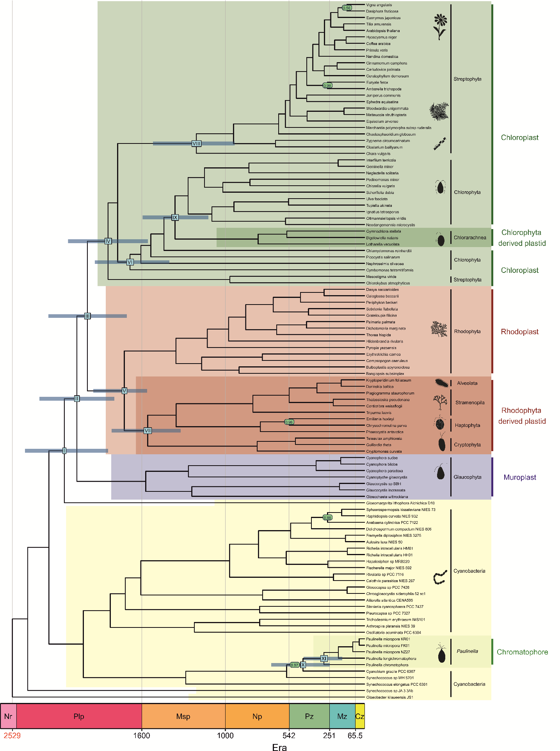
Figure A1. Time-calibrated phylogeny of photosynthetic organelles and cyanobacteria. The tree was inferred with MrBayes under IGR model [79] and calibrated with C3 (Table 1). The roman numerals in blue rectangles mark key evolutionary events for plastids discussed in the article. At these nodes, there are blue bars representing 95% credibility intervals of the node age. The nodes supported with posterior probability lower than one are indicated in green circles.
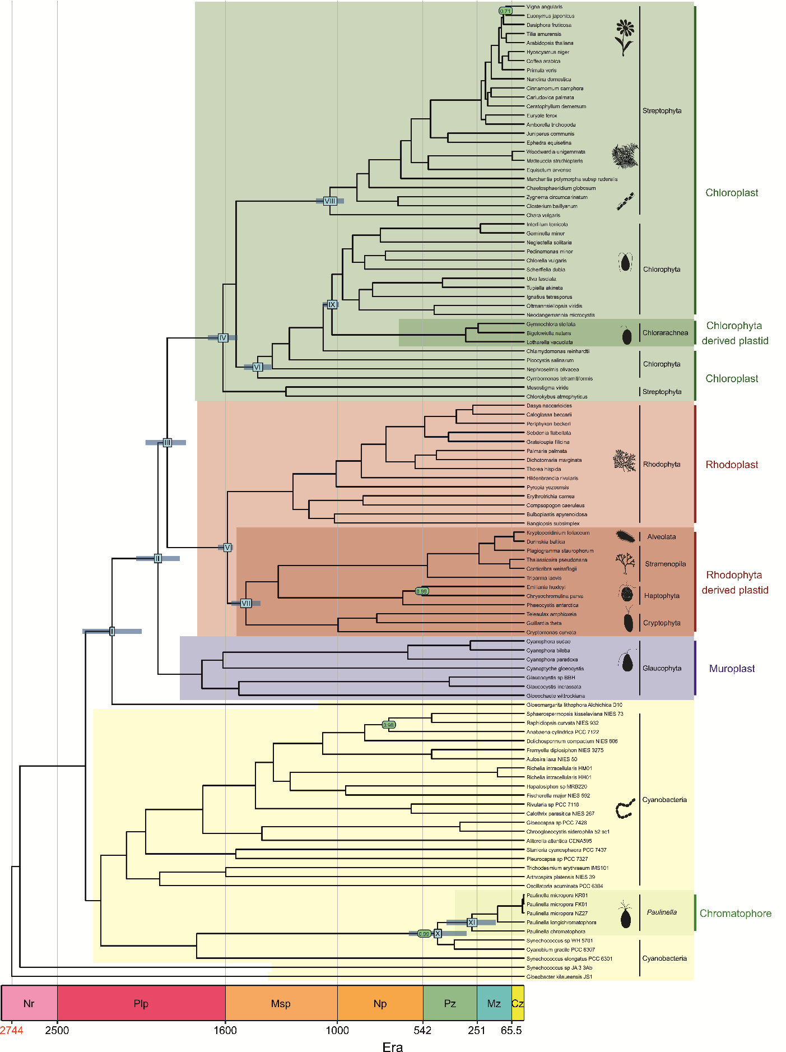Figure A2. Time-calibrated phylogeny of photosynthetic organelles and cyanobacteria. The tree was inferred with MrBayes under TK02 model [79] and calibrated with C3 (Table 1). Other description as in Figure A1.
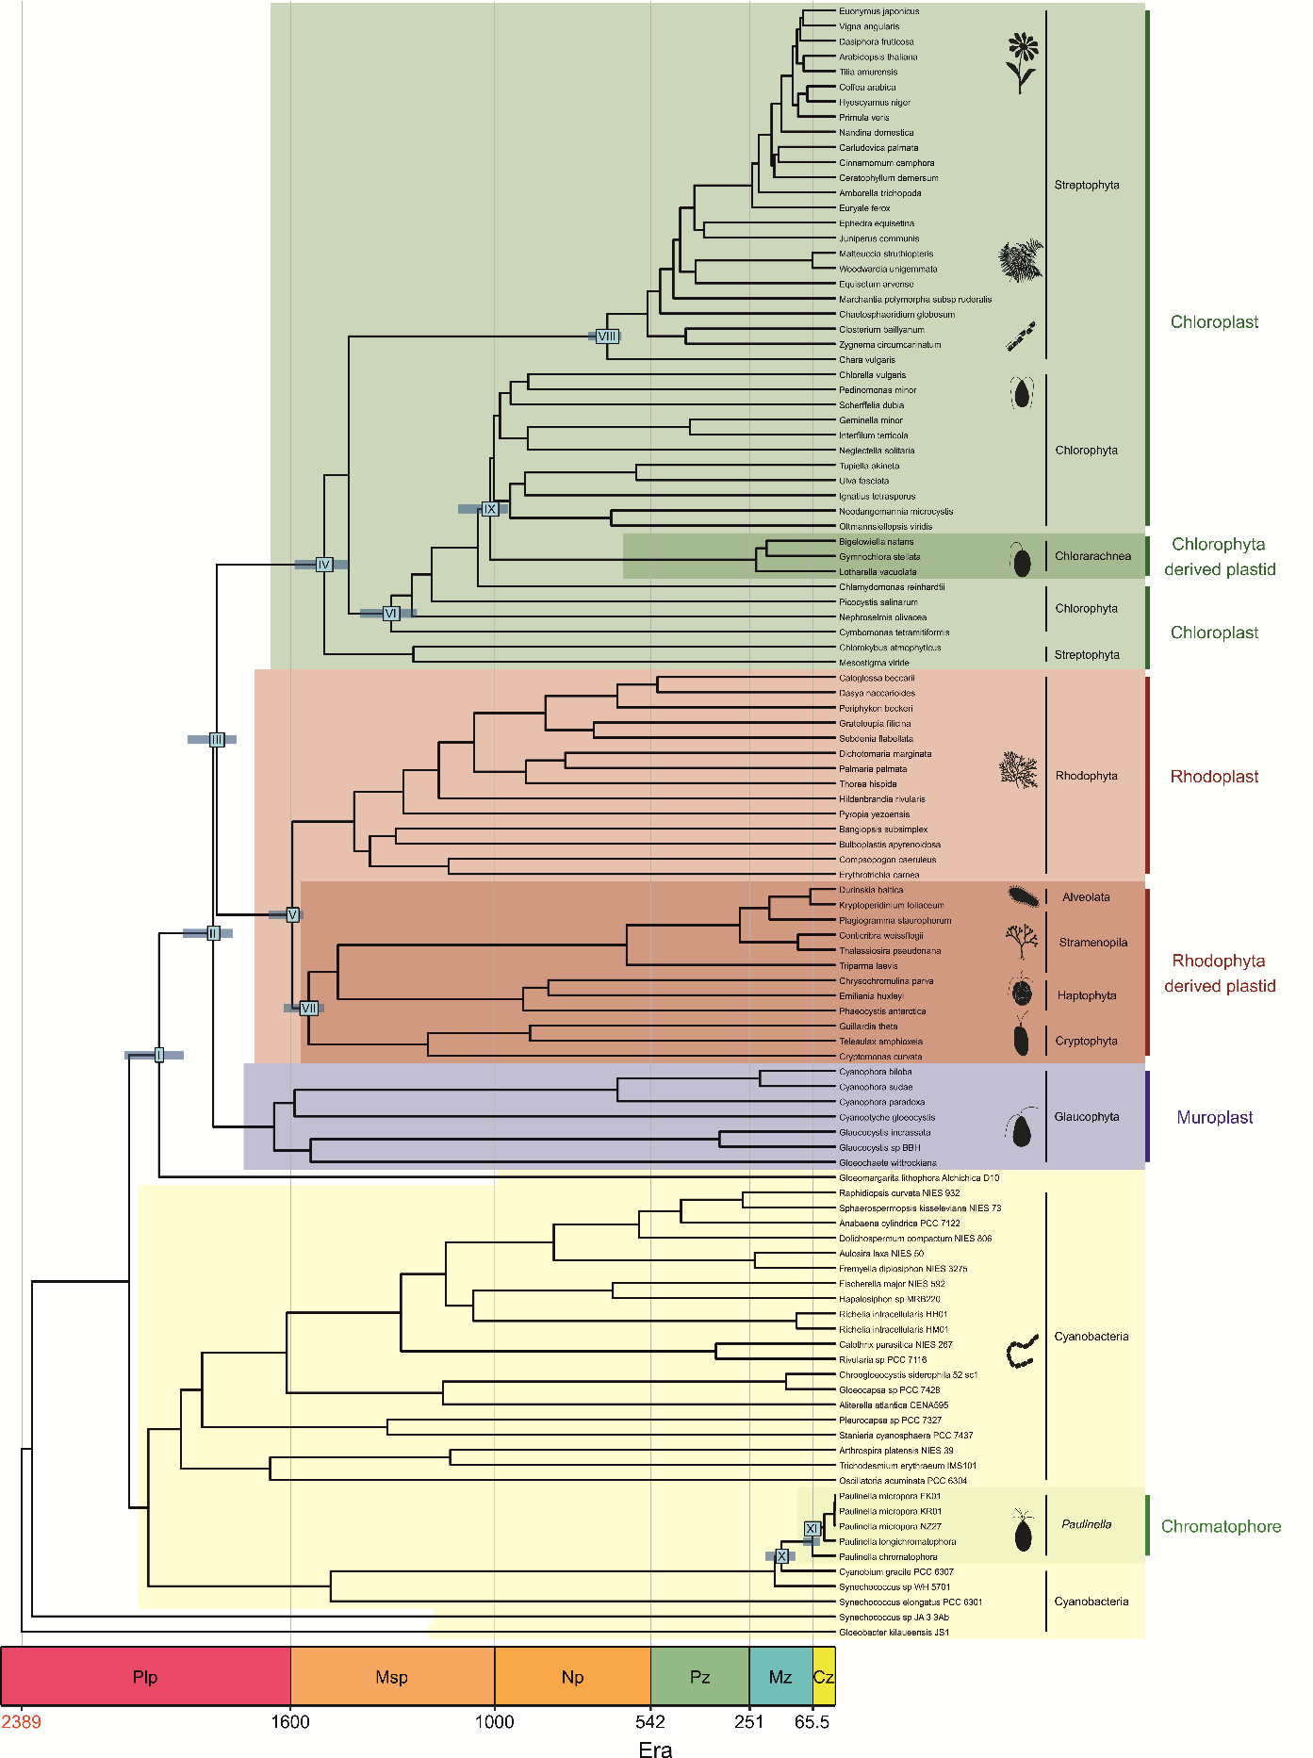
Figure A3. Time-calibrated phylogeny of photosynthetic organelles and cyanobacteria. The divergence times were inferred with Phylobayes under CIR model [115] and calibrated with C3 (Table 1). The tree topology was reconstructed in IQ-TREE [72]. Other description as in Figure A1.
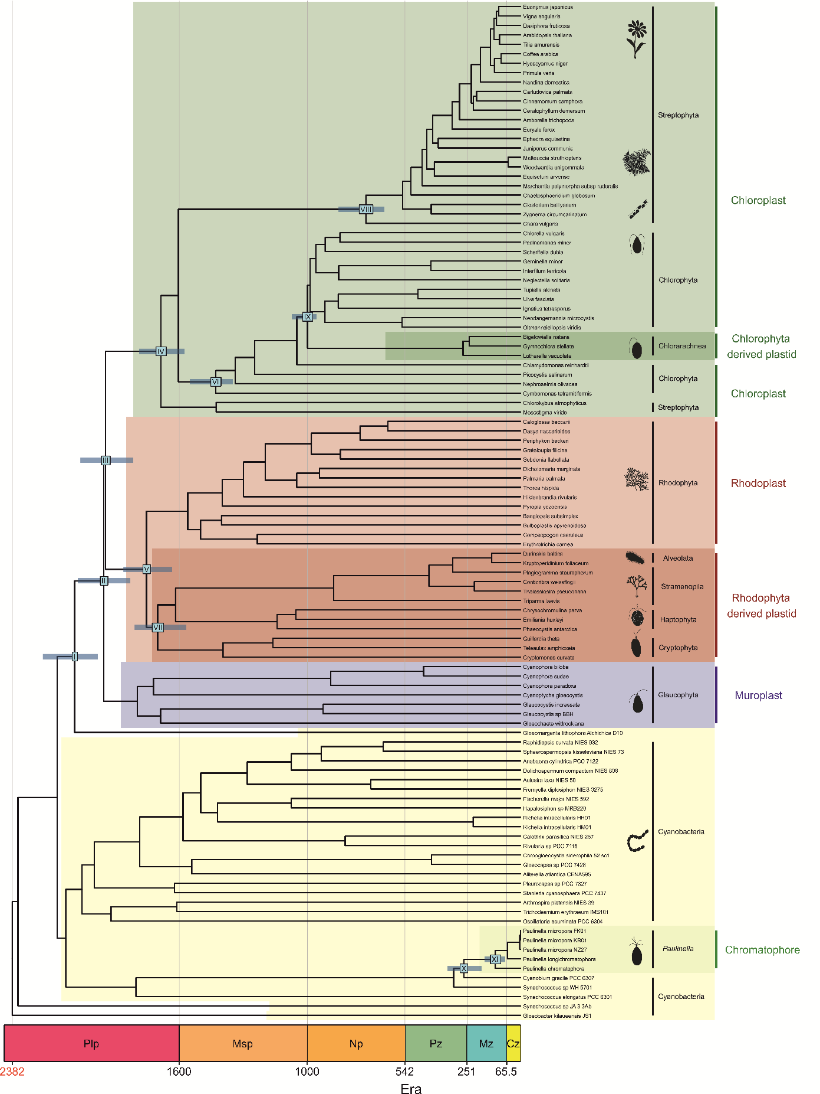
Figure A4. Time-calibrated phylogeny of photosynthetic organelles and cyanobacteria. The divergence times were inferred with Phylobayes under LN model [115] and calibrated with C3 (Table 1). The tree topology was reconstructed in IQ-TREE [72]. Other description as in Figure A1.
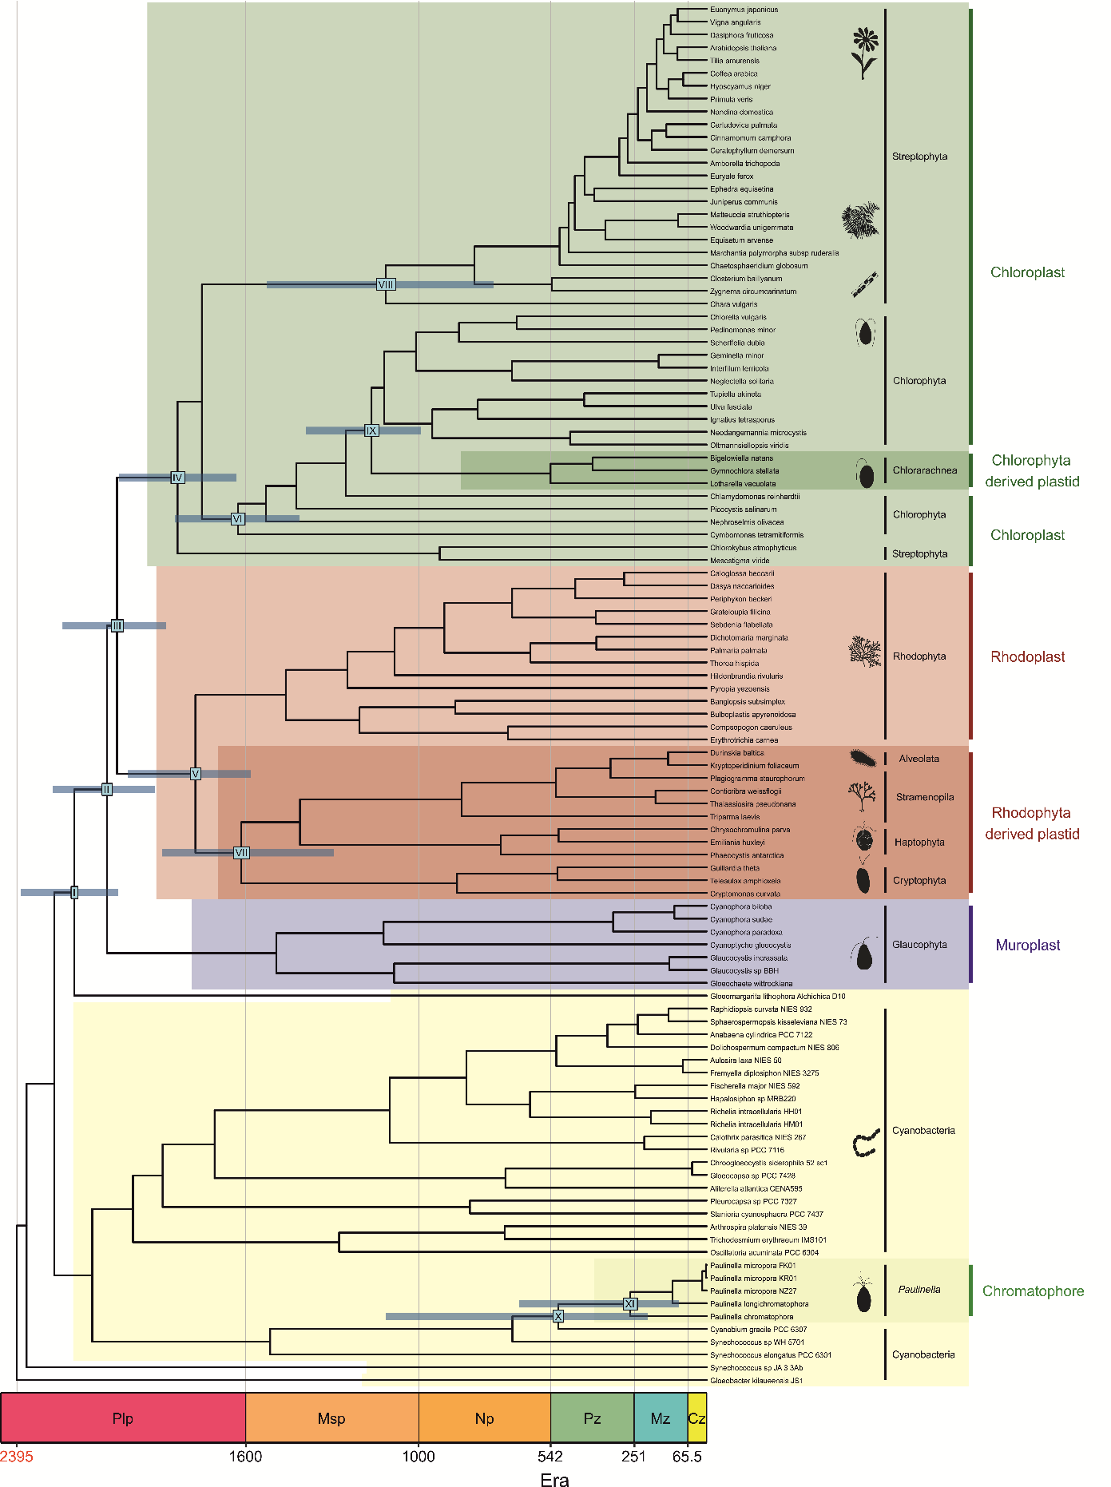Figure A5. Time-calibrated phylogeny of photosynthetic organelles and cyanobacteria. The divergence times were inferred with Phylobayes under UGAM model [115] and calibrated with C3 (Table 1). The tree topology was reconstructed in IQ-TREE [72]. Other description as in Figure A1.
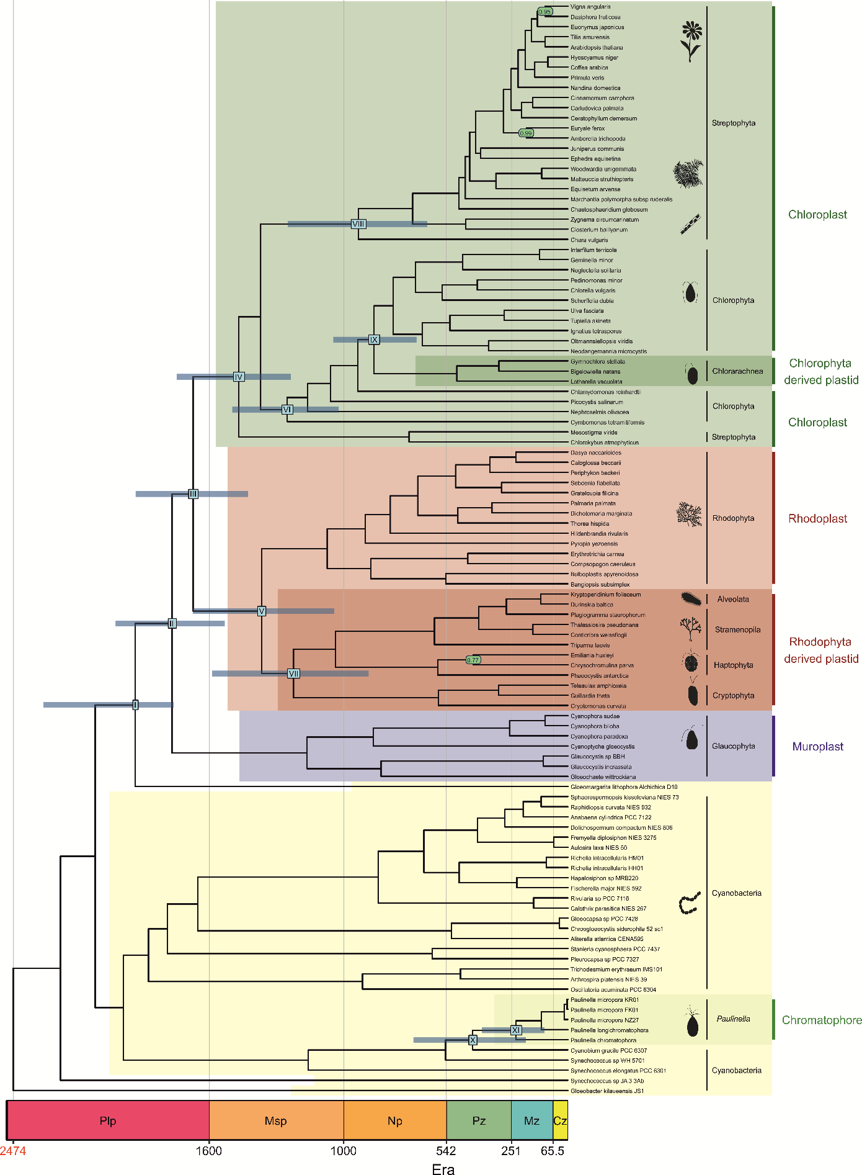Figure A6. Time-calibrated phylogeny of photosynthetic organelles and cyanobacteria. The tree was inferred with Beast under UCLNR model [80] and calibrated with C1 (Table 1). Other description as in Figure A1.
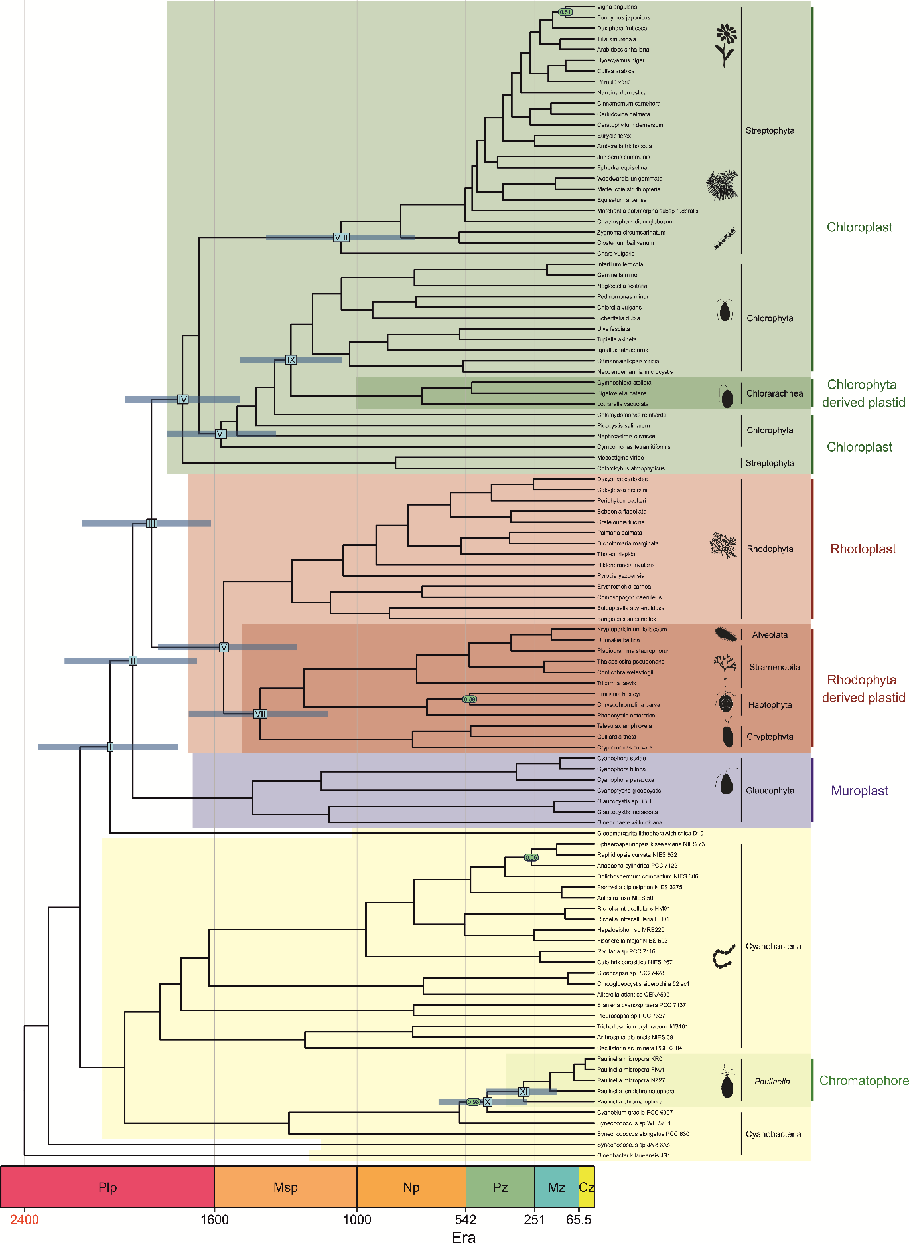Figure A7. Time-calibrated phylogeny of photosynthetic organelles and cyanobacteria. The tree was inferred with MrBayes under IGR model [79] and calibrated with C1 (Table 1). Other description as in Figure A1.
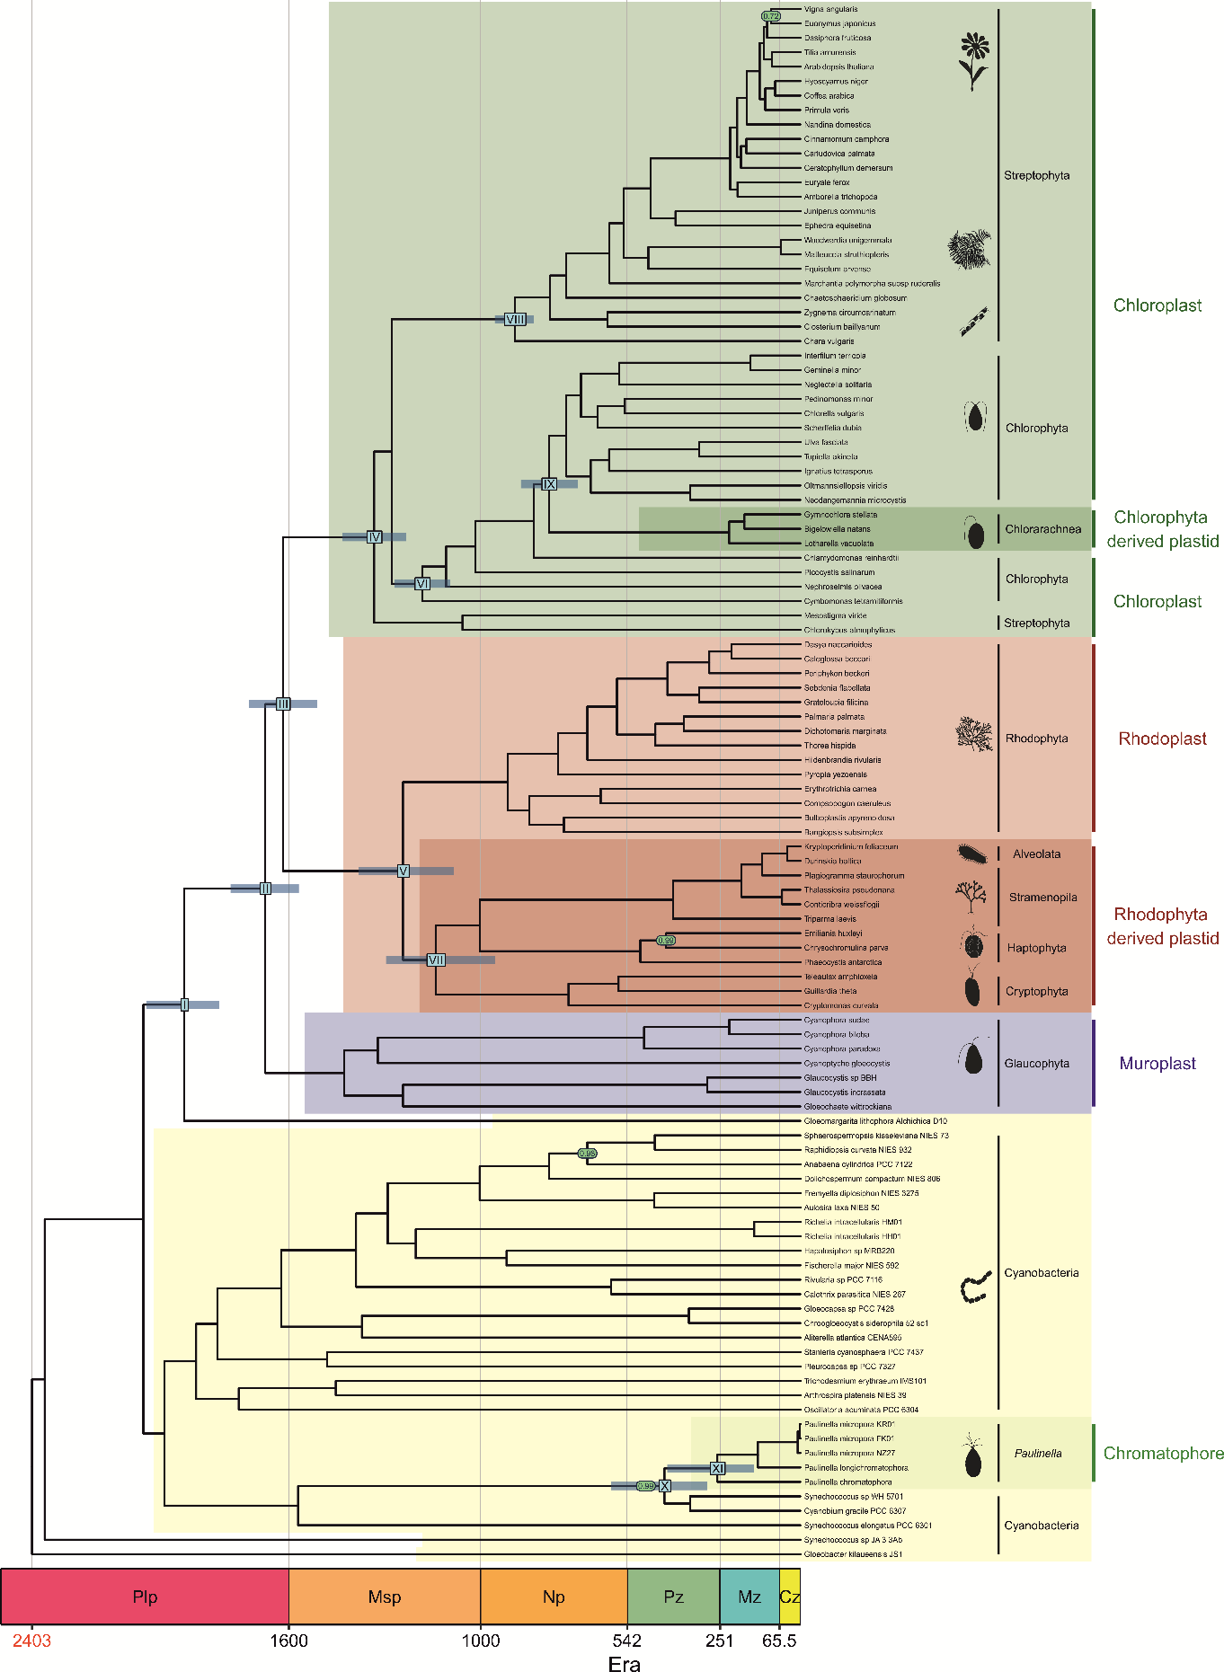Figure A8. Time-calibrated phylogeny of photosynthetic organelles and cyanobacteria. The tree was inferred with MrBayes under TK02 model [79] and calibrated with C1 (Table 1). Other description as in Figure A1.

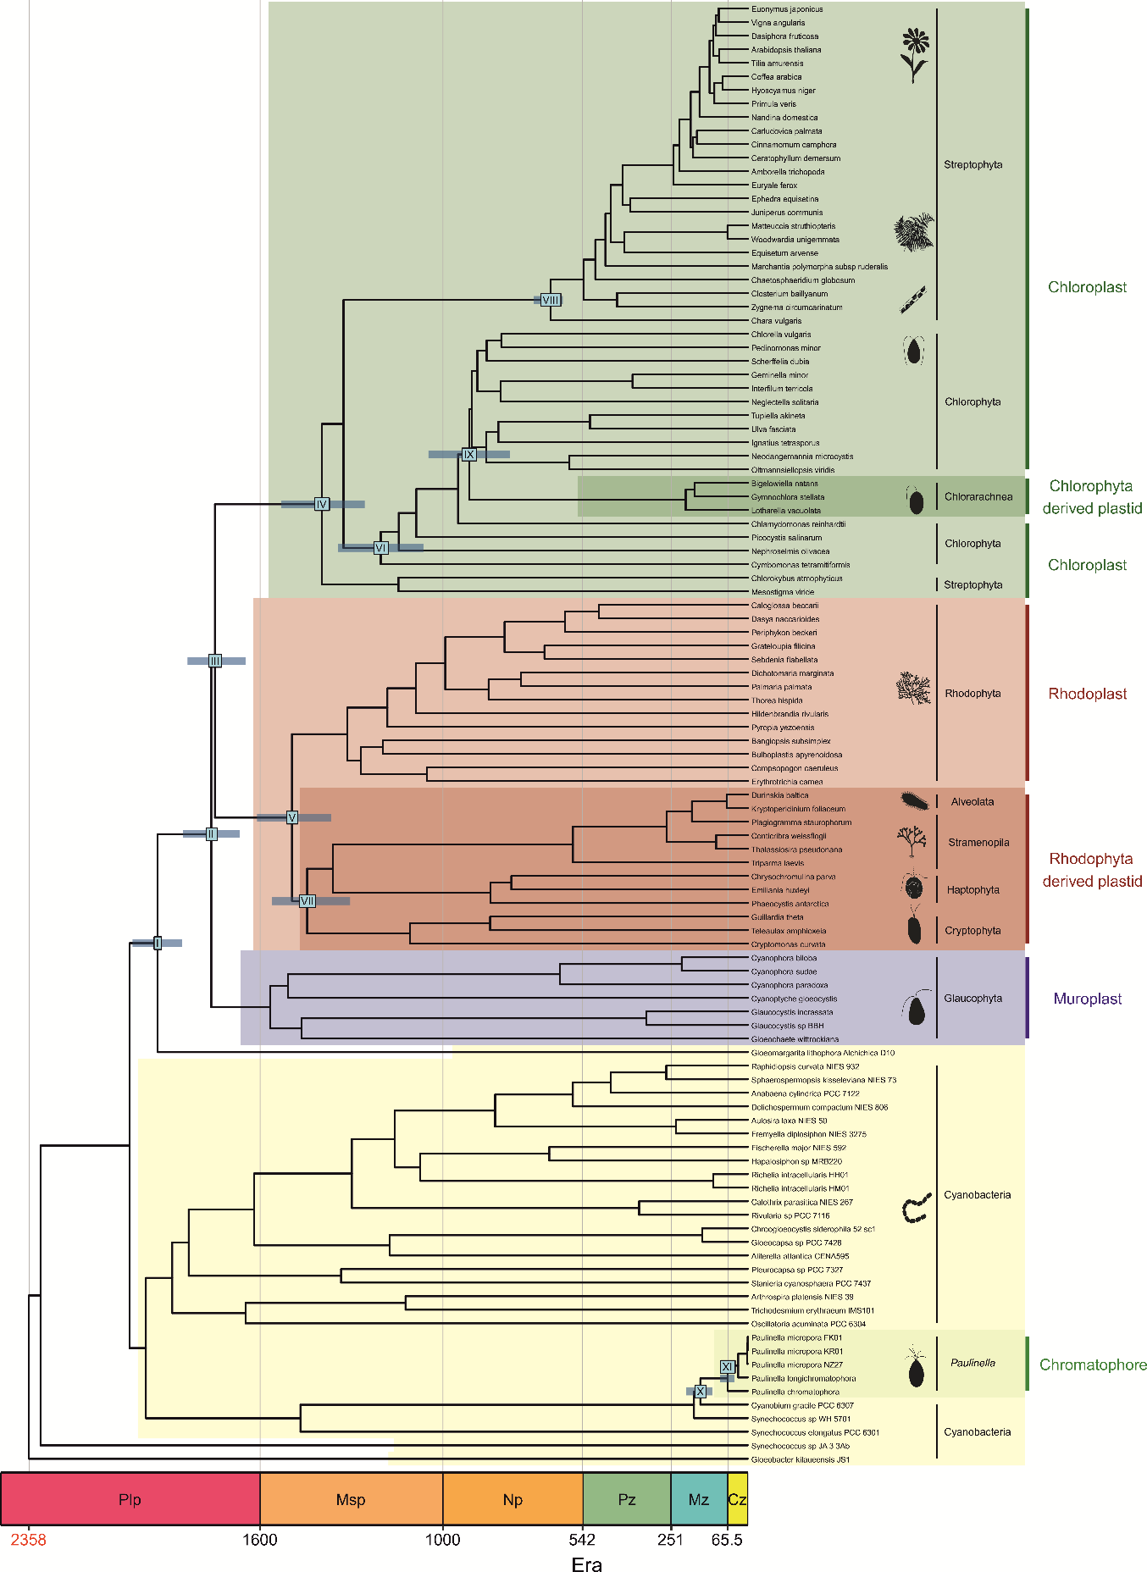Figure A9. Time-calibrated phylogeny of photosynthetic organelles and cyanobacteria. The divergence times were inferred with Phylobayes under CIR model [115] and calibrated with C1 (Table 1). The tree topology was reconstructed in IQ-TREE [72]. Other description as in Figure A1.
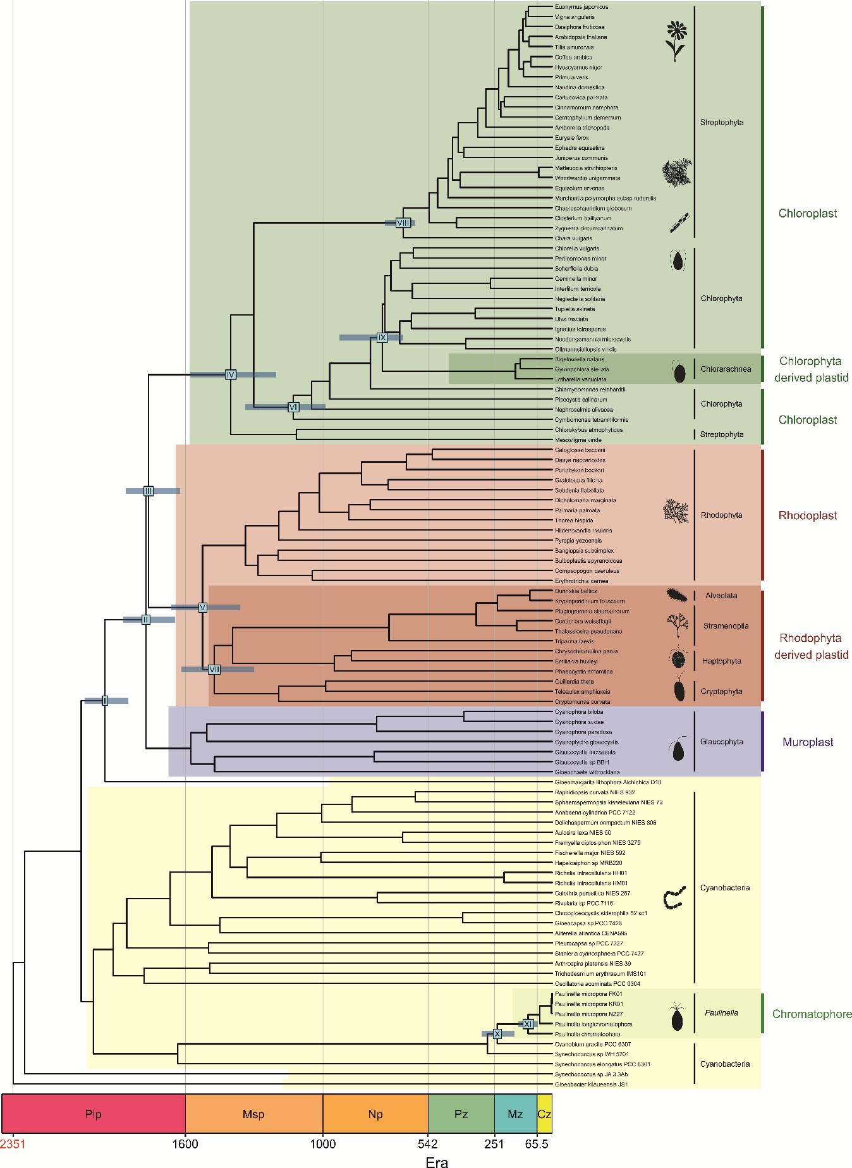
Figure A10. Time-calibrated phylogeny of photosynthetic organelles and cyanobacteria. The divergence times were inferred with Phylobayes under LN model [115] and calibrated with C1 (Table 1). The tree topology was reconstructed in IQ-TREE [72]. Other description as in Figure A1.
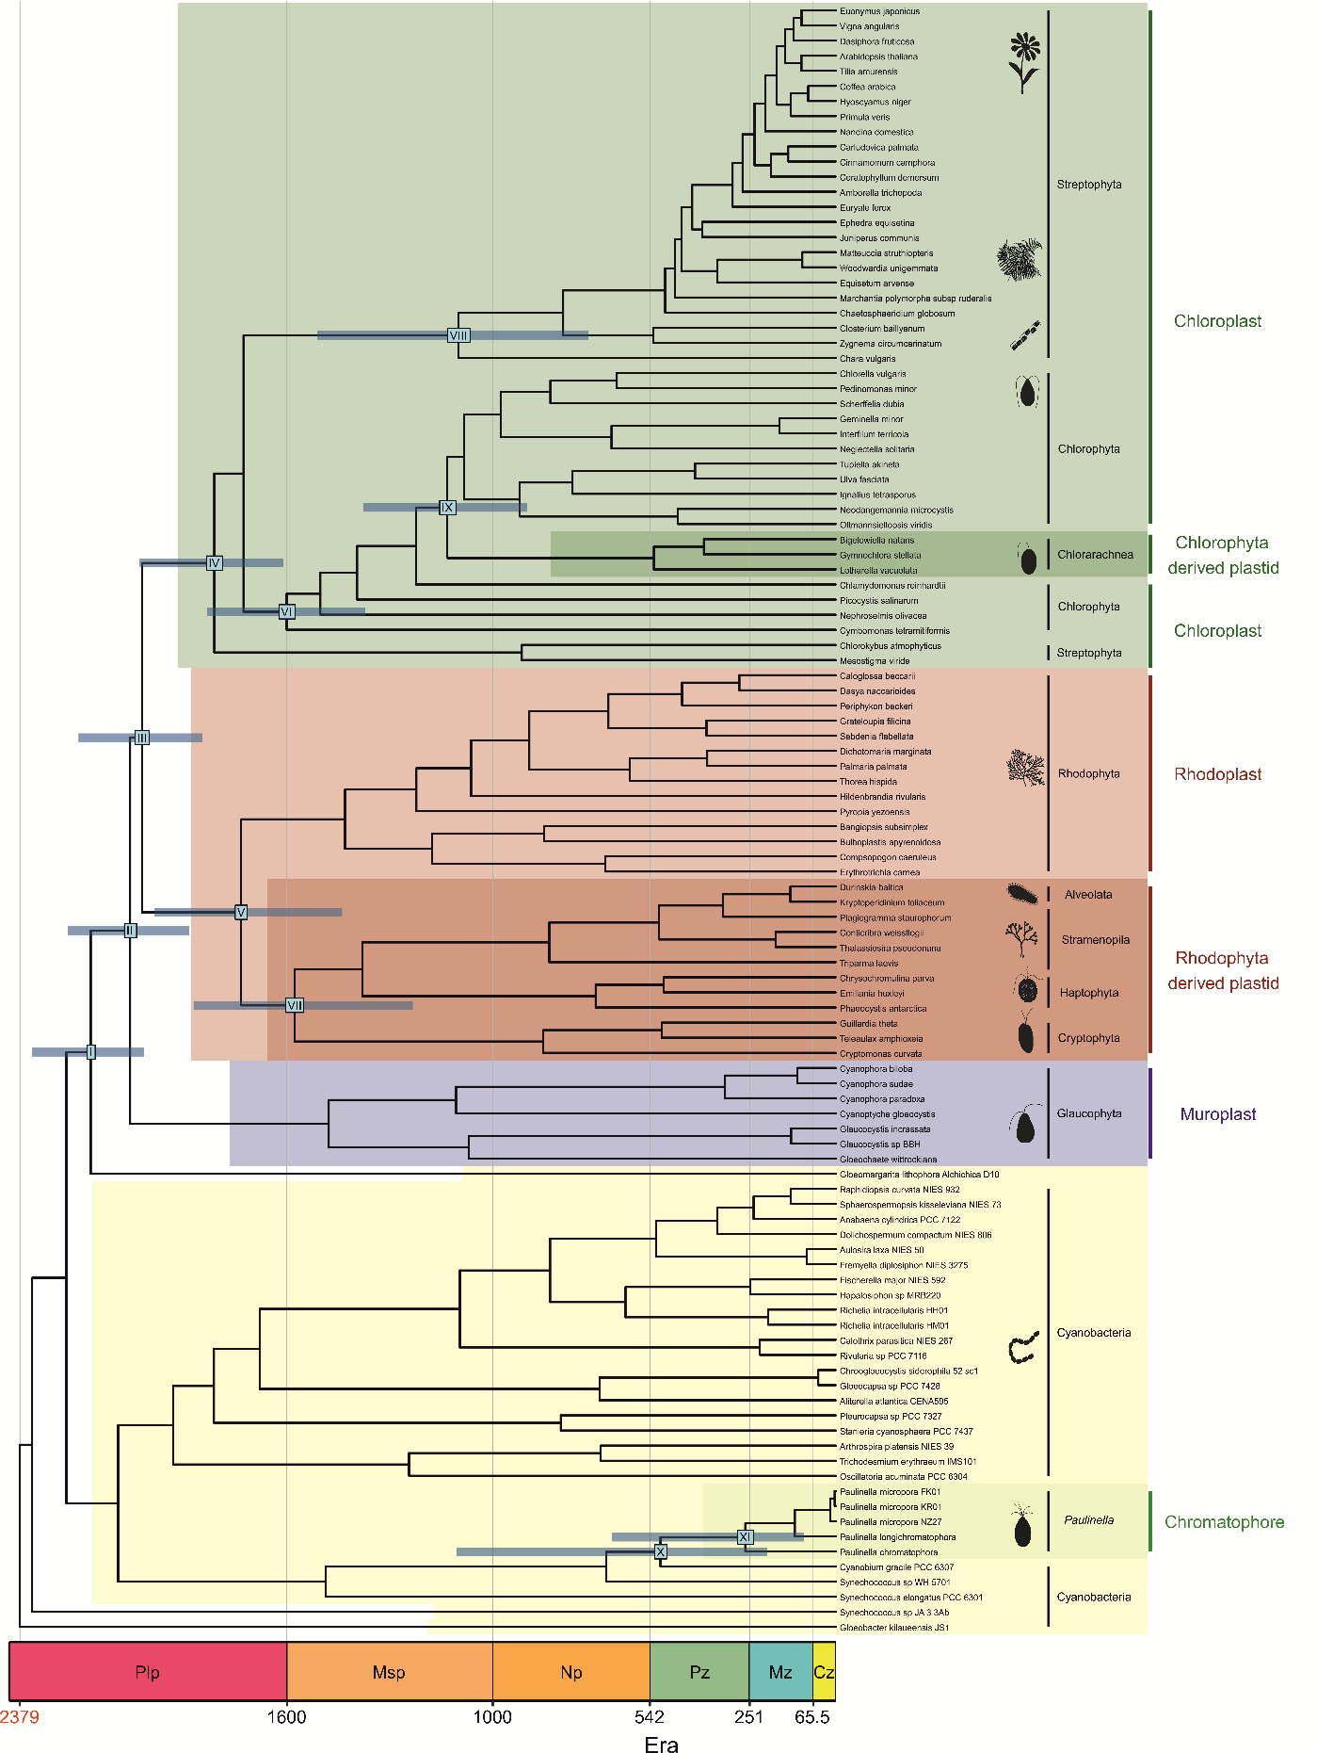Figure A11. Time-calibrated phylogeny of photosynthetic organelles and cyanobacteria. The divergence times were inferred with Phylobayes under UGAM model [115] and calibrated with C1 (Table 1). The tree topology was reconstructed in IQ-TREE [72]. Other description as in Figure A1.
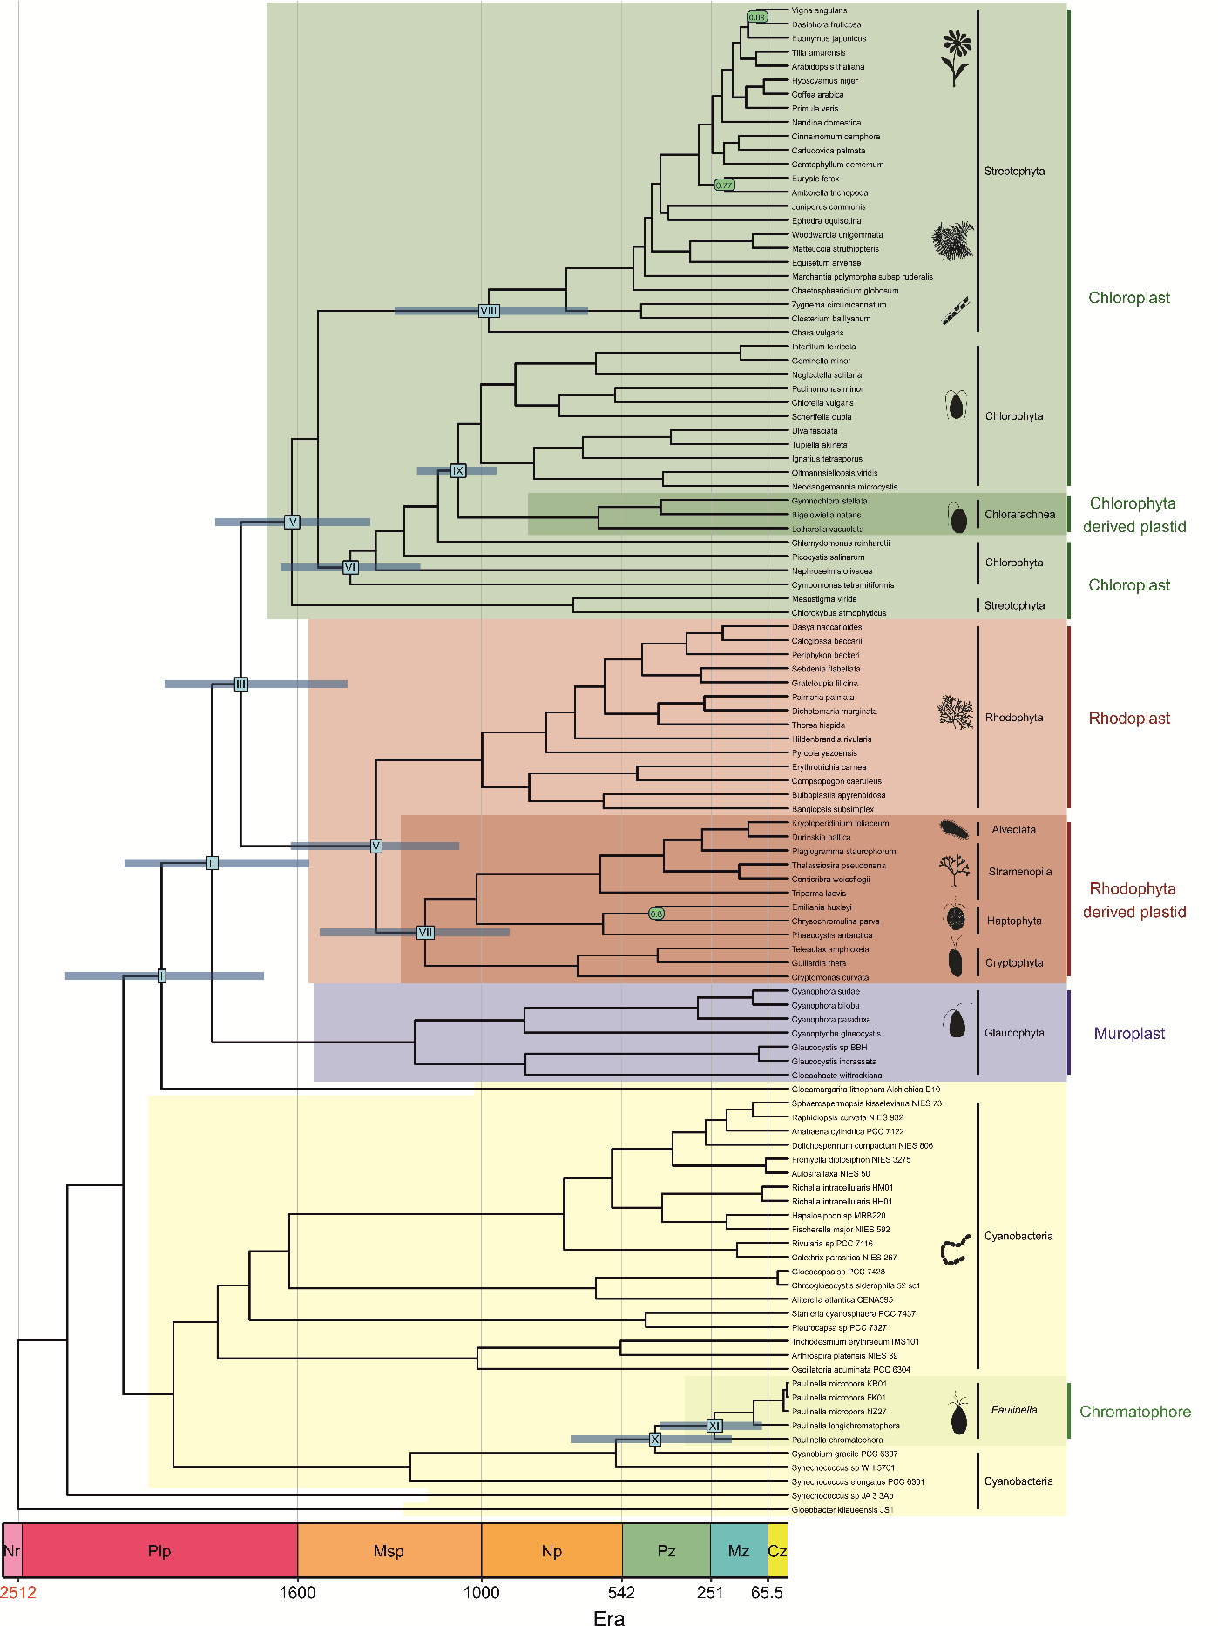Figure A12. Time-calibrated phylogeny of photosynthetic organelles and cyanobacteria. The tree was inferred with Beast under UCLNR model [80] and calibrated with C2 (Table 1). Other description as in Figure A1.
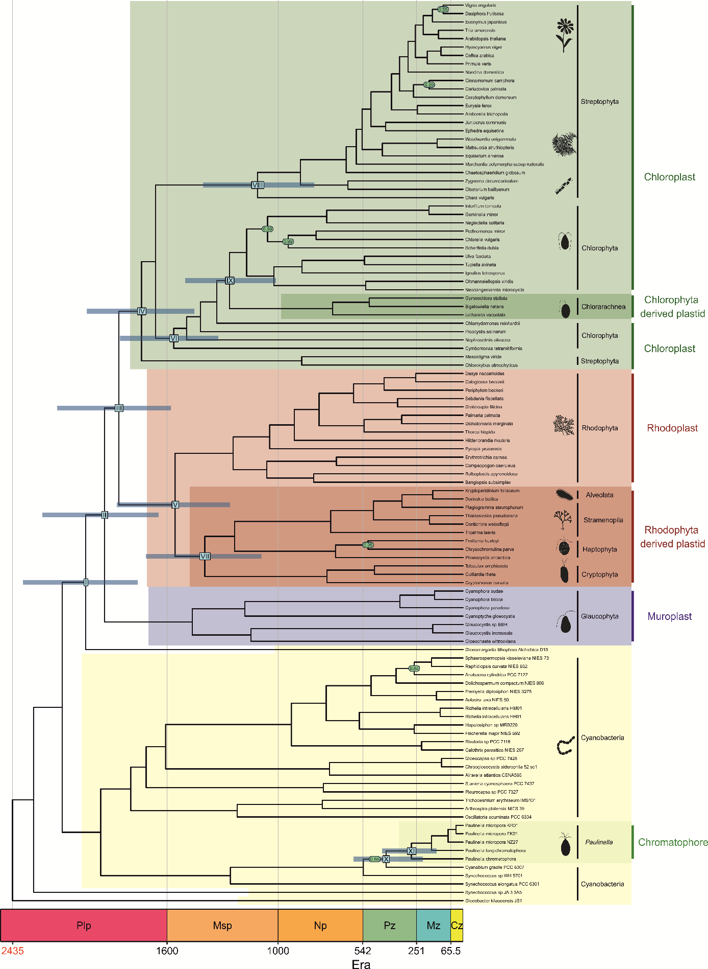Figure A13. Time-calibrated phylogeny of photosynthetic organelles and cyanobacteria. The tree was inferred with MrBayes under IGR model [79] and calibrated with C2 (Table 1). Other description as in Figure A1.
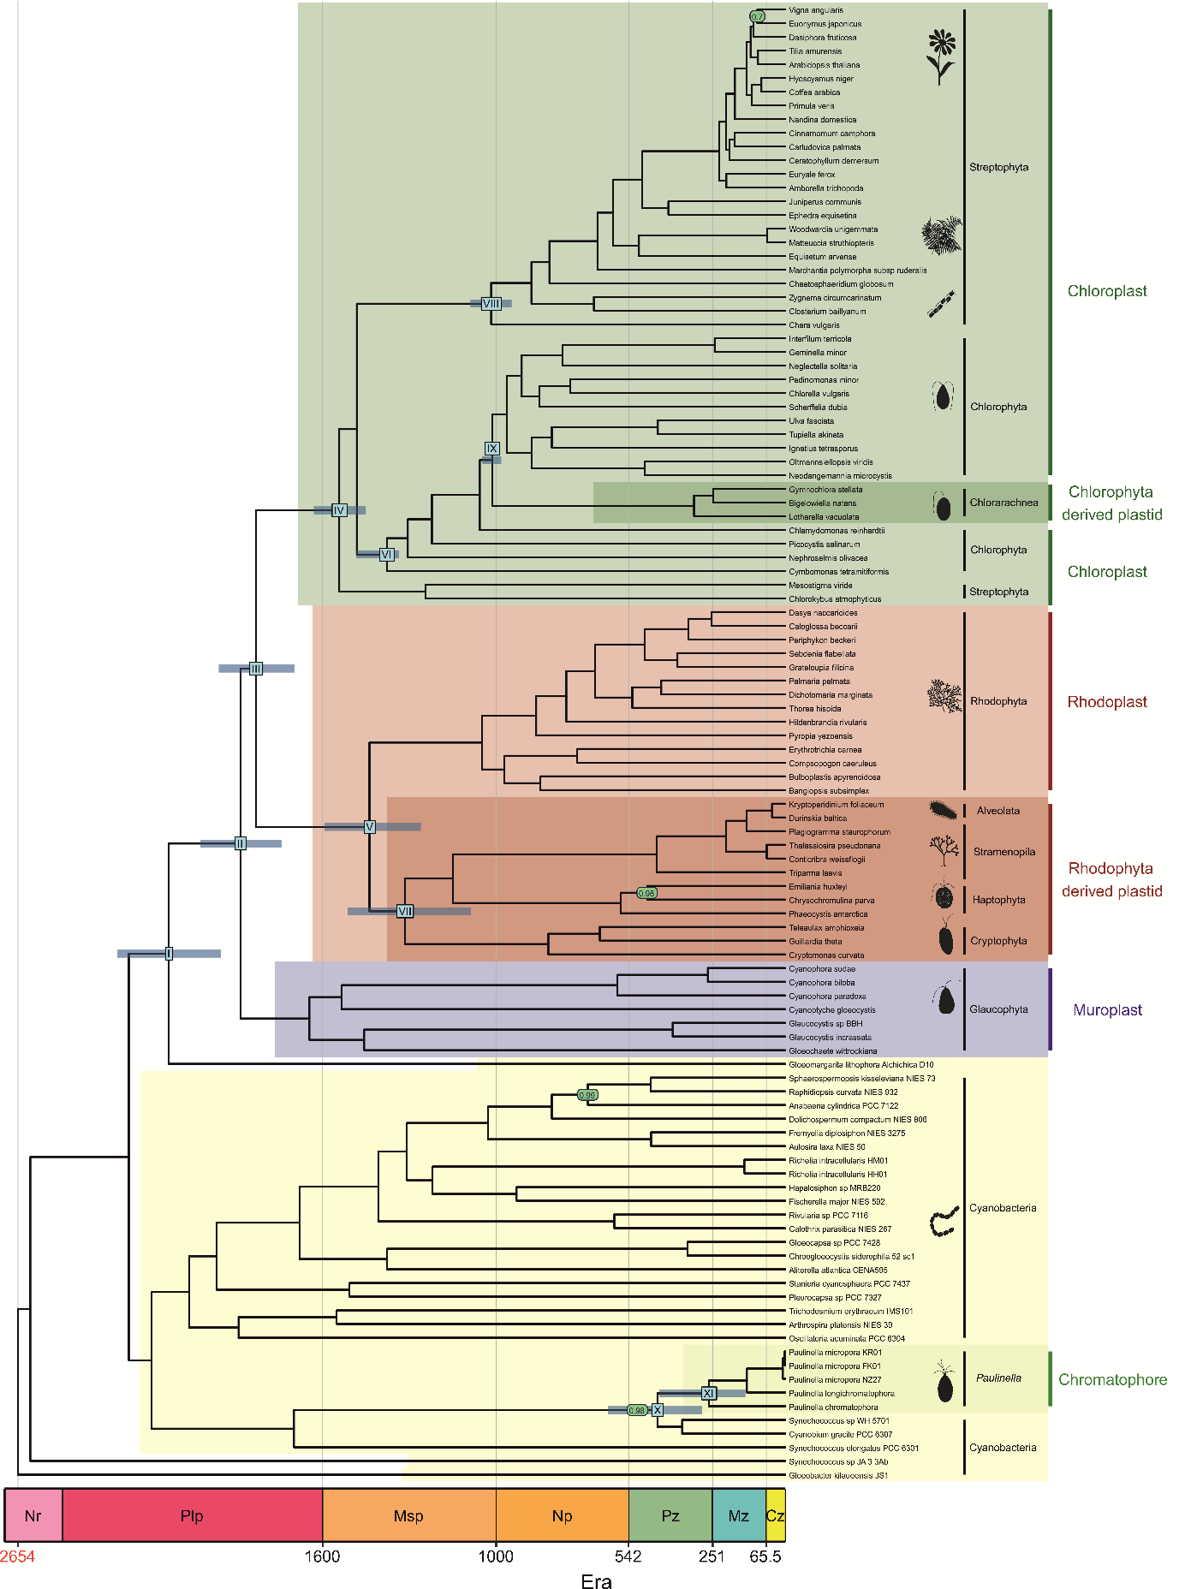Figure S14. Time-calibrated phylogeny of photosynthetic organelles and cyanobacteria. The tree was inferred with MrBayes under TK02 model [79] and calibrated with C2 (Table 1). Other description as in Figure A1.

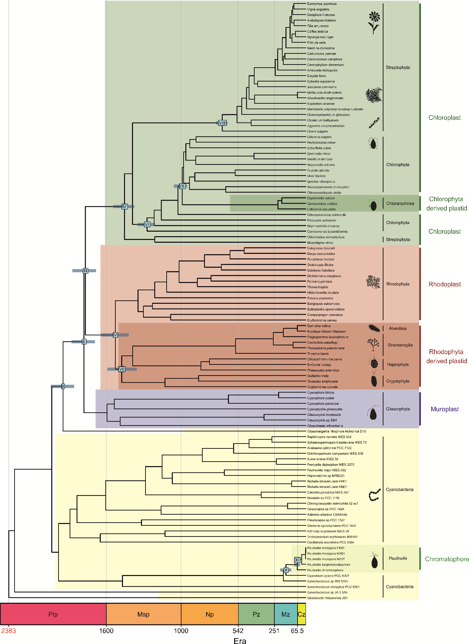
Figure A15. Time-calibrated phylogeny of photosynthetic organelles and cyanobacteria. The divergence times were inferred with Phylobayes under CIR model [115] and calibrated with C2 (Table 1). The tree topology was reconstructed in IQ-TREE [72]. Other description as in Figure A1.
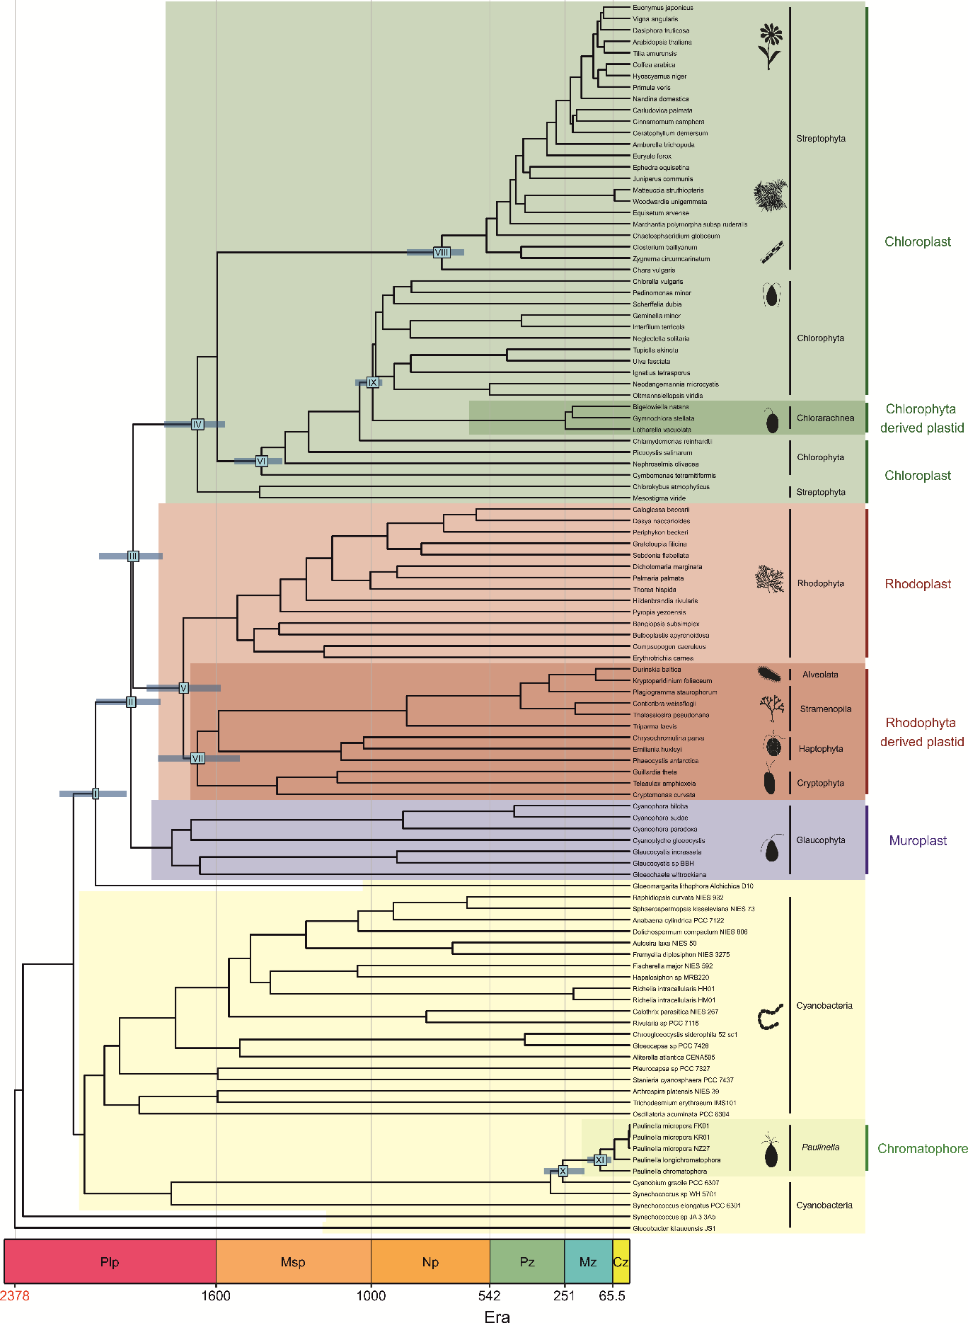
Figure A16. Time-calibrated phylogeny of photosynthetic organelles and cyanobacteria. The divergence times were inferred with Phylobayes under LN model [115] and calibrated with C2 (Table 1). The tree topology was reconstructed in IQ-TREE. Other description as in Figure A1..
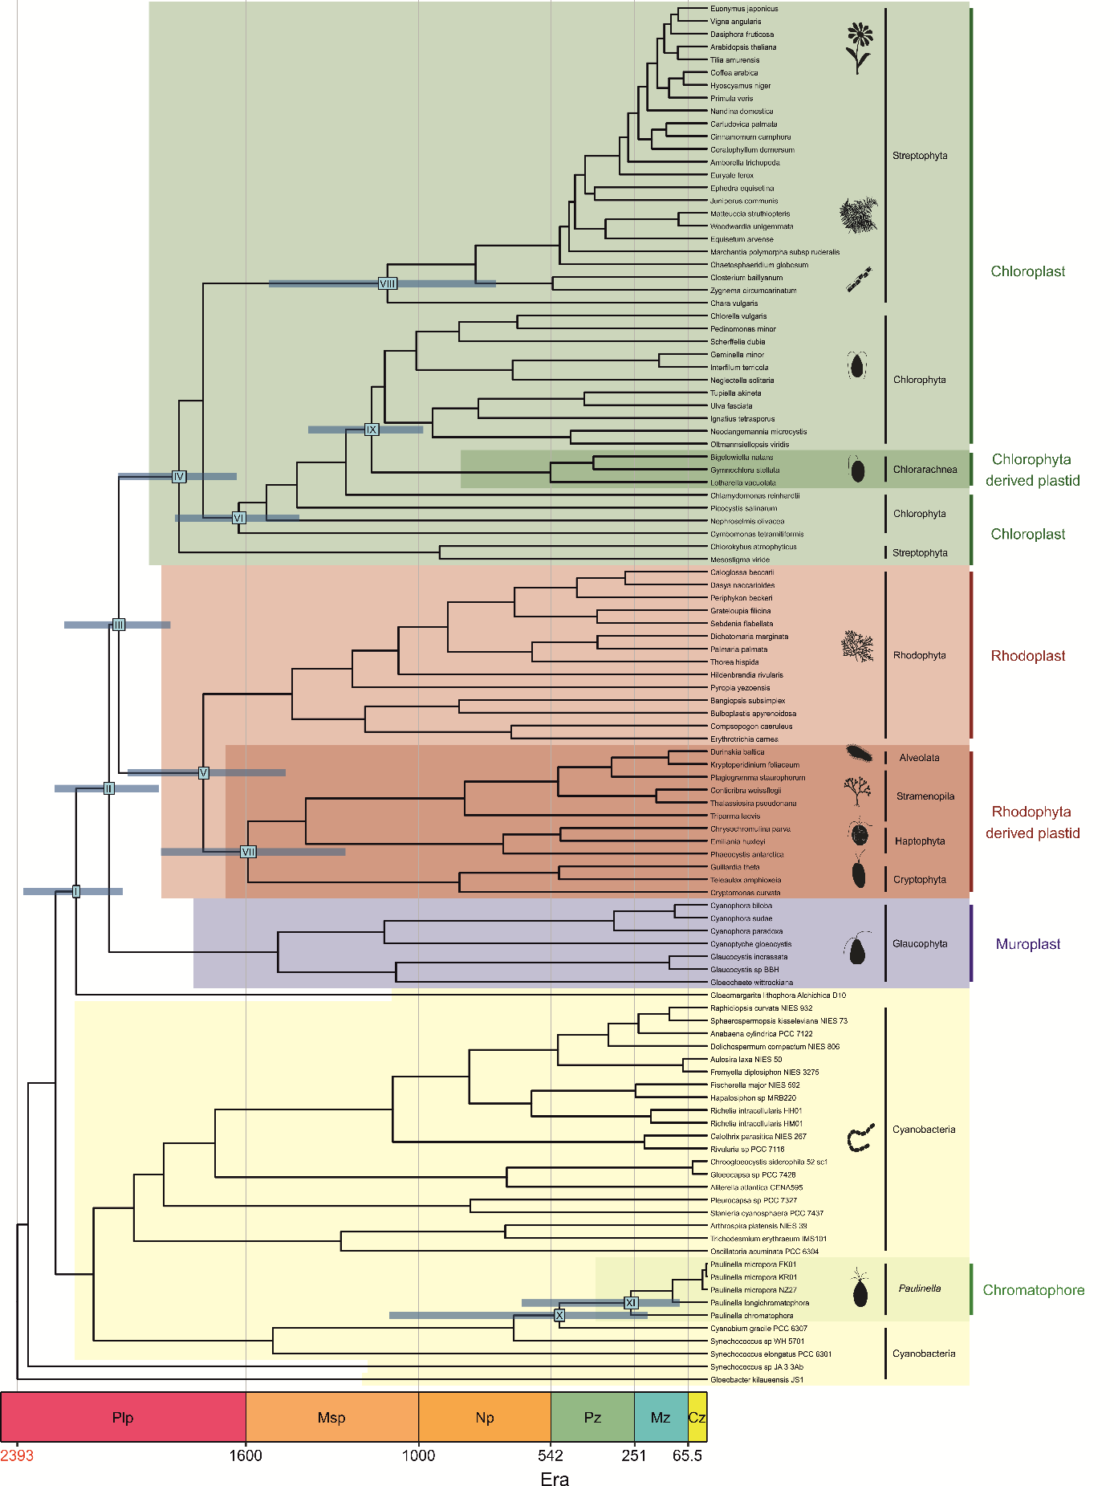Figure A17. Time-calibrated phylogeny of photosynthetic organelles and cyanobacteria. The divergence times were inferred with Phylobayes under UGAM model [115] and calibrated with C2 (Table 1). The tree topology was reconstructed in IQ-TREE [72]. Other description as in Figure A1.
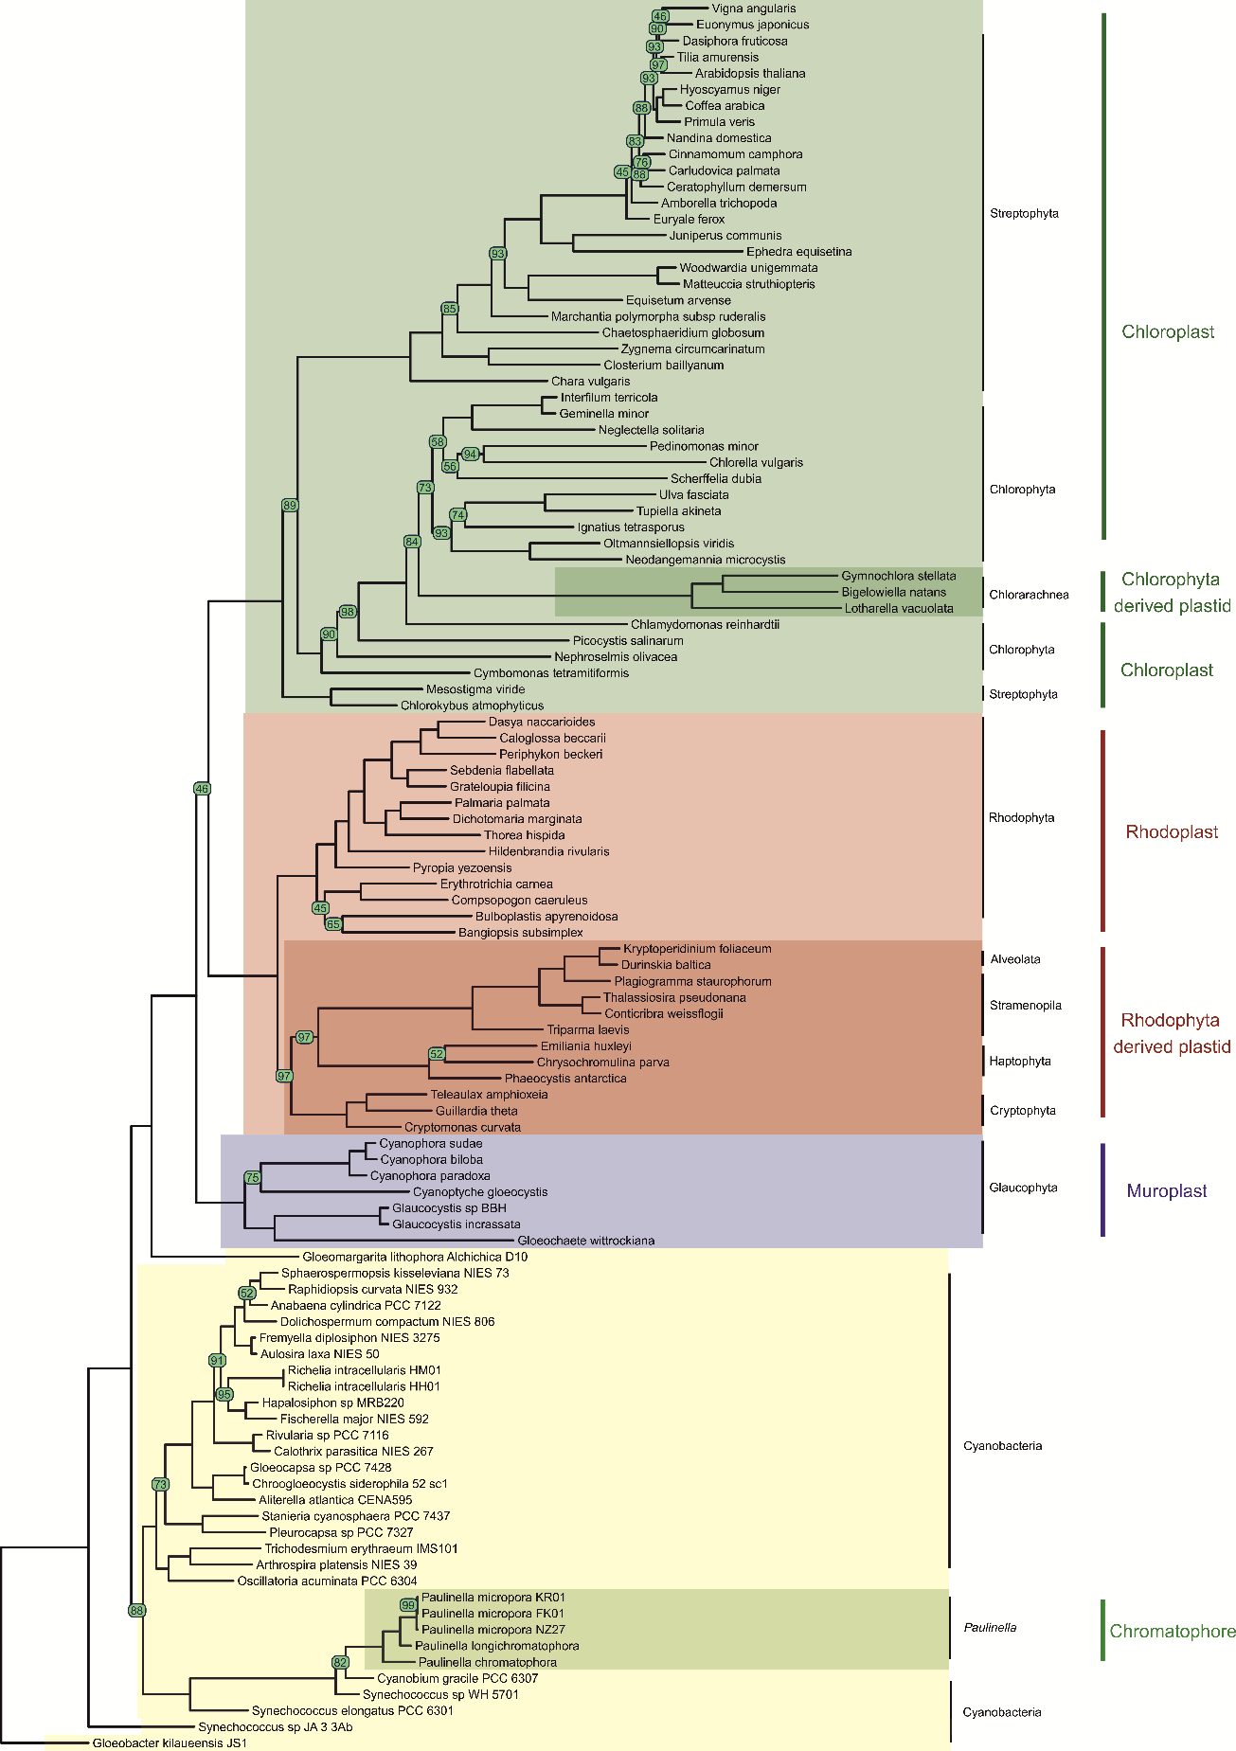
Figure A18. The phylogeny of photosynthetic organelles and cyanobacteria. The tree topology was reconstructed in IQ-TREE [72]. The nodes supported with bootstrap values lower than 100 are indicated in green circles.
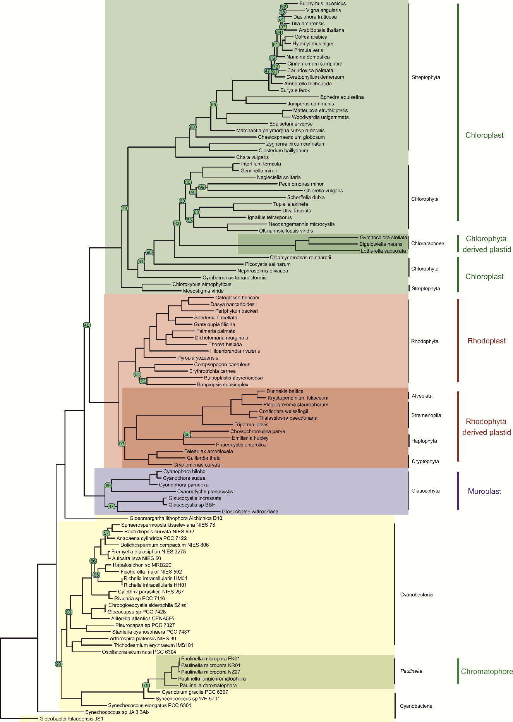
Figure A19. The phylogeny of photosynthetic organelles and cyanobacteria. The tree topology was reconstructed in RAxML [77]. The nodes supported with bootstrap values lower than 100 are indicated in green circles.

Figure A20. Pairwise comparisons of the calibration sets C1, C2 and C3 (Table 1). The x and y-axis represent ages in million years. The circles are individual age estimations for a node with a given molecular clock and calibration set.

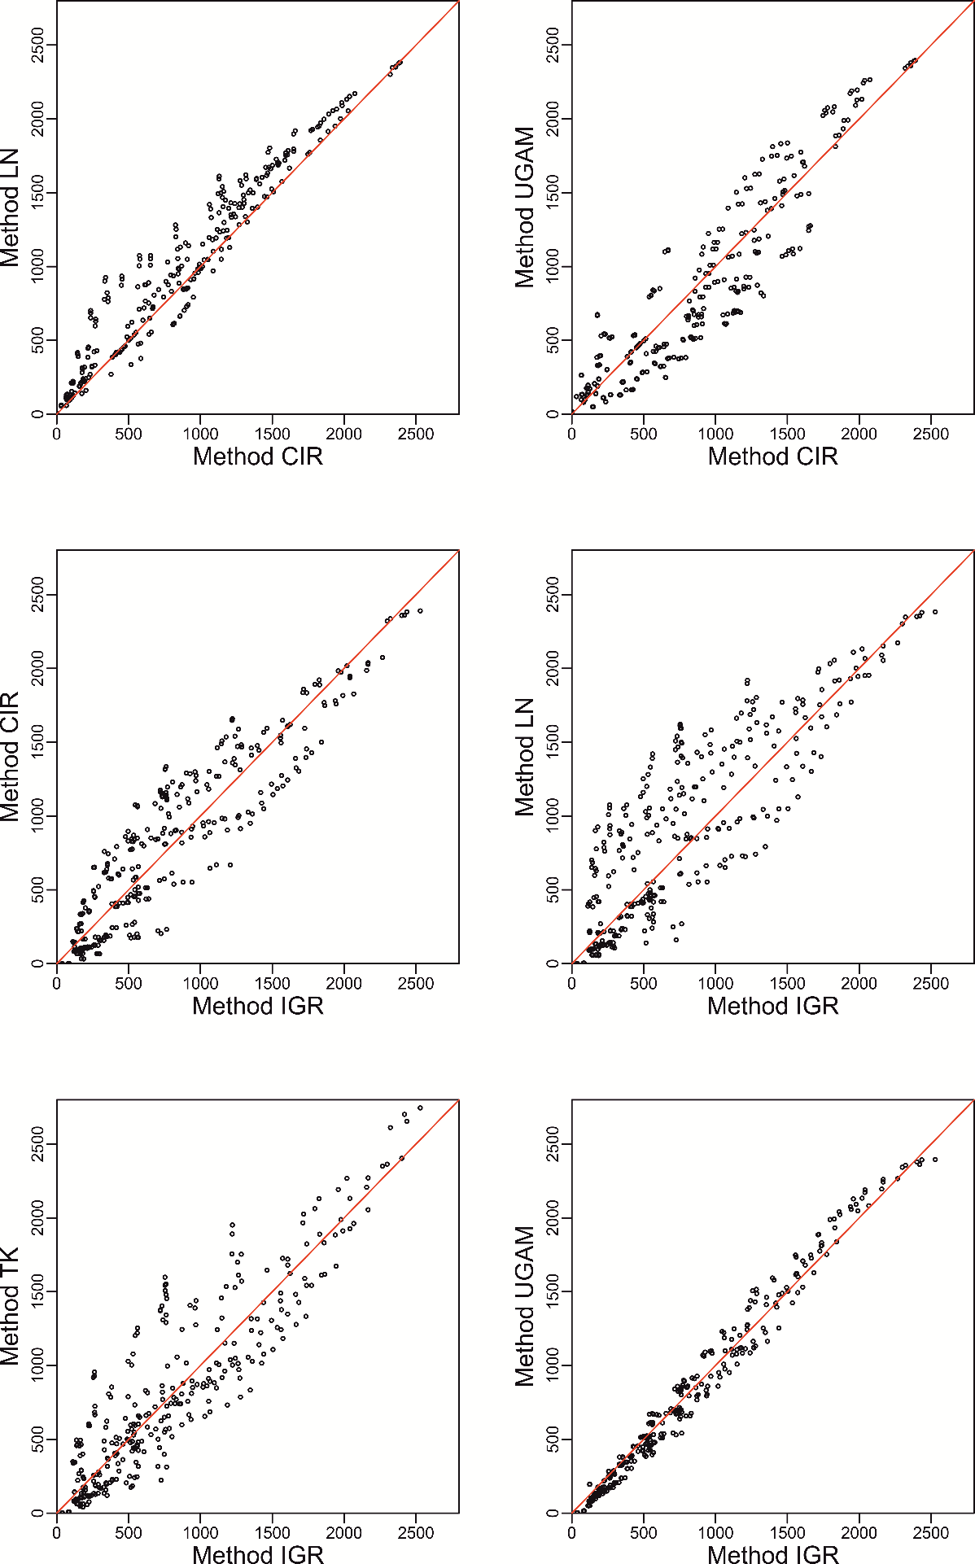

(

Figure A21. Caption on the next page.)
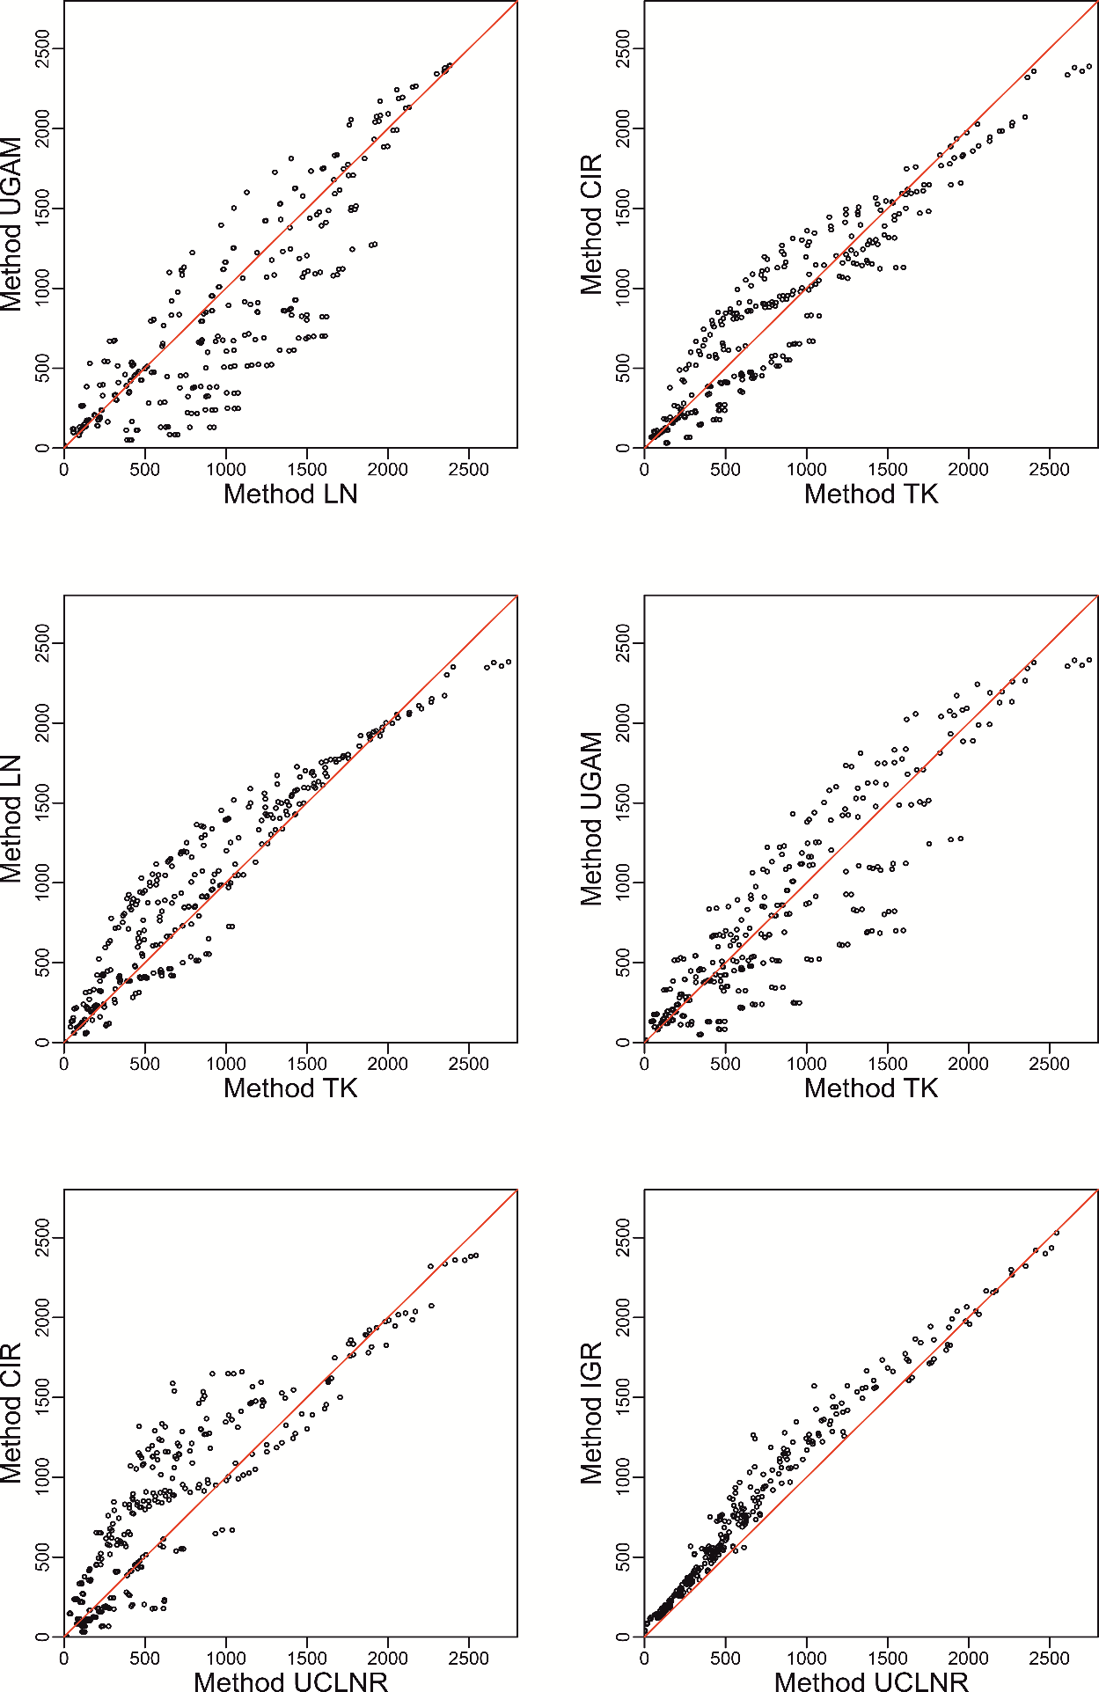

(Figure A21. Caption on the next page.)

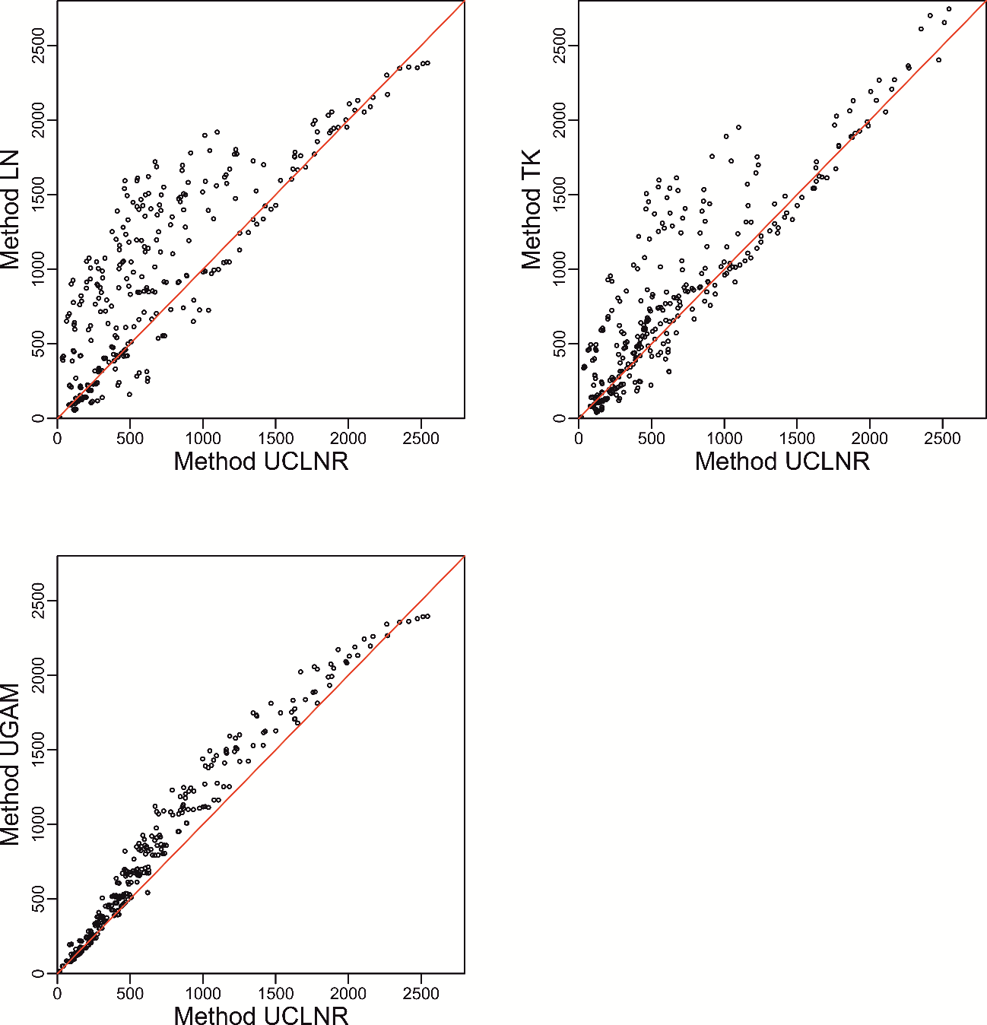

Figure A21. Pairwise comparison between the clocks. The x and y-axis represent ages in million years. The circles are individual age estimations for a node with a given molecular clock and calibration set.

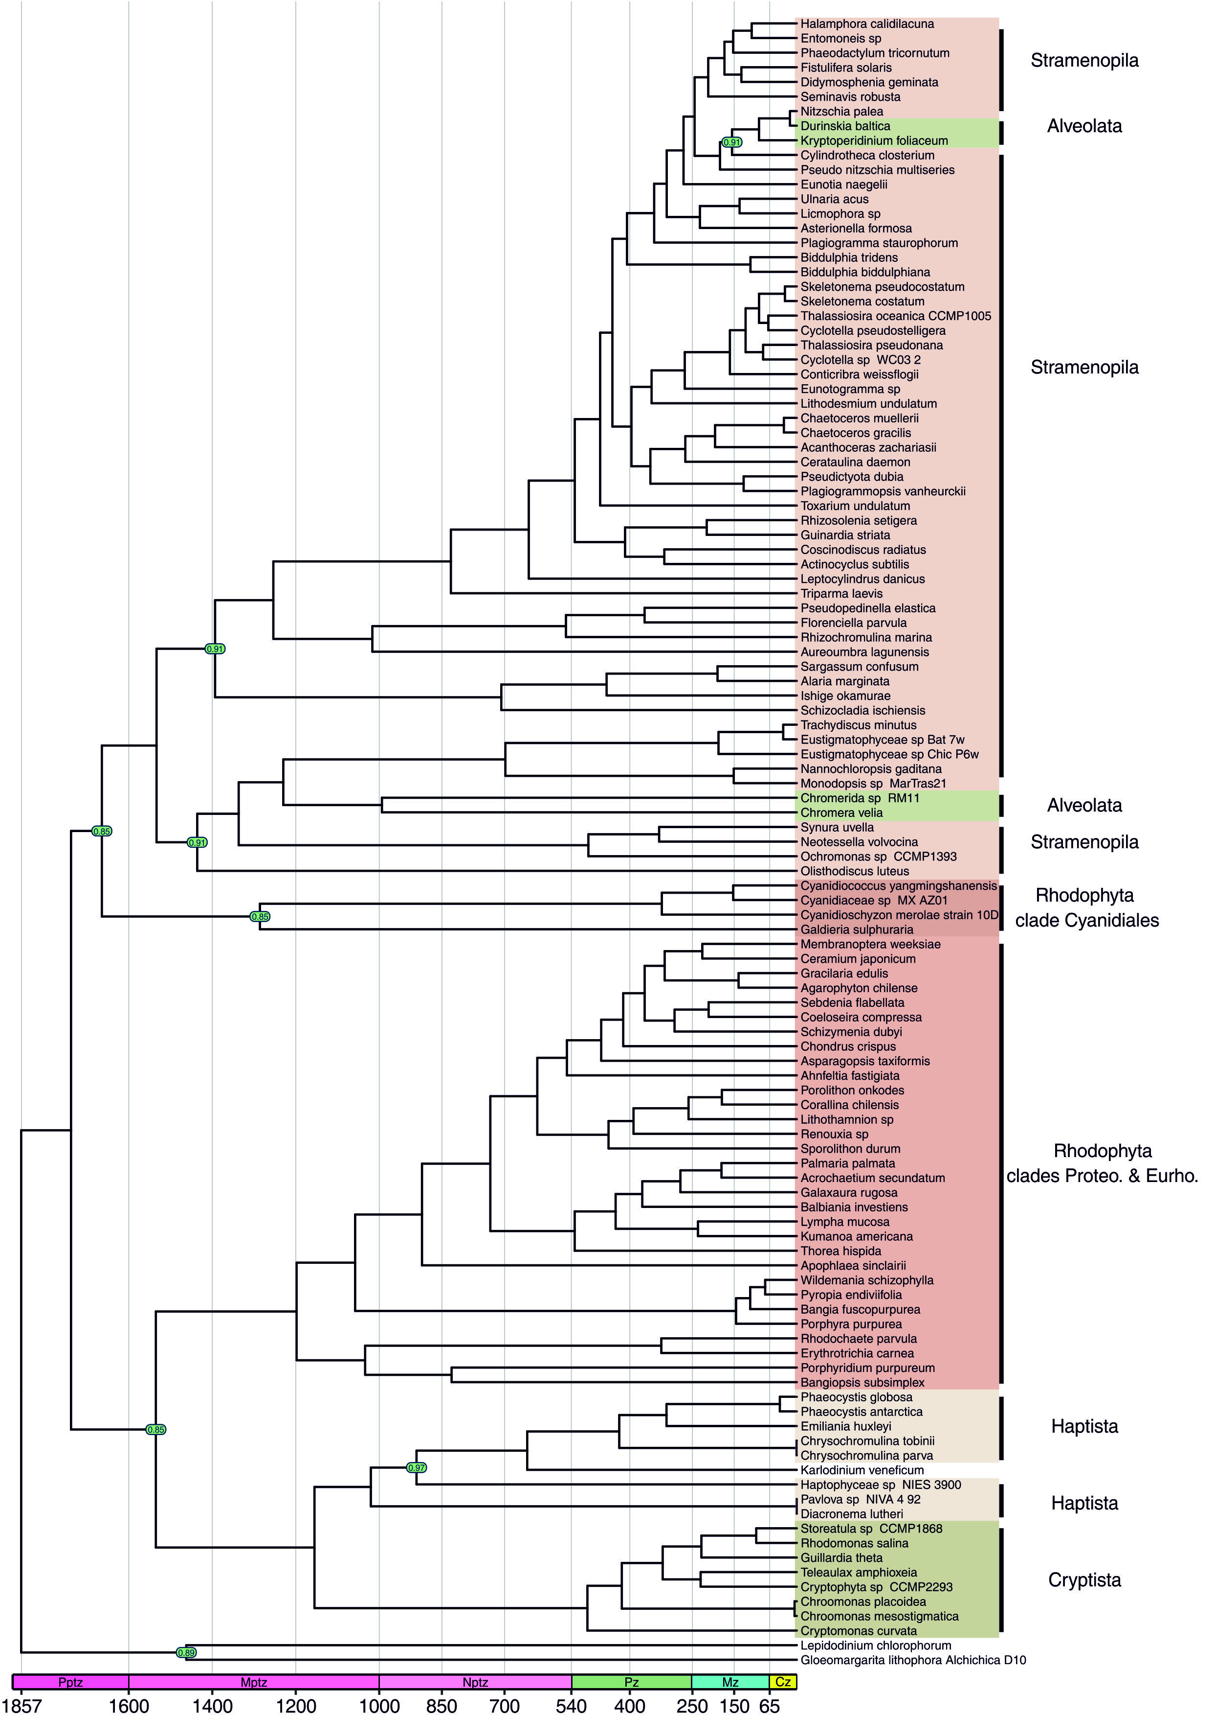Figure A22. Caption on the next page.)

Figure A22. Time-calibrated phylogeny of red algae and red algae plastid bearing organisms. The tree was rooted in Gloeomargarita lithophora Alchichica D10 and Lepidodinium chlorophorum clade, inferred with Beast [80] under lognormal model and calibrated with constraints presented in Table 3 and substiton models presented in Table A14. The nodes supported with posterior probability lower than one are indicated in green circles.
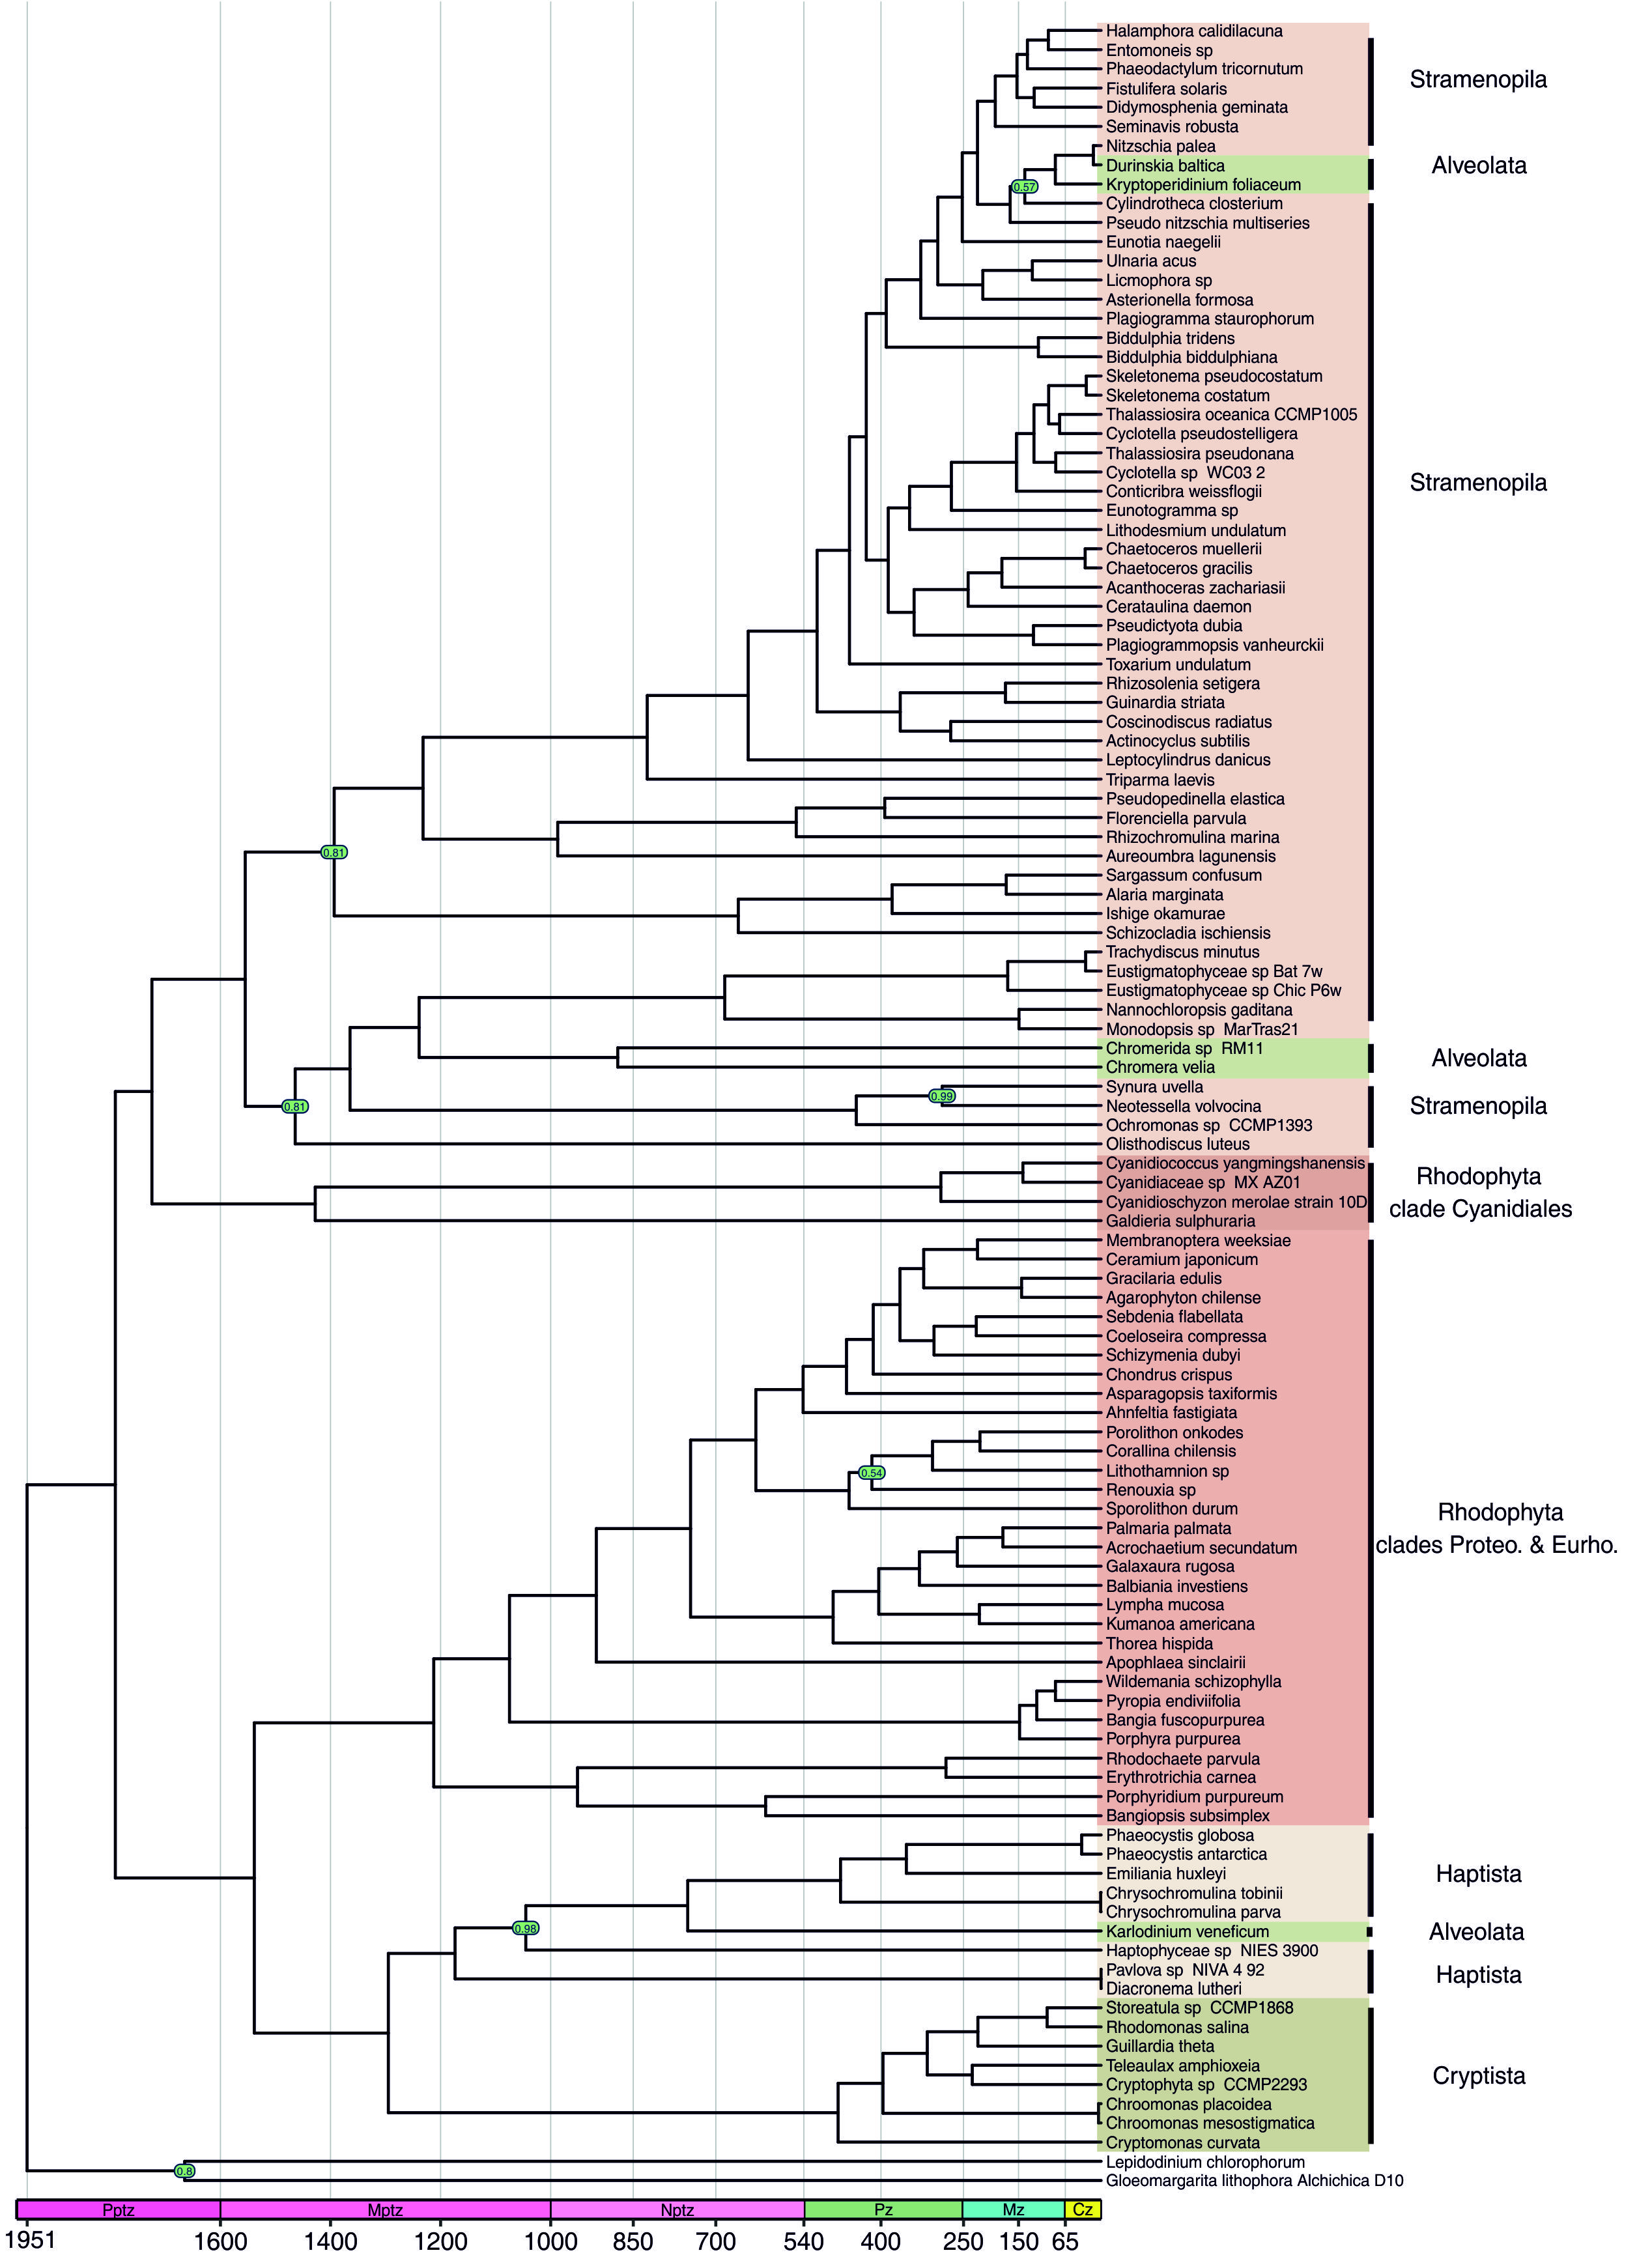(Figure A23. Caption on the next page.)

Figure A23. Time-calibrated phylogeny of red algae and red algae plastid bearing organisms. The tree was rooted in Gloeomargarita lithophora Alchichica D10 and Lepidodinium chlorophorum clade, inferred with MrBayes [79] under IGR model and calibrated with constraints presented in Table 3 and substiton models presented in Table A15. The nodes supported with posterior probability lower than one are indicated in green circles.
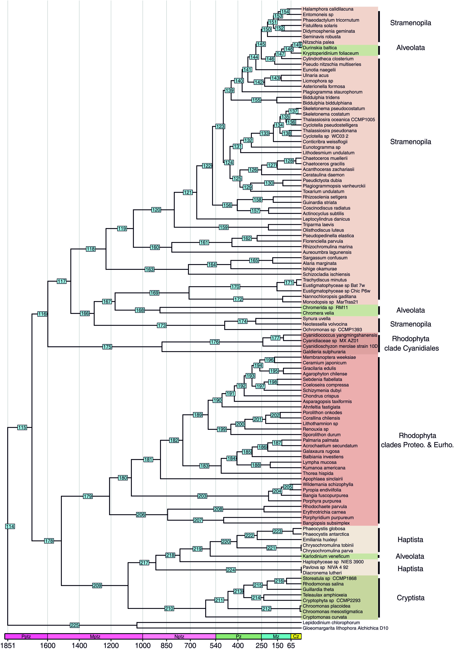 (Figure A24. Caption on the next page.)

Figure A24. Time-calibrated phylogeny, inferred with Beast [80] under expotential model. The numbers in blue rectangles mark nodes numbers to help reading time estimates presented in Table A9. Other description as in
Figure 9.

(Figure A25. Caption on the next page.)

Figure A25. Time-calibrated phylogeny, inferred with Beast [80] under lognormal model. The numbers in blue rectangles mark nodes numbers to help reading time estimates presented in Table A8. Other description as in
Figure A22.
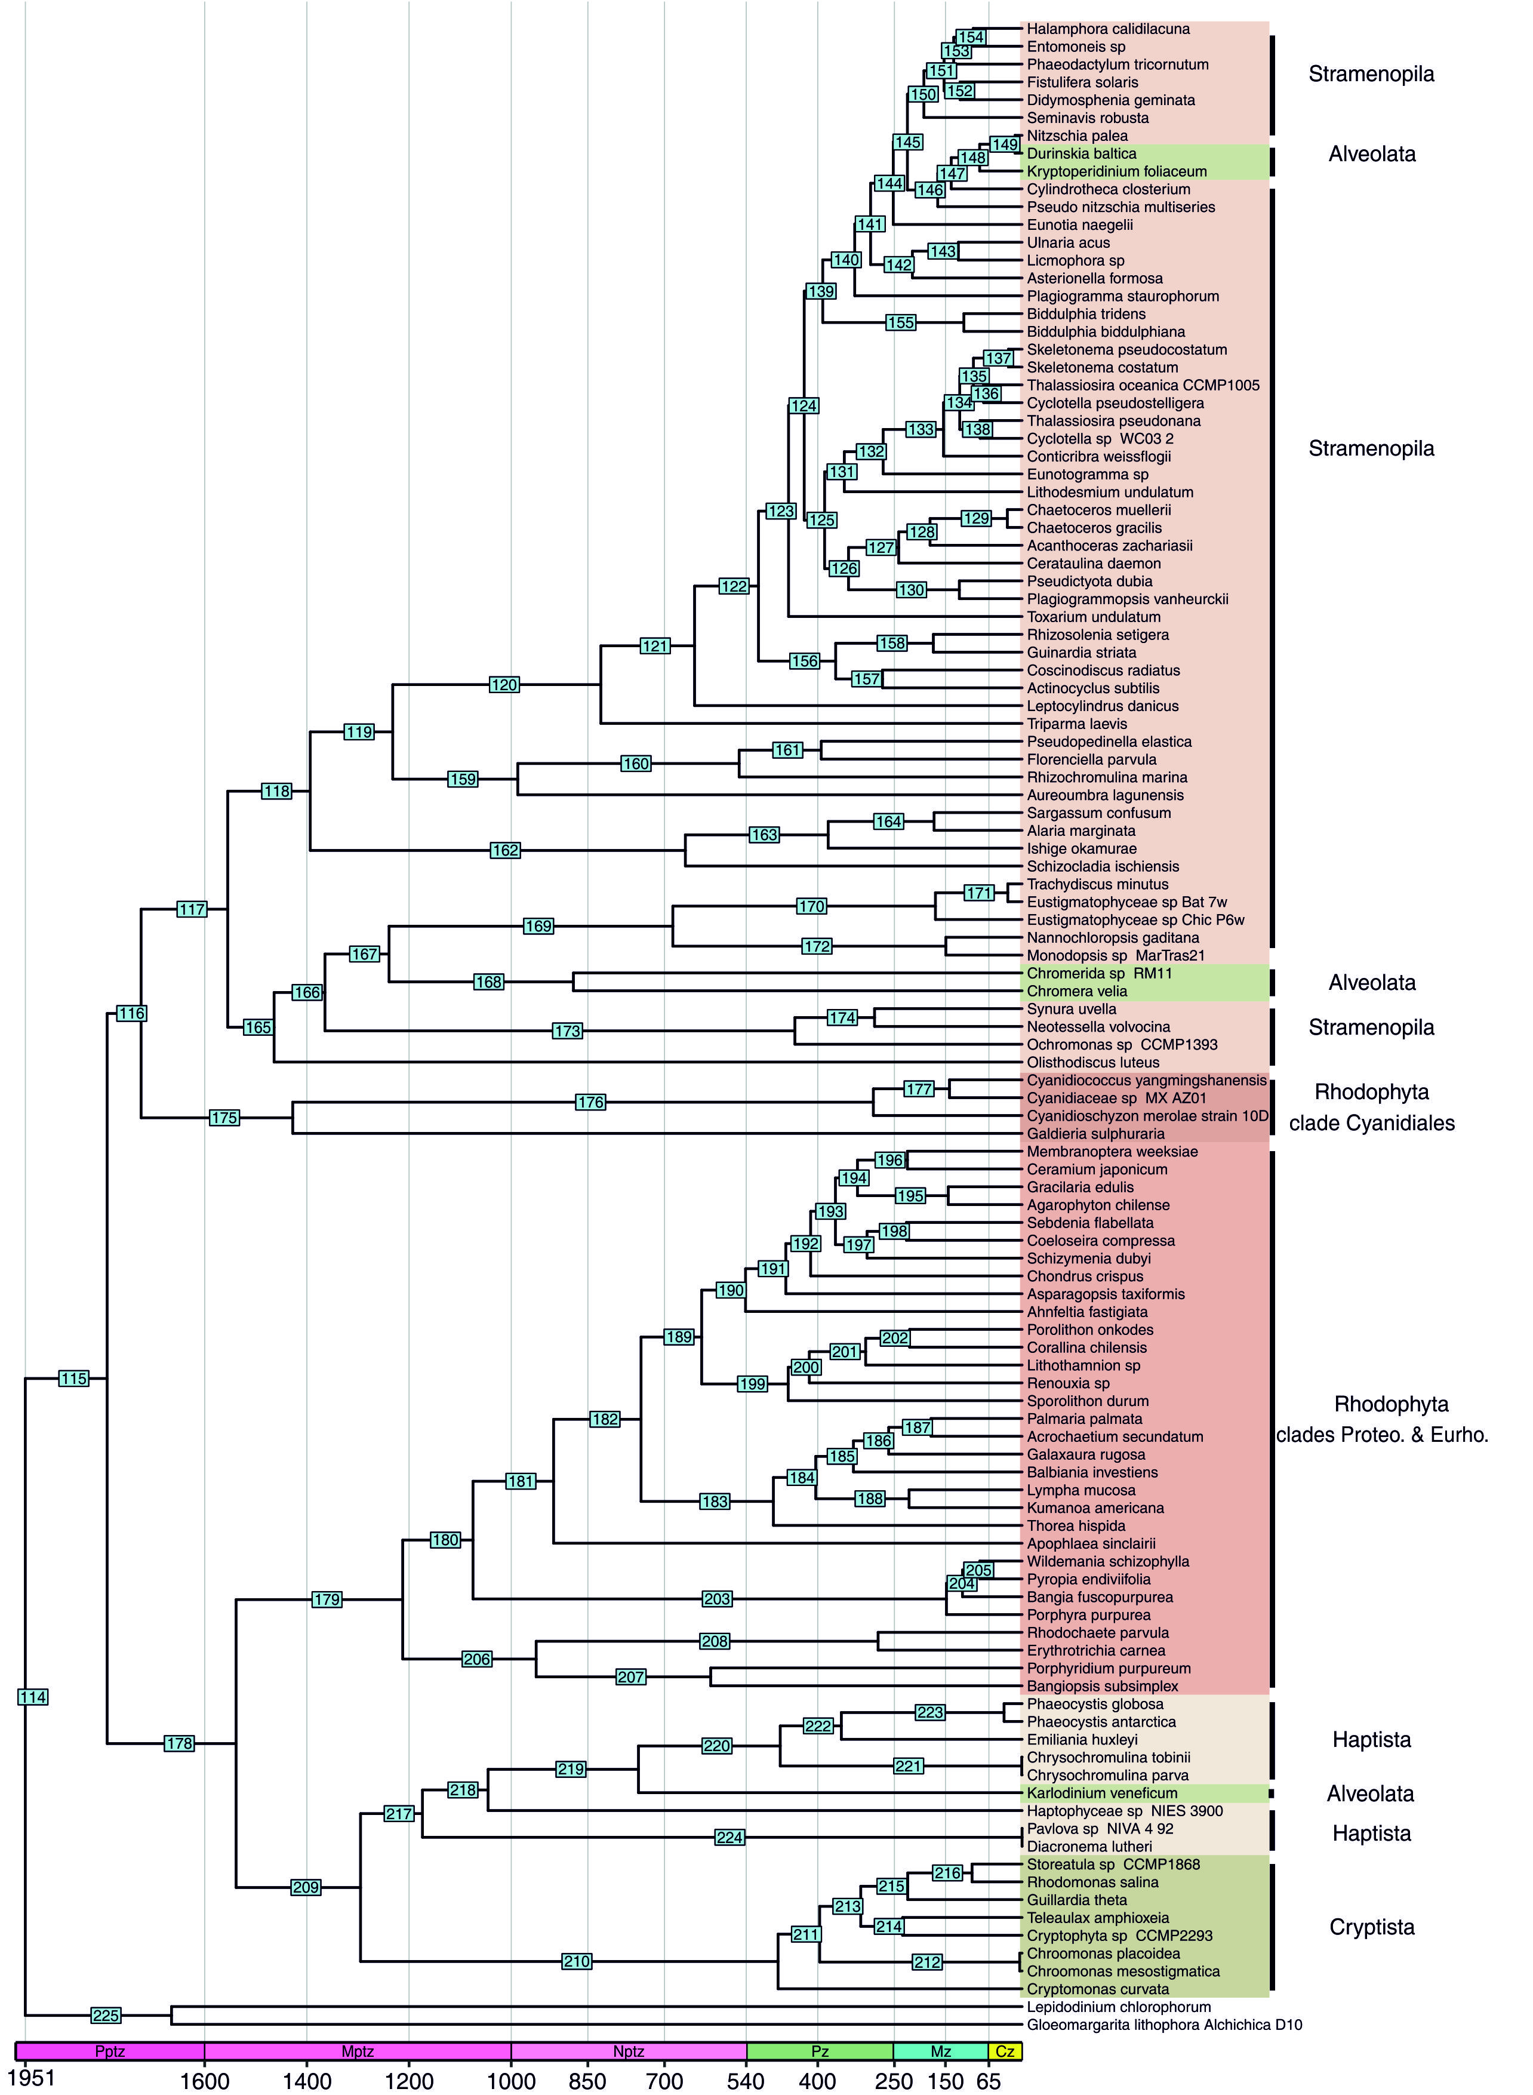(Figure A26. Caption on the next page.)

Figure A26. Time-calibrated phylogeny, inferred with MrBayes [79] under IGR model. The numbers in blue rectangles mark nodes numbers to help reading time estimates presented in Table A7. Other description as in Figure A23.

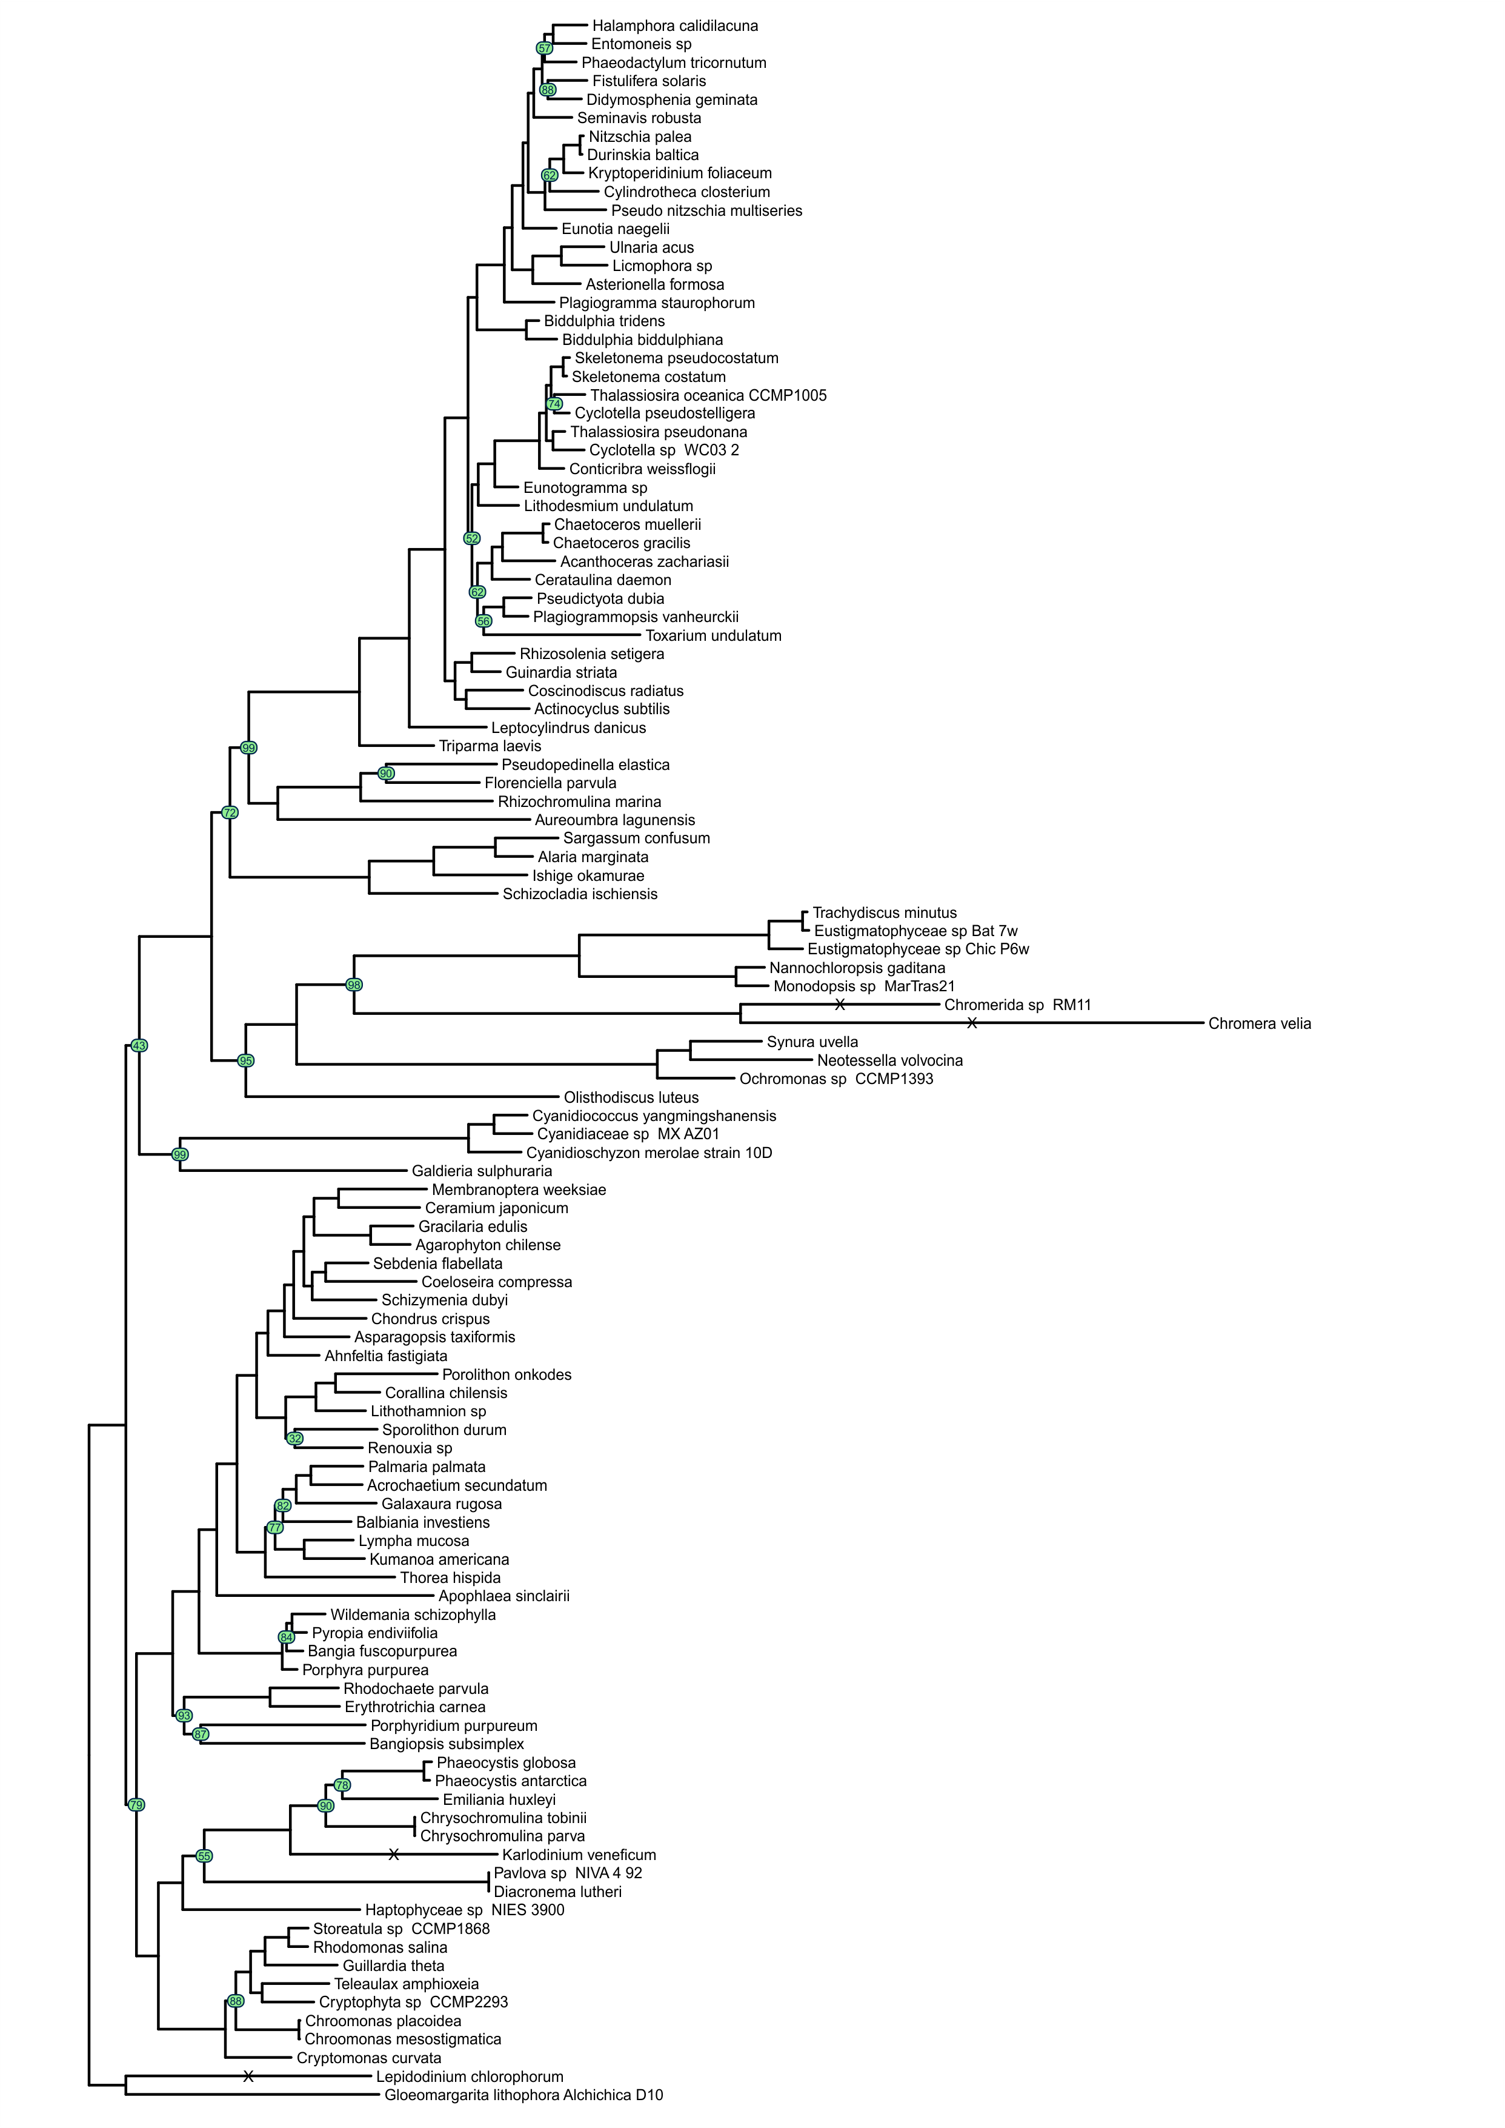
Figure A27. The phylogeny of red algae and red algae plastid bearing organisms. The tree topology was reconstructed in IQ-TREE [72] and ClipKIT gappy alghoritm [108]. The nodes supported with bootstrap values lower than 100 are indicated in green circles. Substition models are presented in Table A16. Nodes with “X” mark are shortened by 50%.
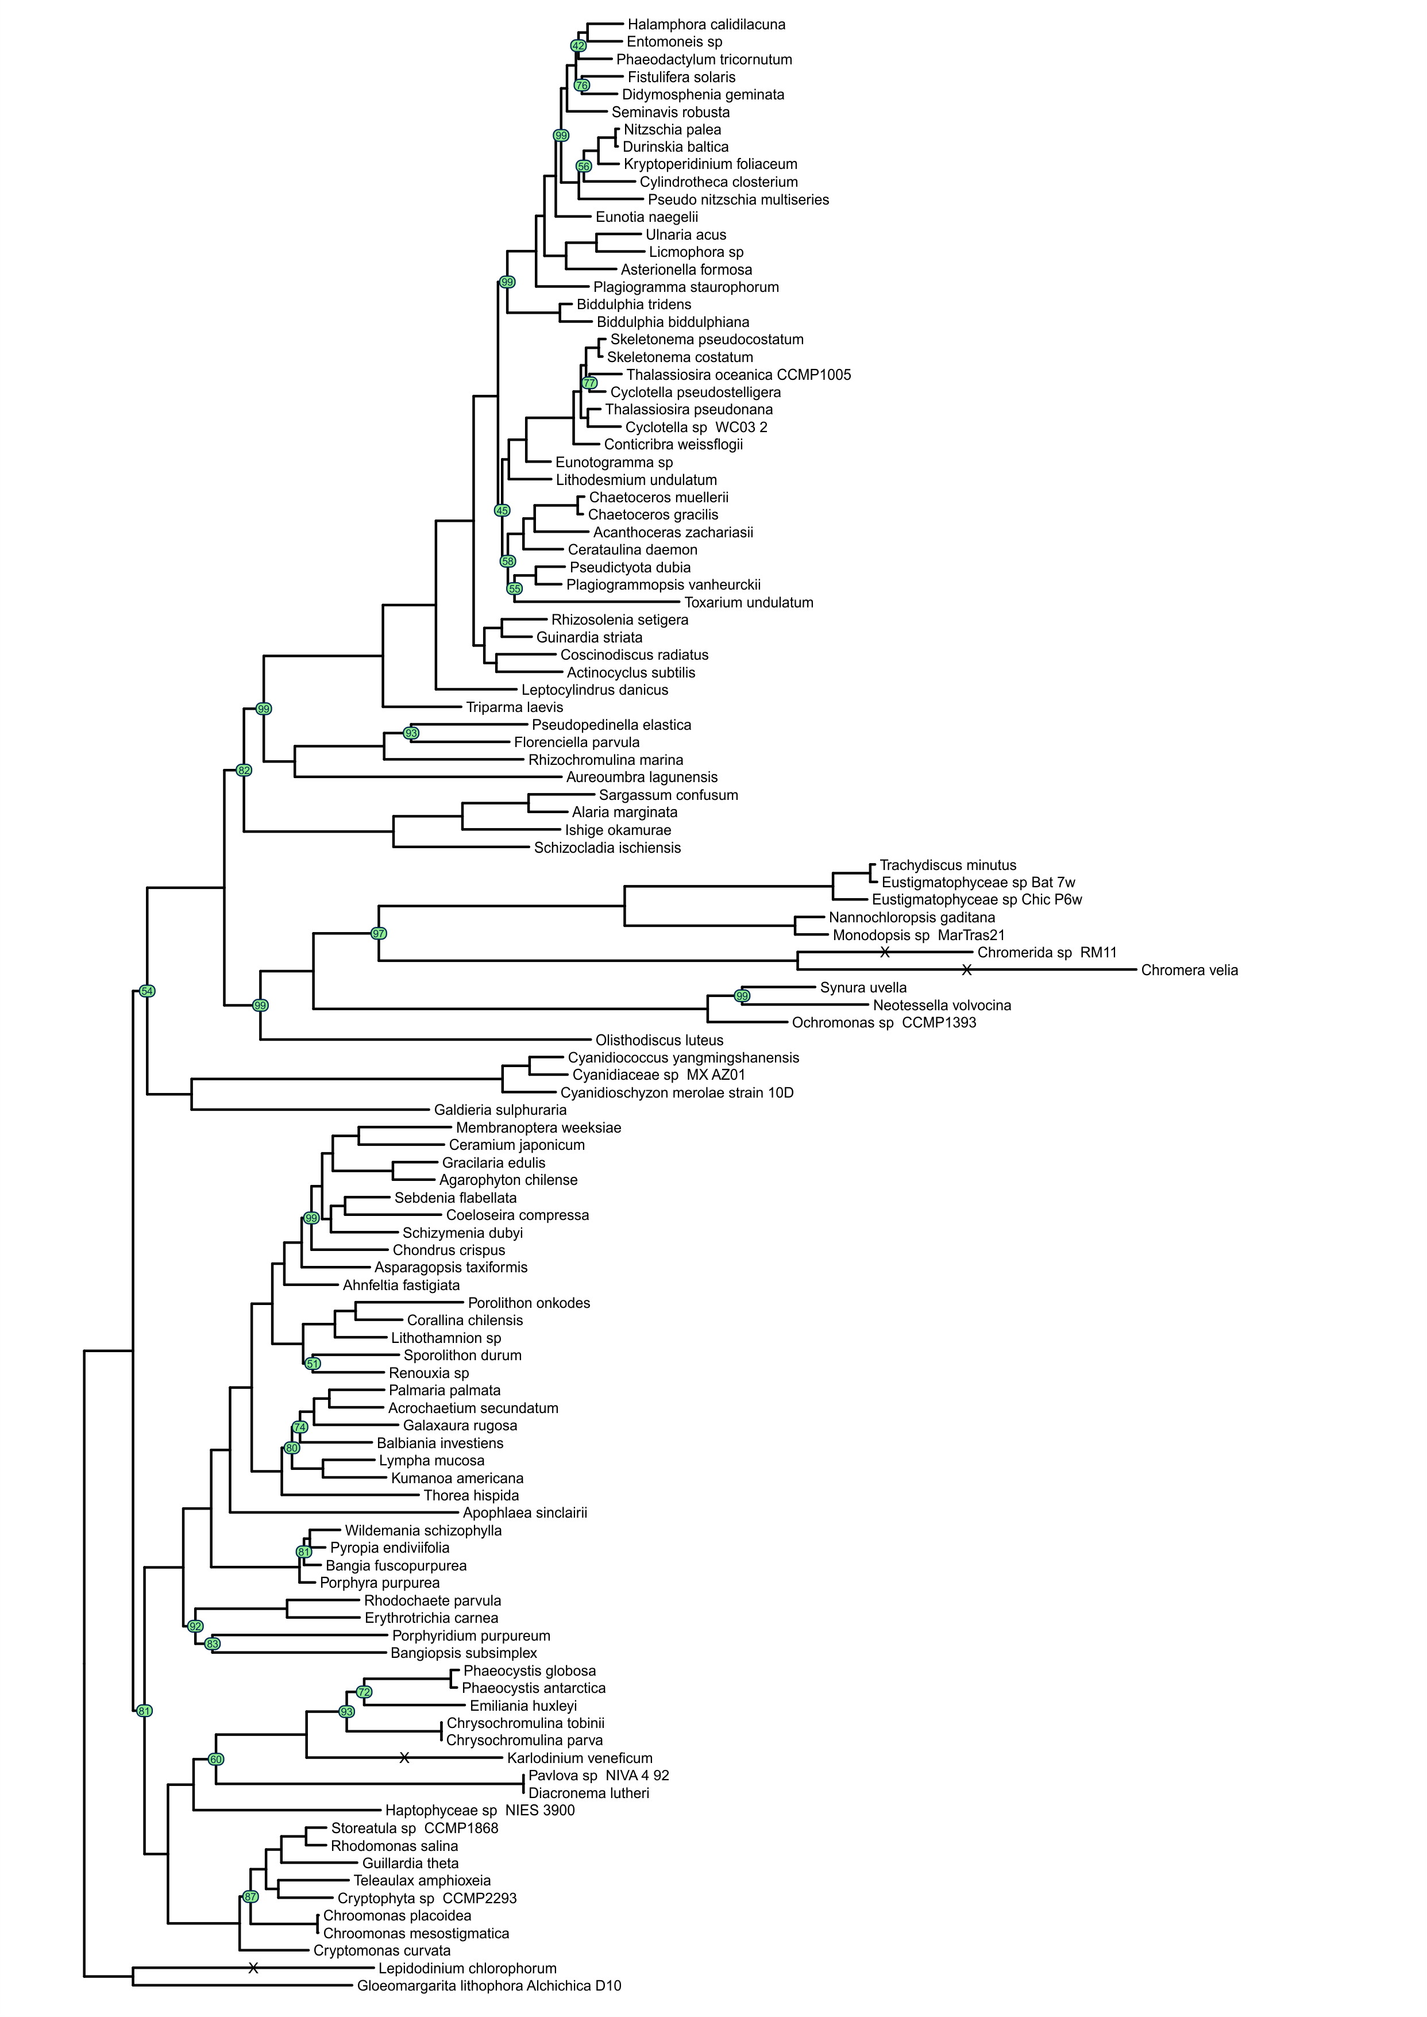
Figure A28. The phylogeny of red algae and red algae plastid bearing organisms. The tree topology was reconstructed in IQ-TREE [72] and ClipKIT kpic alghoritm [108]. The nodes supported with bootstrap values lower than 100 are indicated in green circles. Substition models are presented in Table A17. Nodes with “X” mark are shortened by 50%.
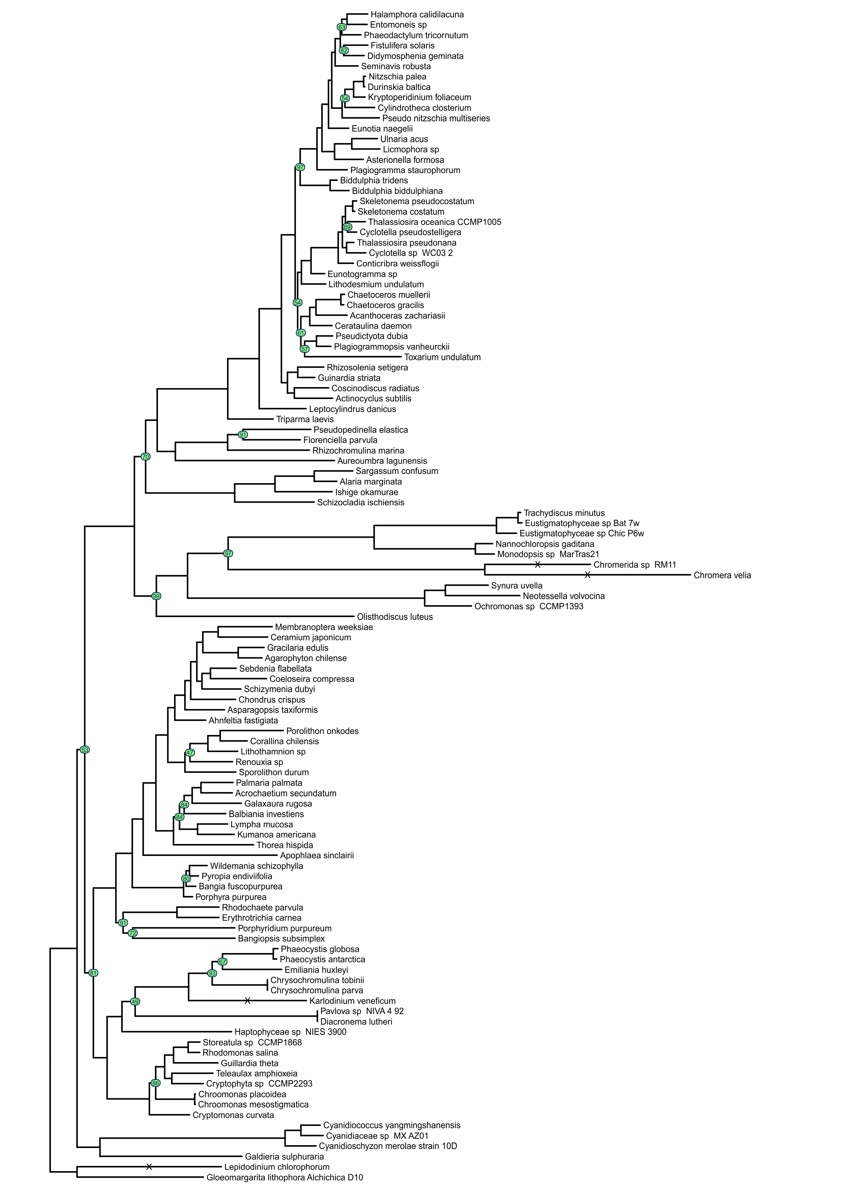
Figure A29. The phylogeny of red algae and red algae plastid bearing organisms. The tree topology was reconstructed in IQ-TREE [72] and ClipKIT kpic-smart-gap alghoritm [108]. The nodes supported with bootstrap values lower than 100 are indicated in green circles. Substition models are presented in Table A18. Nodes with “X” mark are shortened by 50%.
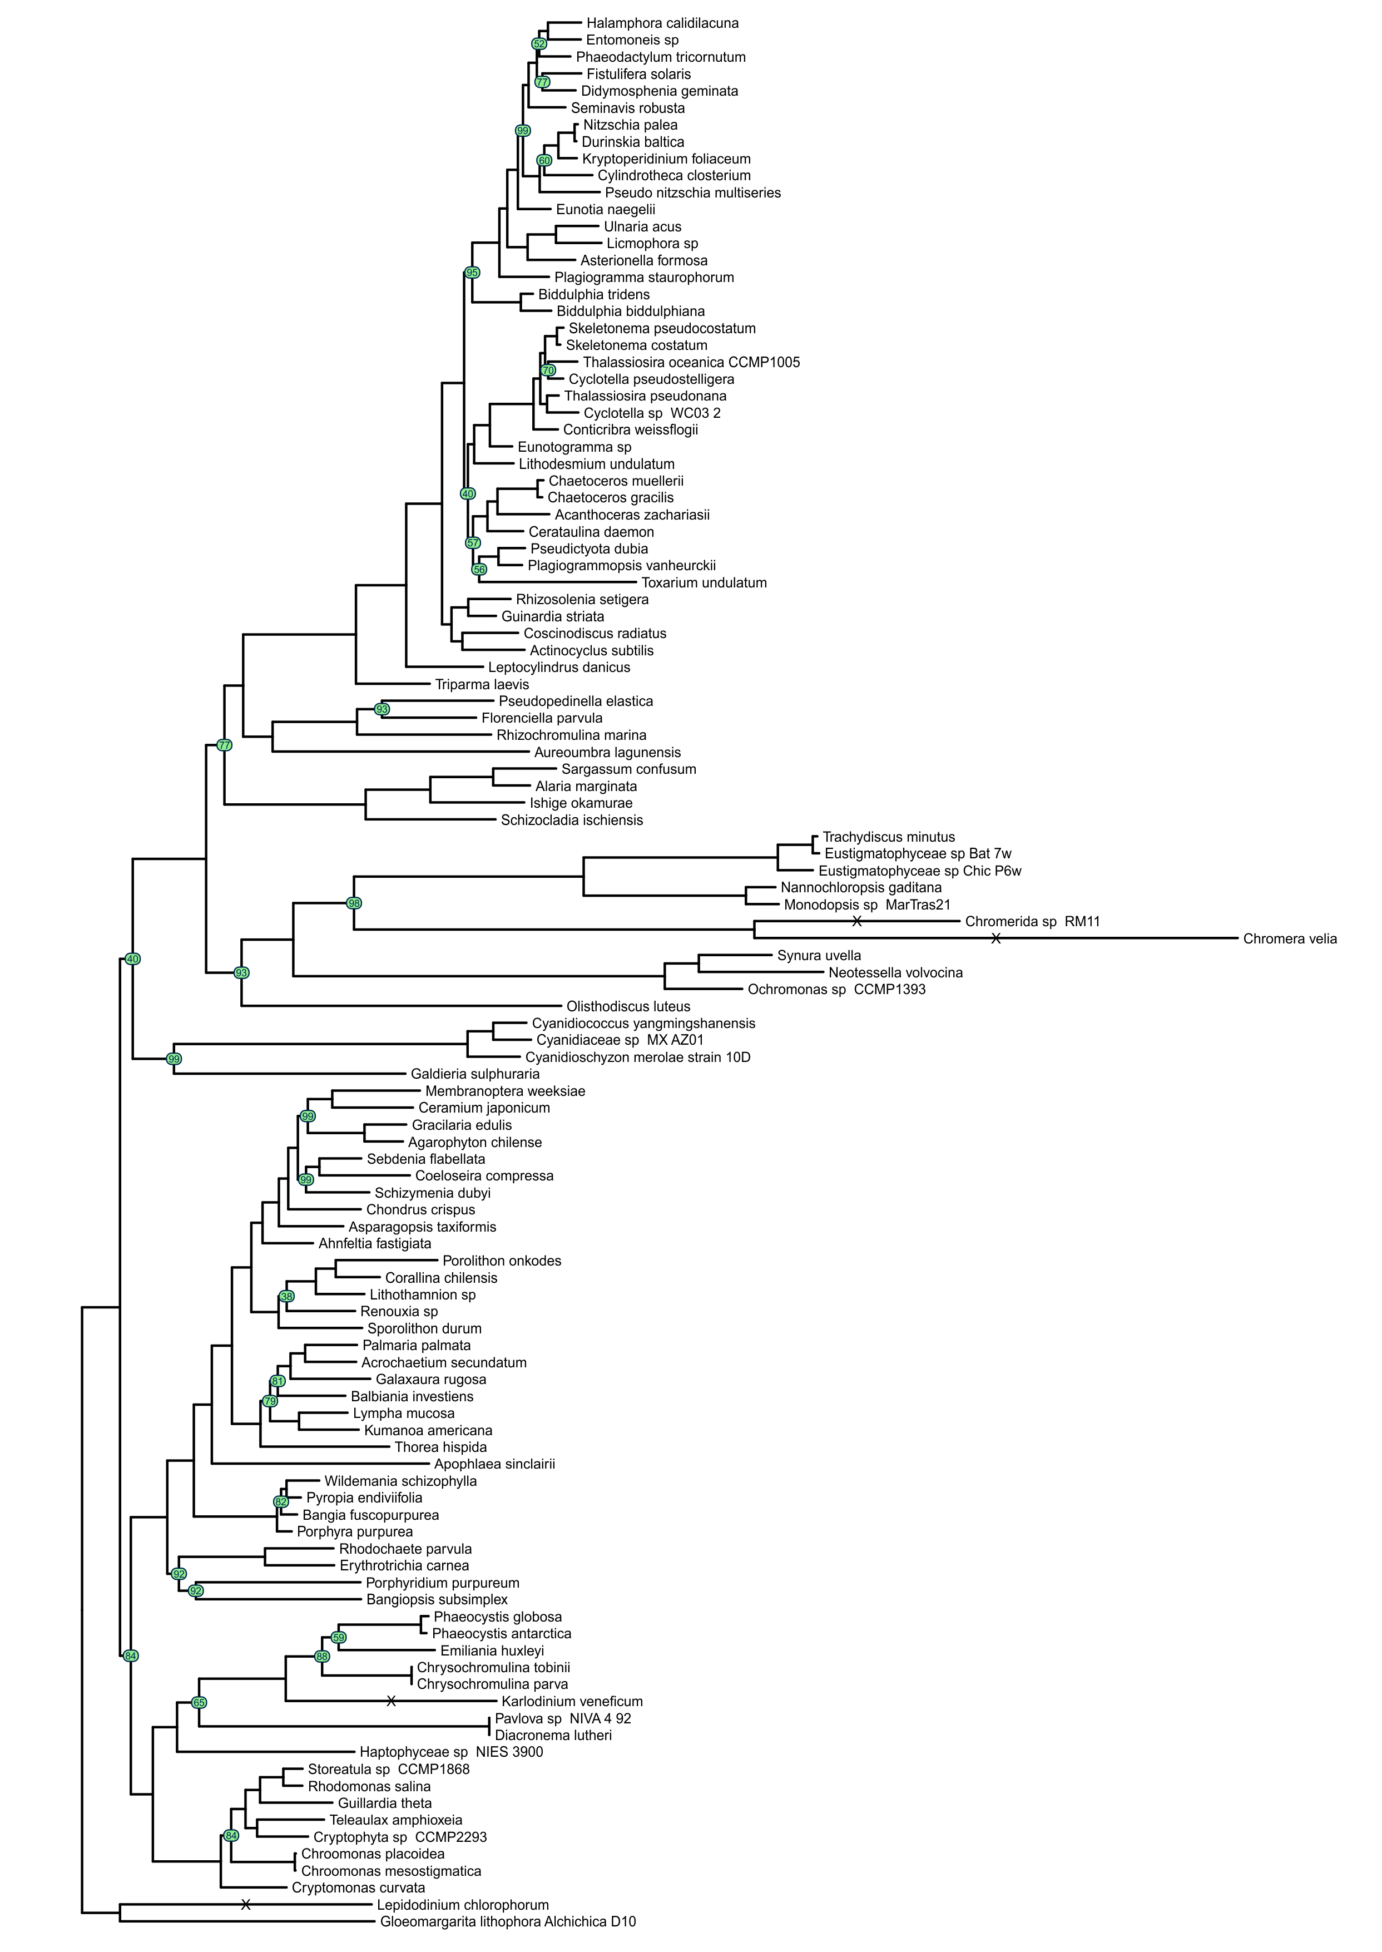
Figure A30. The phylogeny of red algae and red algae plastid bearing organisms. The tree topology was reconstructed in IQ-TREE [72] and ClipKIT smart-gap alghoritm [108]. The nodes supported with bootstrap values lower than 100 are indicated in green circles. Substition models are presented in Table A19. Nodes with “X” mark are shortened by 50%.
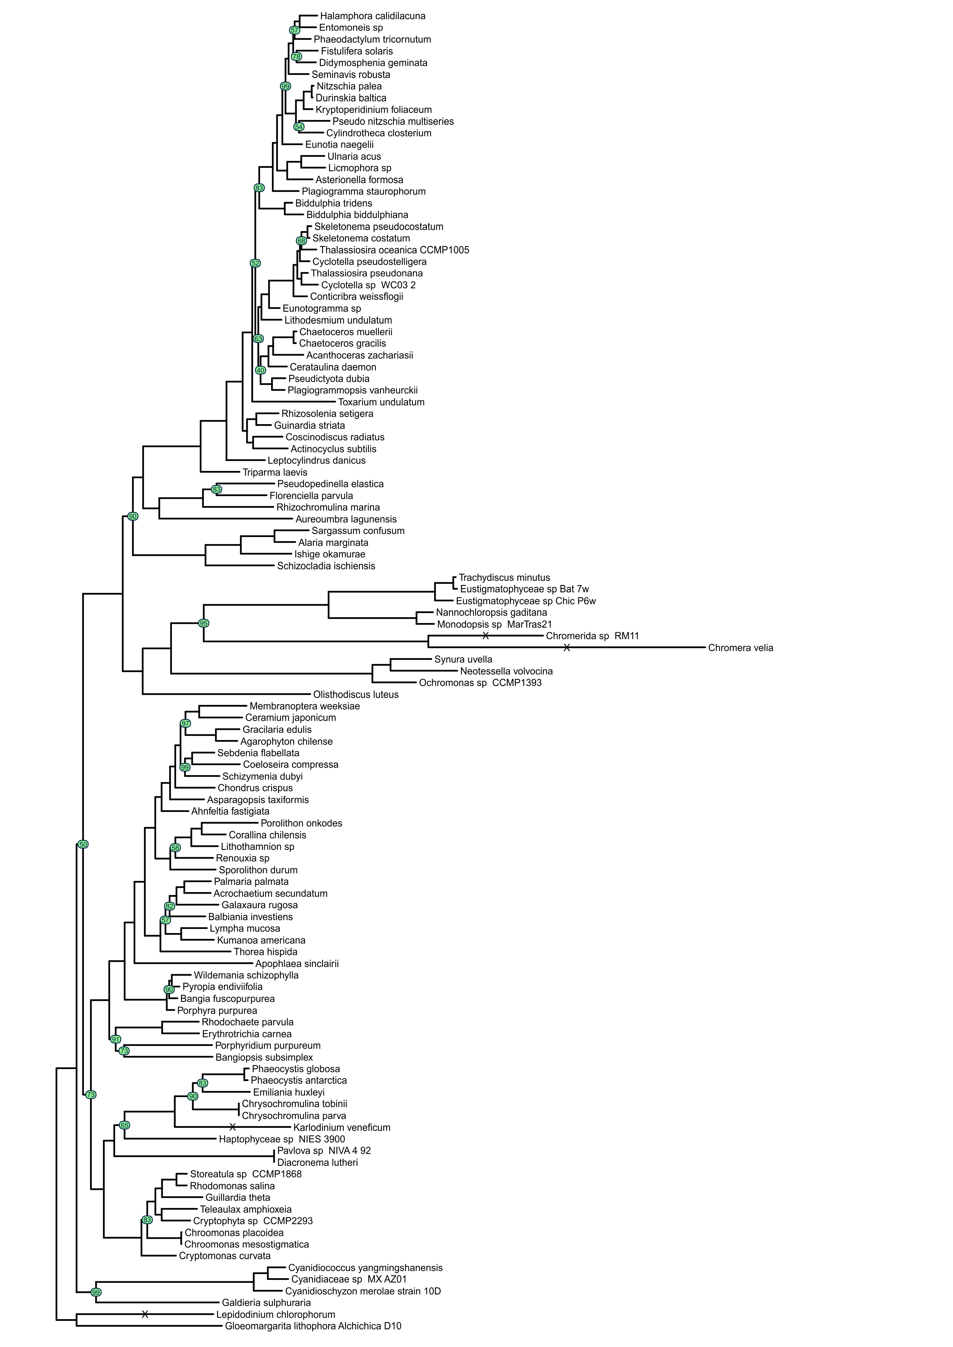
Figure A31. The phylogeny of red algae and red algae plastid bearing organisms. The tree topology was reconstructed in IQ-TREE [72] and trimAl automated1 alghoritm [74]. The nodes supported with bootstrap values lower than 100 are indicated in green circles. Substition models are presented in Table A20. Nodes with “X” mark are shortened by 50%.
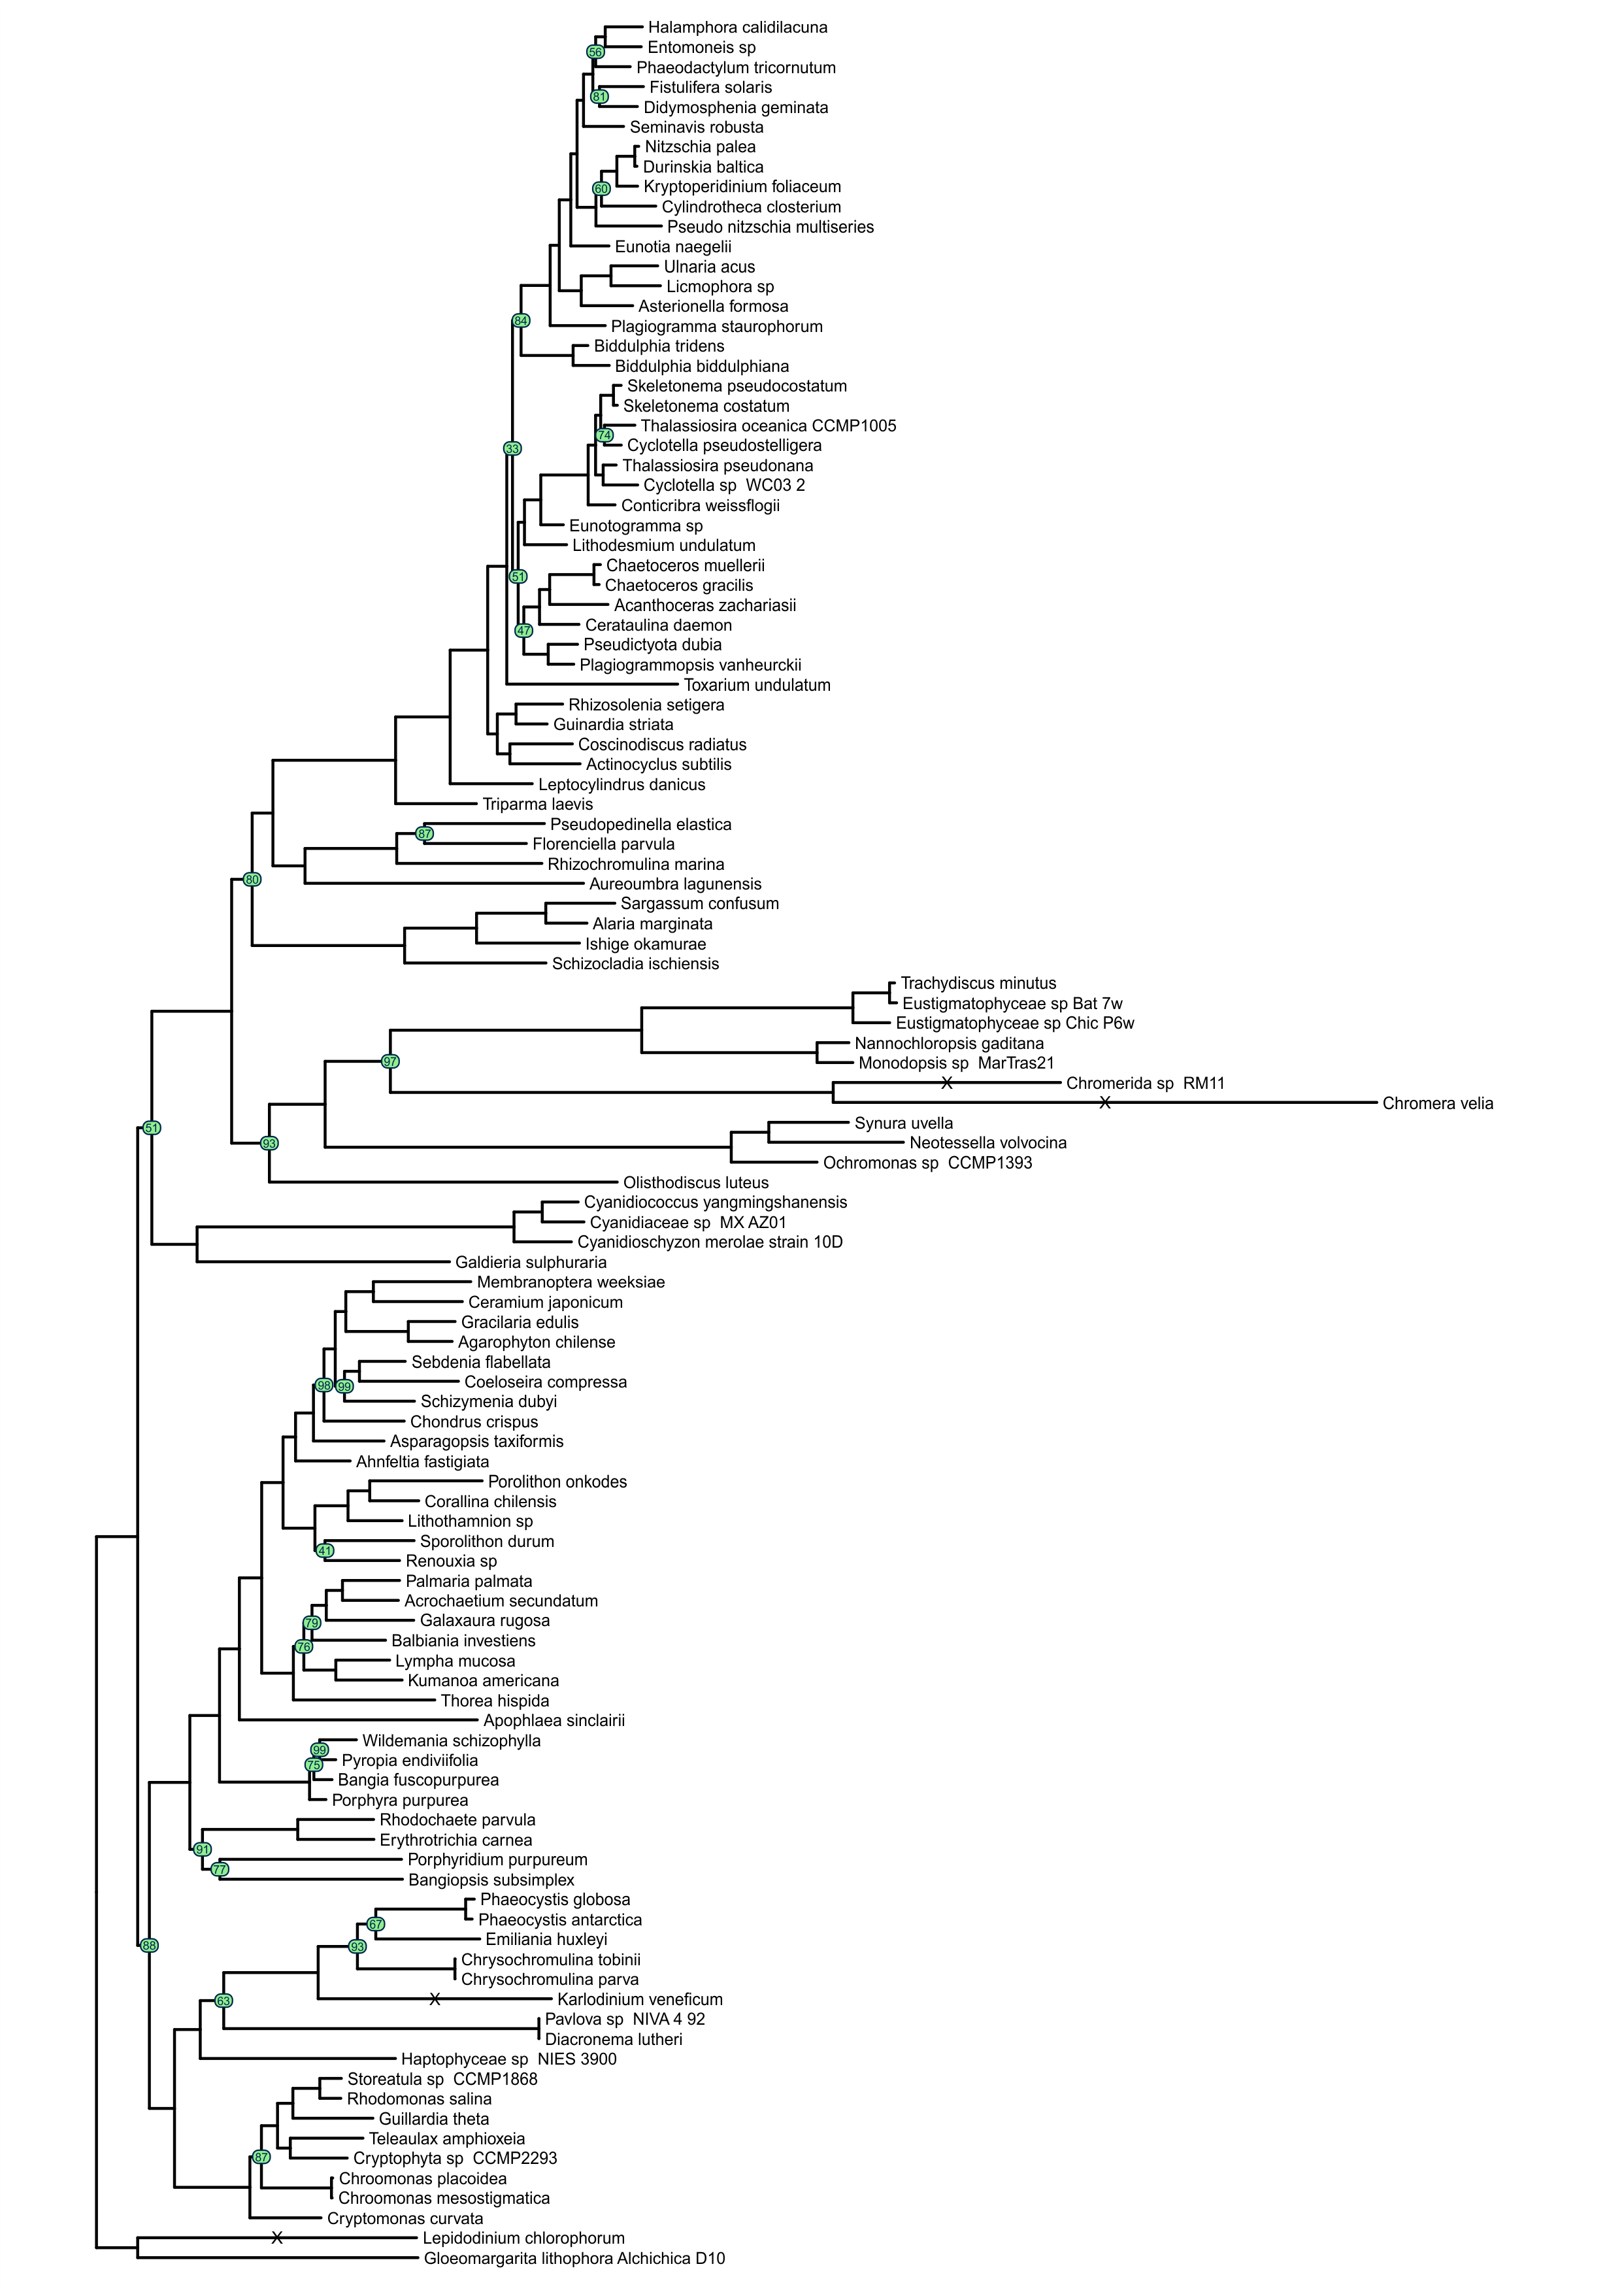
Figure A32. The phylogeny of red algae and red algae plastid bearing organisms. The tree topology was reconstructed in IQ-TREE [72] and trimAl gappyout alghoritm [74]. The nodes supported with bootstrap values lower than 100 are indicated in green circles. Substition models are presented in Table A21. Nodes with “X” mark are shortened by 50%.
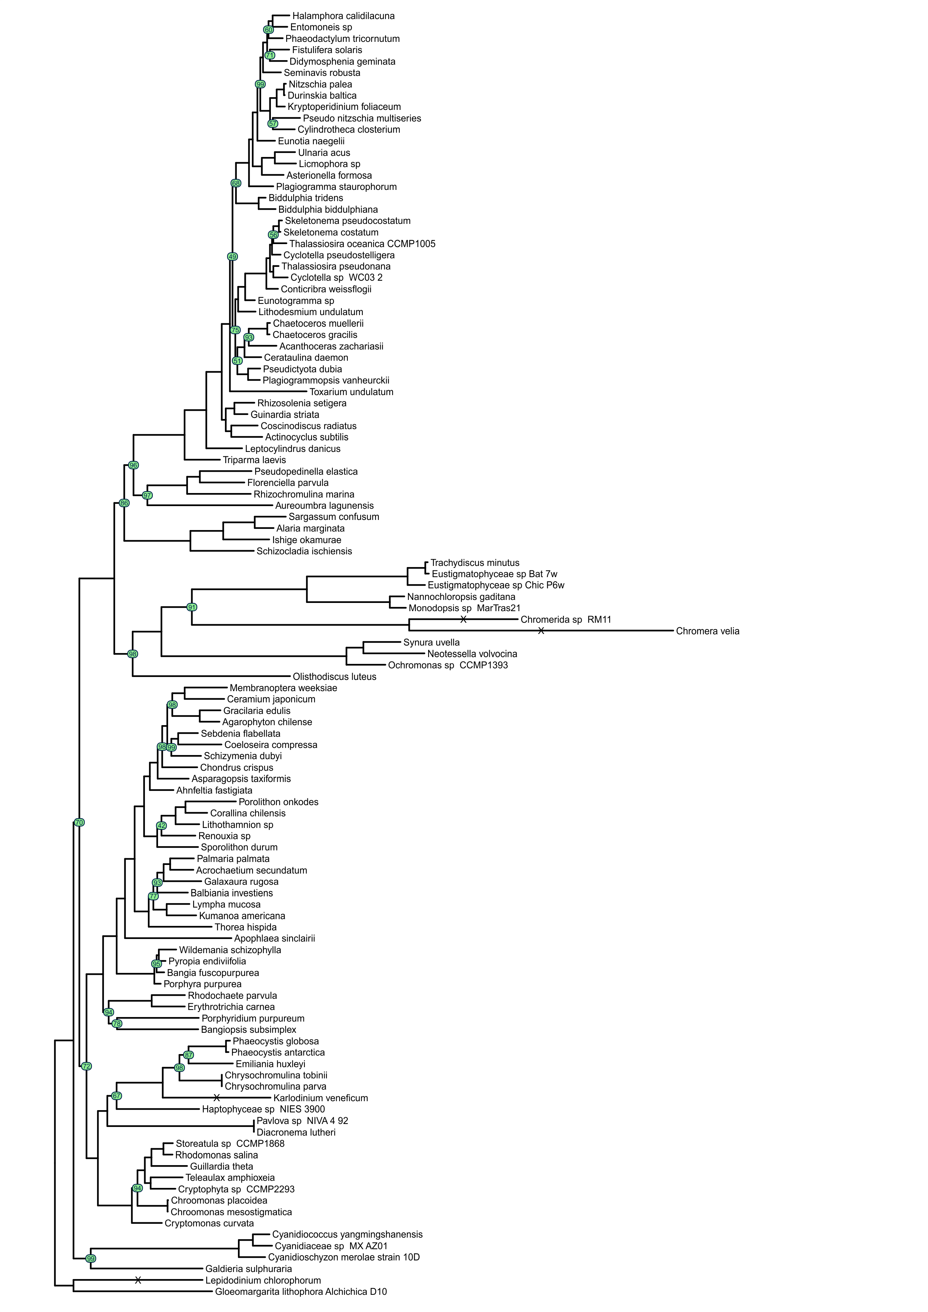
Figure A33. The phylogeny of red algae and red algae plastid bearing organisms. The tree topology was reconstructed in IQ-TREE [72] and trimAl strict alghoritm [74]. The nodes supported with bootstrap values lower than 100 are indicated in green circles. Substition models are presented in Table A22. Nodes with “X” mark are shortened by 50%.
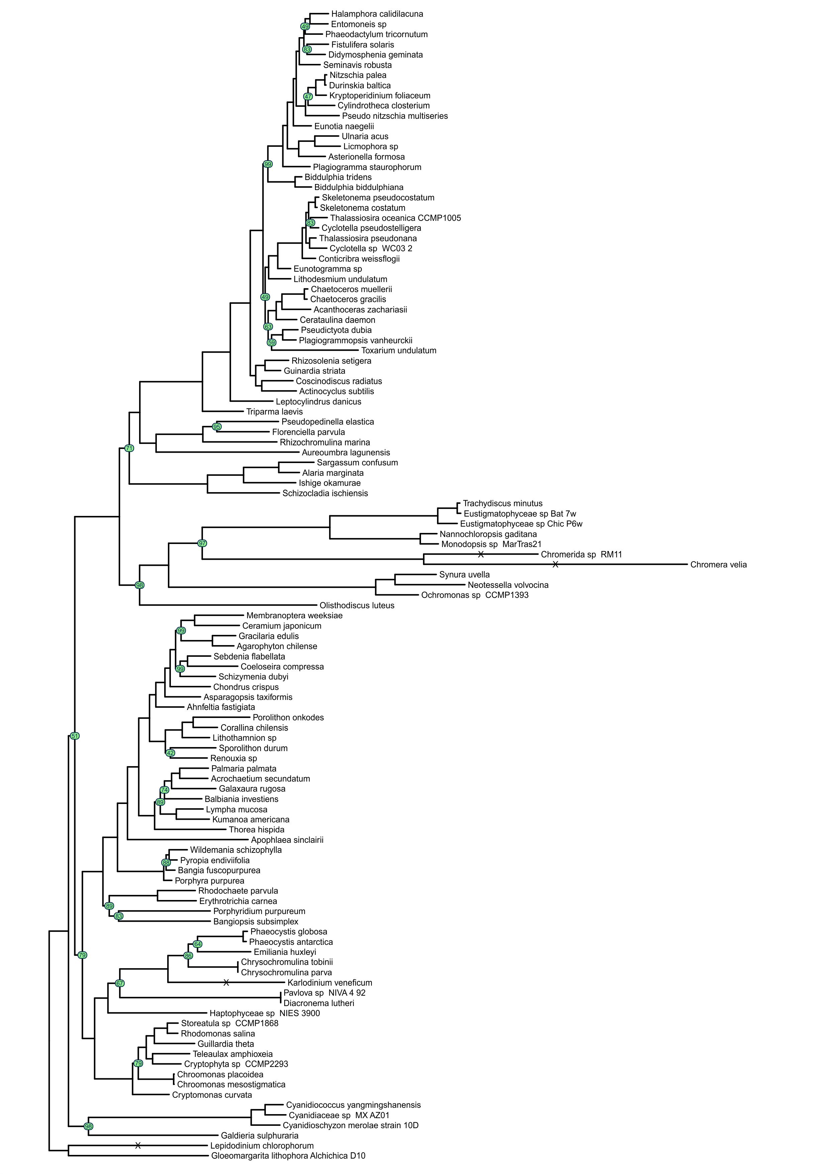
Figure A33. The phylogeny of red algae and red algae plastid bearing organisms. The tree topology was reconstructed in IQ-TREE [72] and original alignment. The nodes supported with bootstrap values lower than 100 are indicated in green circles. Substition models are presented in Table A23. Nodes with “X” mark are shortened by 50%.
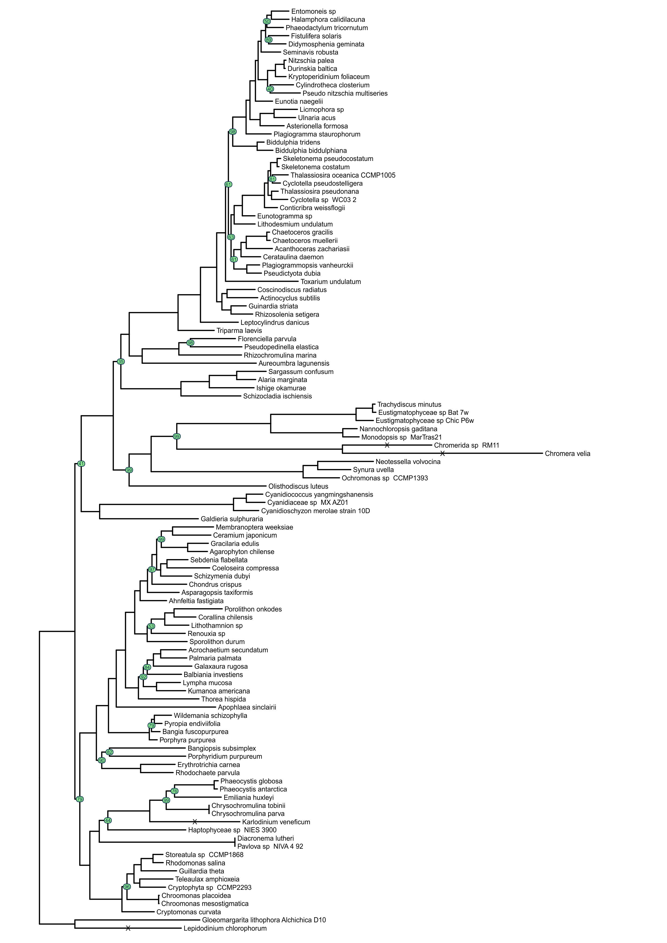
Figure A34. The phylogeny of red algae and red algae plastid bearing organisms. The tree topology was reconstructed in RAxML [77] and ClipKIT gappy alghoritm [108]. The nodes supported with bootstrap values lower than 100 are indicated in green circles. Substition models are presented in Table A24. Nodes with “X” mark are shortened by 50%.
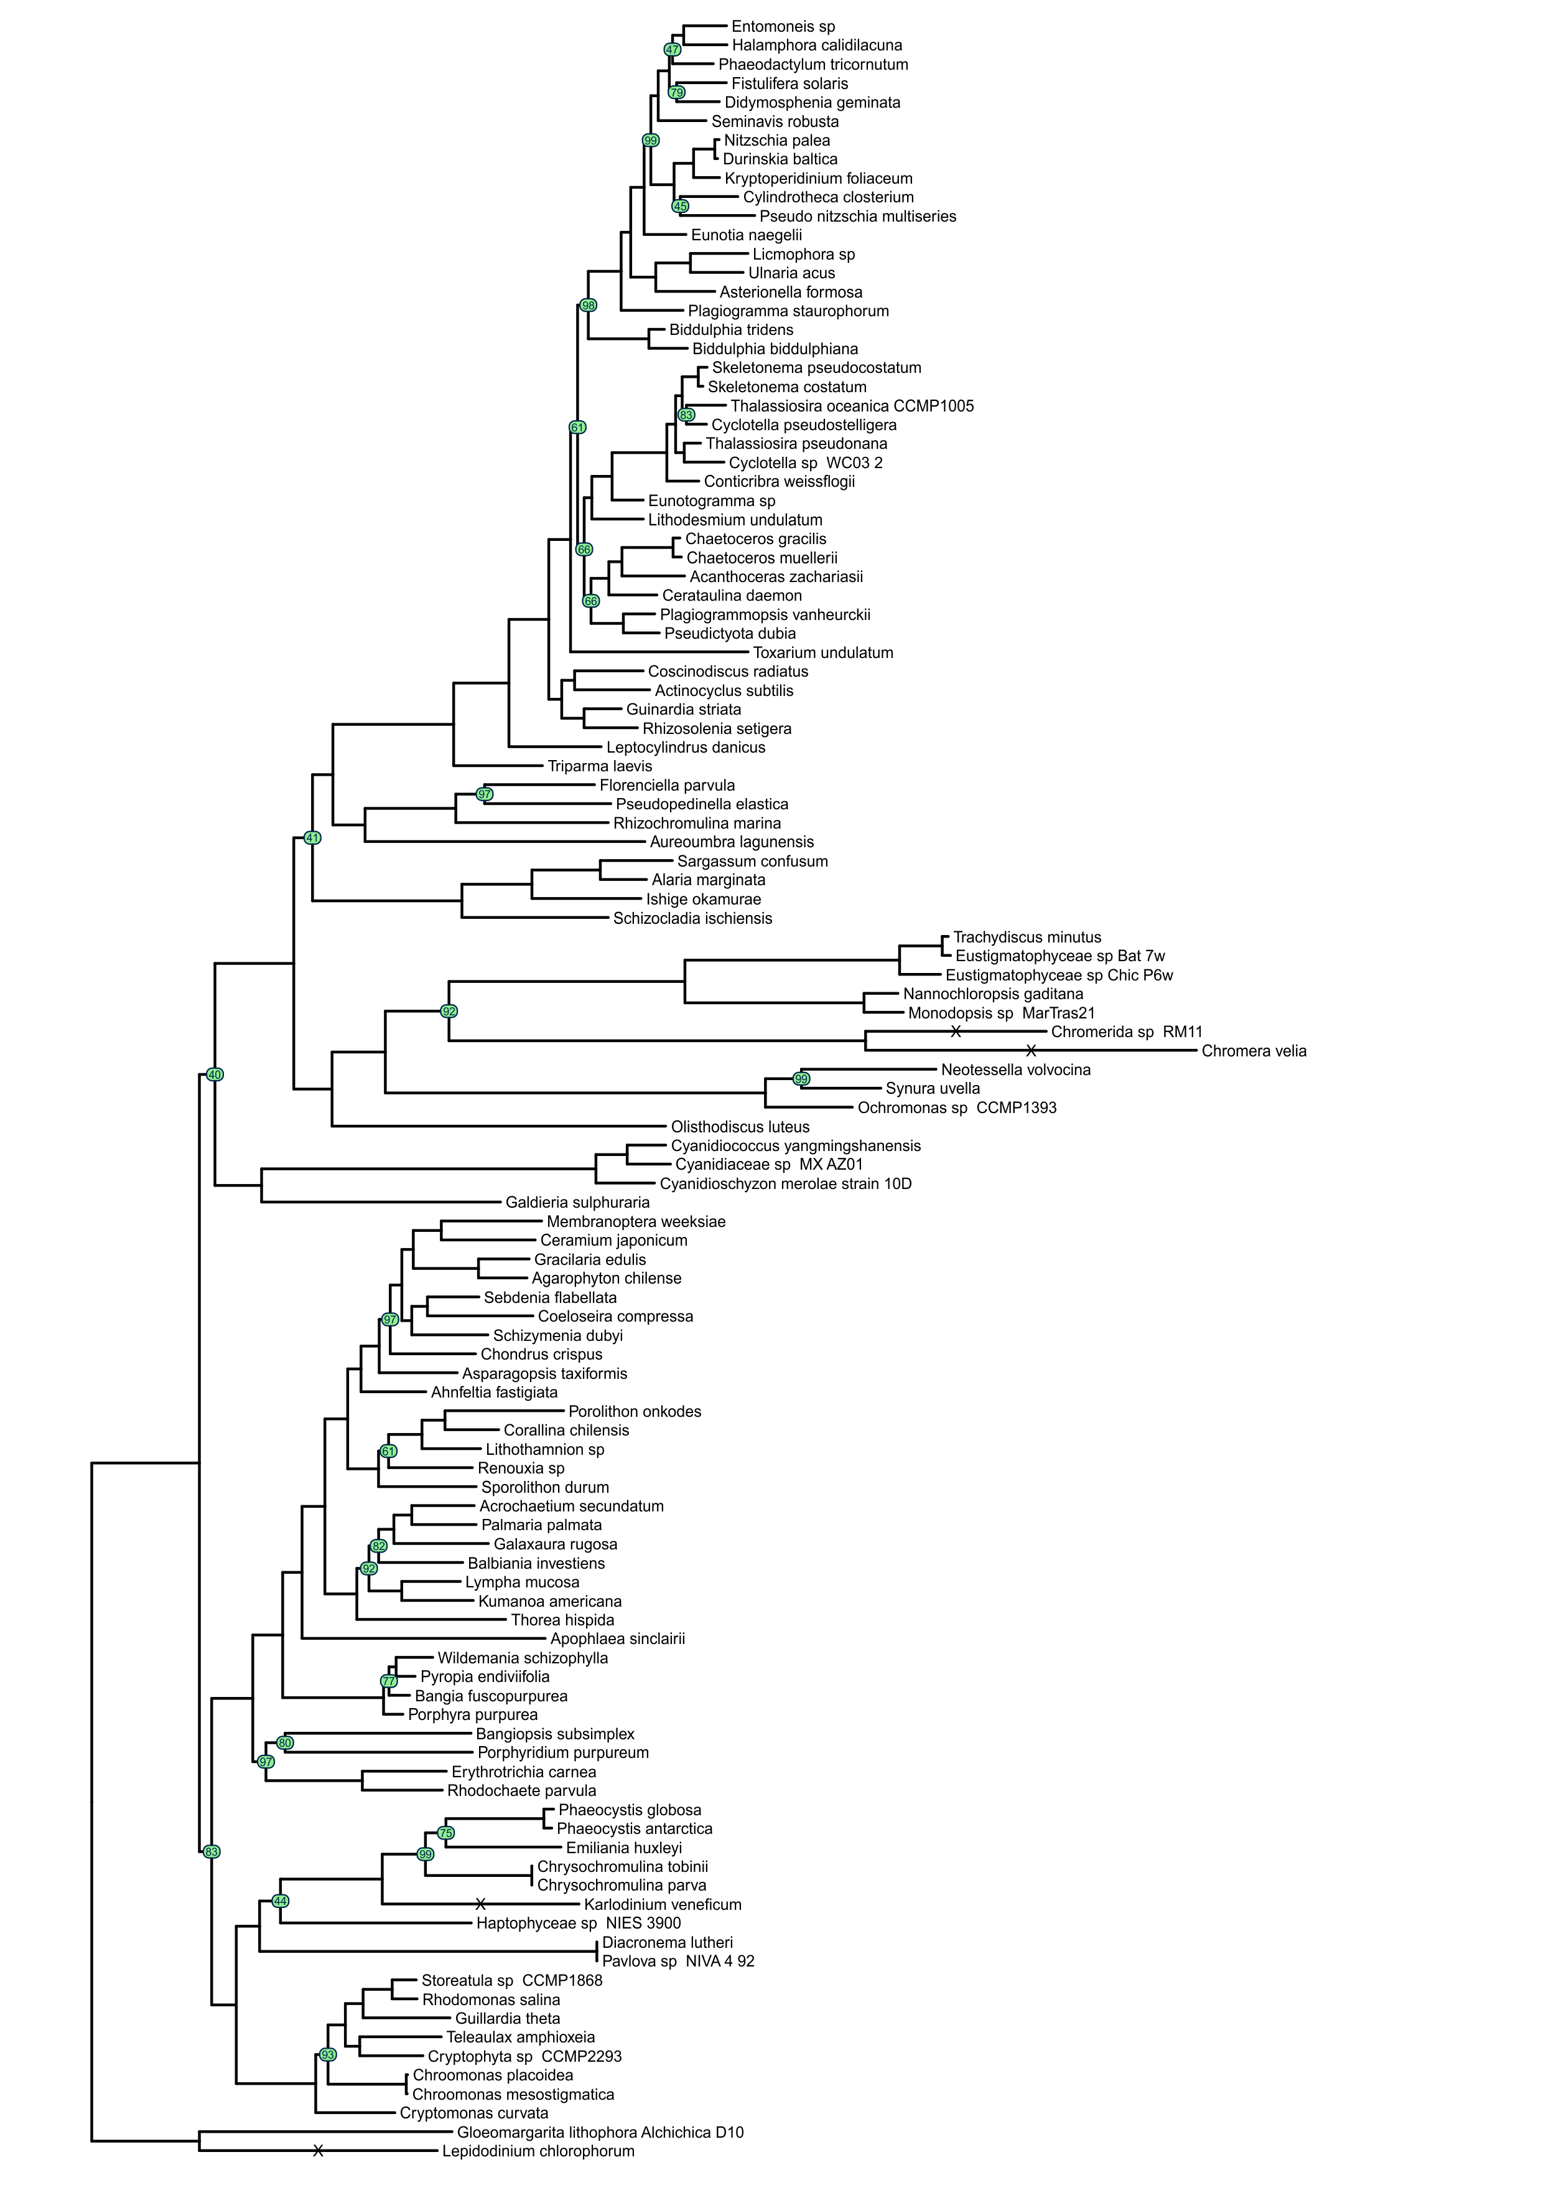
Figure A35. The phylogeny of red algae and red algae plastid bearing organisms. The tree topology was reconstructed in RAxML [77] and ClipKIT kpic alghoritm [108]. The nodes supported with bootstrap values lower than 100 are indicated in green circles. Substition models are presented in Table A25. Nodes with “X” mark are shortened by 50%.
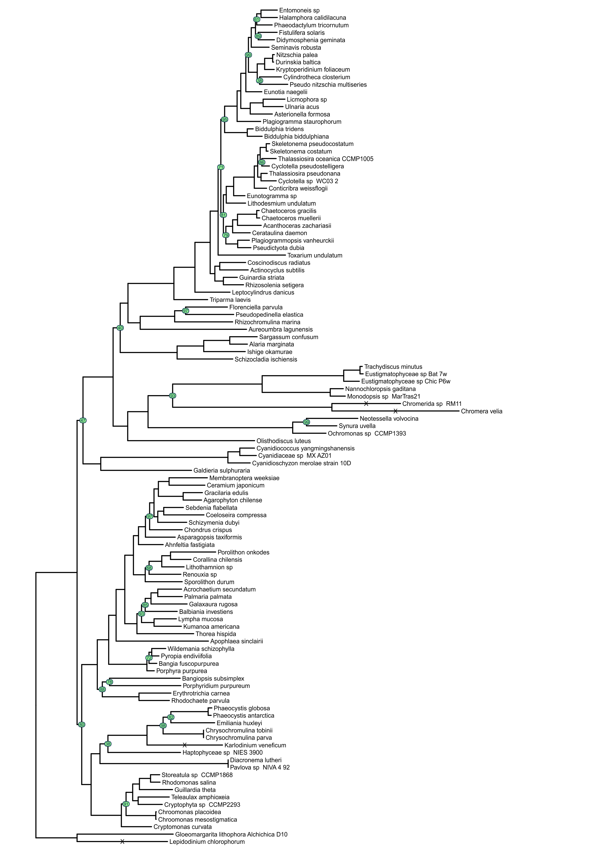
Figure A36. The phylogeny of red algae and red algae plastid bearing organisms. The tree topology was reconstructed in RAxML [77] and ClipKIT kpic-smart-gap alghoritm [108]. The nodes supported with bootstrap values lower than 100 are indicated in green circles. Substition models are presented in Table A26. Nodes with “X” mark are shortened by 50%.
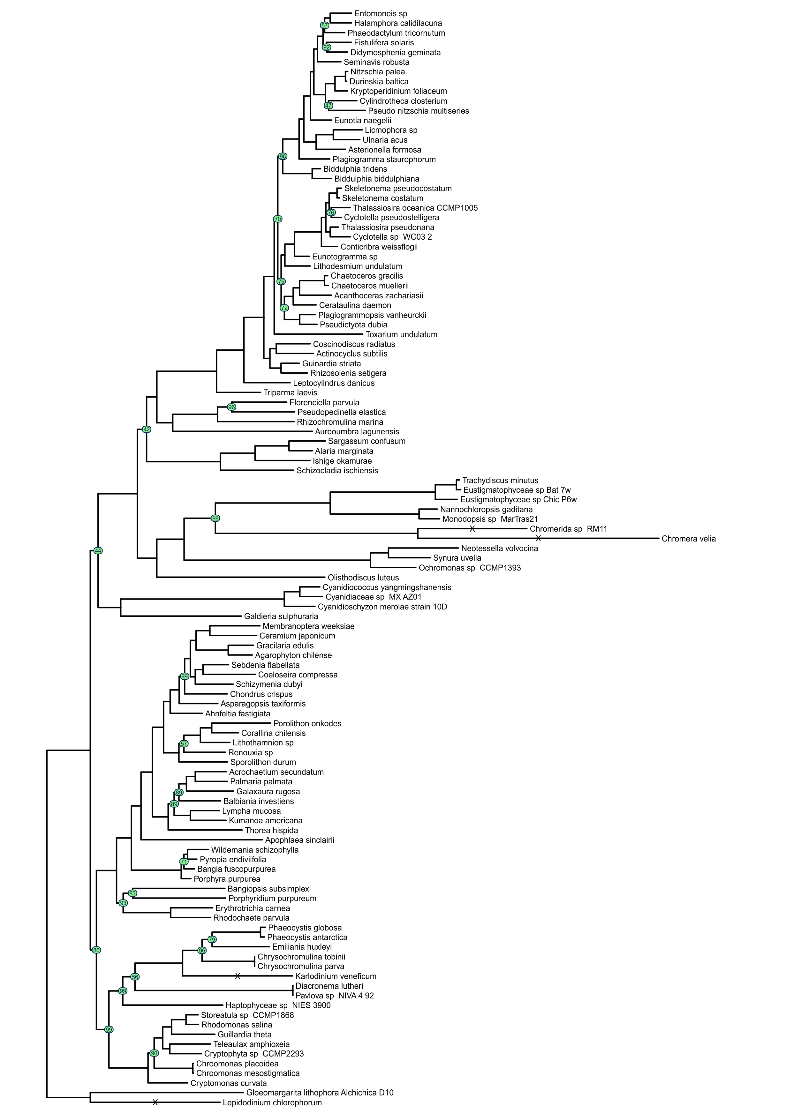
Figure A37. The phylogeny of red algae and red algae plastid bearing organisms. The tree topology was reconstructed in RAxML [77] and ClipKIT smart-gap alghoritm [108]. The nodes supported with bootstrap values lower than 100 are indicated in green circles. Substition models are presented in Table A27. Nodes with “X” mark are shortened by 50%.
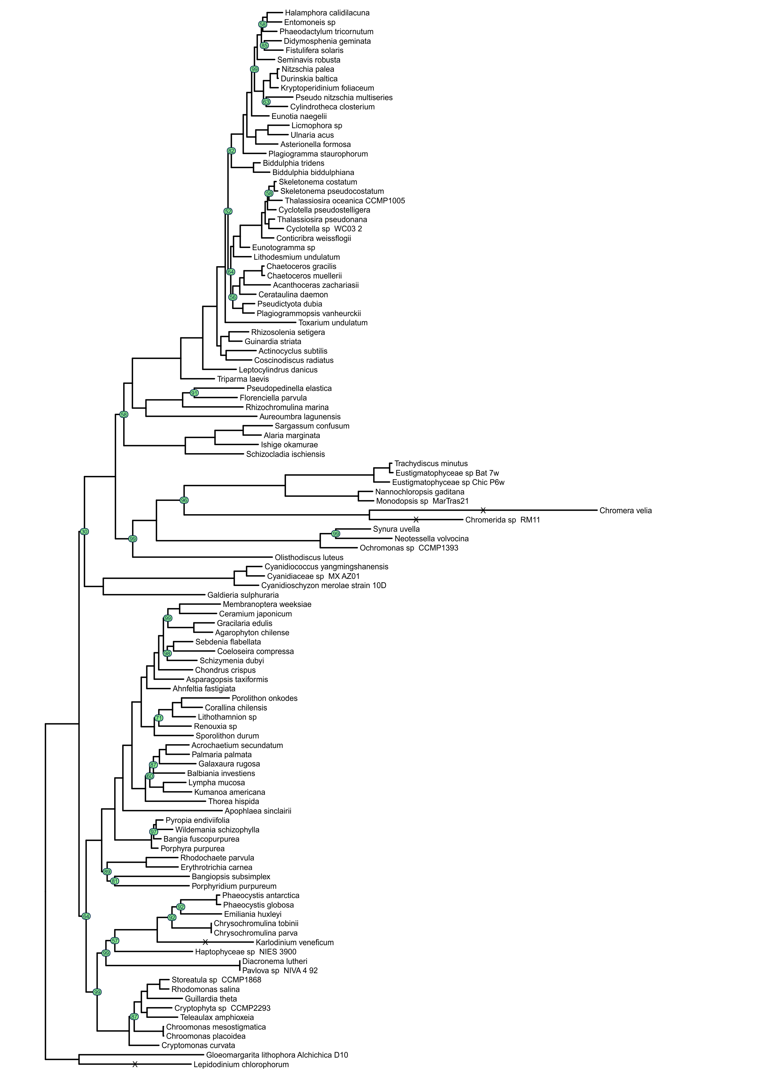
Figure A38. The phylogeny of red algae and red algae plastid bearing organisms. The tree topology was reconstructed in RAxML [77] and trimAl automated1 alghoritm [74]. The nodes supported with bootstrap values lower than 100 are indicated in green circles. Substition models are presented in Table A28. Nodes with “X” mark are shortened by 50%.
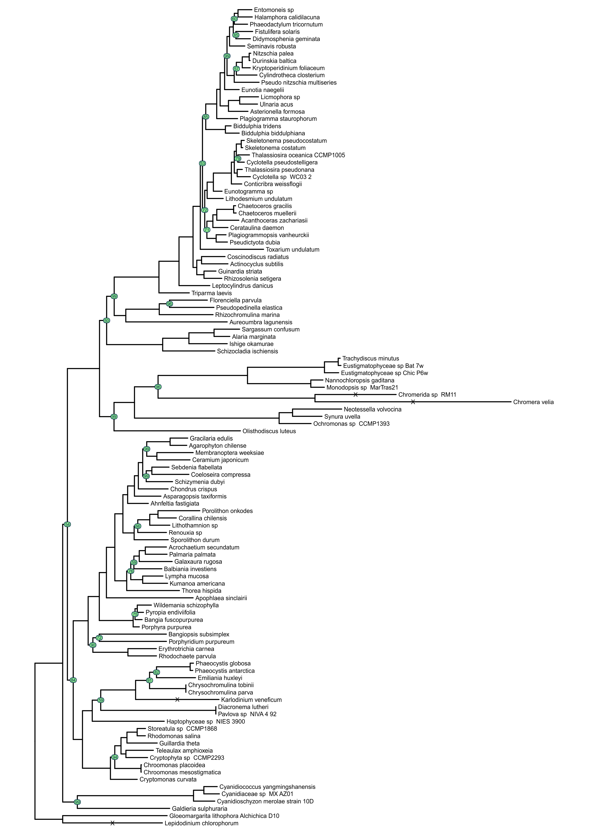
Figure A39. The phylogeny of red algae and red algae plastid bearing organisms. The tree topology was reconstructed in RAxML [77] and trimAl gappyout alghoritm [74]. The nodes supported with bootstrap values lower than 100 are indicated in green circles. Substition models are presented in Table A29. Nodes with “X” mark are shortened by 50%.
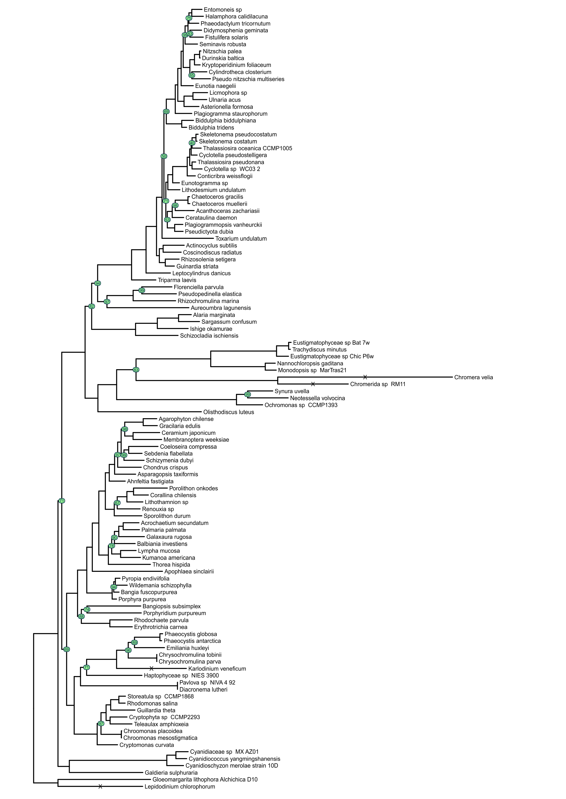
Figure A40. The phylogeny of red algae and red algae plastid bearing organisms. The tree topology was reconstructed in RAxML [77] and trimAl strict alghoritm [74]. The nodes supported with bootstrap values lower than 100 are indicated in green circles. Substition models are presented in Table A30. Nodes with “X” mark are shortened by 50%.
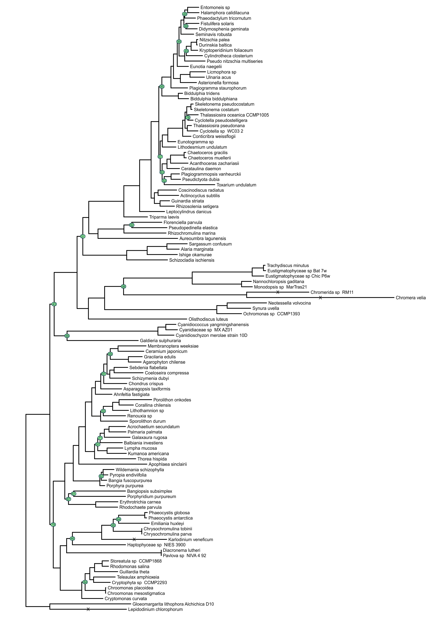
Figure A41. The phylogeny of red algae and red algae plastid bearing organisms. The tree topology was reconstructed in RAxML [77] and and original alignment. The nodes supported with bootstrap values lower than 100 are indicated in green circles. Substition models are presented in Table A31. Nodes with “X” mark are shortened by 50%.
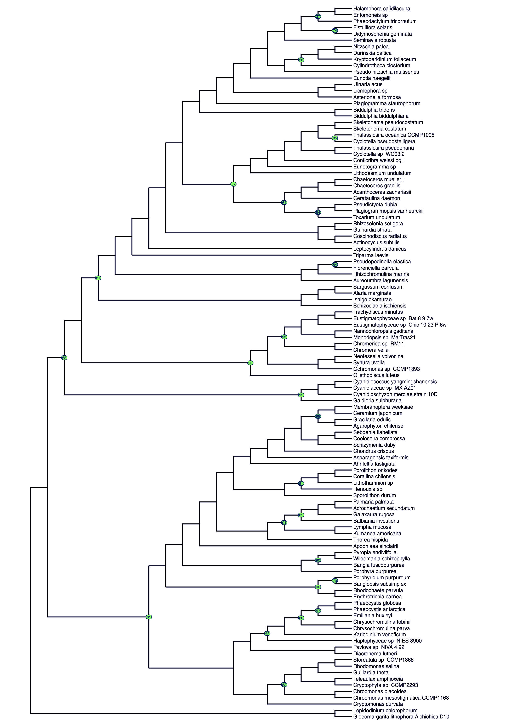(Figure A42. Caption on the next page.)
Figure A42. The phylogeny of red algae and red algae plastid bearing organisms. The tree topology was reconstructed in IQ-TREE [72] and ClipKIT smart-gap alghoritm [104]. The nodes supported with bootstrap values lower than 100 are indicated in green circles The best substitution model LG+C20+F+R10 was found using ModelFinder [81].

Dorobek naukowy

Publikacje
- Sidorczuk K, Gagat P, Kała J, Nielsen H, Pietluch F, Mackiewicz P, Burdukiewicz M. Prediction of protein subplastid localization and origin with PlastoGram. Scientific Reports 2023, 13:8365. IF: 4.997, punkty MNiSW: 140
- Sidorczuk K, Gagat P, Pietluch F, Kała J, Rafacz D, Bąkała L, Słowik J, Kolenda R, Rödiger S, Fingerhut L C H W, Cooke I R, Mackiewicz P, Burdukiewicz M. Benchmarks in antimicrobial peptide prediction are biased due to the selection of negative data. Briefings in Bioinformatics 2022, 23(5):bbac343. IF: 13.994, punkty MNiSW: 140
- Burdukiewicz M, Sidorczuk K, Rafacz D, Pietluch F, Bąkała M, Słowik J, Gagat P. CancerGram: An Effective Classifier for Differentiating Anticancer from Antimicrobial Peptides. Pharmaceutics 2020, 12(11), 1045. IF: 6.525, punkty MNiSW: 100
- Burdukiewicz M, Sidorczuk K, Rafacz D, Pietluch F, Chilimoniuk J, Rödiger S, Gagat P. Proteomic Screening for Prediction and Design of Antimicrobial Peptides with AmpGram. International Journal of Molecular Sciences. 2020 Jun 17;21(12):4310. IF: 6.208, punkty MNiSW: 140
- Gagat P, Sidorczuk K, Pietluch F, Mackiewicz P. The photosynthetic adventure of Paulinella spp. Springer Nature 2020, Malgorzata Kloc (Eds): Symbiosis: Cellular, Molecular, Medical and Evolutionary Aspects, 978-3-030-51848-6, 483283_1_En, (Chapter 13). IF: 3.109, punkty MNiSW: 70
- Gagat P, Duda-Madej A, Ostrówka M, Pietluch F, Seniuk A, Mackiewicz P, Burdukiewicz M. Testing Antimicrobial Properties of Selected Short Amyloids. International Journal of Molecular Sciences. 2023 Jan 2;24(1):804. IF: 6.208, punkty MNiSW: 140

Wystąpienia konferencyjne
- „New Insights into the Evolution of Complex Plastids: Unveiling the Origins and Diversification Times of Red Alga-Derived Lineages”, prezentacja ustna, 9th Polish Evolutionary Conference, 18-20 września 2023, Kraków, Polska.

- „Differentation anticancer from antimicrobial pepides using Cancergram”, prezentacja plakatowa, CASUS-HZDR 2022, 11-15 lipca 2022, Wrocław, Polska.

- „Phylogenetic and molecular clock study of plastid encoded genes untangle archaeplastidia evolution”, prezentacja plakatowa, Congress of the European Society for Evolutionary Biology (ESEB 2022), 14-19 sierpnia 2022, Praga, Czechy.

- „When did Plastids and Chromatophores Evolve? Phylogenetic and Molecular Clock Studies in the Context of Climatic and Atmospheric Changes”, prezentacja plakatowa, Congress of the European Society for Evolutionary Biology (EMBO 2022), 12-17 września 2022, Sant Feliu de Guix, Hiszpania.

- „Differentiation anticancer from antimicrobial peptides using Cancergram”, prezentacja plakatowa, 2023 Antimicrobial Peptides GRC, 15-20 stycznia 2023, Lucca, Włochy.

- “Dating the photosynthetic organelle evolution in Archaeplastida, Paulinella and secondary-plastid bearing lineages”, prezentacja plakatowa, EMBO Young Scientists' Forum 21-22 października 2021, Warszawa, Polska.

- “Production-ready Shiny apps with golem and ShinyProxy” , prezentacja ustna, Data Science Summit, 16 października 2020, online.

- “Untangling the puzzle of Archaeplastidia evolution with phylogenies of plastid-encoded proteins”, prezentacja ustna, 7th Polish Evolutionary Conference 18-20 września 2019, Gdańsk, Polska.

- “Phylogenetic analyzes of plastid-encoded proteins untangle the Archaeplastida evolution”, prezentacja ustna, XII Symposium of Polish Bioinformatics Society 19-21 września 2019, Kraków, Polska.

- “In search of primary plastids origin”, prezentacja plakatowa, XI Symposium of Polish Bioinformatics Society 5-7 wrzesień 2018, Wrocław, Polska

Staże
- 9-24.03.2020 - Faculty of Mathematics and Information Science, Warsaw University of Technology, Poland (supervisor: Michał Burdukiewicz).
- 1-15.07.2019 - Faculty of Mathematics and Information Science, Warsaw University of Technology, Poland (supervisor: Michał Burdukiewicz)

